1. **CAST OBJECTS TO A DATA TYPE**

SELECT customerNumber,

    COUNT(*) AS number_payments,

    MIN(CAST(amount AS INT)) AS min_purchase,

    MAX(CAST(amount AS INT))  AS max_purchase,

    AVG(CAST(amount AS INT)) AS avg_purchase,

    SUM(CAST(amount AS INT)) AS total_spent

FROM payments

pd.read_sql('''

select cast(round(priceEach) as INTEGER) as rounded_price_int

        from orderDetails

            ''',conn)

**2.Strip year or month from date as a string object**

WHERE strftime('%Y',paymentDate)='2004'

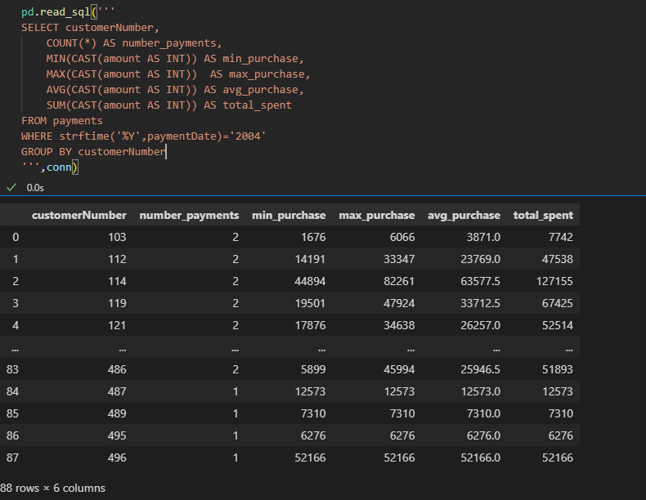

pd.read_sql('''

select orderDate,

            strftime('%m',orderDate) AS month,

            strftime('%Y',orderDate) AS year,

            strftime('%d',orderDate) as day

from orders;

''',conn)

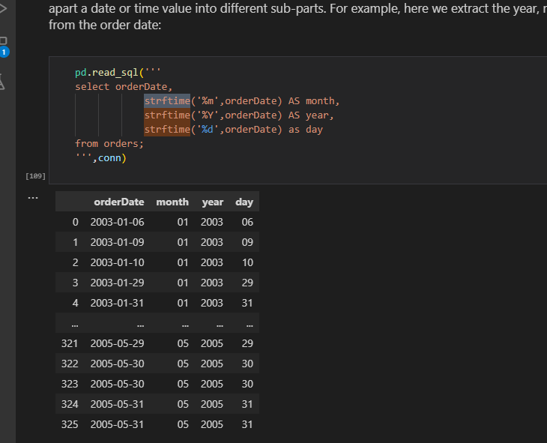

**Or use substr method**

pd.read_sql('''

SELECT customerNumber,

    COUNT(*) AS number_payments,

    MIN(CAST(amount AS INT)) AS min_purchase,

    MAX(CAST(amount AS INT))  AS max_purchase,

    AVG(CAST(amount AS INT)) AS avg_purchase,

    SUM(CAST(amount AS INT)) AS total_spent

FROM payments

WHERE substr(paymentDate,1,4) ='2004'

GROUP BY customerNumber

''',conn)

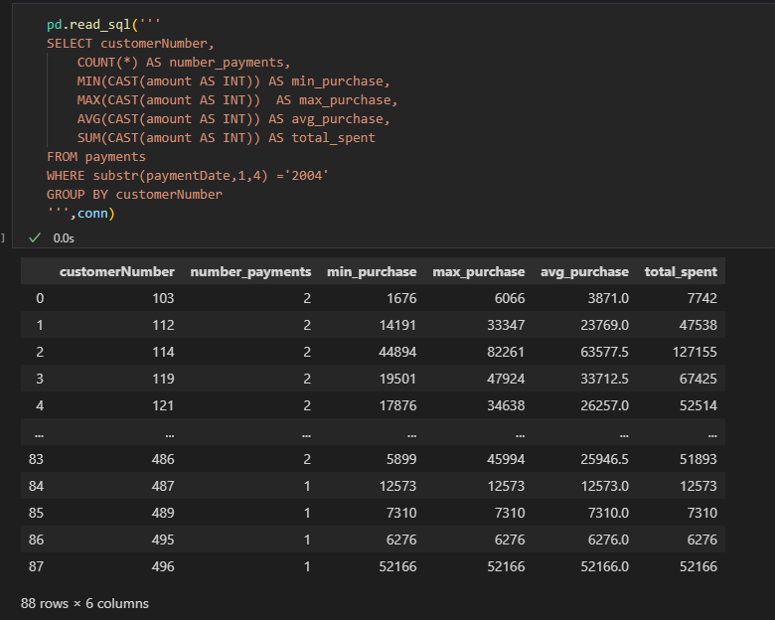

**3.Convert select statement to dataframe**

import pandas as pd

cur.execute('select * from   contactinfo')

df = pd.DataFrame(cur.fetchall())

df.columns = [x[0] for x in cur.description]

df

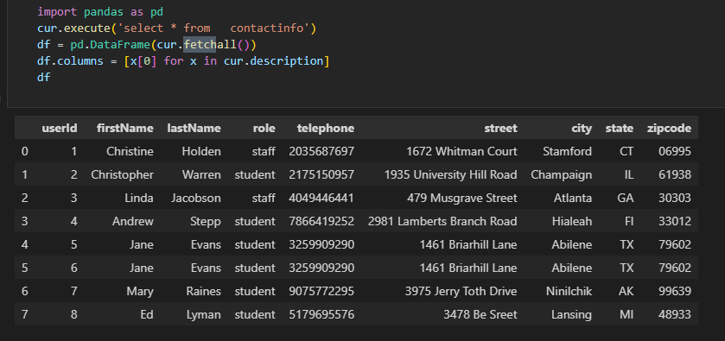

* 4. Highest -**altitude**
* Southern/northern – **latitude eg** northern-most airport is the highest latitude

Southern-most – smallest latitude

**5.Pandasql Error**

**----> 6** passenger_names **=** pysqldf**(**q**)**

**ImportError**: Unable to find a usable engine; tried using: 'sqlalchemy'.

A suitable version of sqlalchemy is required for sql I/O support.

Trying to import the above resulted in these errors:

**- Pandas requires version '1.4.0' or newer of 'sqlalchemy' (version '1.3.19' currently installed).**

**TO update use**

conda update sqlalchemy

Check version if updated

pip show sqlalchemy

6.

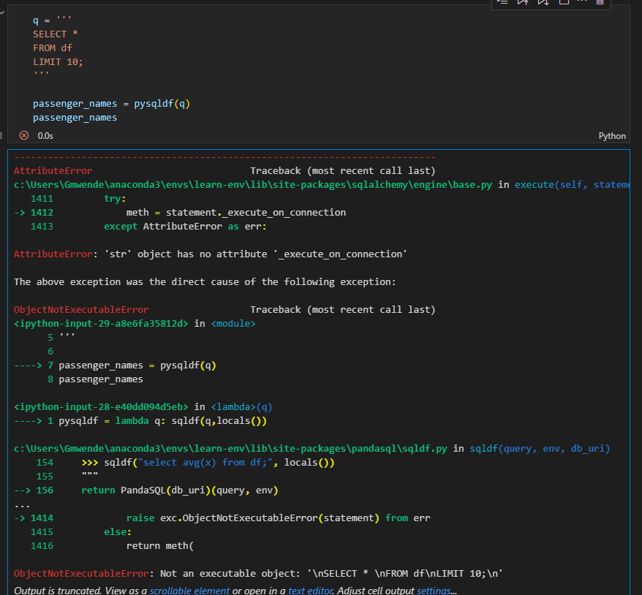

Works well in colab

**7.Put dataframe in memory as to use conn**

#put df to memory

import sqlite3

conn = sqlite3.connect(':memory:')

df.to_sql('df', conn, index=False, if_exists='replace')

# Execute SQL query using the connection

query = "SELECT * FROM df"

result = pd.read_sql(query, conn)

result

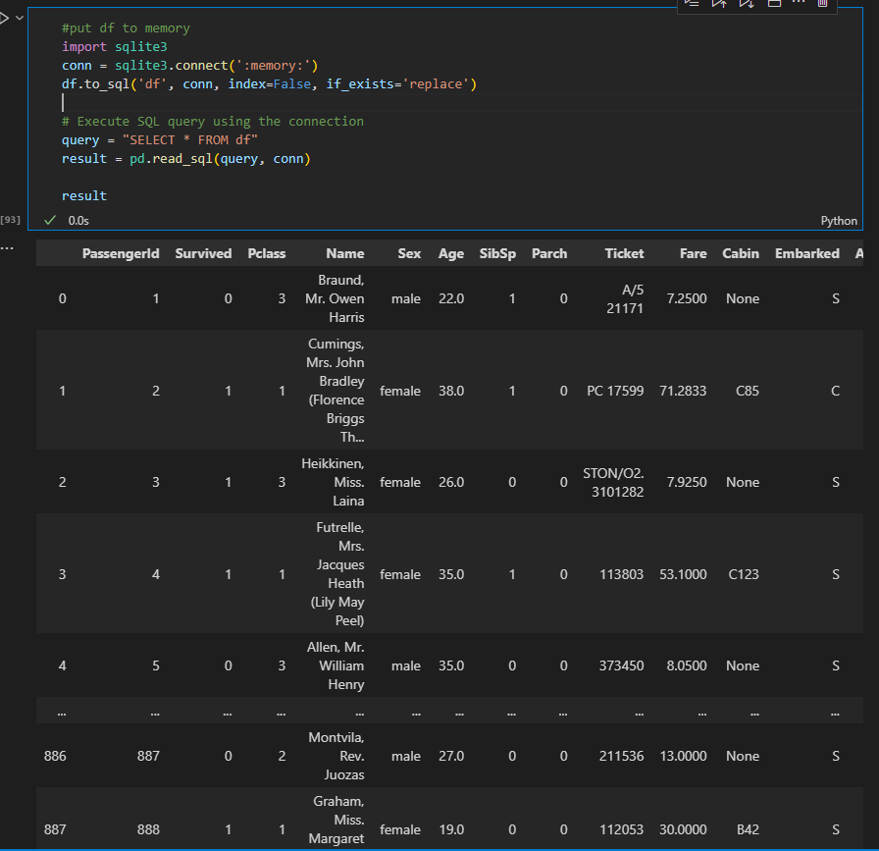

**8.Get female and children that is female and male less than or equal to 15**

df[(df['Sex'] == 'female') | (df['Age'] <= 15)]

**9.Select everyonelse other than 1**

df[df['Pclass'] != '1']

**10.calculate totals using counter(get frequency for each value)**

counter = collections.Counter(x)

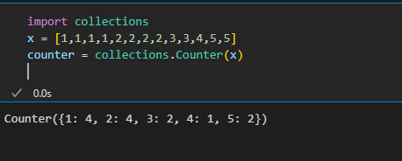

11. **Create two vertical subplots sharing 15% and 85% of plot space**

**Create density instead of count on seaborn histogram**

*#Create two vertical subplots sharing 15% and 85% of plot space*

*#sharex allows sharing of axes i.e building multiple plots on the same axes*

*fig, (ax,ax2) = plt.subplots(2,sharex=True,gridspec_kw={'height_ratios':(.15,.85)},figsize=(10,8))*

*sns.histplot(data['Height'],*

*lw=2,*

*edgecolor='r',*

*alpha=0.4,*

*color='w',*

*label='Histogram',*

*stat='density',*

*ax=ax2*

*)*

*sns.kdeplot(data.Height,*

*lw=3,*

*color='b',*

*label='Kernerl Density Estimation plot',*

*alpha=0.7,*

*ax=ax2*

*)*

*mean = data.Height.mean()*

*std = data.Height.std()*

*parametric_dist = stats.norm(loc=mean, scale=std)*

*x=np.linspace(parametric_dist.ppf(0.01),parametric_dist.ppf(0.99),100)*

*ax2.plot(x,*

*parametric_dist.pdf(x),*

*color='g',*

*alpha=0.7,*

*lw=3,*

*label = 'Parametric Fit'*

*)*

*ax2.set_title('Density Estimations')*

*sns.boxplot(data=data,x='Height',ax=ax,color='r') #sns.boxplot(x=data.Height, ax = ax,color = 'red')*

*ax.set_title('Box and Whiskers Plot')*

*ax2.set(ylim=(0, 0.08))*

*plt.ylim(0, 0.11)*

*plt.legend();*

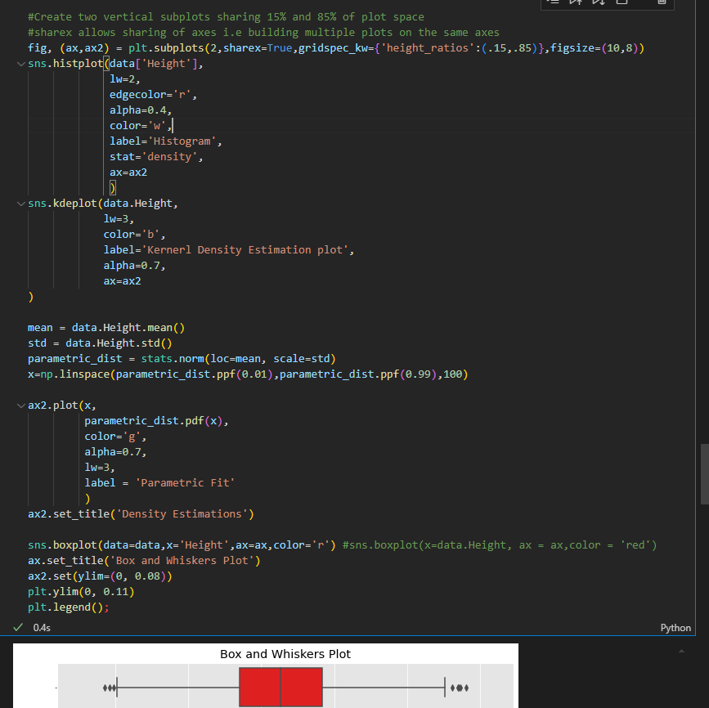

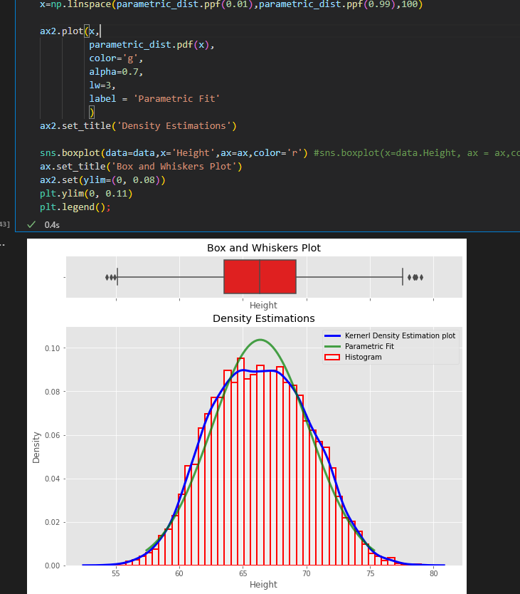

**12. Add density (probability) instead of counts in matplotlib histogram**

xtick_locations = range(1,6)

bins = np.arange(6) +0.5 #[0.5, 1.5, 2.5, 3.5, 4.5, 5.5]

plt.hist(x,bins=bins,rwidth=0.25,density=True)

plt.xticks(ticks=xtick_locations)

plt.xlabel('Bins of Outcomes')

plt.ylabel('Probabilities of Bins of Outcomes')

plt.title("Adjusted Histogram with `density=True`");

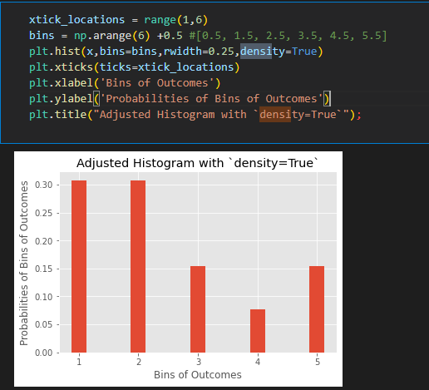

**13. ttest**

t= (x_bar-mu)/(sample_std/np.sqrt(25))

print('t: ',t)

critical_t_value = stats.t.ppf(1-alpha,24)

print('critical_t_value: ',critical_t_value)

p_value = stats.t.sf(t,df)

print("p-value:",p_value)

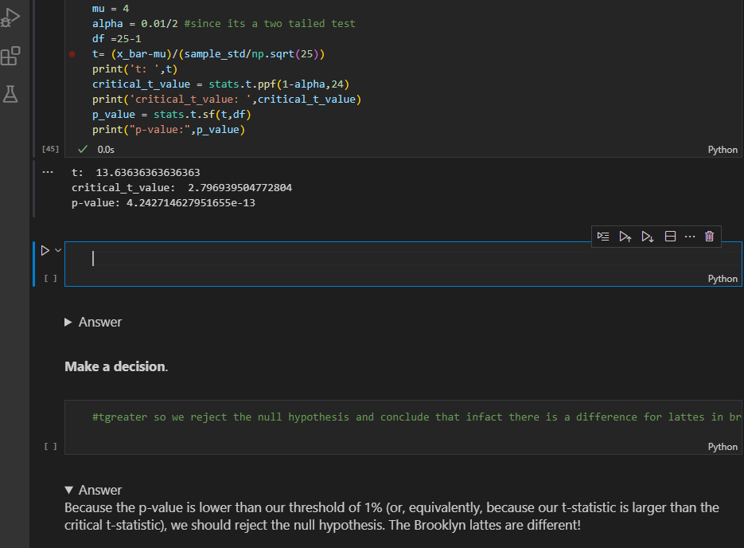

b)Example 2#one tailed left tail

sample =[20, 30, 30, 50, 75, 25, 30, 30, 40, 80]

x_bar =  np.mean(sample)

sample_std = np.std(sample,ddof=1)

n=len(sample)

df=n-1

mu =58

t_stat1 = stats.ttest_1samp(a=sample,popmean=58)

print('t_stat1:', t_stat1[0])

print('alpha:', t_stat1[1]/2)

t_stat2 = (x_bar-mu)/(sample_std/np.sqrt(n))

print('t_stat2:', t_stat2)

alpha2 = stats.t.cdf(t_stat2, df) #used cdf since it is left tail(checking less)

print('alpha2:', alpha2)

t_crit = stats.t.ppf(0.1,df)

print('t_crit:', t_crit)

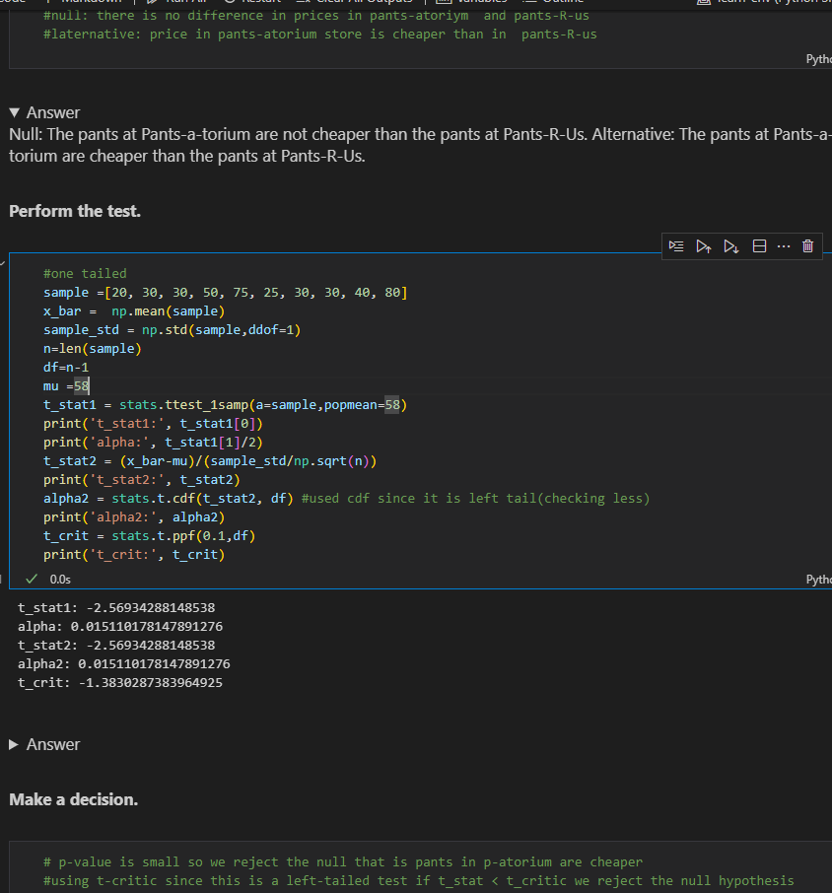

**c)two-sample t-test**

**delivery_times_A = [28.4, 23.3, 30.4, 28.1, 29.4, 30.6, 27.8, 30.9, 27.0, 32.8]**

**mean_A = np.mean(delivery_times_A)**

**std_A = np.std(delivery_times_A)**

**nobs_A = len(delivery_times_A)**

**mean_B = 26.8**

**std_B = 2.6**

**nobs_B = 10**

**stats.ttest_ind_from_stats(mean1=mean_A, std1=std_A, nobs1=nobs_A,**

**mean2=mean_B, std2=std_B, nobs2=nobs_B,**

**equal_var=False)**

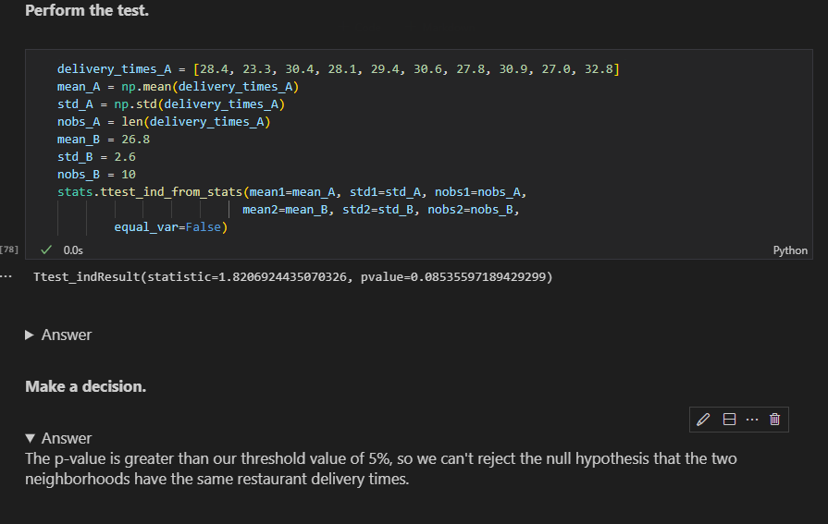

**c)2 sample again two tailed**

**high_protein = [134, 146, 104, 119, 124, 161, 107, 83, 113, 129, 97, 123]**

**low_protein = [70, 118, 101, 85, 107, 132, 94]**

**stats.ttest_ind(a=high_protein, b=low_protein)**

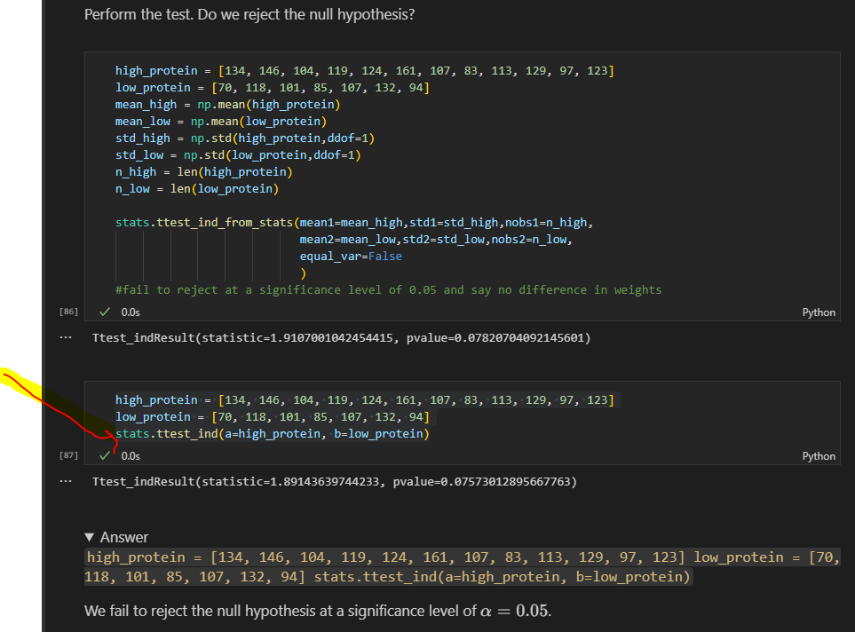

**d)2 sample one tailed**

h_bar = np.mean(high_protein)

l_bar = np.mean(low_protein)

h_df = len(high_protein) - 1

l_df = len(low_protein) - 1

pooled_var = (h_df*np.var(high_protein) + l_df*np.var(low_protein)) / (h_df + l_df)

t_stat = (h_bar - l_bar) / np.sqrt(pooled_var * (1/len(high_protein) + 1/len(low_protein)))

t_stat

stats.t(df=h_df+l_df).cdf(t_stat)

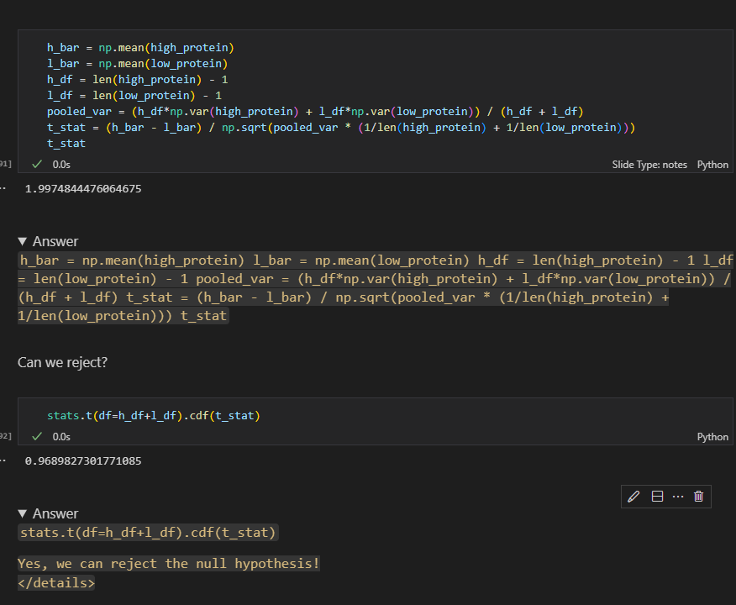

**SQL SUMMARY**

* We will primarily use SQLite in these lessons because it is lightweight and portable (and therefore useful for educational purposes)
* SQLite is a C library that provides lightweight disk-bases databse that doesn’t require a separate server process and allows accessing the database using a nonstandard variant of the SQL query language.
* Some applications can use SQLite for internal data storage.Its also possible to prototype an application using sqlite and then port the code to a larger databse such as postresgreSQL or Oracle

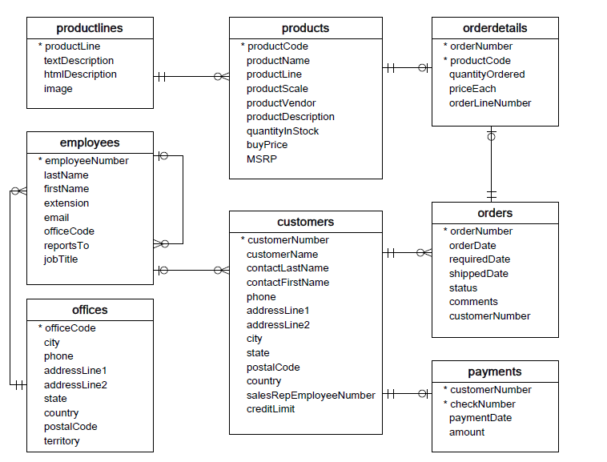

1. **ERD** (Entity Relationship Diagram)- shows the relationship between tables. It does not give us any information about the specific data stored in the database, but rather the metadata
2. **Connect to sqlite 3**

import sqlite3

conn = sqlite3.connect('data.sqlite')

1. **Select Records**

q='''SELECT * FROM EMPLOYEES'''

pd.read_sql(q,conn)

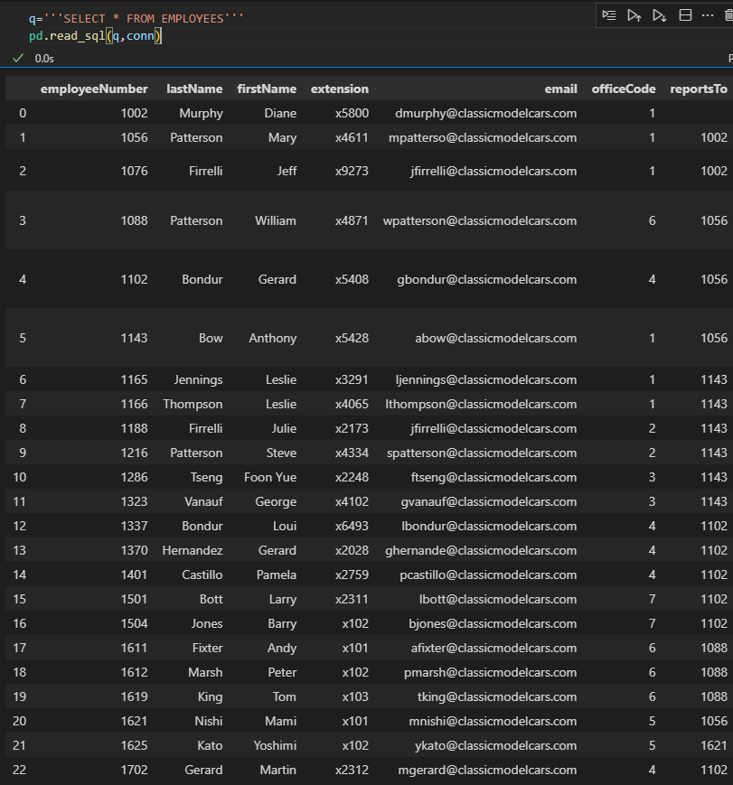

1. Check table in a database(Note that the .execute() method didn't actually return our data. The data is now just available in our cursor object. We'll use the .fetchall() method to get all the rows from our query.)

cur = conn.cursor()

cur.execute("""SELECT name FROM sqlite_master WHERE type = 'table';""")

table_names = cur.fetchall()

table_names

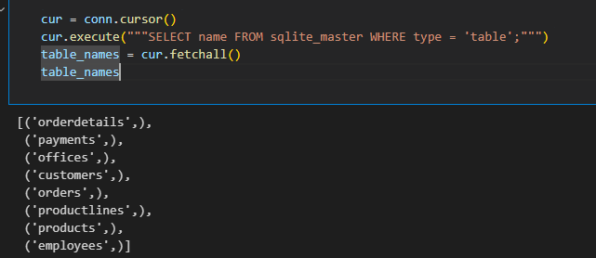

1. Select * using cursor or can use ‘curr.execute(''' select * from offices''').fetchall(),

curr.execute(''' select * from offices ''')

curr.fetchall()

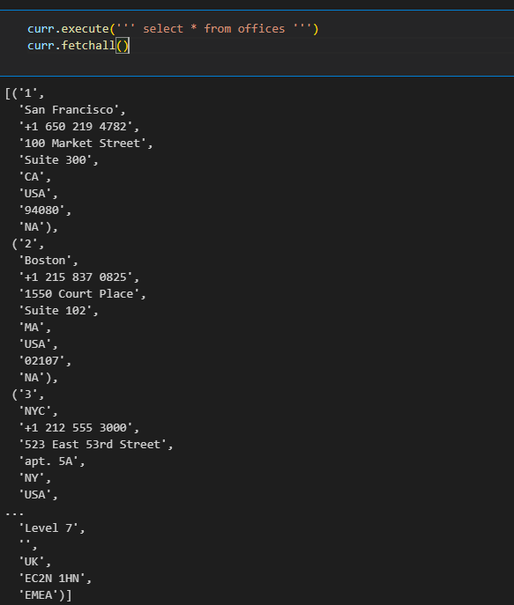

1. curr.execute(''' select * from offices''').fetchall()[0][2]

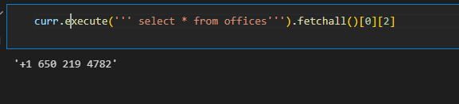

1. Viewing column names(  
   Looks like we got some data, but it's not clear what each element represents. We can view the column names in the cursor's description attribute.)

curr.description

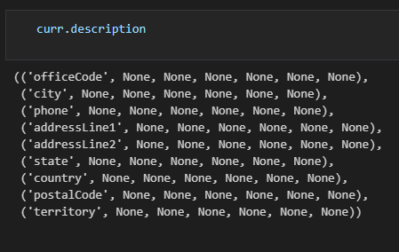

1. Create a dataframe with column names from the records/from a table

import pandas as pd

pd.DataFrame(

    data = curr.execute(''' select * from offices;''').fetchall(),

    columns =[x[0] for x in curr.description]

)

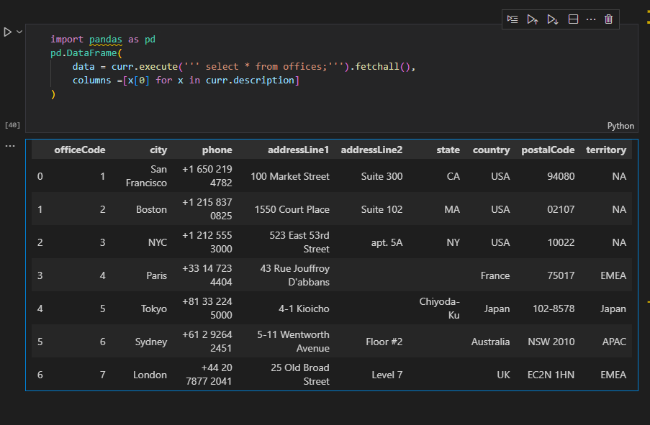

1. Retrieving a subset of columns

pd.read_sql('''

      select lastName,FirstName from employees

            ''',conn).head()

1. Use Aliases (AS keyword) to change column names

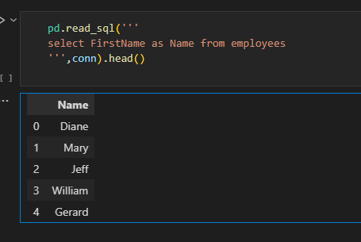

1. Using SQL case statements

pd.read_sql('''

select Firstname,LastName,jobTitle,

            CASE

            WHEN jobTitle = 'Sales Rep' then 'Sales Rep'

            ELSE 'Not Sales Rep'

            END AS role

From employees

''',conn)

1. Cases to make Human Readable

pd.read_sql('''

select FirstName,lastName,officeCode,

            CASE officeCode

            WHEN '1' then 'San Francisco, CA'

            WHEN '2' then 'Boston, MA'

            WHEN '3' then 'New York, NY'

            WHEN '4' then 'Paris, France '

            WHEN  '5' then  'Tokyo, Japan'

            END as office

from employees

            ''',conn).head(10)

1. a**)Check length**

pd.read_sql('''

select length(firstName)  as name_length

    from employees

''',conn).head(5)

b)**Convert to upper**

pd.read_sql('''

select upper(firstName) as name_in_all_caps

        from employees;

''',conn).head(5)

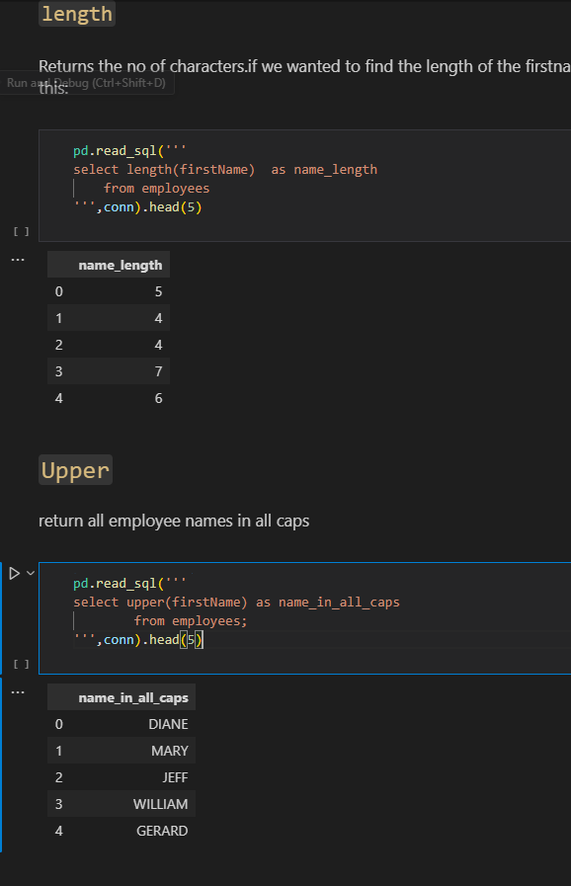

**c)Slicing**

select substr(firstname,1,1) as first_initial

from employees;

select substr(firstName,1,1) || '.' as first_initial     --use || as **concatentate** operator

    from employees

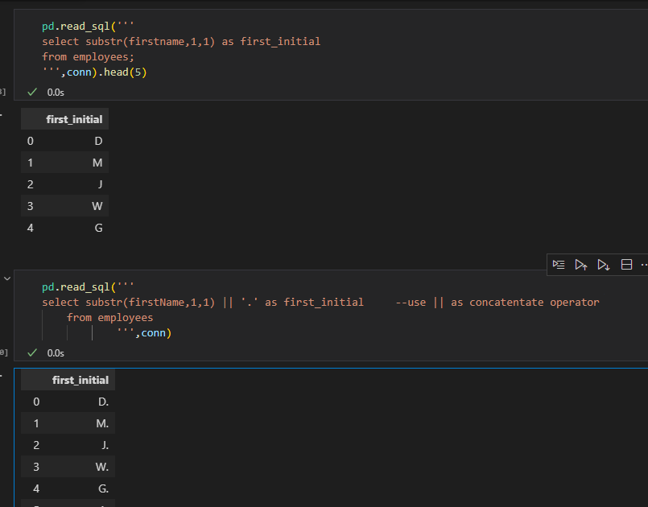

d) We can also **combine multiple column values**, not just string literals

pd.read_sql('''

select firstname || ' ' || lastname as name

from employees

''',conn).head()

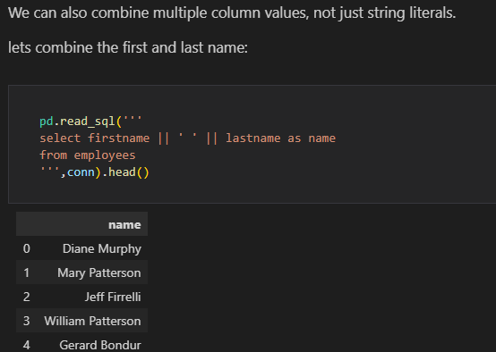

e)**Aggregations eg count**

pd.read_sql('''

select COUNT() as "Number of Airports"

from airports

            ''',con)

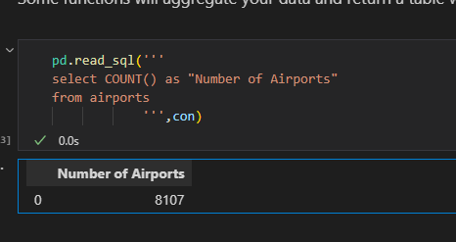

NB: in AGGREGATIONS ensure that’s it’s the correct datatype for the function to avoid unexpected results eg

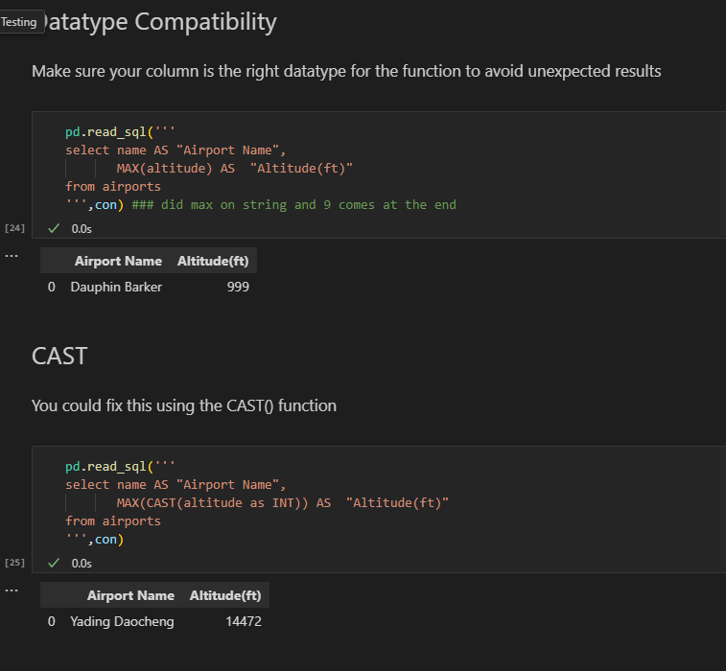

1. **Built in SQL for Math Functions**

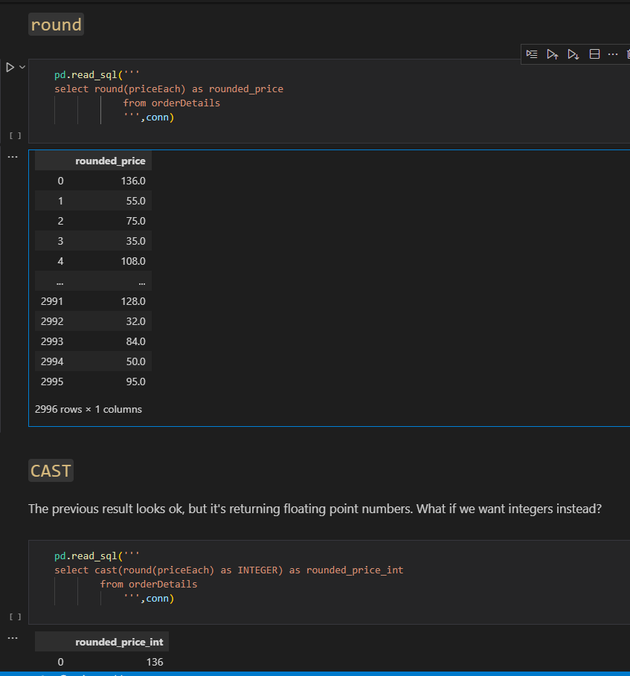

1. **Built-in SQL Functions for Date and Time Operations-**

(JulianDay and Date)

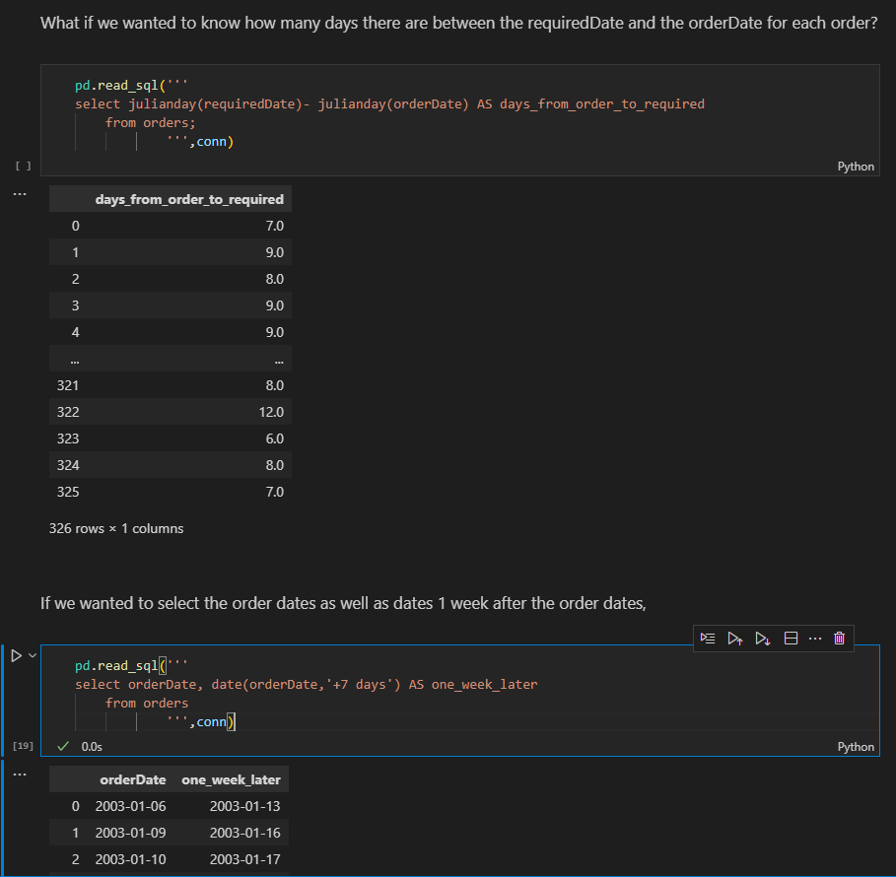

1. strftime function

pd.read_sql('''

select orderDate,

            strftime('%m',orderDate) AS month,

            strftime('%Y',orderDate) AS year,

            strftime('%d',orderDate) as day

from orders;

''',conn)

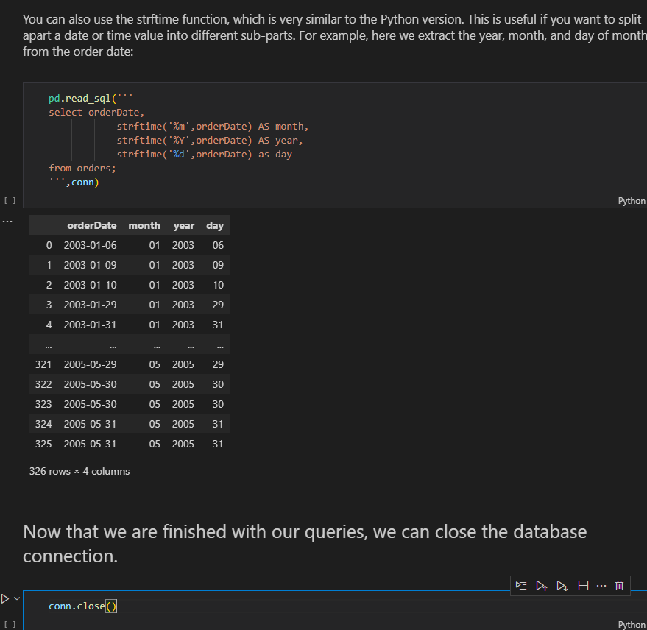

**13. If we really wanted to, we could just use those same SQLite terminal commands directly in a Jupyter Notebook using magic commands.**

%%script sqlite3 data/data.sqlite --out offices_data

select* from offices;

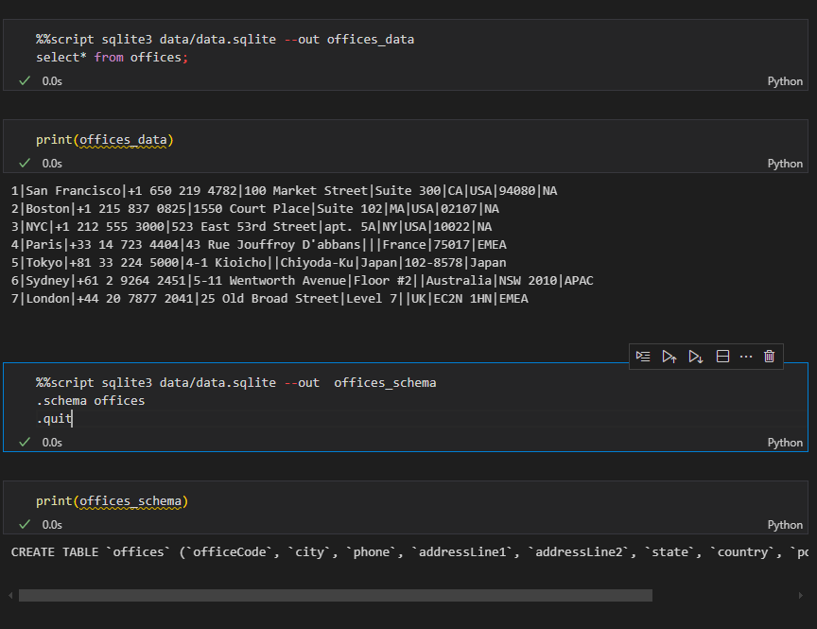

%%script sqlite3 data.sqlite --out tables

.tables

.quit

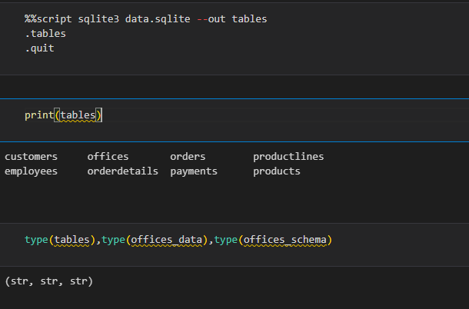

1. Connecting to the database using the terminal

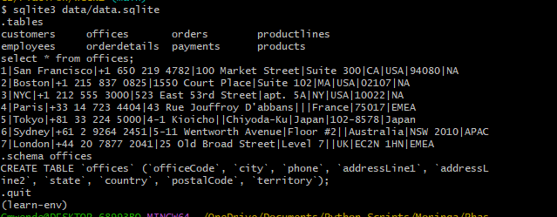

1. **Relational databases** typically have multiple tables containing data, and the tables have defined relationships

Database **Schema** – defines the structure of the database, including the tables and relationships between tables

**Primary key** – uniquely identifies each row in a table

**Foreign key** - used in one table to refer to the primary key of another table

1. Acess schema of lets say the first table

print(schema_df['sql'].iloc[0]) #print(schema_df.iloc[0]['sql'])

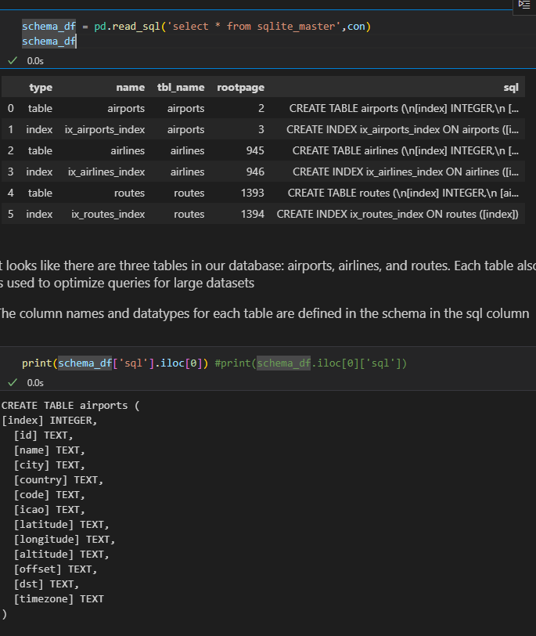

1. **Between**

pd.read_sql('''

SELECT  name AS "Airport Name",

        CAST(latitude AS int) AS "Airport Latitude",

        CAST(altitude AS int) AS "Altitude (ft)"

FROM airports

WHERE "Airport Latitude" between 20 AND 50 AND "Altitude (ft)">10000

''',con)

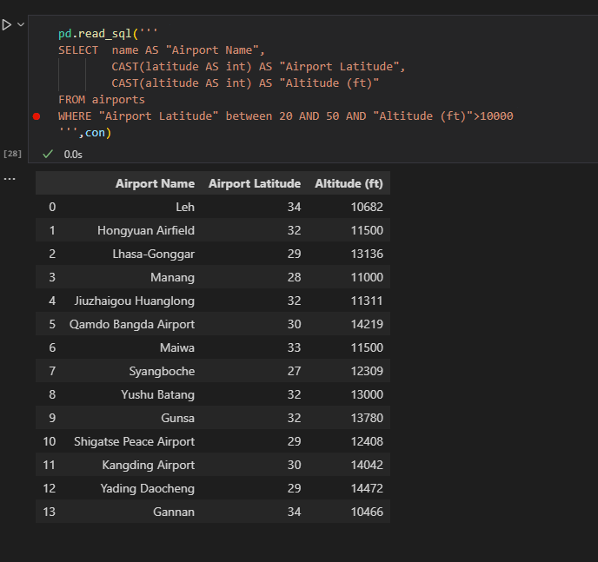

1. **IS** – Useful when working with NULL values

pd.read_sql('''

SELECT name AS "Airport Name",

       code as "Airport Code"

FROM airports

WHERE "Airport Code" IS NOT NULL

''',con)



1. **ORDER BY**

pd.read_sql('''

SELECT name AS "Aiport Name",

        CAST(latitude AS int) AS "Airport Latitude",

        CAST(altitude AS int) AS "Altitude(ft)"

FROM airports

WHERE "Altitude(ft)" >=10000

ORDER BY "Airport Latitude" DESC,

         "Altitude(ft)" DESC

 ''',con)

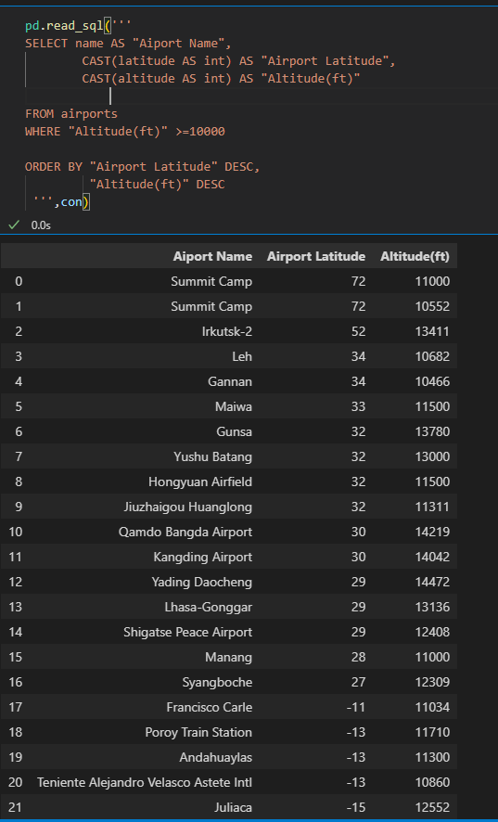

1. **LIMIT**

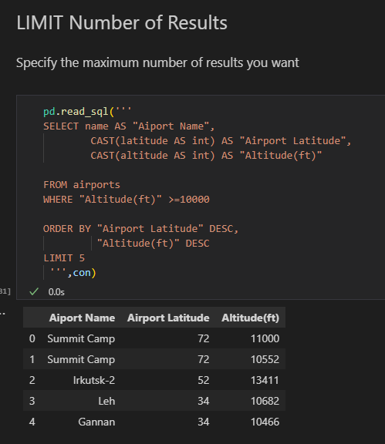

1. **a)Filtering by price**

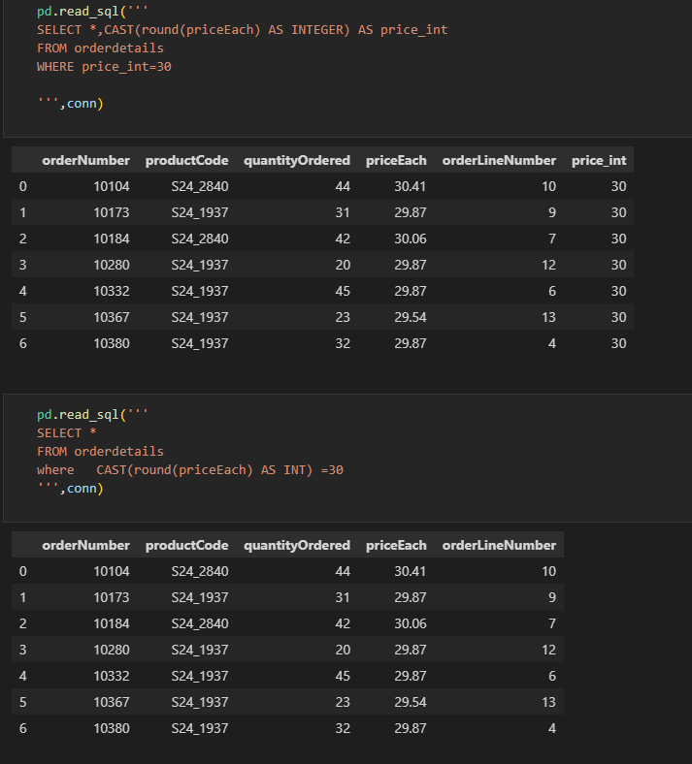

b)**Filter by Date eg select all January orders**

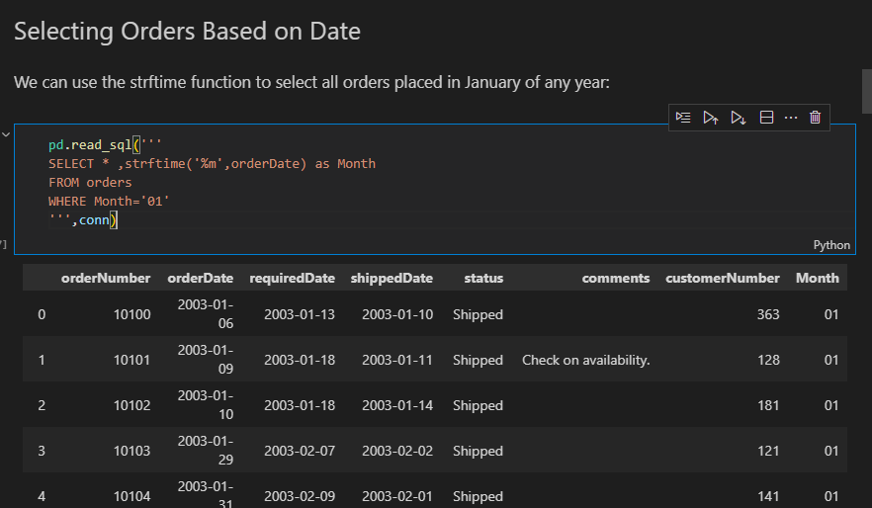

**C)Filter late orders**

pd.read_sql('''

SELECT julianday(shippedDate) - julianday(requiredDate) as days_late ,*

FROM orders

WHERE days_late >0

 ''',conn)

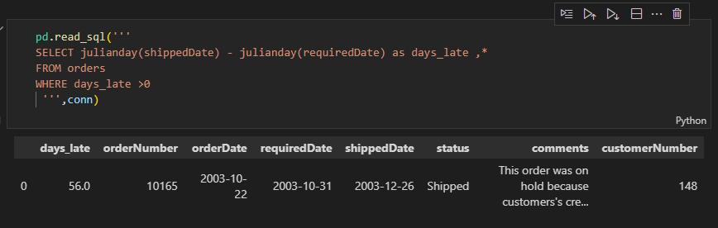

**d)Like –** select cats starting with ‘M’ or ‘m’

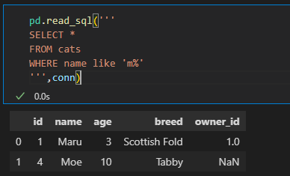

**e) select all cats with four-letter names where the second letter was "a", we could use _a__**

pd.read_sql('''

SELECT *

FROM cats

WHERE name like '_a__'

''',conn)

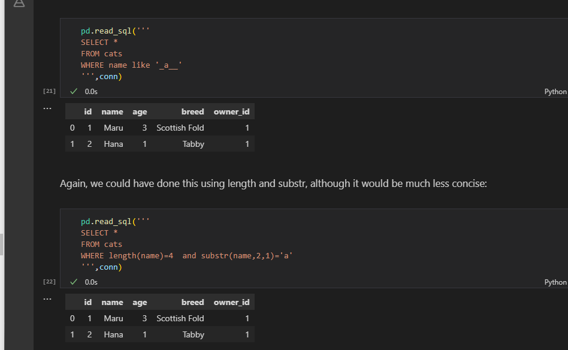

1. Select from 2 tables

pd.read_sql('''

select cats.name,dogs.name

from cats,dogs;

''',conn)

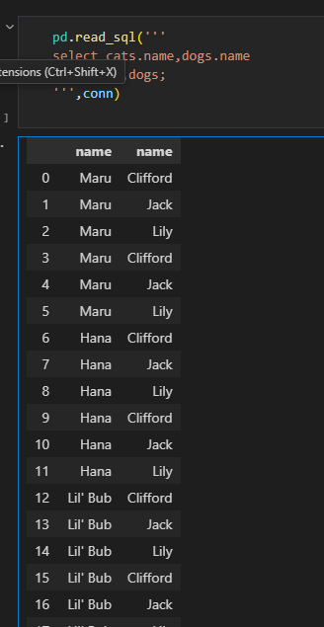

1. way of thinking about which column should come first after ORDER BY, is that the fewer unique values the column has, the earlier it should appear

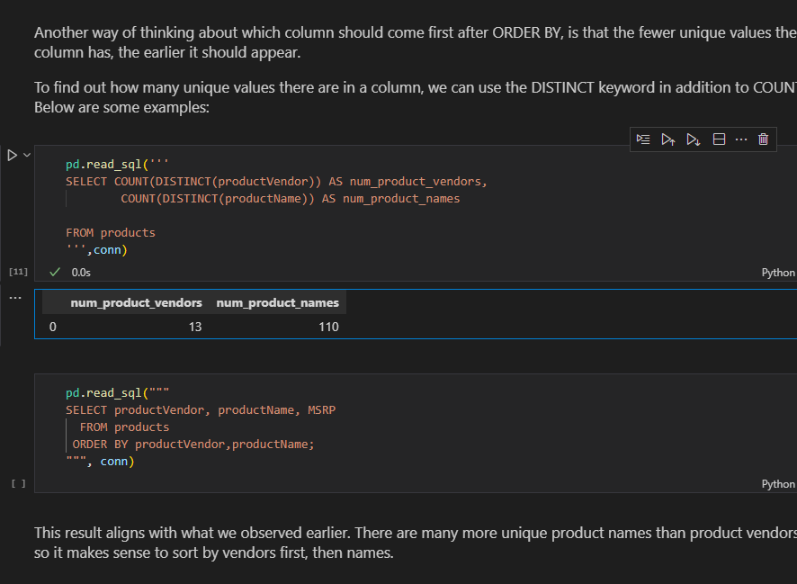

1. Create database and tables

**import sqlite3**

**conn = sqlite3.connect('pets_database.db')**

**cur = conn.cursor()**

a)Create Cats table and insert records

#Creating the cats table

cur.execute('''

CREATE TABLE cats(

            id INTEGER PRIMARY KEY,

            name TEXT,

            age INTEGER,

            breed TEXT

            )

''')

============================================================= cur.execute('''

INSERT INTO cats(name,age,breed)

            VALUES('Maru',3,'Scottish Fold'),

                  ('Lil Bub',2,'Sheperd cat'),

                  ('Hannah',4,'German cats')

''')

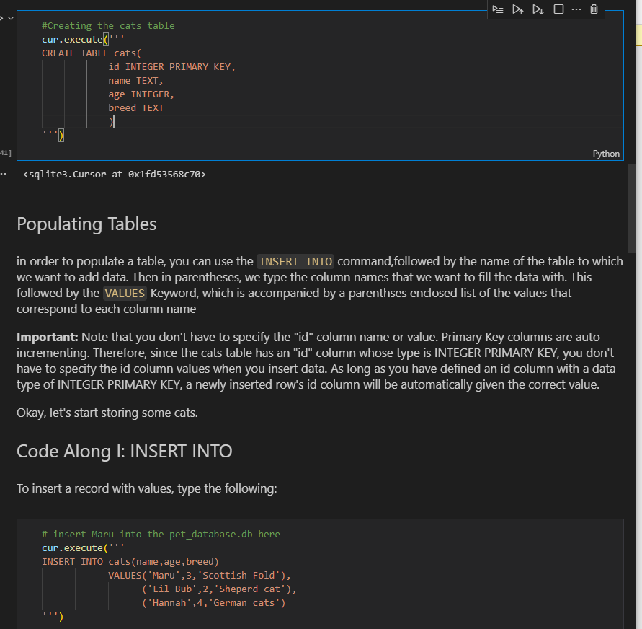

1. Altering(update) and deleting data

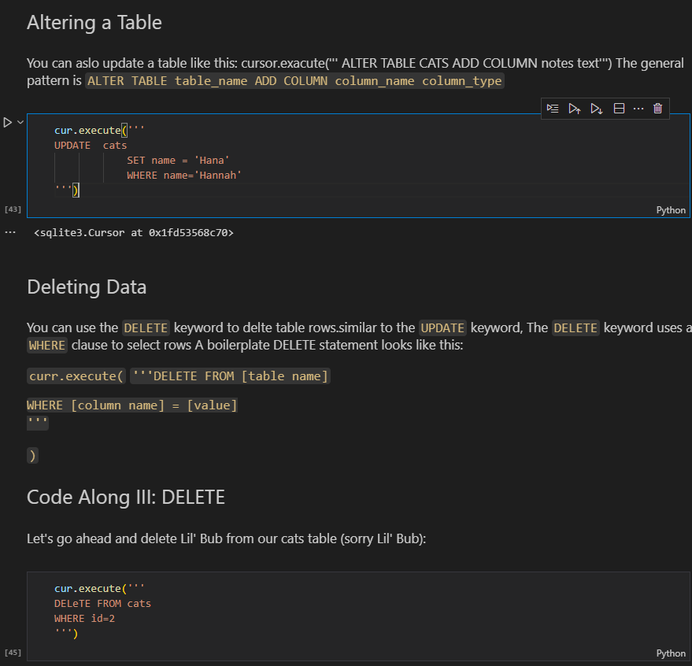

1. We need to save the changes otherwise when we create and new connection and acess record we find that its empty

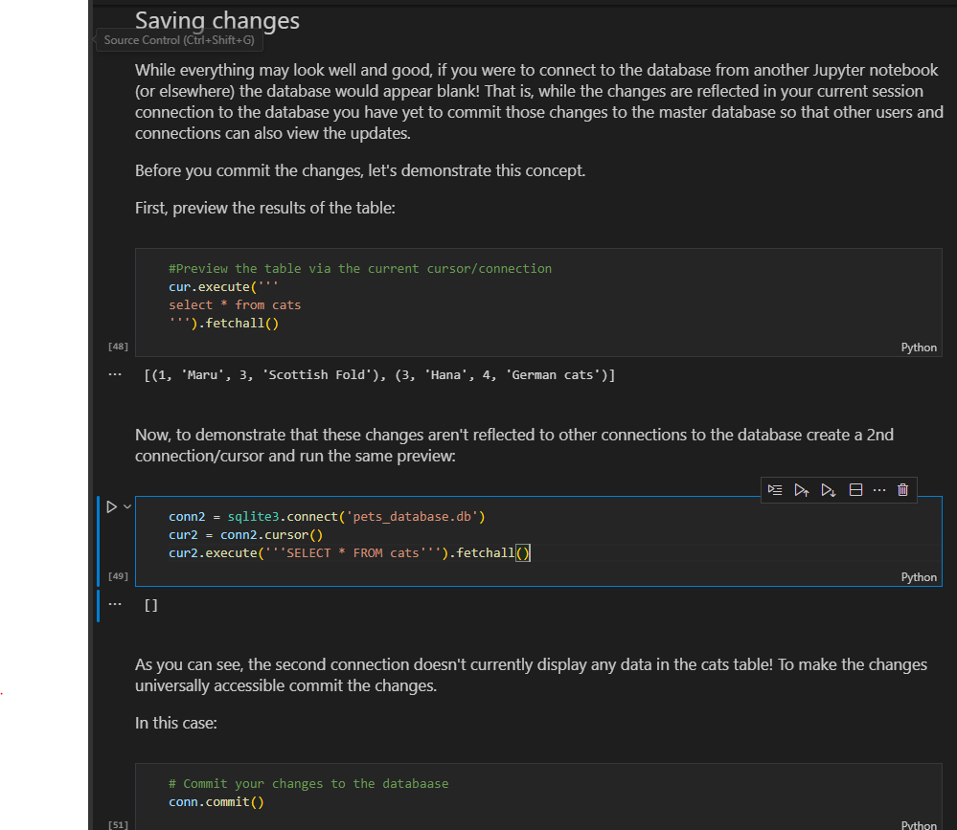

1. Insert into table from dictionary

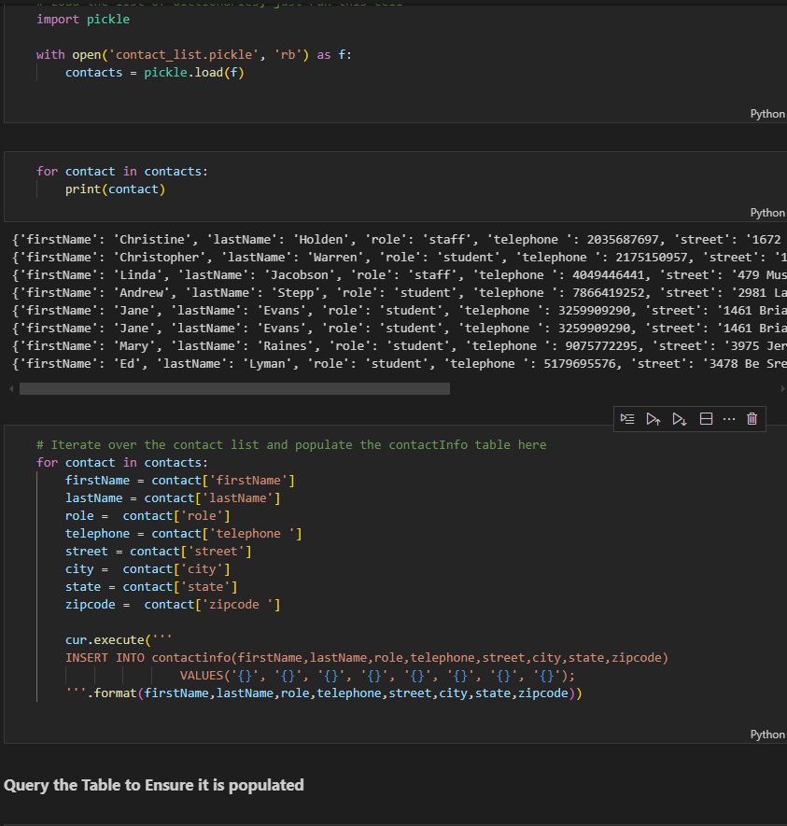

1. Create table with dual key

cur.execute('''

CREATE TABLE Grades(

            userid INTEGER NOT NULL,

            courseid INTEGER NOT NULL,

            grade INTEGER,

            PRIMARY KEY(userid,courseid)

            )

''')

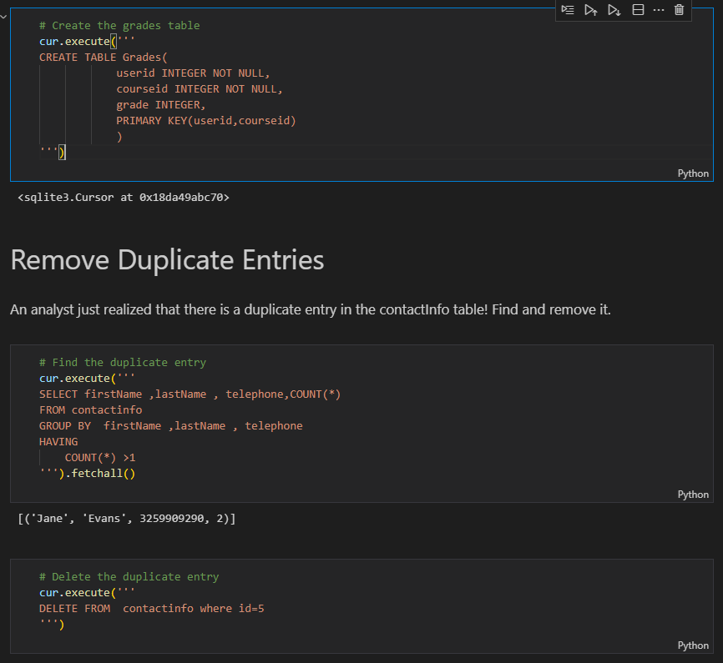

1. **Typing** – the practice of explicitly declaring a type.execises some level of control over our data.Without typig our data can become complicated and messy and it would be difficult to ask the database questions about large sets of data

* TEXT -str
* INTEGER- int
* REAL -float
* BLOB

1. **JOINS**

q= '''

select *

FROM orderdetails

JOIN products

ON orderdetails.productCode = products.productCode

LIMIT 10

'''

pd.read_sql(q,conn)

**b)Columns have the same name**

#IF COLUMNS HAVE THE SAME NAME

q= '''

select *

FROM orderdetails

JOIN products

USING (productCode)

LIMIT 10

'''

pd.read_sql(q,conn)

1. **JOIN IF table is related by joining another table** eg checking how many customers are there per office yet customer does relate to offices but related through employee

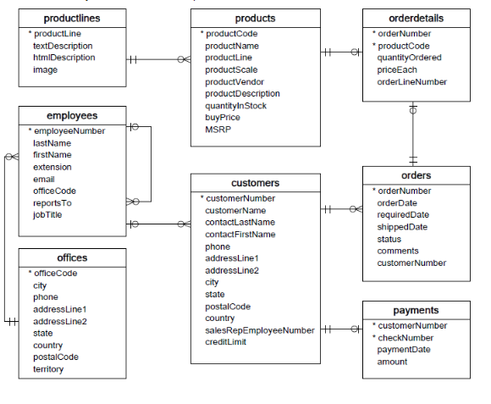q = """

SELECT

    o.officeCode,

    o.city,

    COUNT(c.customerNumber) AS n_customers

FROM offices AS o

JOIN employees AS e

    USING(officeCode)

JOIN customers AS c

    ON e.employeeNumber = c.salesRepEmployeeNumber

GROUP BY officeCode

;

"""

pd.read_sql(q, conn)

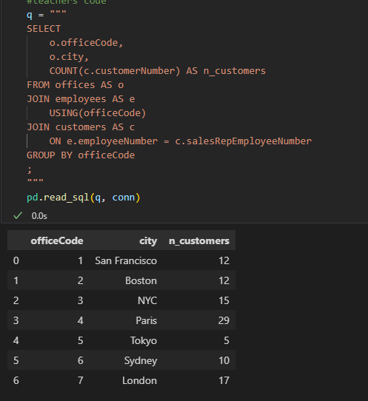

1. **Cast** for numeric purposes

q='''

SELECT

-- Note we have to cast to a numerical value first

MAX(CAST(longitude as REAL)) AS max_longitude

From airports

'''

pd.read_sql(q,conn)

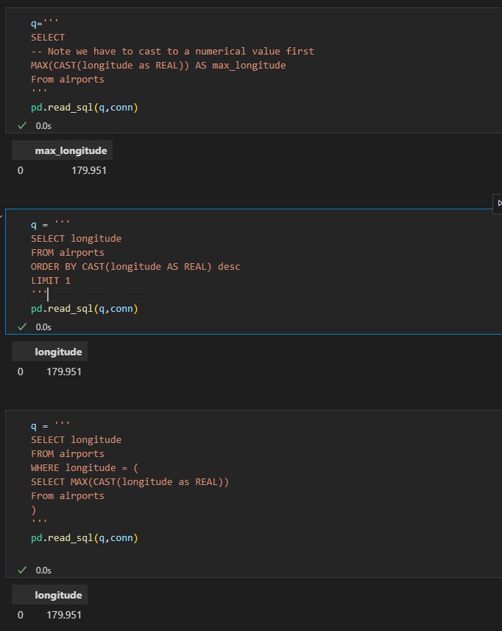

1. Using eval to create new columns

df = df.eval('Age_x_Fare= Age * Fare')

df.head()

1. Querying dataframes with sql(using pandassql)- easier to write than from dataframes

pip install pandasql

from pandasql import sqldf

pysqldf = lambda q: sqldf(q,globals())

q = '''

SELECT name

FROM df

LIMIT 10;

'''

passenger_names = pysqldf(q)

passenger_names

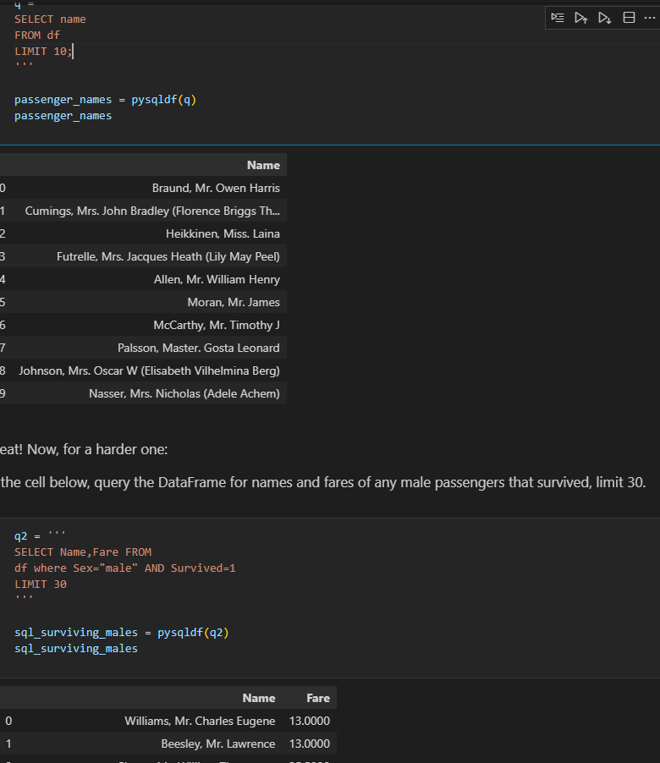

1. **Statistical Distribution** – Representation of the frequencies of potential events or the percentage of time each event occurs.

**a.Discrete Distribution**- Known number of possible outcomes(describes random variables that can take on a countable number of distinct values).use PMF

**Eg**

* Rolling a dice(possible outcomes 1,2,3,4,5,6)
* Number of defective items in a batch
* Count of customers arriving at the store in an hour

**b. Continous Distributions** – infinite no of possible values(describes random variables that can take on an infinite number of values within a given range)

**Eg**

* Heights of individuals
* Time taken to complete a task
* Temperature measurements

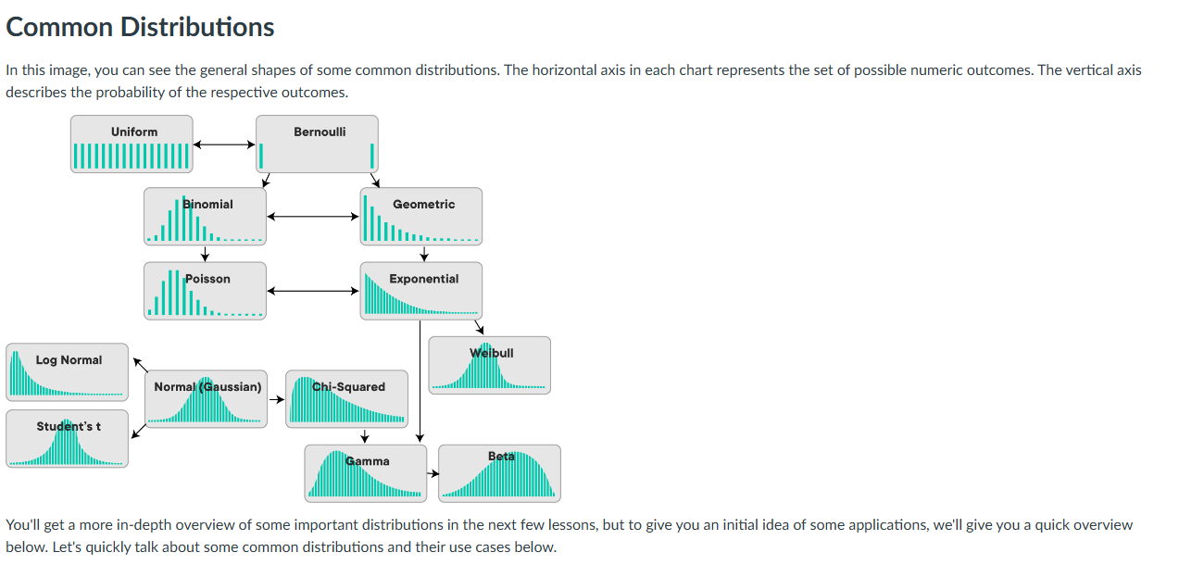

**c. Common distributions and their use cases**

**Examples of Discrete Distributions**

* **The Bernoulli Distribution –** deals with a series of Boolean events eg coin toss
* **Poisson Distribution –** rep the likelihood of a given no of successes over a given period of time. A typical example is pieces of mail. If your overall mail received is constant, the number of items received on a single day (or month) follows a Poisson distribution. Other examples might include visitors to a website, or customers arriving at a store, or clients waiting to be served in a queue.
* **Uniform distribution-** Occurs when all possible outcomes are equally likely eg dice
* **Binomial distribution –** Probability of observing a specific no of successes (Bernoulli trials) in a specific no of trials
* **Geometric**

**Examples of Continuous Distributions**

* **Normal/Gaussian Distribution –** follows a bell shape and is a foundational distribution for many models and theories un statistics and data science. A normal distribution turns up very often when dealing with real-world data including heights, weights of different people, errors in some measurement or grades on a test. Our temperature example above follows a normal distribution as well!
* **Exponential –**  rep the amt of time it takes before an event occurs
* **Continous uniform**

1. **Population** -Whole set of possible outcomes(universal set)
2. **Sample** – subset of the population

**Reasons we cant observe a whole group/population**

* Expensive(not enough fuding)
* Unrealistic (grp too large)
* We don’t need a whole population to gain insights
* People not willing to give info
* A large enough sample has mean close to the population mean,small samples can be misleading
* Sample means with multiple samples has mean close to the population mean

1. **Descriptive statistics** – summary metrics that describe and summarize the main features of a dataset. They help in understanding the basic aspects of the data by providing quantitative descriptions eg meausures of central tendency(mean,mode, median),measures of dispersion/spread eg(variance. Std,IQR) and measures of shape(skweness and kurtosis)

-We use visualizations such as histograms and boxpplots to understand the shape of the distributions

**Population statisctics**- when descriptive statistics are applied to populations

**Point estimates**- descriptive statisctics applied to samples

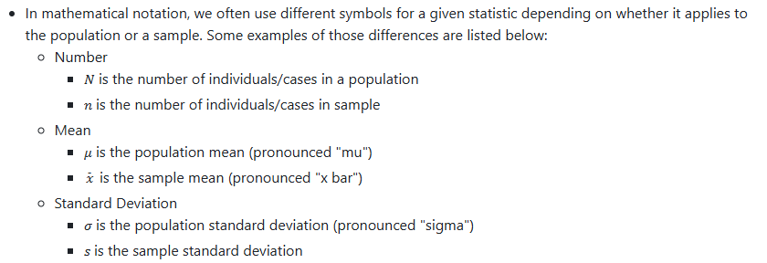

1. **Probability Mass Function(PMF) –** Used for discrete random variables.It gives the probability that a discrete random variable is exacly equal to a specific value.

**PMF Intuition -** Probability is a number in the range [0,1] that is calculated as the frequency expressed as fraction of the sample size

**-**In order to convert any random variables frequency into a probability we need to perform the following steps

* Get the frequency of each possible value in te dataset
* Divide the frequency of ach value by the total number of values(length of the dataset
* Get the probability of each value

**EXAMPLE1**

**Simple toy example**

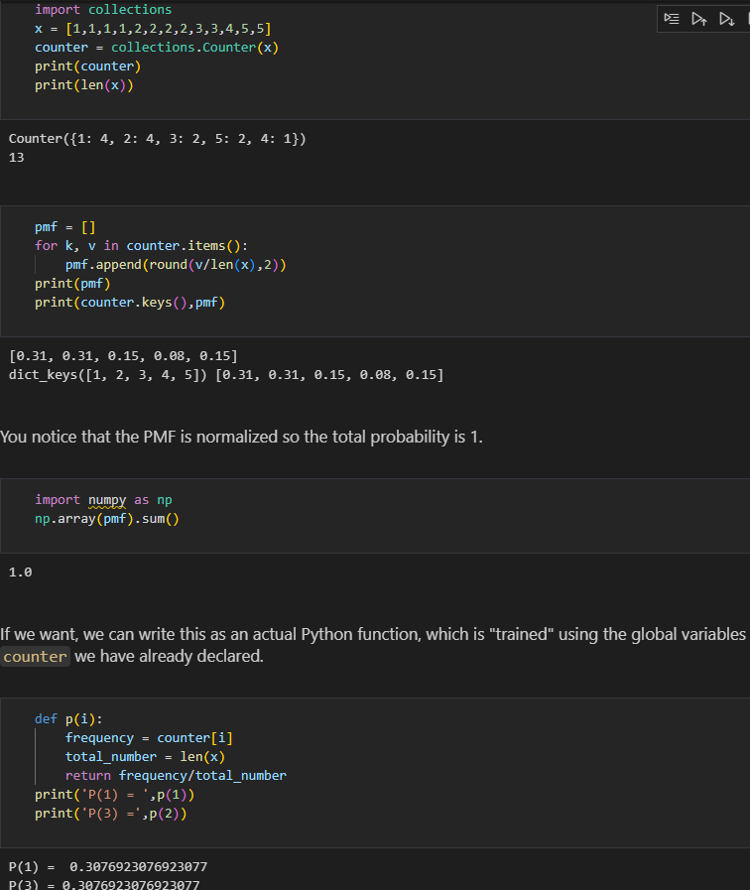

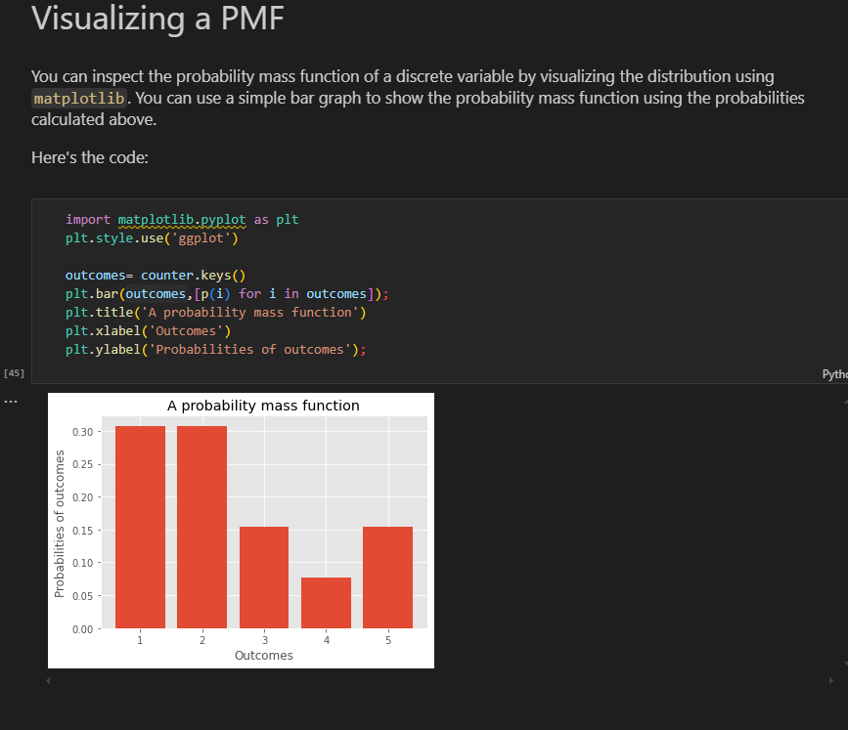

**-**Can use histogram as well but include desnsity =true

plt.hist(x,bins=bins,rwidth=0.25,density=True)

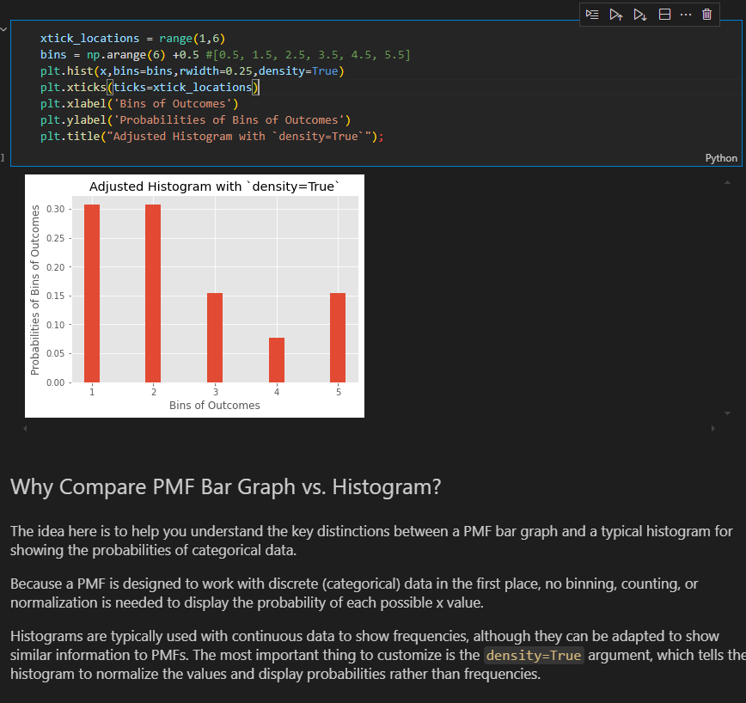

**EXAMPLE 2(Titanic dataset)**

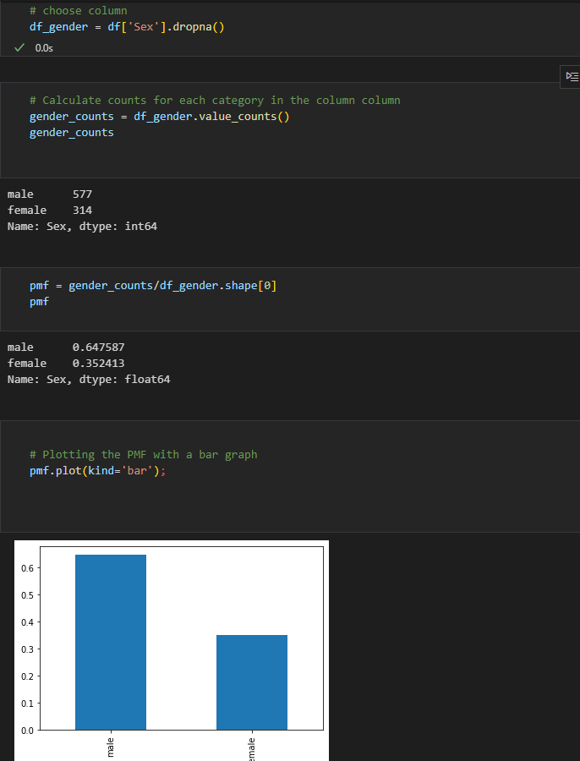

1. **Probability Density Function(PDF)** – used for continuous random variables. It describes the likelihood of the variable falling within a particular range of values , rather than taking on a specific value

**PDF Intution**-

**1. Concept of Density**

**\*\*Continuous Variables\*\***: Unlike discrete variables, continuous variables can take on an infinite number of values within a given range (e.g., heights, weights). Therefore, we can't assign a probability to a specific value (e.g., the probability of someone being exactly 170 cm tall is zero).

    Density: Instead, the PDF represents the density of probabilities. Higher values of the PDF at a point indicate a higher likelihood of the random variable being near that value.

**2. Area Under the Curve**

**\*\*Probability as Area:\*\*** The PDF itself does not give probabilities directly; instead, probabilities are found by calculating the area under the curve of the PDF over a specific interval. For instance, the probability that a random variable X falls between a and b is given by:

    P(a<X<b)=∫ab​f(x)dx

**3. Total Area Equals One**

**\*\*Normalization\*\***: The total area under the PDF curve is always equal to 1. This reflects the fact that the random variable must take on some value within the range of possible values.

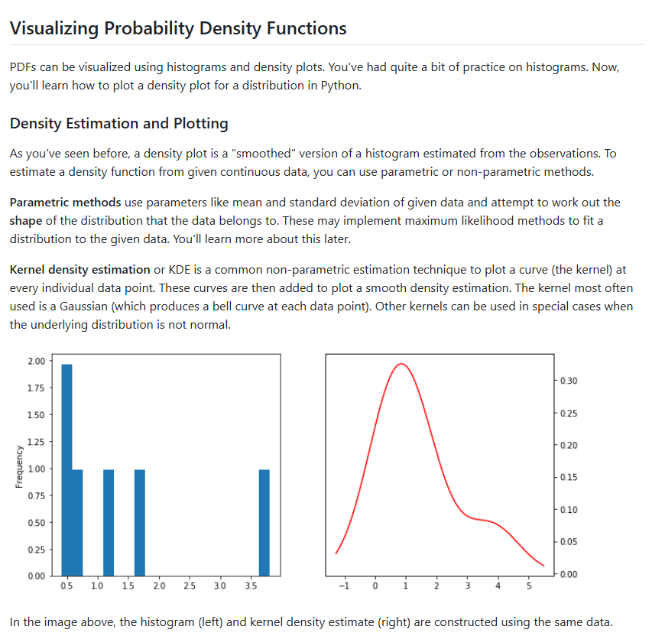

**EXAMPLE:TITANIC DATA SET**

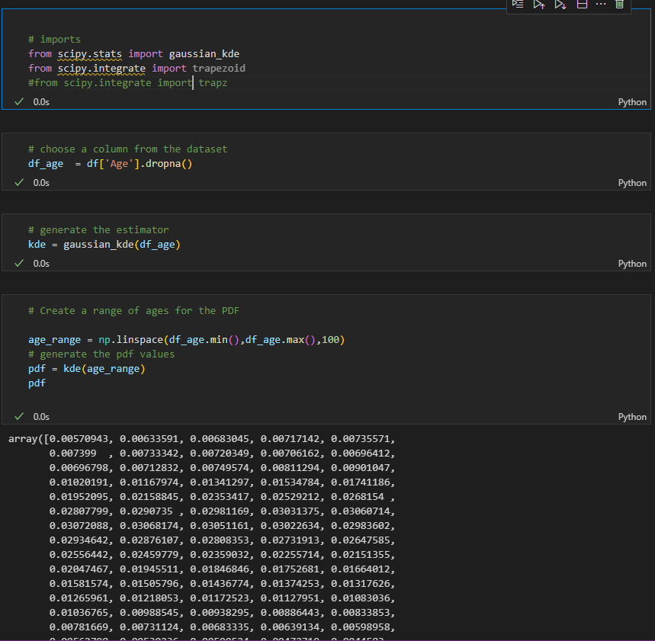

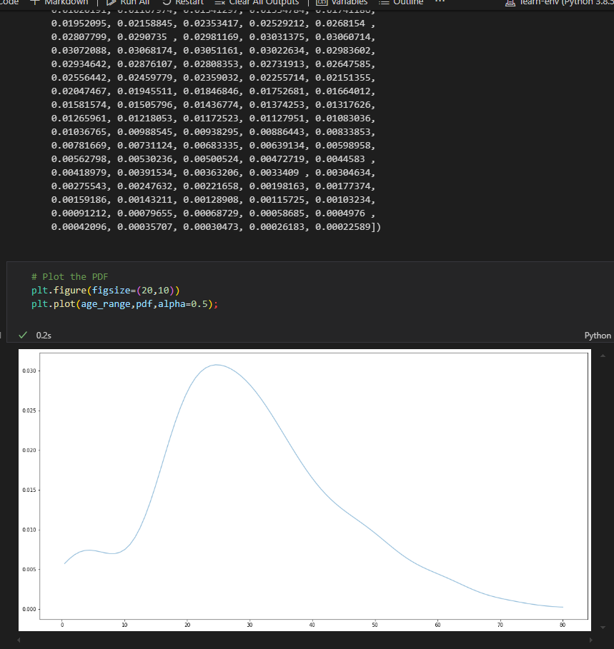

1. **CUMULATIVE DISTRIBUTION FUNCTION (CDF)-** provides a way to describe the probability distribution of a random variable

Gives the probability that variable X is less than or equal to a certain possible value of x

**Properties of CDF**

* Non-decreasing – CDF is always non-decreasing;as x increases,f(x) either increases or stays the same
* Range- CDF takes values in the range [0,1]
* Right-continous- CDF approaches its limit from the right

**EXAMPLE 1: CONT from titanic dataset**

1. sort data

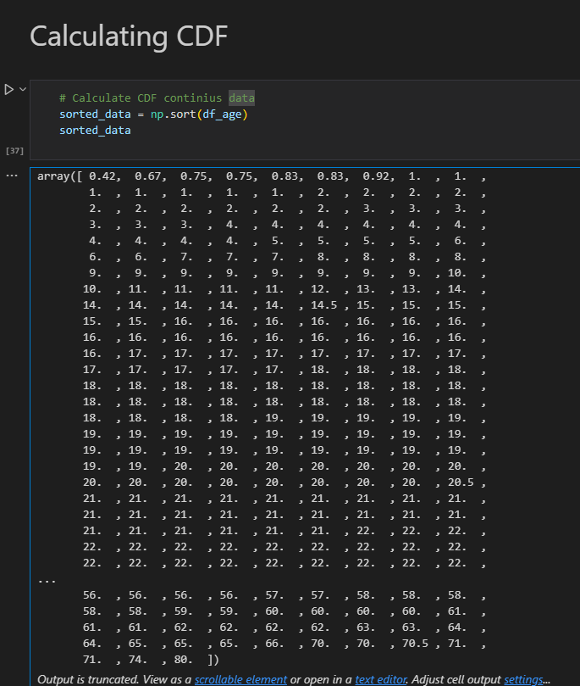

1. Do a cumulative sum and calculate cdf

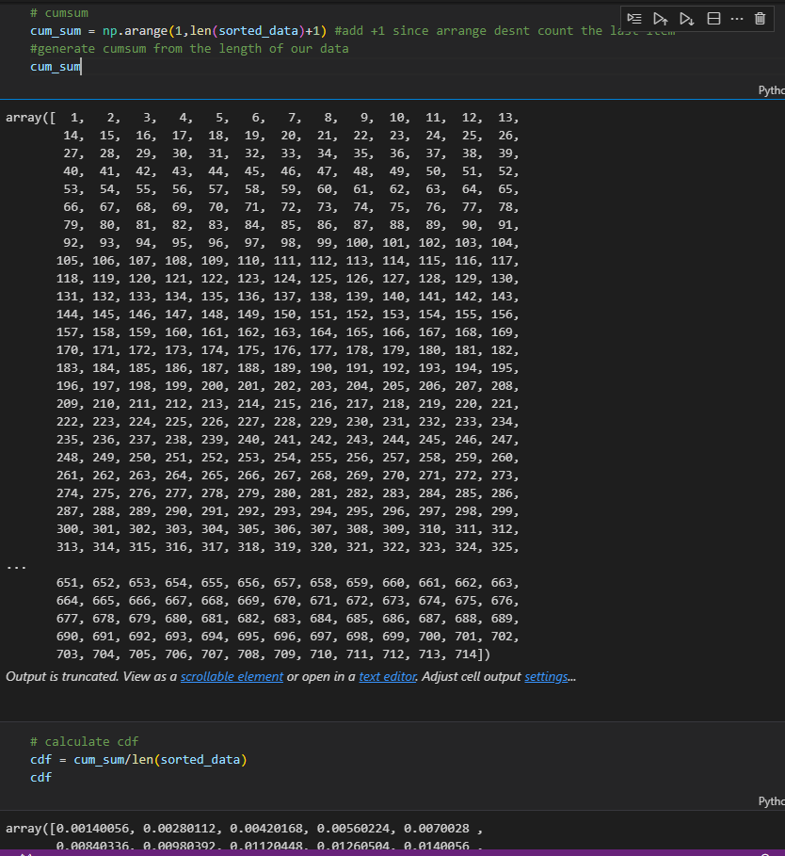

3.Plot

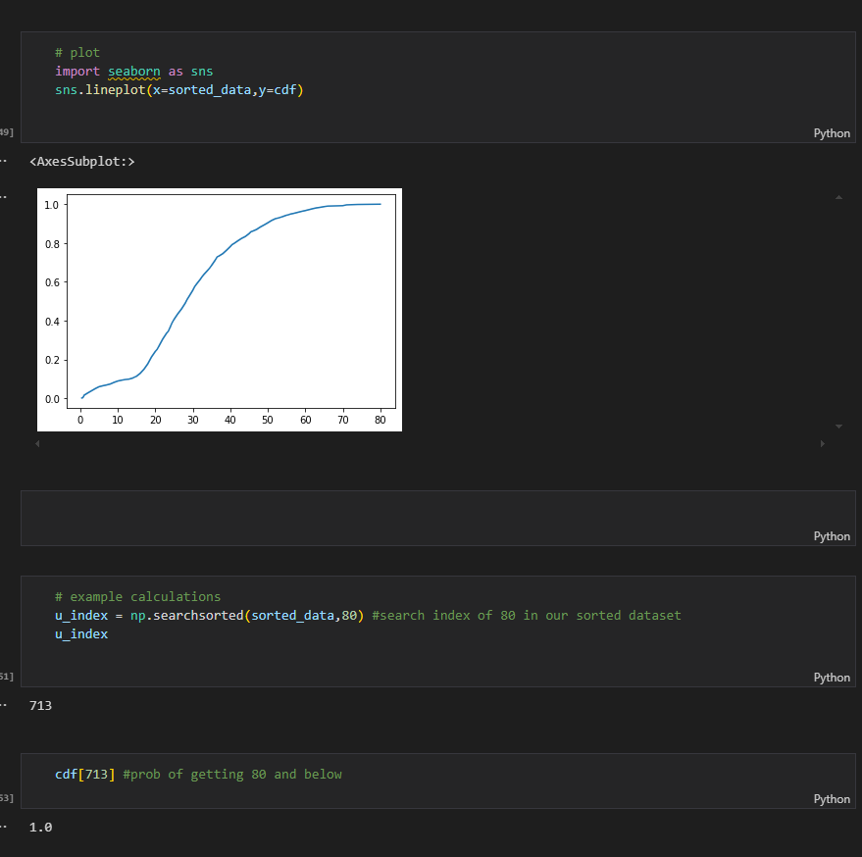

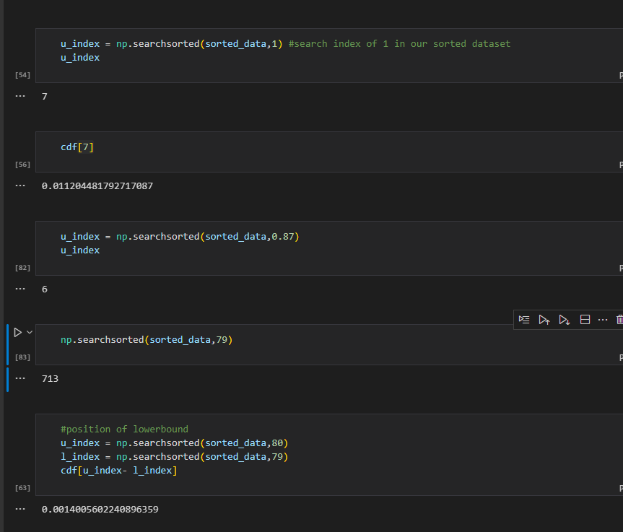

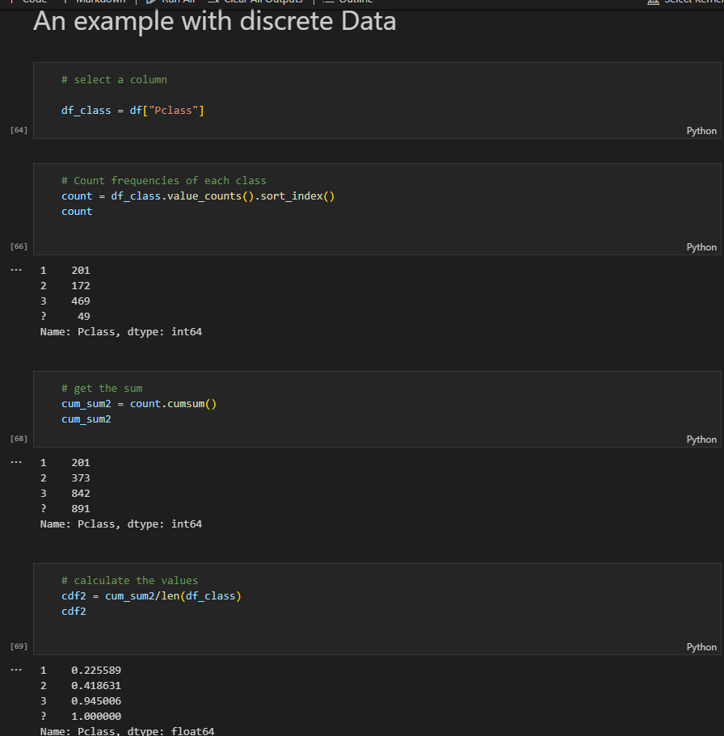

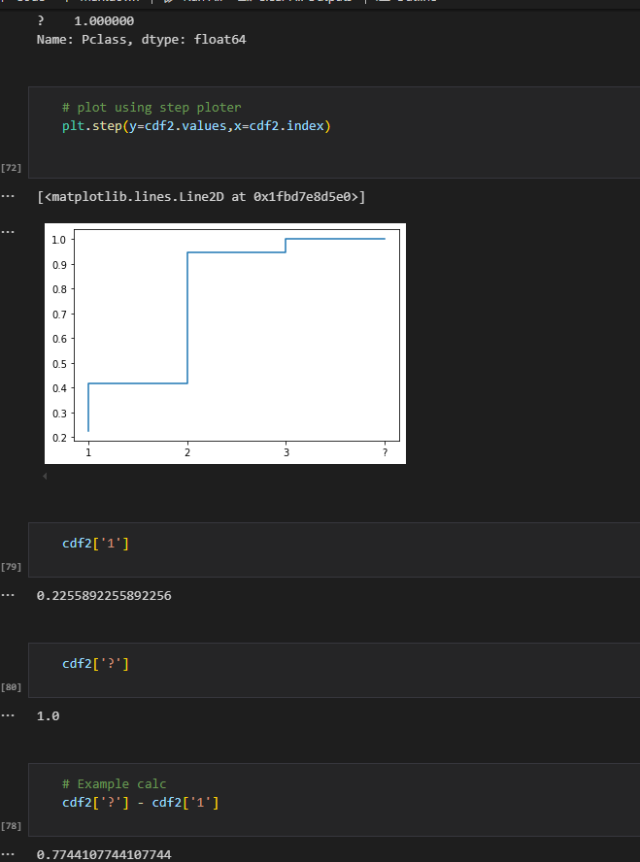

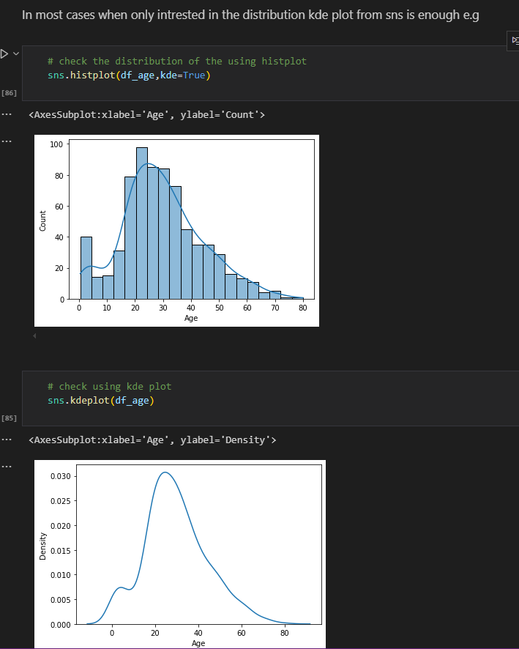

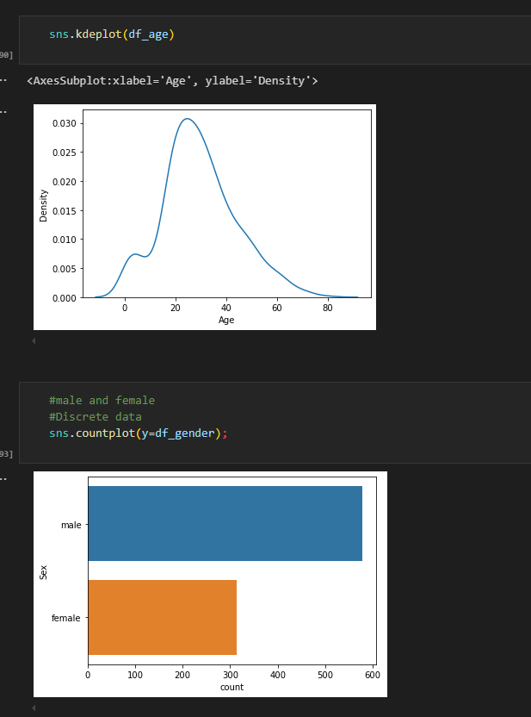

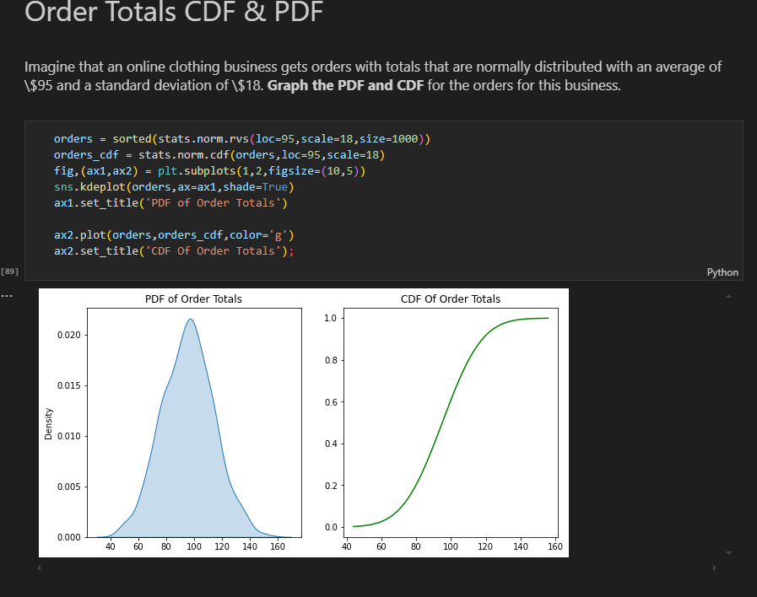

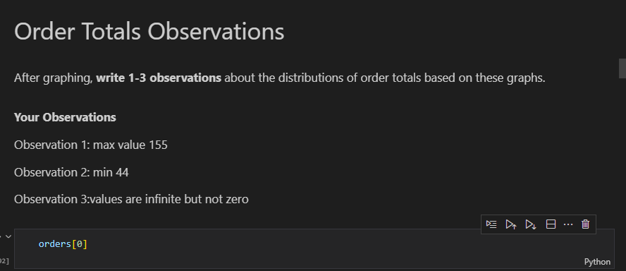

HISTOGRAM AND CDF

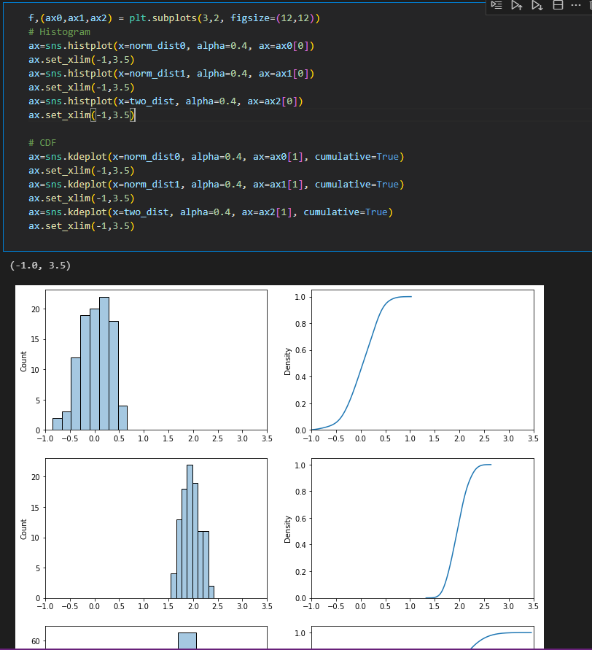

1. **Normal Distributions/Gaussian Distribution** - is defined by two parameters: the mean (μ) and the standard deviation (σ). The mean determines the center of the distribution, while the standard deviation measures the dispersion or spread of the data points around the mean. The probability density function

* The curve is symmetric about the mean, meaning that approximately 68% of the data lies within one standard deviation (σ) from the mean, about 95% within two standard deviations, and about 99.7% within three standard deviations. This is often referred to as the empirical rule or the 68-95-99.7 rule.

**Importance in Statistics**

* The normal distribution holds a central place in statistics for several reasons:
* Central Limit Theorem: One of the most significant reasons for the prominence of the normal distribution is the Central Limit Theorem (CLT). The CLT states that the distribution of the sample means will tend to be normally distributed, regardless of the original distribution of the data, as long as the sample size is sufficiently large. This makes the normal distribution a key tool for inferential statistics.
* Statistical Inference: Many statistical tests and methods, including t-tests, ANOVA, and regression analysis, assume that the underlying data is normally distributed. This assumption allows for the application of parametric tests, which can provide more powerful results than non-parametric alternatives.
* Natural Phenomena: Numerous real-world measurements—such as heights, weights, test scores, and measurement errors—tend to follow a normal distribution. This natural occurrence in various fields, including psychology, biology, and economics, makes the normal distribution a useful model for analyzing data

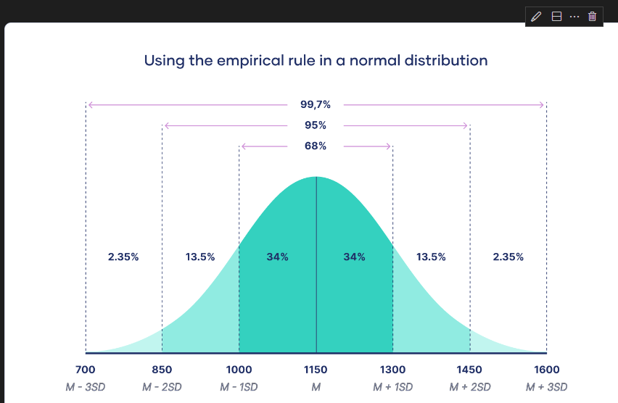

**X-Stics of Normal Distribution**

**1. Symmetry**- Bell-Shaped Curve: The normal distribution is symmetric about the mean (μ). This means that the left side of the curve is a mirror image of the right side. Mean = Median = Mode: In a normal distribution, the mean, median, and mode are all located at the center of the distribution.

**2. Defined by Mean and Standard Deviation-** Mean (μ): The average value around which the data points are distributed. It determines the center of the distribution.

 Standard Deviation (σ): This measures the spread or dispersion of the data. A smaller standard deviation results in a steeper curve, while a larger standard deviation produces a flatter curve.

**3. Empirical Rule (68-95-99.7 Rule)-**  68% of Data within 1 Standard Deviation: Approximately 68% of the data falls within one standard deviation (σ) of the mean (μ).

  95% within 2 Standard Deviations: About 95% of the data lies within two standard deviations.

   99.7% within 3 Standard Deviations: Nearly all (99.7%) of the data is within three standard deviations from the mean.

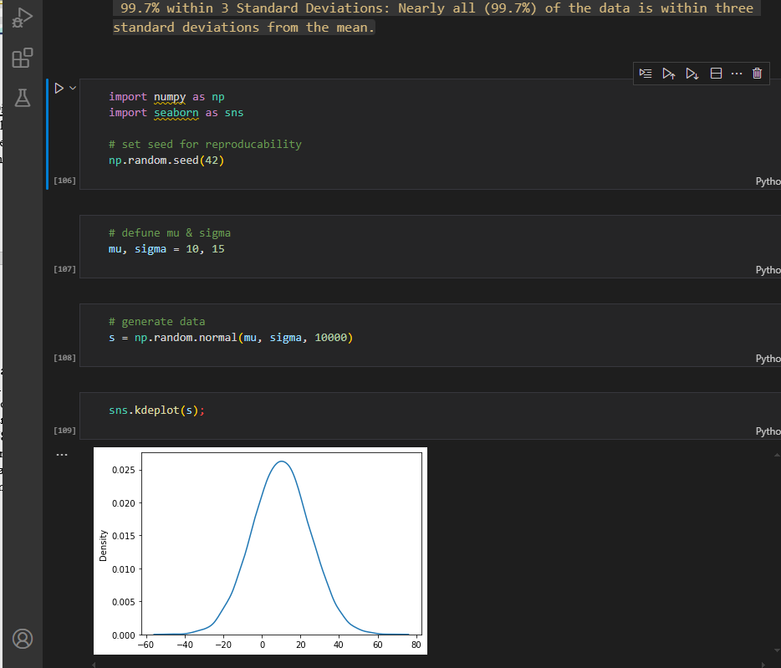

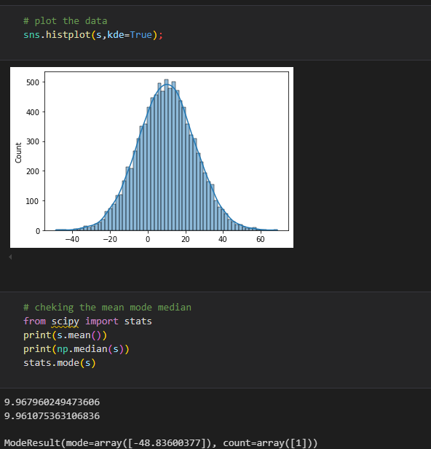

1. **Standard Normal Distribution**- Special case of the normal distribution that has been standardized to simplify analysis and interpretation.Its crucial in statisctics due to its properties and its role in various statisctical methods.

Special case of normal distribution with a mean of 0 and std of 1

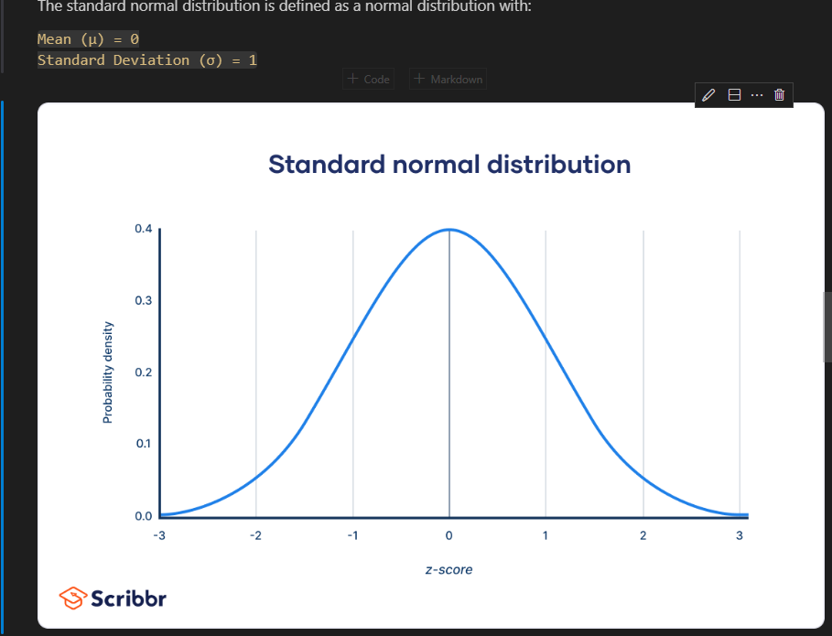

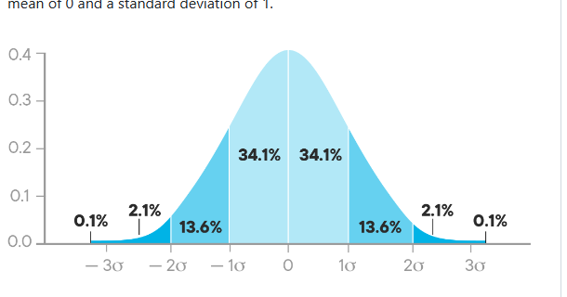

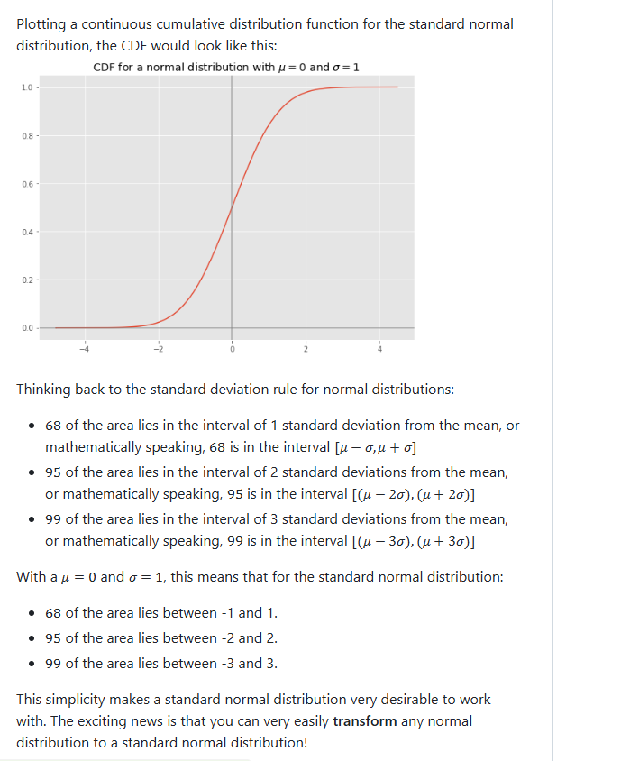

**a)Standard score/z score –** Statisctical measurement that describes a value’s relation to the mean of a group of values.It indicates how many standard deviations a data point is from the mean of the dataset

**z=(X−μ)/σ**

Where:

    X is the value in question.

    μ is the mean of the dataset.

    σ is the standard deviation of the dataset.

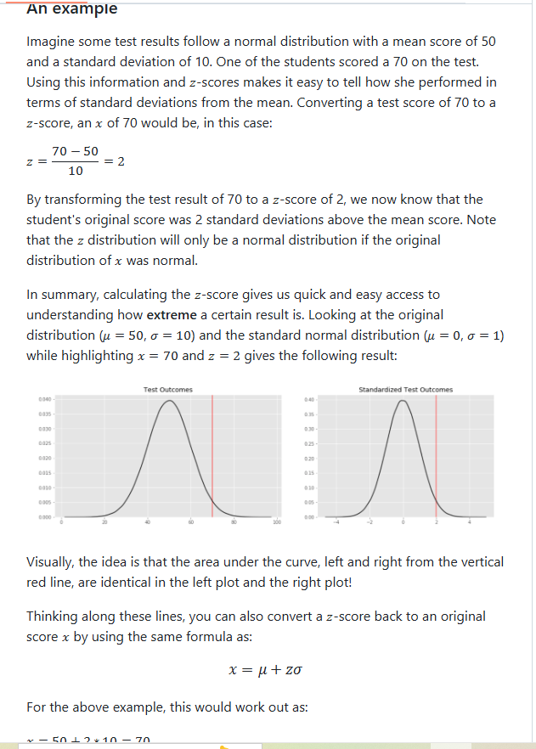

**b. Data Standardization –** common data preprocessing skill, which is used to compare a number of observations belonging to the different normal distributions which may have distinct means and standard deviations

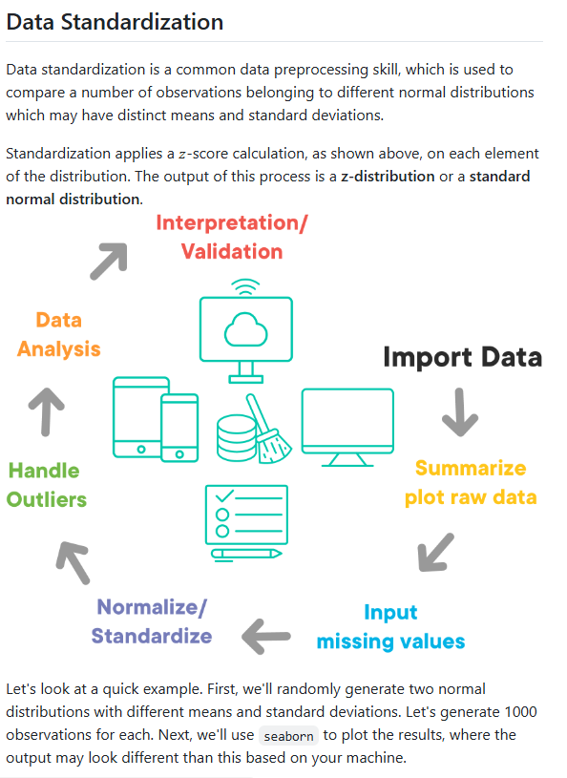

import numpy as np

import seaborn as sns

mean1,sd1 = 5,3 #dist1

mean2,sd2 = 10,2 #dist 2

d1 = np.random.normal(mean1,sd1,1000)

d2 = np.random.normal(mean2,sd2,1000)

sns.histplot(d1,alpha=0.2,color='b',kde=True,stat='density')

sns.histplot(d2,alpha=0.2,color='orange',kde=True,stat='density');

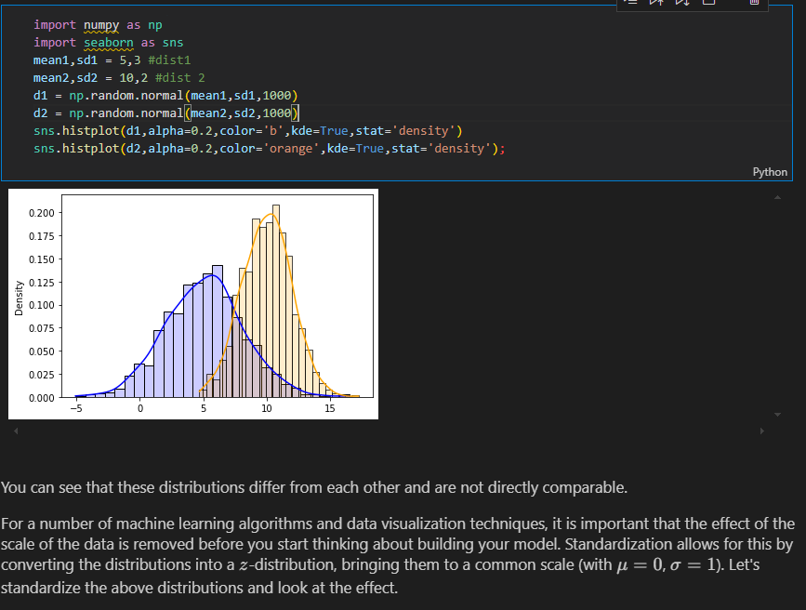

**TEACHERS CODE using kde instead of stat**

sns.histplot(d1,kde=True,alpha=0.2,color="blue",edgecolor='none')

sns.histplot(d2,kde=True,alpha=0.5,color="green",edgecolor='none')

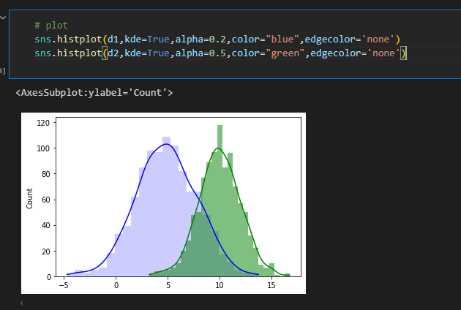

**AFTER STANDARDIZATION**

# Stardardizing and visualizing distributions

sns.histplot([(x - d1.mean())/d1.std() for x in d1],alpha=0.2,color='b',kde=True,stat='density');

sns.histplot([(x - d2.mean())/d2.std() for x in d2],alpha=0.2,color='orange',kde=True,stat='density');

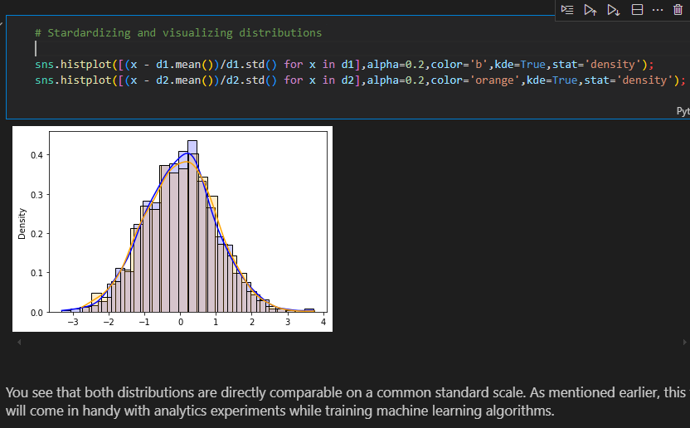

**Teachers code without stat**

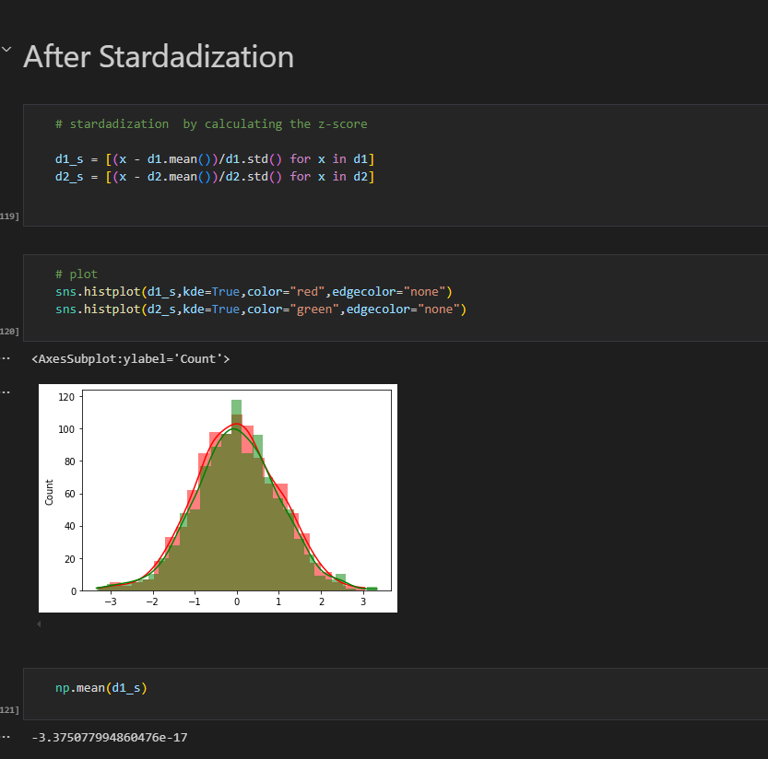

1. The **z-score** can be used to understand how extreme a certain result is
2. **Skewness** and **kurtosis** can be used to measure how different a given distribution is from a normal distribution

**Examples of z scores**

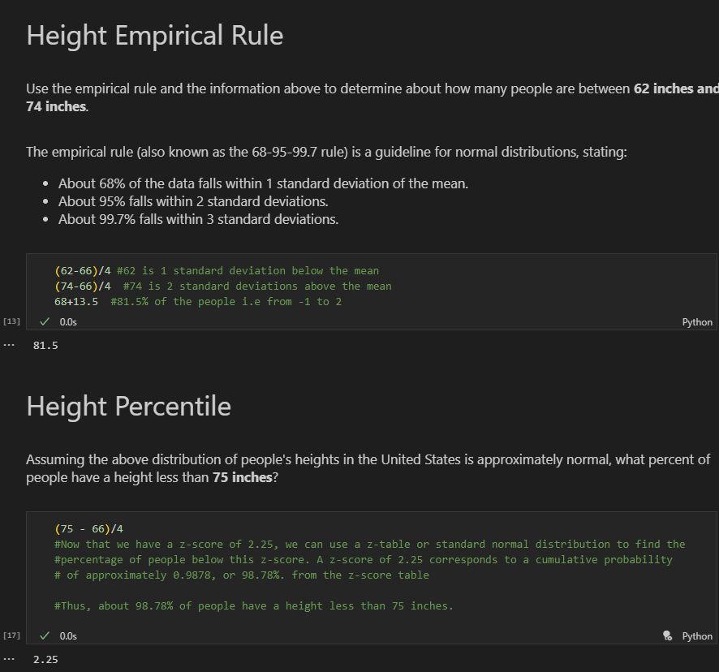

stats.norm.cdf(2.25)

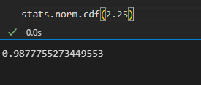

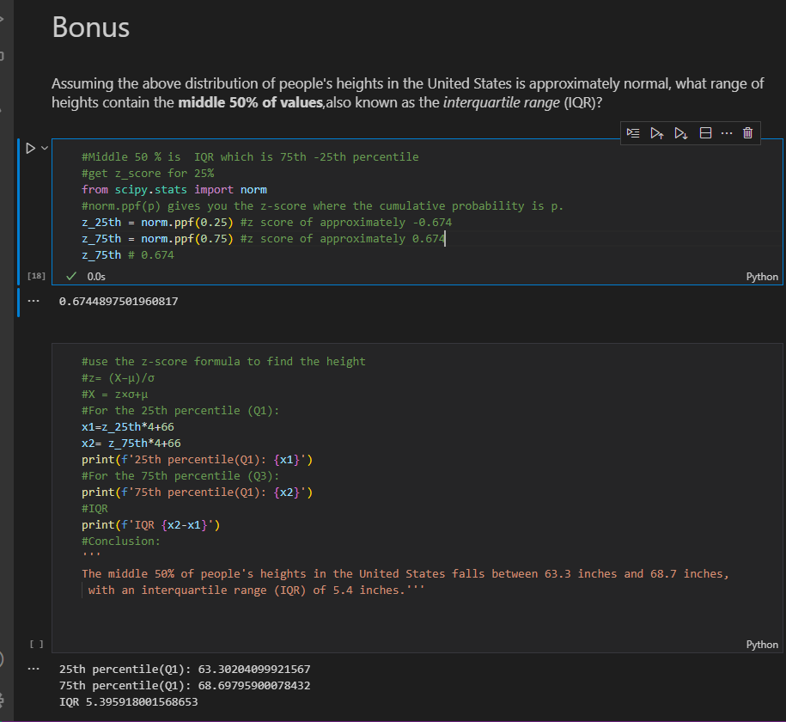

1. **Inferential statistics** – drawing conclusions beyond just describing statisctics of your sample data.Allows us to make claims abt data that we don’t have access to.
2. **Central Limit theorem** – states that given a sufficiently large sample size, the sampling distribution of the sample mean will be approximately normally distributed regardless of the orginal population’s distribution.

allows us to treat non-normal distributions as normal distributions and provides ways for us to estimate paramaters about a population

**CENTAL LIMIT THEOREM**

* **Plot** the data to check **distribution** eg sns.kdeplot(bimodal_data) OR sns.distplot()

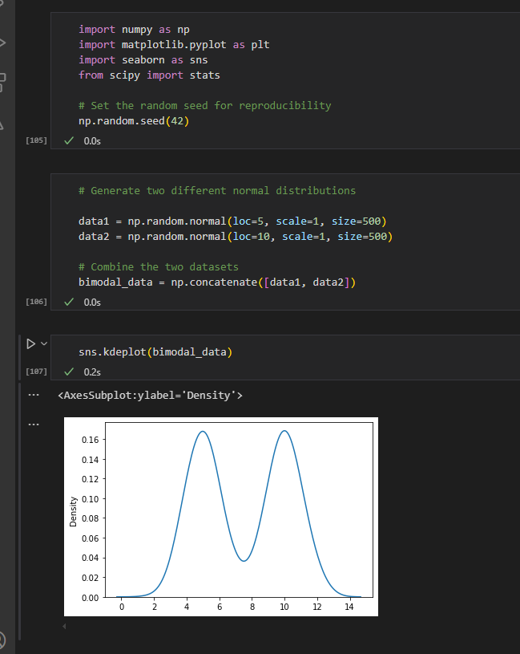

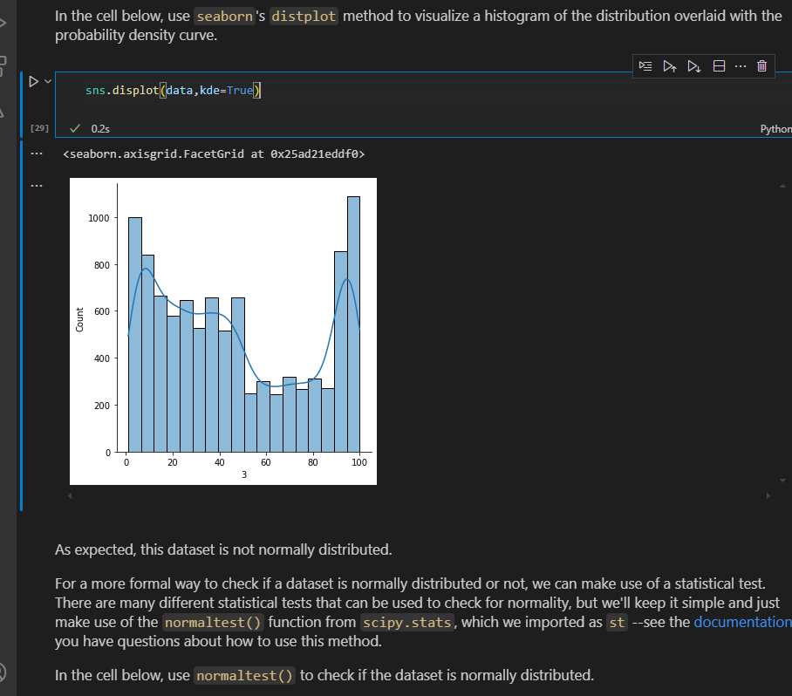

* Also use a **statistical** **test** to check normality

stat,p_value = st.normaltest(data)

print(stat)

print(p_value)

alpha = 0.05

#nterpret the result

if p_value > alpha:

    print('Fail to reject the null hypothesis(data is likely normally distributed)')

else:

    print('Reject the null hypothesis(data is likely not normally distributed)')

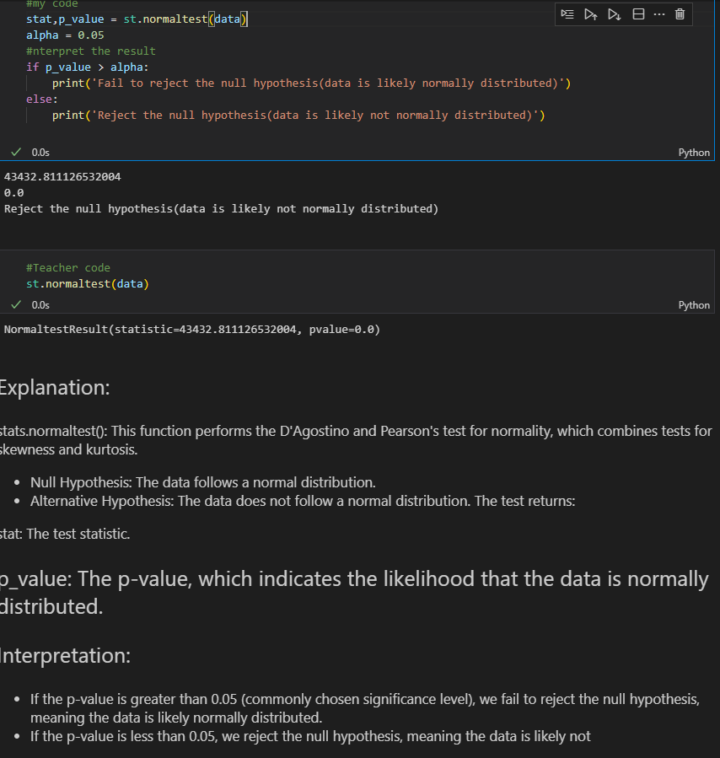

Since our dataset is non-normal, that means we'll need to use the **\*\****_Central Limit Theorem._***\*\***

* We **sample** our data

sample_30 = np.random.choice(bimodal_data,30)

sample_30.mean()

* Create a sampling distribution of sample means

sample_means = []

for i in range(100):

    sample_30 = np.random.choice(bimodal_data,30)

    sample_means.append(sample_30.mean())

sample_means

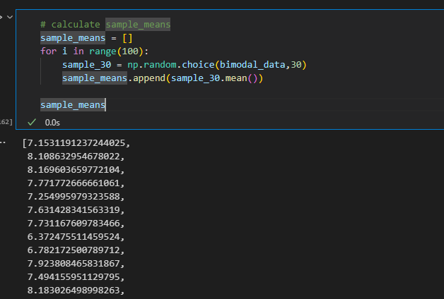

* Plot the sample means

sns.kdeplot(sample_means)

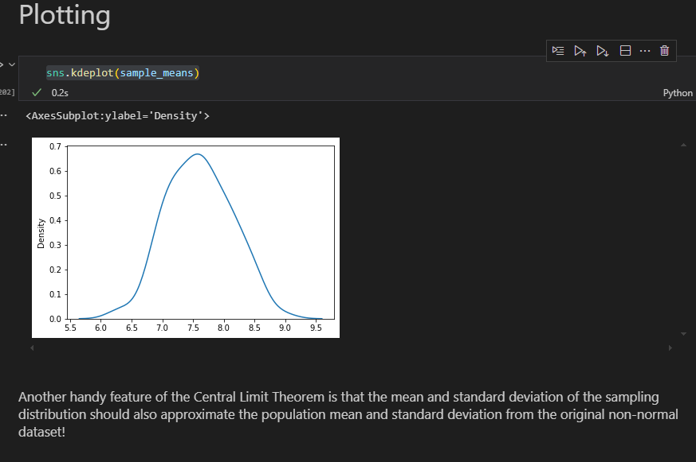

* Data almost look normal

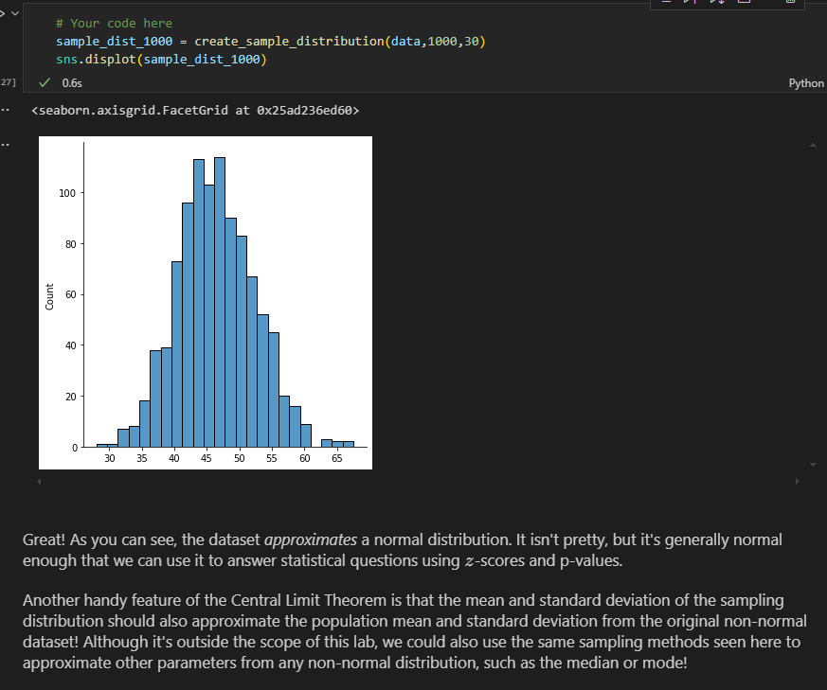

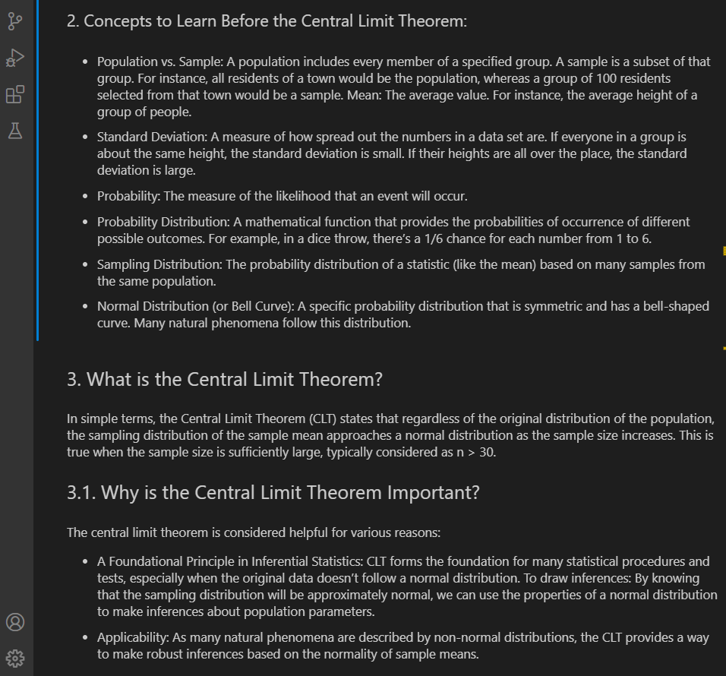

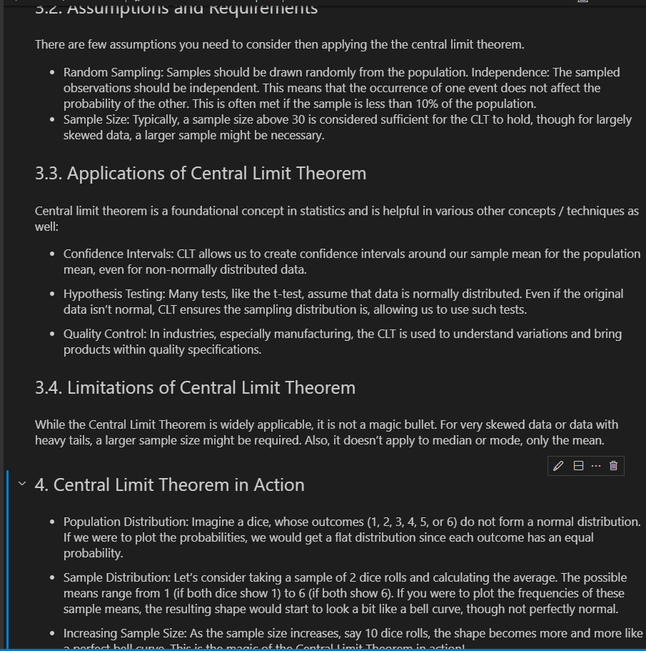

1. **Confidence intervals** – range of values above and below the point estimate that captures the true population parameter at some predetermined confidence level

range of values surrounding an estimated parameter eg 12-18 inches is the height of chairs required for 12 yr-olds

**(If we pulled 100 samples and constructed confidence intervals in the same manner, we would expect that 95 of the intervals would contain the true mean of population age. )**

**Sample Distribution -** The sample distribution is the distribution of values in a single sample taken from a population.

**Sampling Distribution -** The sampling distribution is the distribution of a sample statistic (e.g., the mean, proportion, or variance) across multiple samples taken from the same population

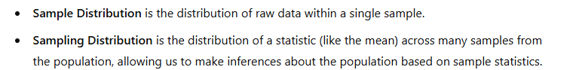

Calculate the Confidence Interval: Using the formula:

**CI=xˉ±z∗⋅SE**

**Margin of Error = z ∗ σ / √n #** where SE = ∗ σ / √n meaning MOE = z*SE

Example:

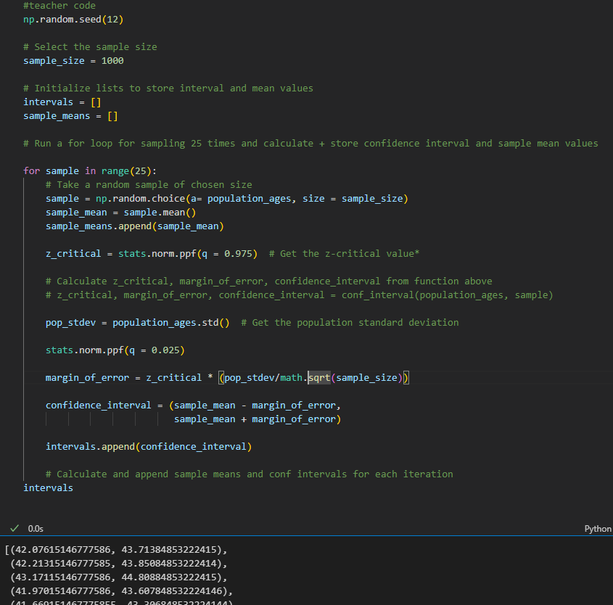

**If we pulled 100 samples and constructed confidence intervals in the same manner, we would expect that 95 of the intervals would contain the true mean of population age.**

**Example 2:**

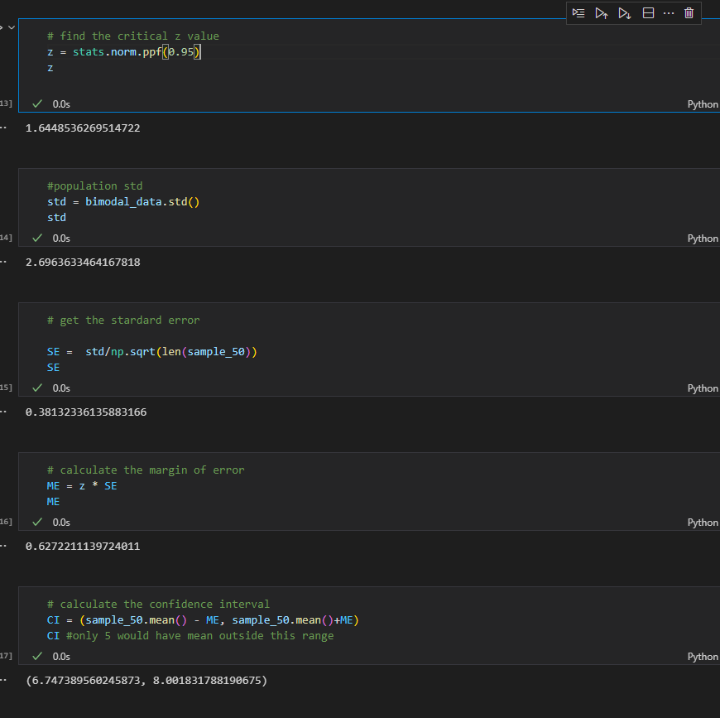

**With library**

stats.norm.interval(alpha= 0.95,                         # Confidence level

                 loc = sample_50.mean(),                       # Sample mean

                 scale = SE)

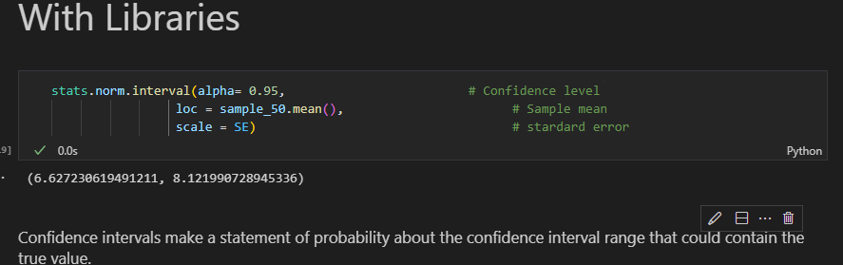

**Zcore for a two-tailed test**

90% = norm.ppf(95)

Stats.norm.ppf()

z_80 = stats.norm.ppf(0.9)

**calculate p-value from z score**

stats.norm.cdf(z)

stats.norm.ppf(1-alpha)

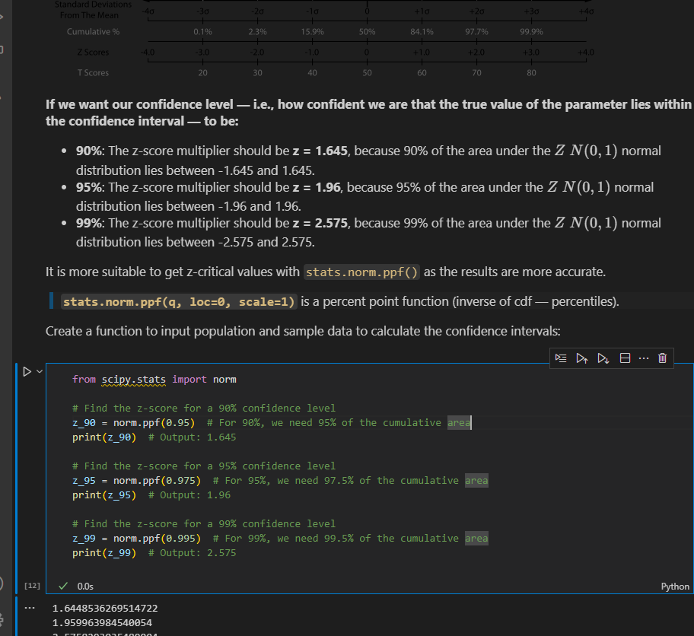

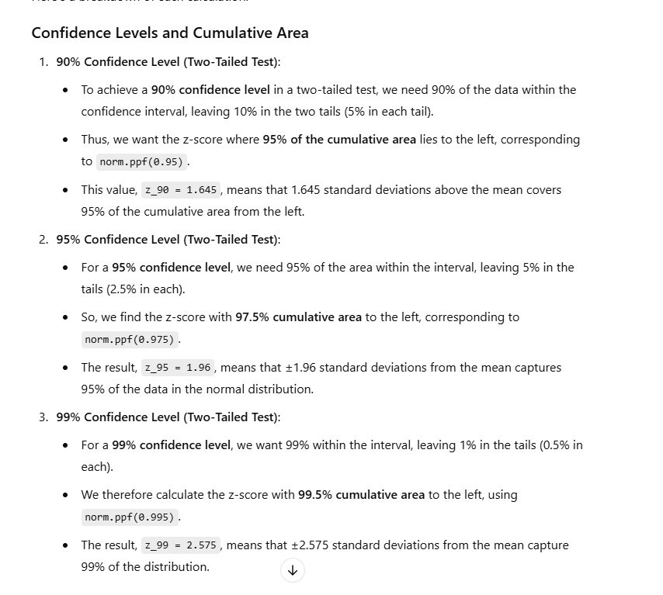

**CONFIDENCE INTERVALS WITH T DISTRIBUTION**

* Used in statisctics particularly when dealing with small sample sizes or when the population standard deviation is unknown

**Example 1:**

Stats.t.ppf(0.95,ddof) where ddof =len(sample)-1(get t-value) for 90%CI

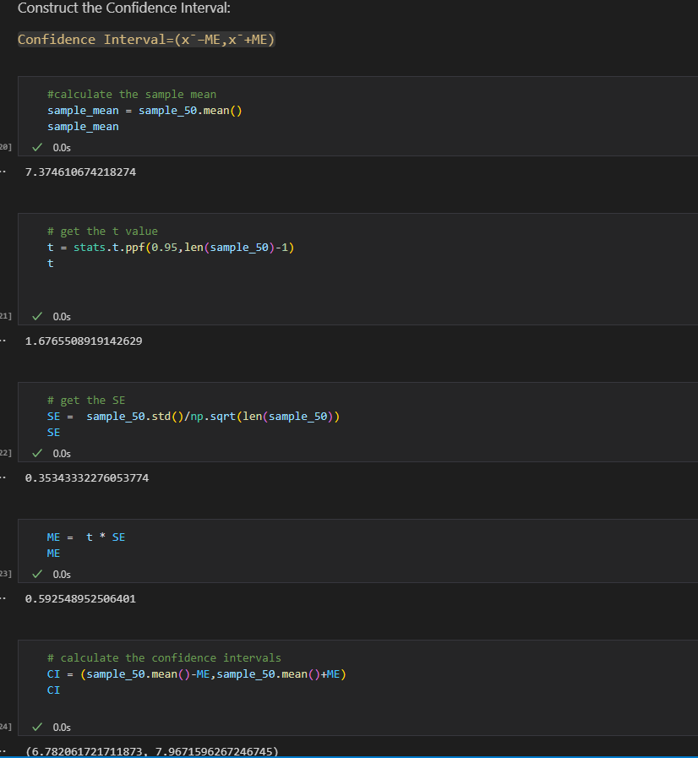

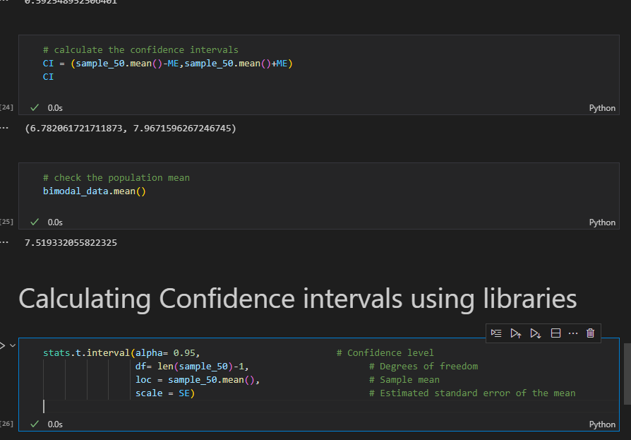

**EXAMPLE 2:**

**NB: added** ddof when calculating standard deviation

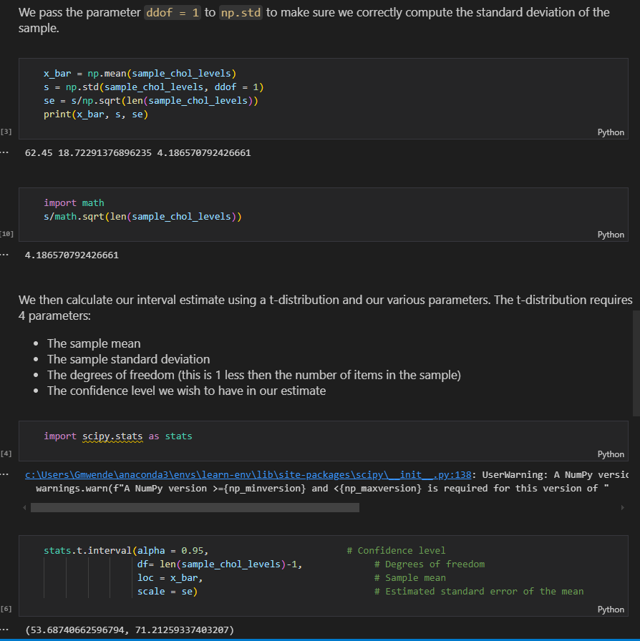

**Example 3: Using libraries**

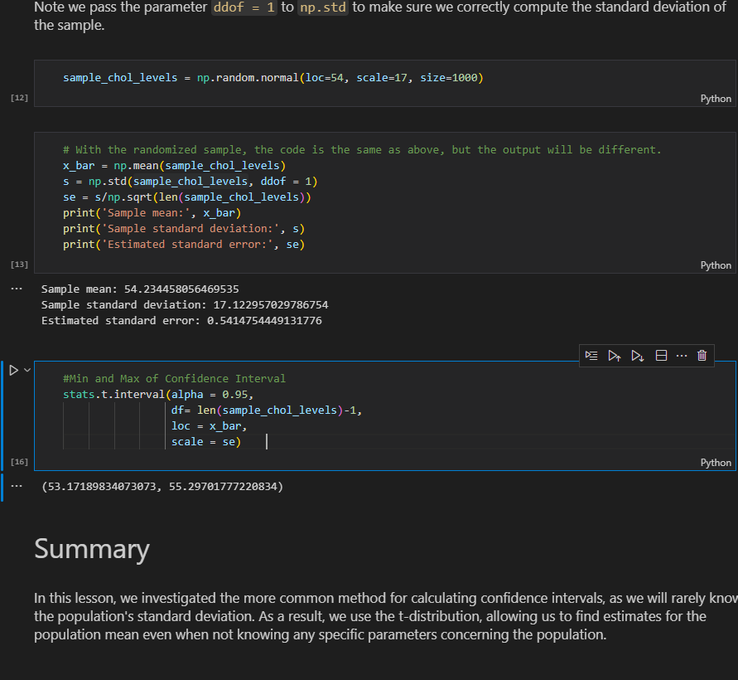

**Example 4: Using a real life scenario**

n = 30

mean = 4.8

sd = 0.4

t_value = stats.t.ppf(0.95, n-1)

margin_error = t_value * sd/(n**0.5)

confidence_interval = (mean - margin_error, mean + margin_error)

confidence_interval

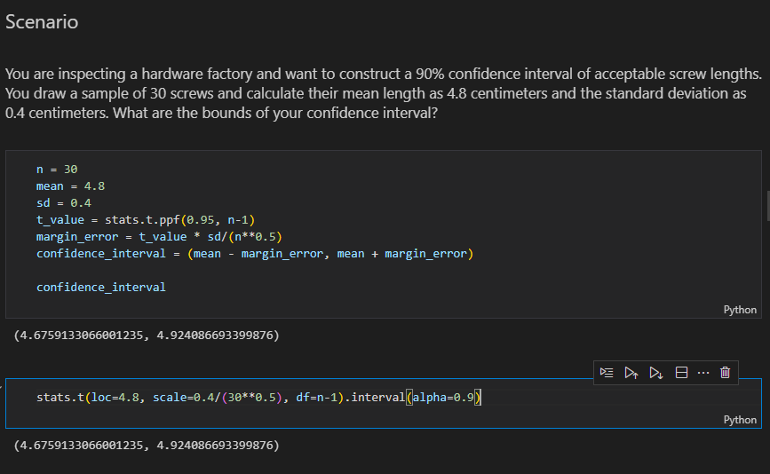

**RECAP ON CENRTAL LIMIT THEOREM AND CONFIDENCE LEVEL**

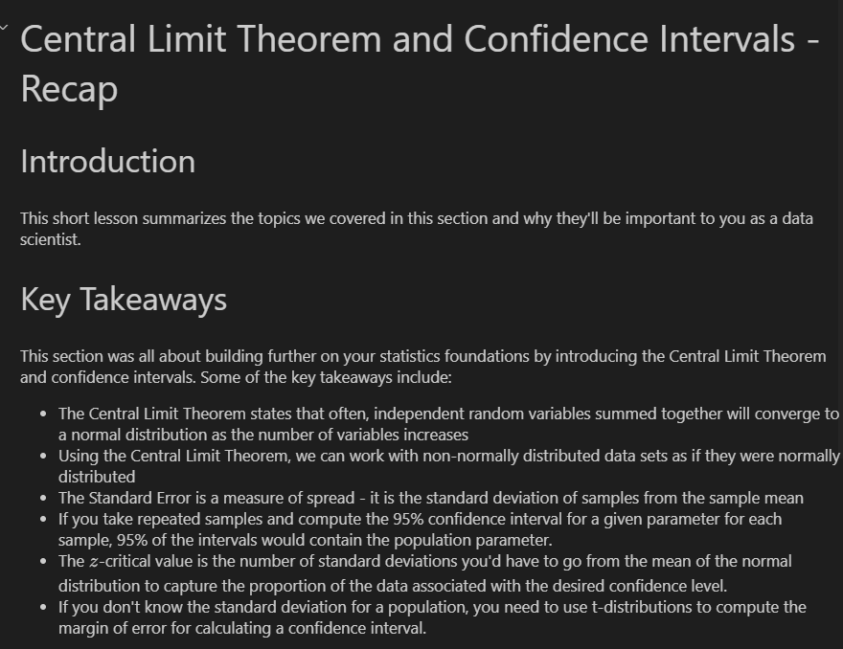

1. **Z distribution** – requires that we know the standard deviation of the population while **t-distribution** allows us to work with samples where the population standard deviation is unkown(as well as as smaller samples) in order to form confidence intervals
2. **Standard Error** – measure of the variability or dispersion of a sample mean estimate relative to the true population mean.it quantifies how much the sample mean is expected to fluctuate from the true population mean due to sampling variability

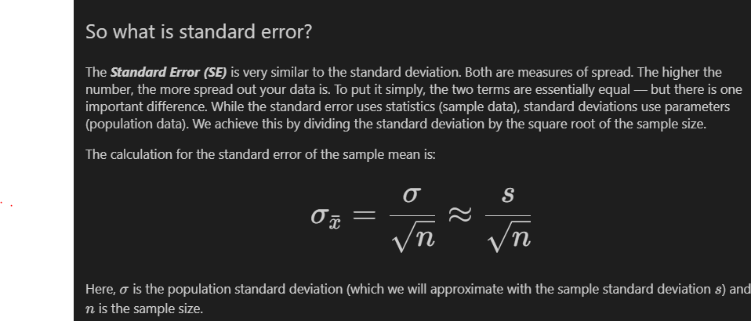

Example:

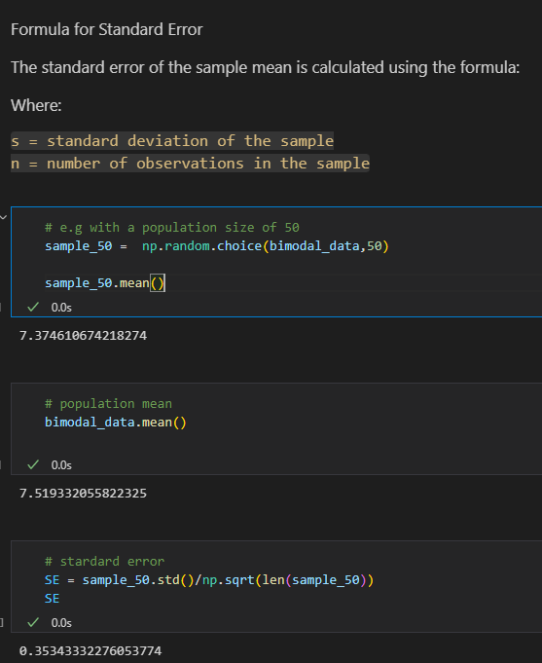

1. Generate data points using poisson distribution

population_ages1 = stats.poisson.rvs(loc=18,mu=35,size=150000)

population_ages2 = stats.poisson.rvs(loc=18,mu=10,size=100000)

population_ages = np.concatenate((population_ages1,population_ages2))

1. Create normal distribution data from scipy

population = list(stats.norm.rvs(size=1000,

                          random_state=42))

1. Convert single column to a dataframe and plot

pd.DataFrame(point_estimates).plot(kind='density',# Plot sample mean density

                                   figsize=(9,9),

                                   xlim=(40,45)

                                   )

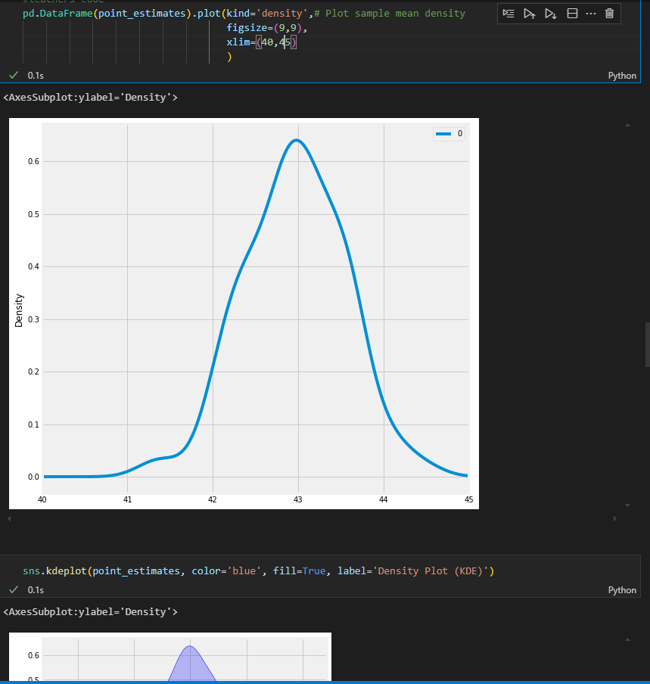

1. Adding mean formula labels(x-bar using code)

import matplotlib.pyplot as plt

import seaborn as sns

fig, ax = plt.subplots()

ax = sns.kdeplot(sample, ax=ax, label='Sample PDF')

ax.axvline(sample_mean, color="red", label=r'$\bar{x}$')

ax.legend();

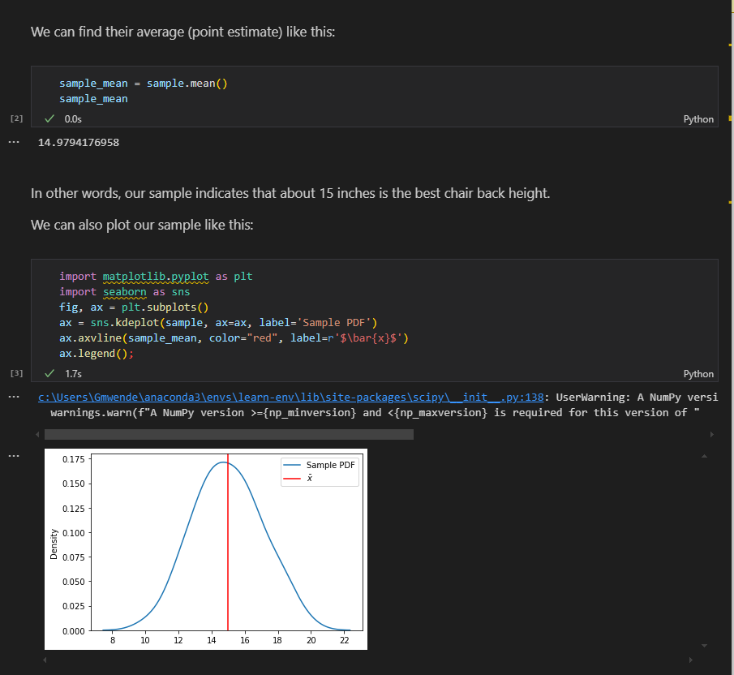

1. Add mu and sigma label using code
2. f, ax = plt.subplots()
3. ax = sns.kdeplot(population, ax=ax, label='Population PDF')
4. plt.axvline(pop_mean, ls='-.', c='r', label='$\mu$')
5. std_label = f'$\mu \pm\sigma$: ({pop_mean-pop_std:.3f},{pop_mean+pop_std:.3f})'
6. plt.axvline(pop_mean-pop_std, ls='--', c='pink')
7. plt.axvline(pop_mean+pop_std, ls='--', c='pink', label=std_label)
8. ax.legend()
9. plt.tight_layout()

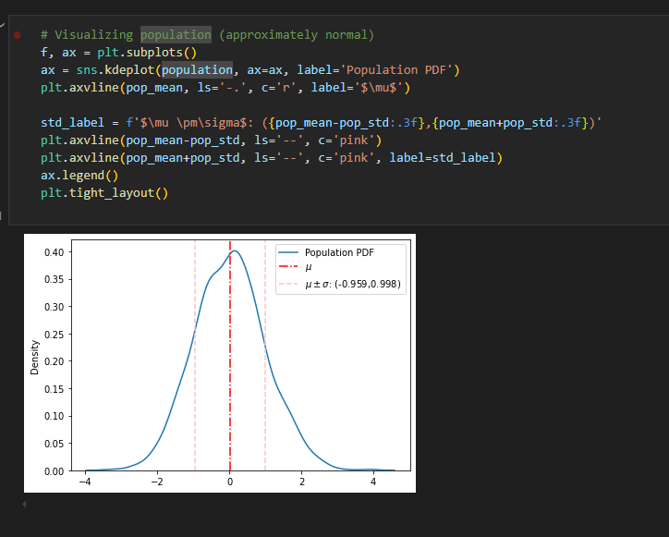

1. **Statistical significance –** determination about whether the observed effect in the data is unlikely to have occurred by random chance alone.
2. **Significance level** = alpha eg **0.05(5%) 95%** confidence level or **0.01(1%)99%** confidence level
3. **HYPOTHESIS TESTING**

**a).General structure of an experiment**

* **Make an Observation**- observe sth you want to test. During this step, you must observe phenomena to help refine the question that you want to answer. This might be anything from "does this drug have an effect on headaches?" to "does the color of this button affect the number of sales a website makes in a day?". Before testing these ideas, you need to observe that there might be some phenomena occurring and then come up with a specific question to answer.
* **Examine the research -** Good data scientists work smart before they work hard. In the case of the scientific method, this means seeing what research already exists that may help you answer your question, directly or indirectly. It could be that someone else has already done an experiment that answers your question--if that's the case, you should be aware of that experiment before starting your own, as it could inform your approach to structuring your experiment, or maybe even answer your question outright!
* **Form an hypothesis -** you'll formulate 2 hypotheses to test--your educated guess about the outcome is called the *Alternative Hypothesis*, while the opposite of it is called the *Null Hypothesis*.
* **Conduct an experiment -** This step is the part of the scientific method that will be the focus of this section. You can only test a hypothesis by gathering data from a well-structured experiment. A well-structured experiment is one that accounts for all of the mistakes and randomness that could give you false signals relating to the effect of an intervention. Just because you're running an experiment doesn't prove that A causes B, or that there's even a relationship between A and B! A poorly designed experiment will lead to false conclusions that you haven't considered or controlled for. A well-designed experiment leaves you no choice but to acknowledge that the effects seen in a dependent variable are related to an independent variable. The world is messy and random. You have to account for this messiness and randomness in experiments so that you can filter it out and be left only with the things you're actively trying to measure.
* **Analyze experimental Results-**  All the work you've done with statistics is usually in service of this goal--looking at the data and understanding what happened. During this step, you will tease out relationships, filter out noise, and try to determine if something that happened is ***statistically significant*** or not.
* **Draw conclusions -** This step is the logical endpoint for an experiment. You've asked a question, looked at experimental results from others that could be related to your question, made an educated guess, designed an experiment, collected data, and analyzed the results.

The reality of this step is that you use your analysis of the data to do one of two things: either ***reject the null hypothesis or fail to reject the null hypothesis***

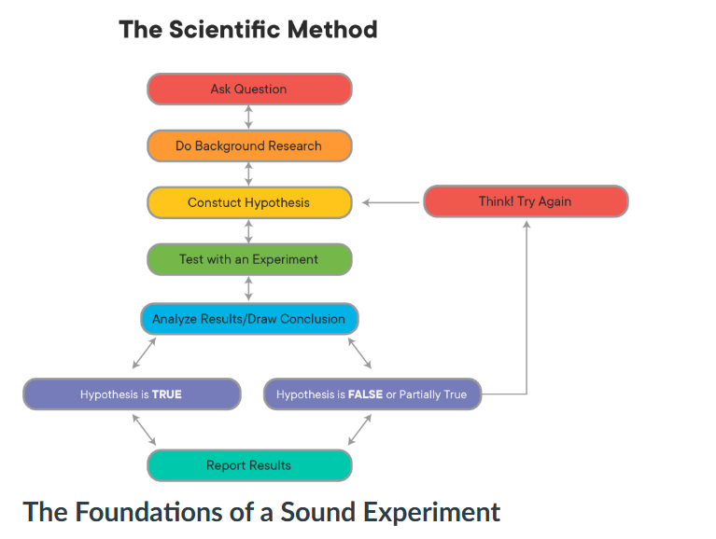

***b).*Foundations of a sound experiment**

All experiments are not created equal--simply following the steps outlined above does not guarantee that the results of any experiment will be meaningful. For instance, there's nothing stopping a person from testing the hypothesis that "wearing a green shirt will make it rain tomorrow!", seeing rain the next day, and rejecting the null hypothesis, thereby incorrectly "proving" that their choice of wardrobe affected the weather. Good experiments demonstrate that independent variables {X} have an effect on the dependent variables {Y} because you control for all the other things that could be affecting {Y}, until you are forced to conclude that the only thing that explains what happened to {Y} is {X}!

Although there are many different kinds of experiments, there are some fundamental aspects of experimental design that all experiments have:

* **Control group/Random controlled Trials** -

One of the most important aspects of a sound experiment is the use of a ***Control Group***. A Control Group is a cohort that receives no treatment or intervention--for them, it's just business as usual. In a medical test, this might be a ***placebo***, such as a sugar pill. In the example of testing the color of a button on a website, this would be customers that are shown a version of the website with the button color unchanged. Using a control group allows researchers to compare the results of doing nothing (the control) with the effects of doing something (the ***intervention***). Without a control group, you have no way of knowing how much of the results you see can be attributed to the intervention, and how much would have happened anyway

**NB:** **A control group is only a control group if they are sampled from the same population as the treatment groups!**

The main way scientists deal with this is through ***Random Controlled Trials***. In a Random Controlled Trial, there is a control group and an intervention (also called treatment) group, where subjects are ***randomly assigned to each***.

A ***Single-Blind*** or ***Blind Trial*** is one where the participant does not know if they are receiving the treatment or a placebo.

A ***Double-Blind Trial*** is one where the participant does not know if they are receiving the treatment or a placebo, and neither does the person administering the experiment (because their bias could affect the outcomes, too!). Instead, knowing whether someone received the treatment or a placebo is kept hidden from everyone until after the experiment is over (obviously, *someone* has to know for recordkeeping purposes, but that person stays away from the actual experiment to avoid contaminating it with bias from that knowledge).

* **Appropriate Sampling techniques and sample size**

When data scientists are performing experiments, they rarely have the opportunity to work with an entire population of data. Rather, they must obtain a sample that is representative of the population. In order to get a high quality sample, you should follow these four assumptions related to sampling techniques and sample size.

* **Sample is independent**

Independence means the value of one observation does not influence or affect the value of other observations. Independent data items are not connected with one another in any way (unless you account for it in your model). This includes the observations in both the “between” and “within” groups of your sample. Non-independent observations introduce bias and can make your statistical test give too many false positives.

* **Sample is collected randomly**

A sample is random when each data point in your population has an equal chance of being included in the sample; therefore, the selection of any individual observation happens by chance, rather than by choice. This reduces the chance that differences in materials or conditions strongly bias results. Random samples are more likely to be representative of the population; therefore, you can be more confident with your statistical inferences with a random sample.

* **The sample is approximately normally distributed**

The normal distribution assumption is that the sampling distribution of the mean is normal. That is, if you took a sample, calculated its mean, and then you took another (independent) sample (from the same population) and got its mean (and repeated this an infinite number of times), then the distribution of the values that you wrote down would always be a perfect bell curve. This is the principle behind the Central Limit Theorem, and it is this idea that allows us to perform hypothesis tests. While maybe surprising, this assumption turns out to be relatively uncontroversial, at least when each of the samples is large, such as N ≥ 30.

* **Appropriate Sample Size**

Randomness is a big problem in experiments. It can lead you to false conclusions by making you think that something doesn't matter when it does, or vice versa. Small sample sizes make experiments susceptible to the problem of randomness; whereas, large sample sizes protect experiments from it. The following scenario illustrates this point:

A person tells you that they can predict the outcome of a fair coin flip. You flip a coin, they call "tails", and they are correct. Is this enough evidence to accept or reject this person's statement? What if they got it right 2 times in a row? 5 times in a row? 55 times out of 100?

This situation illustrates two things that are important for us to understand and acknowledge:

1. No matter how large your sample size, there's always a chance that your results can be attributed to randomness or luck.
2. At some point, you would cross a threshold where random chance is small enough that you'd say "this probably isn't random", and are okay with accepting the results as the result of something other than randomness or luck.

With the situation above, you probably wouldn't assume that this person can predict coin flips after only seeing them get 1 correct. However, if this person got 970 out of 1000 correct, you would probably believe very strongly that this person *can* predict coin flips because the odds of guessing randomly and getting 970/1000 correct are very, very small--but not 0!

Large sample sizes protect us from randomness and variance. A more realistic example would be testing a treatment for HIV. Less than 1% of the global population carries a protective mutation that makes them resistant to HIV infection. If you took a randomly selected sample of 1 person from the population, there is a ~1% chance that you may mistakenly attribute successful prevention to the drug you're testing, when the results really happened because you randomly selected a person with this mutation. However, if your sample size was 100 people per sample, your odds of randomly selecting 100 people with that mutation are *0.01100* . The larger your sample size, the more unlikely it is that you randomly draw people that happen to affect your study in a way that is not reflected by the general population.

* **Reproducibility**
* This one is a big one, and it represents a bit of a crisis in some parts of the scientific community right now. Good scientific experiments have **Reproducible Results**! This means that if someone else follows the steps you outline for your experiment and performs it themselves, they should get pretty much the same results as you did (allowing for natural variance and randomness). If many different people try reproducing your experiment and don't get the same results, this might suggest that your results are due to randomness, or to a **lurking variable** that was present in your samples that wasn't present in others. Either way, a lack of reproducibility often casts serious doubts on the results of a study or experiment.
* This is less of a problem for data scientists, since reproducibility usually just means providing the dataset you worked with and the corresponding Jupyter notebook. However, this isn't always the case! Luckily, you can use code to easily run your experiments multiple times and show reproducibility. When planning experiments, consider running them multiple times to ensure to really help show that your results are sound, and not due to randomness!

1. **Hypothesis testing –** statisctical method used to make inferences or draw conclusions about a population based on sample data.It involves two competing hypothesis

* **Null hypothesis –** default assumption that there is no effect or no difference. It represents the status quo or a statement of no change
* **Alternative hypothesis –** This is what you want to prove.It suggest that there is an effect, a difference or a relationship

**Applicatios of hypothesis in real life**

**# Practicability of Hypothesis Testing in Real Life**

**1. Finance**

- **\*\*Investment Decisions\*\***: Investors use hypothesis testing to evaluate whether a new investment strategy will outperform existing strategies. For example, a null hypothesis might state that the new strategy does not yield higher returns than the traditional strategy.

- **\*\*Risk Assessment\*\***: Financial analysts may test whether changes in market conditions significantly impact asset prices. For instance, they might test if a particular economic indicator affects stock prices (H₀: no effect vs. H₁: significant effect).

- **\*\*Credit Risk\*\***: Banks use hypothesis testing to determine whether a particular demographic group is more likely to default on loans, which can influence lending policies.

**2. Education**

- **\*\*Program Evaluation\*\***: Educators may use hypothesis testing to assess the effectiveness of new teaching methods or curricula. For example, they might test whether students taught with a new method score higher on standardized tests compared to those taught with traditional methods (H₀: no difference in scores).

- **\*\*Student Performance Analysis\*\***: Schools can analyze whether there is a significant difference in performance between different groups of students (e.g., those receiving tutoring vs. those who do not).

- **\*\*Survey Analysis\*\***: Educational institutions often conduct surveys to gather feedback on courses. Hypothesis testing can help determine if a new course format leads to higher student satisfaction levels compared to the previous format.

**3. Manufacturing**

- **\*\*Quality Control\*\***: Manufacturers use hypothesis testing to maintain product quality. For example, they might test whether a new production process results in a lower defect rate compared to the old process (H₀: defect rates are equal).

- **\*\*Process Improvement\*\***: Companies may test hypotheses about the effects of changes in manufacturing processes on output. For instance, they might evaluate whether increasing the temperature during production improves product quality.

* **\*\*Supply Chain Decisions\*\***: Businesses can test whether changes in supplier performance metrics significantly affect overall production efficiency, aiding in vendor selection and contract negotiations.
* - Chemistry - do inputs from two different barley fields produce different
* yields?
* - Astrophysics - do star systems with near-orbiting gas giants have hotter
* stars?
* - Medicine - BMI vs. Hypertension, etc.
* - Business - which ad is more effective given engagement?

**Examples of null and alternative hypothesis**

**1. A drug manufacturer claims that a drug increases memory. It designs an experiment where both control and experimental groups are shown a series of images, and records the number of correct recollections until an error is made for each group.**

* **Null:** People who took the drug don’t have more correct correlations than people who didn’t take the drug
* **Altermnative:** prople who took the drug do have more correct recollections than people who didn’t take the drug

**2. An online toystore claims that putting a 5 minute timer on the checkout page of its website decreases conversion rate.** **It sets up two versions of its site, one with a timer and one with no timer.**

* **Null:**putting a timer on the checkout page does not decrease conversion rate
* **Alterative:** putting a timer on the checkout page decreases conversion rate

**3. The Kansas City public school system wants to test whether the scores of students who take standardized tests under the supervision of teachers differ from the scores of students who take them in rooms with school administrators.**

* **Null:** There is no difference on scores of students under the supervision of teachers and that of school administrators
* **Alternative:** There is a difference on scores of students under the supervision of teachers and that of school administrators

**a).Hypothesis Testing Using the t-Distribution**

- You construct a test statistic from the measured data and use the value of tha statisticto decide whether to reject the null hypothesis.

**Test statisctic-** lower-dimensional summary of the data but still maintains the discriminatory power necessary to determine whether a result is statistically significant for a given signifance level

**t-test-** (also called Student’s t-test) statistical test used to determine if there is a significant difference between the means of two groups

You should run a t-test when you either:

* Don’t know the population standard deviation- used as it accounts for the additional uncertainity introduced by estimating the standard deviation from a small sample
* You have a small sample size -less than 30.Z-tests are generally used for larger samples, where the Central Limit theorem applies, allowing the use of normal distribution
* Normality- data should be approximately normally distributed.For small sample sizes this is critical

Like a z-test, the t-test also tells you how significant the differences are i.e. it lets you know if those differences could have happened by chance

1. **Types of t-test**

* **One sample t test –** Compares the mean of your sample data to a known value.eg you might want to know how your sample mean compares to a known population mean

*Suppose you are interested in determining whether a bakery production line produces cakes with a weight of exactly 2 pounds. To test this hypothesis, you could collect a sample of cakes from the production line, measure their weights, and compare the sample with a value of 2 using a one-sample t-test.*

**Sample Question 1**

*Acme Ltd. wants to improve sales performance. Past sales data indicate that the average sale was 100 dollars per transaction. After training the sales force, recent sales data (from a random sample of 25 salesmen) is shown below.\**

```

      [122.09, 100.64, 125.77, 120.32, 118.25,

        96.47, 111.4 ,  80.66, 110.77, 111.14,

        102.9, 114.54,  88.09,  98.59,  87.07,

       110.43, 101.9 , 123.89,  97.03, 116.23,

        108.3, 112.82, 119.57, 131.38, 128.39]

import numpy as np

from scipy import stats

import math

# For visualizing distributions - optional

import seaborn as sns

import matplotlib.pyplot as plt

# Sample data listed above

sample = np.array([122.09, 100.64, 125.77, 120.32, 118.25,  96.47, 111.4 , 80.66,

       110.77, 111.14, 102.9 , 114.54,  88.09,  98.59,  87.07, 110.43,

       101.9 , 123.89,  97.03, 116.23, 108.3 , 112.82, 119.57, 131.38,

       128.39])

#population mean

#(Known from past data)

mu = 100

mu

# Sample mean (x̄) using NumPy array method mean()

x_bar = sample.mean()

x_bar

# Sample standard deviation (sigma) using NumPy function std()

sigma = np.std(sample,ddof=1)

sigma

# Sample size (n)

n = len(sample)

n

#degrees of freedom

df = n-1

df

#Difference between sample and population mean

diff = x_bar - mu

diff

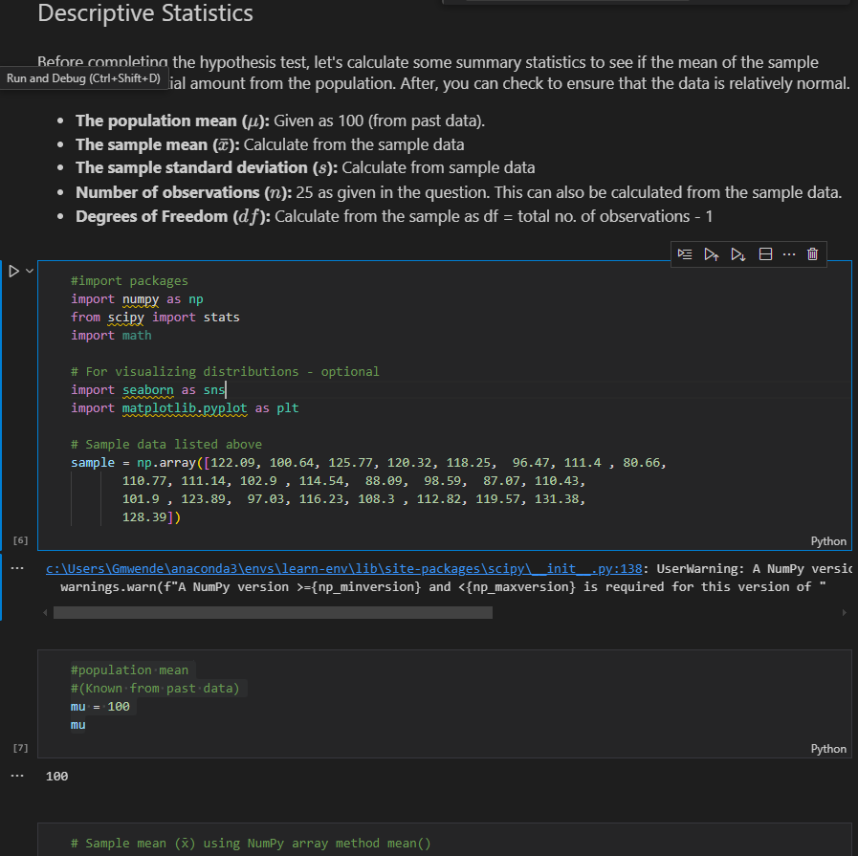

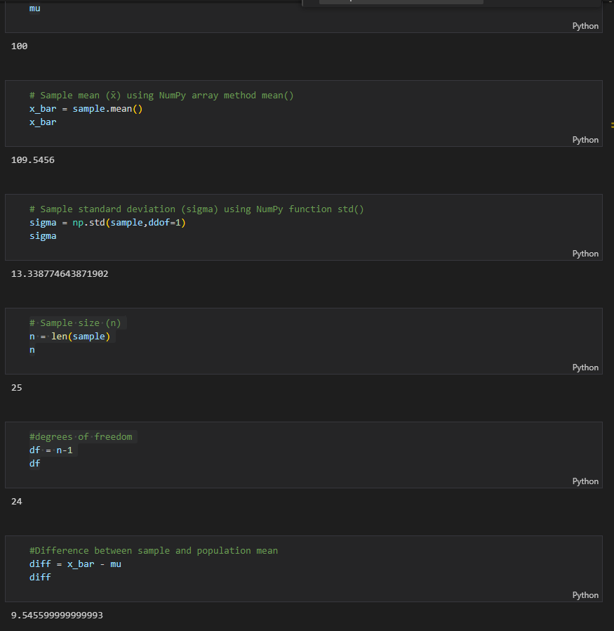

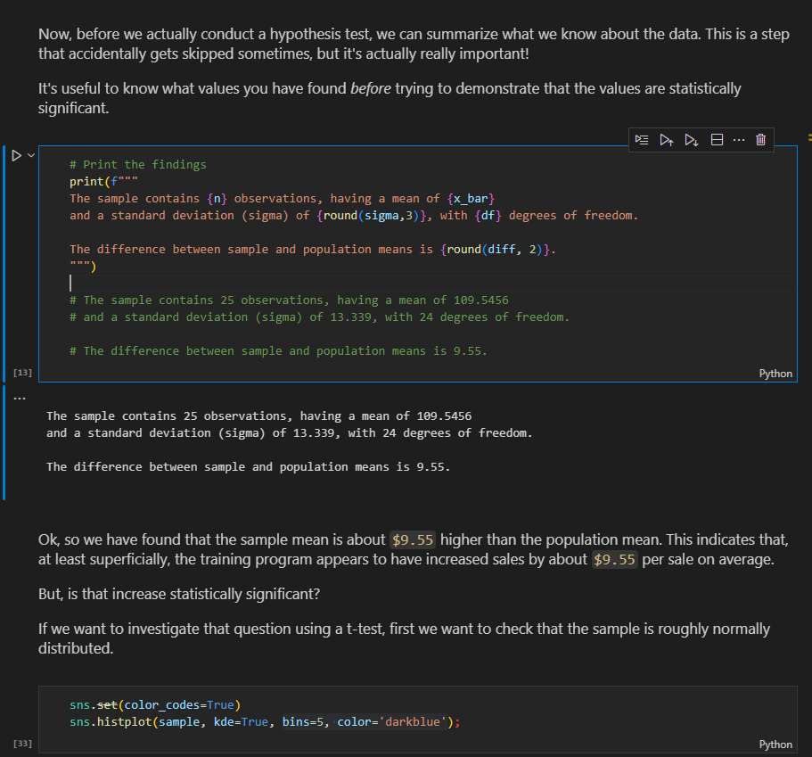

sns.set(color_codes=True)

sns.histplot(sample, kde=True, bins=5, color='darkblue');

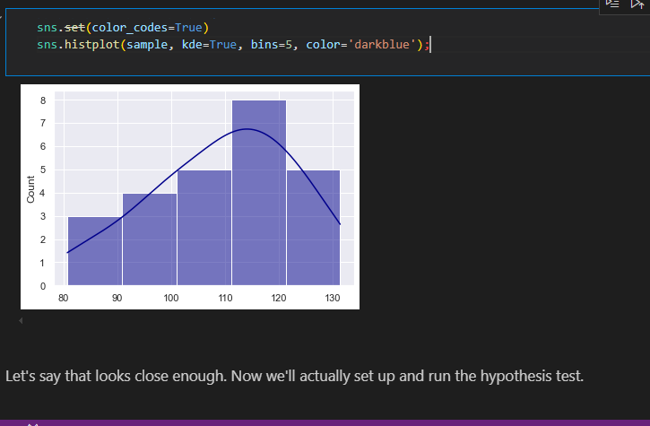

Step1:Establish null and Alternative hypothesis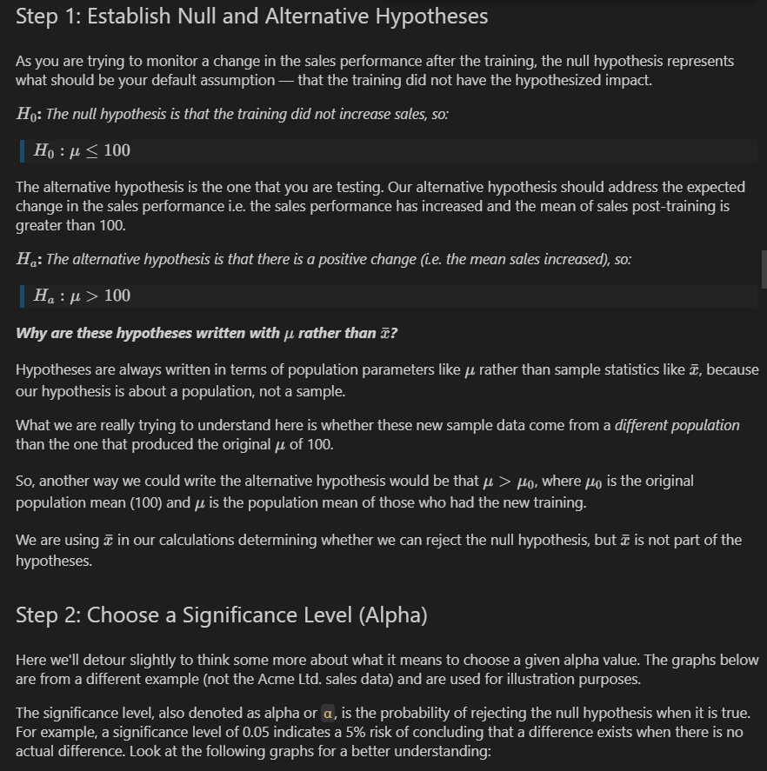

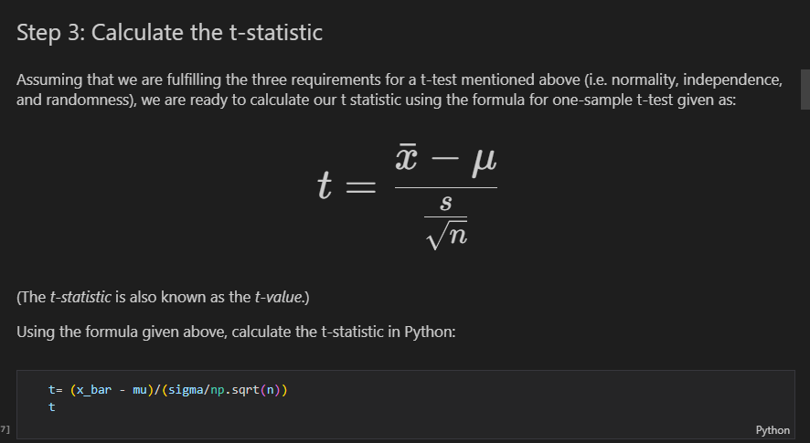

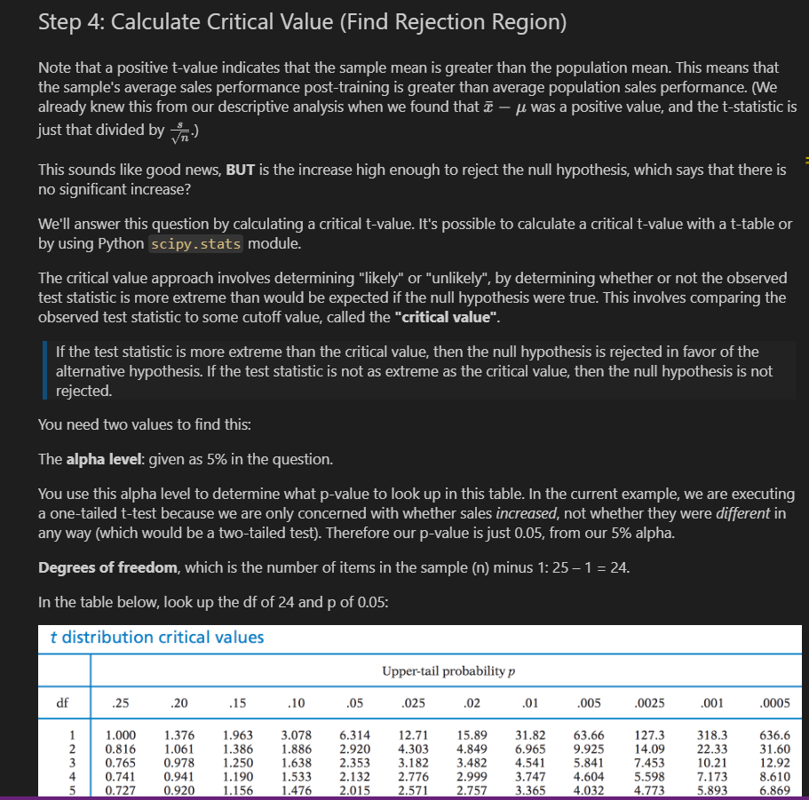

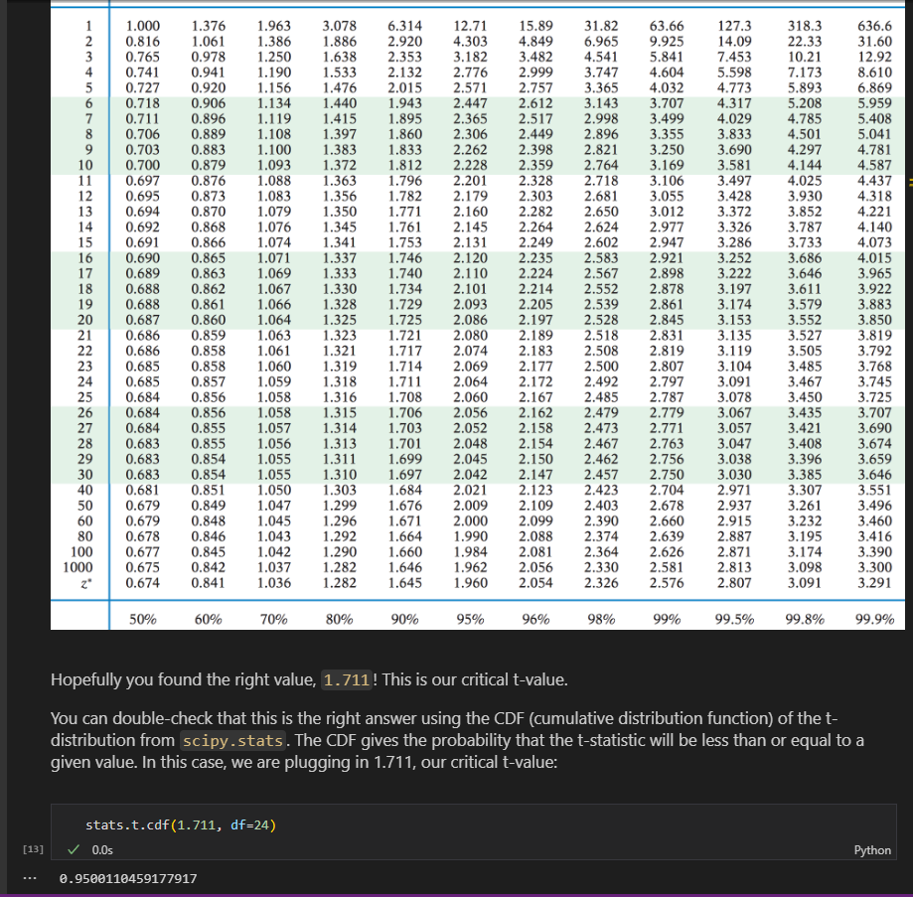

stats.t.cdf(1.711, df=24)

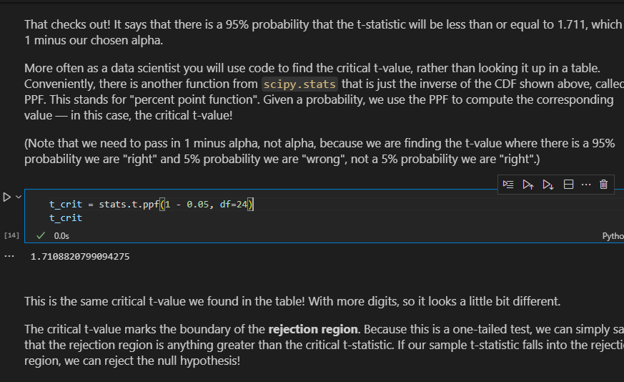

t_crit = stats.t.ppf(1 - 0.05, df=24)( right tail,greter than one sample

t_crit

**Step 5: Compare sample t-value with critical t-value**

fig, ax = plt.subplots(figsize=(8,5))

#plot the PDF as a line graph

# (x and y were created in previous plotting code)

ax.plot(x,y,color='darkblue',label='t-distribution PDF')

#plot a vertical line for our criical t-value

ax.axvline(t_crit,color='g',ls='--',lw=4,label='critical t-value')

#fill area under line graph where x value is greater than critical t

ax.fill_betweenx(y,x,t_crit,where= x > t_crit,color='gray',label='rejection region')

#plot a vertical line for our measured difference in sales t-statistic

ax.axvline(t,color='r',ls='--',lw=5,label='observed-t-statistic')

ax.legend()

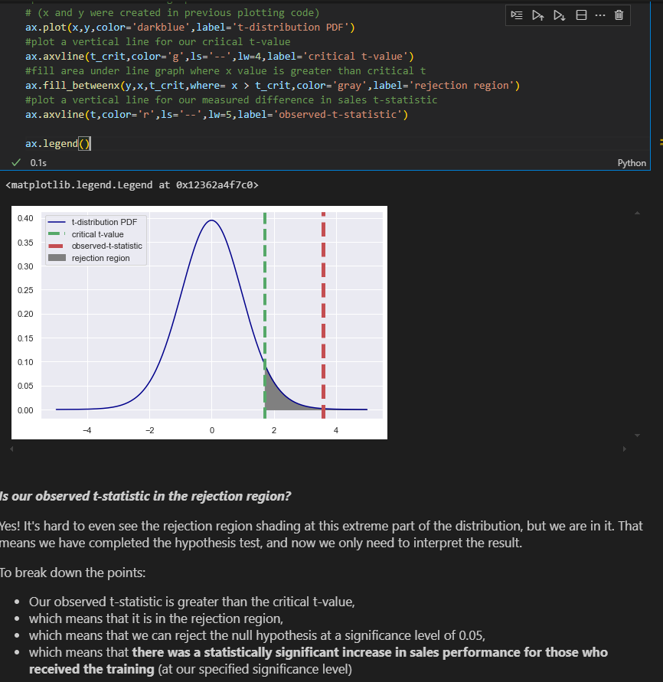

**Use p_value to reject(calculate p-value in t tests)**

p_value = stats.t.sf(t,df=24)

p_value

**p_value for left tail**

stats.t.cdf(t_statistic, df)

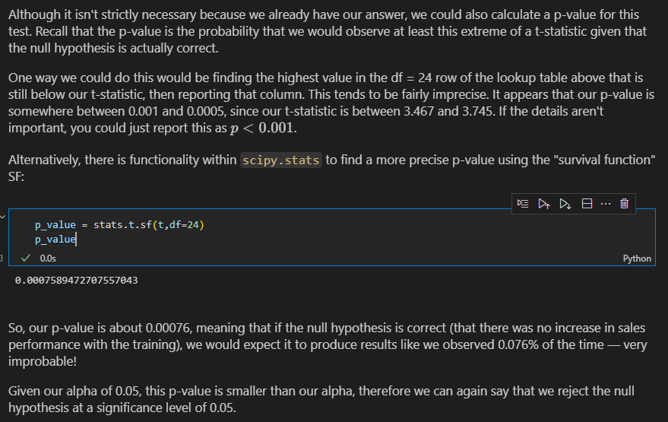

**Sample Question 2**

*_Educators may use hypothesis testing to assess the effectiveness of new teaching methods or curricula. For example, they might test whether students taught with a new method score higher on standardized tests compared to those taught with traditional methods (H₀: no difference in scores)._*

Hypothesis:

- Null Hypothesis (H₀): There is no difference in scores between students taught using the new method and the traditional average score of 75.

- Alternative Hypothesis (H₁): Students taught with the new method score higher than 75.

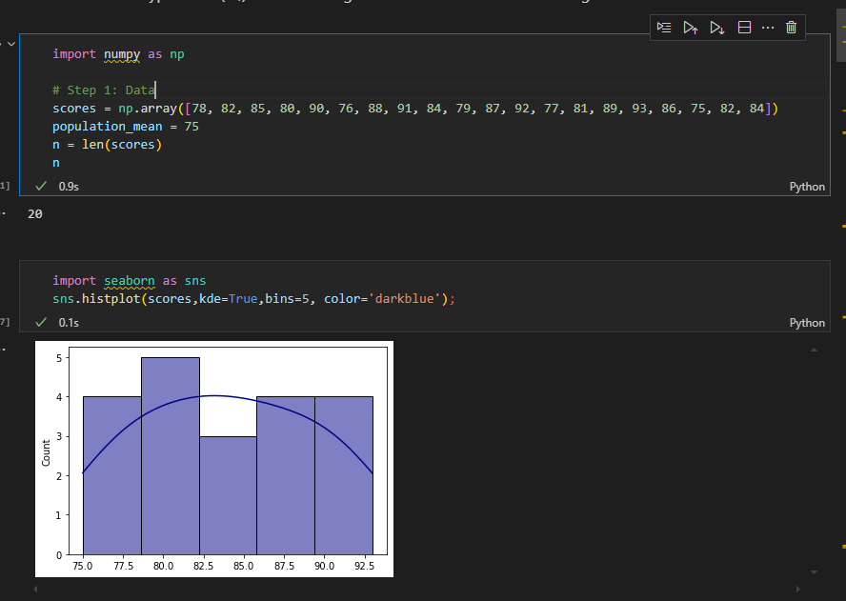

# Step 2: Calculate Sample Mean (X_bar)

X_bar = np.mean(scores)

X_bar

# Step 3: Calculate Sample Standard Deviation (s)

s = np.std(scores, ddof=1)  # Use ddof=1 for sample standard deviation

s

diff = X_bar - population_mean

print('diff:there is a difference yes but is it statisctically significant?',diff)

# Step 4: Calculate T-Statistic

t_statistic = (X_bar - population_mean) / (s / np.sqrt(n))

t_statistic

# Step 5: Calculate Degrees of Freedom

df = n - 1

df

# Step 6: Calculate Critical T-Value (one-tailed) for alpha = 0.05

alpha = 0.05

t_critical = 1.65

# Step 8: Output Results

print(f"Sample Mean (X_bar): {X_bar:.2f}")

print(f"Sample Standard Deviation (s): {s:.2f}")

print(f"T-Statistic: {t_statistic:.4f}")

print(f"Degrees of Freedom (df): {df}")

#print(f"T-Critical Value (α=0.05): {t_critical:.4f}")

#print(f"P-Value: {p_value:.4f}")

# Step 9: Conclusion

if t_statistic > t_critical:

    print("Reject the null hypothesis (H₀): Students taught with the new method score significantly higher than 75.")

else:

    print("Fail to reject the null hypothesis (H₀): No significant difference in scores.")

import scipy.stats as st

print(st.t.ppf(1-0.05,19)) #from ttable use df as 19 and 0.05 to give 1.729#check greater (right tail)

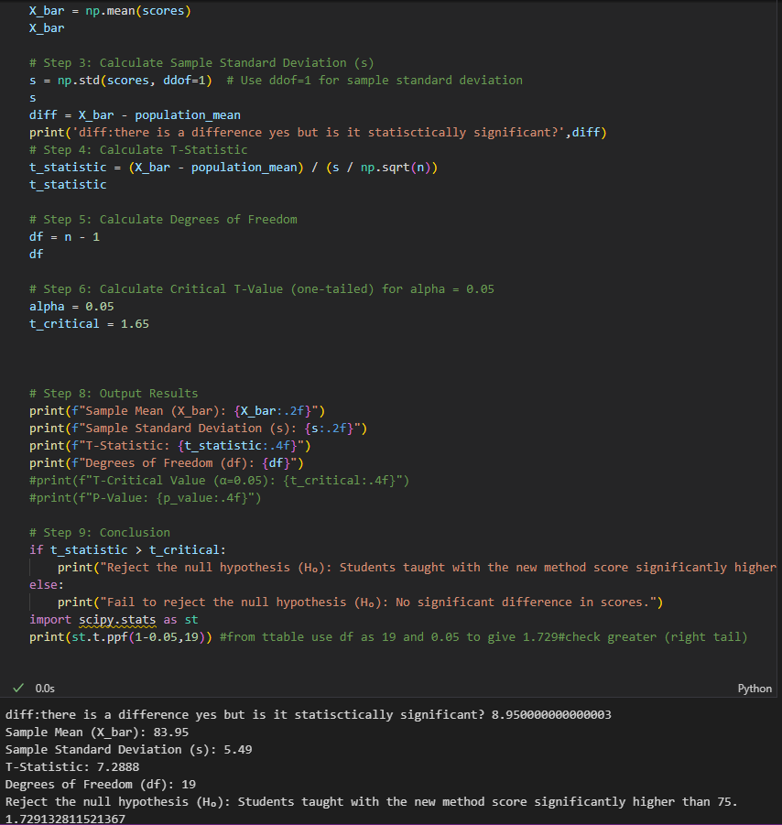

**Using stats Library ttest_1samp sample question 1**

stats.ttest_1samp gives tstatic / t_value

t_critic = stats.t.ppf(1-0.05/2,df=19) for two tailed tests

t_critic = stats.t.ppf(1-0.05,df=19) for one tailed tests

results = stats.ttest_1samp(

    a=sample, #entire array-like sample

    popmean = 100 #mean u'r testing the sample against

)

results

alpha = 0.05

t_crit = stats.t.ppf(1-alpha,df=len(sample)-1)

if results.statistic > t_crit:

    print('Null hypothesis rejected')

    print('The increase in sales performance is statisctically significant at the',alpha,'level')

else:

  print('Failed to rject the null hypothesis.')

  print('The increase in sales performance is not statistically at the', alpha,'level')

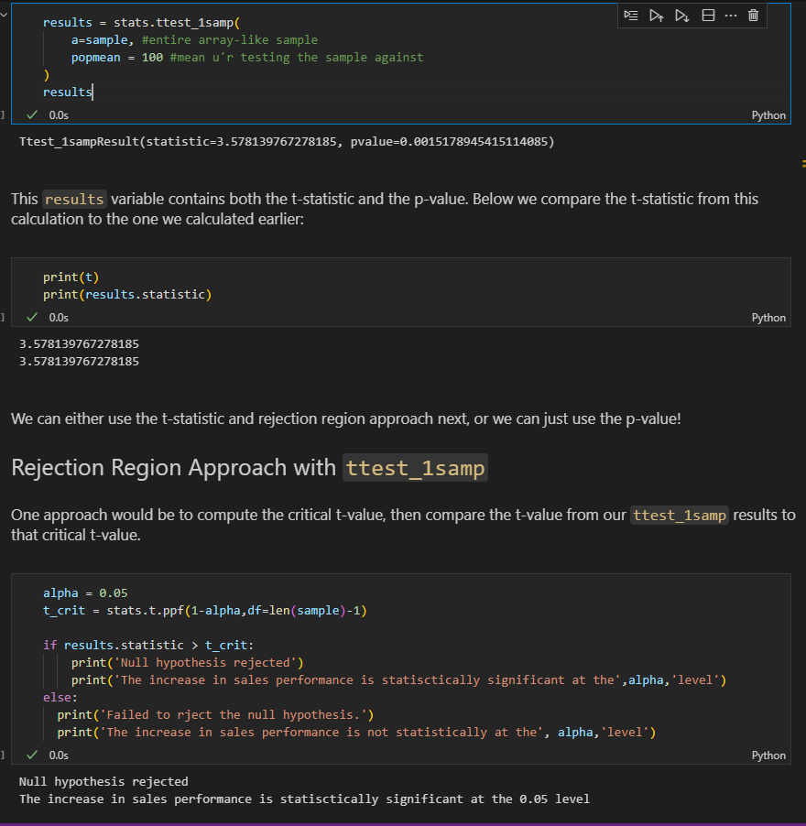

Using p-value we divide by two since since ttest assumes you are performing two sided one-sample t-test

print(p_value)

print(results.pvalue / 2)

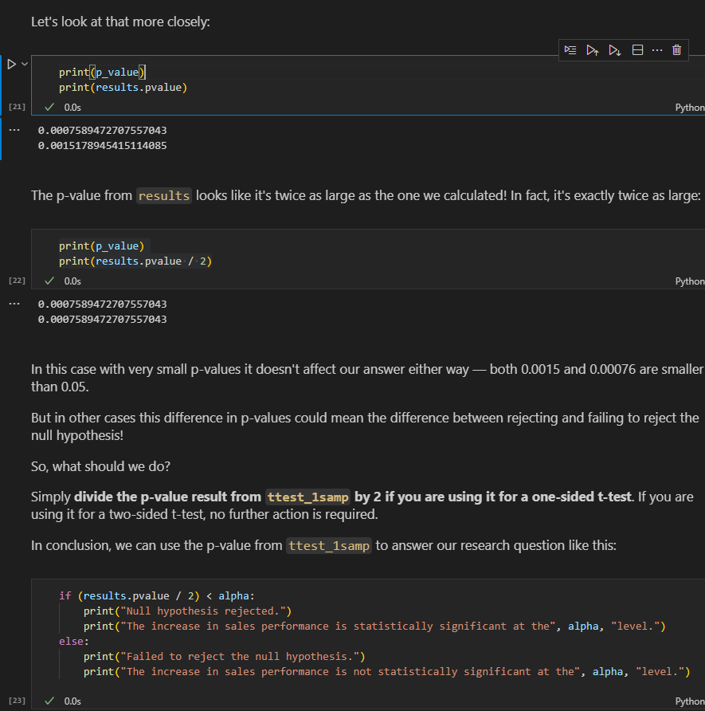

print("results.statistic:", results.statistic)

print("results[0]:       ", results[0])

print("results.pvalue:   ", results.pvalue)

print("results[1]:       ", results[1])

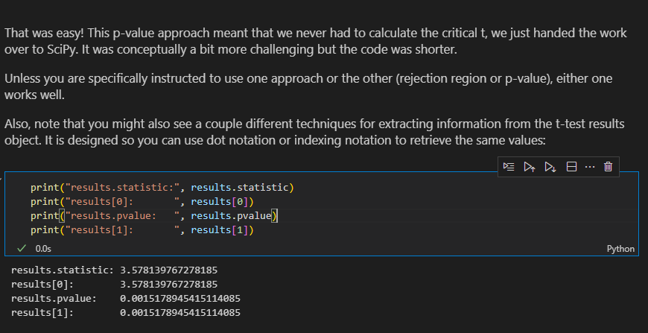

**Using stats Library ttest_1samp sample question 2**

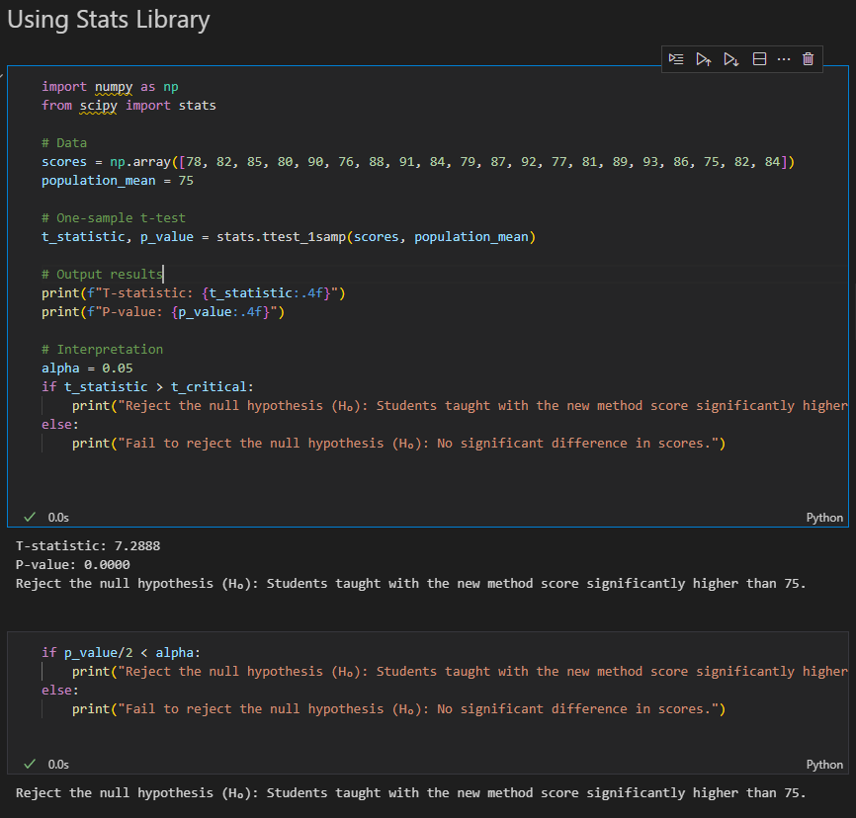

* **Two sample t test –** used to compare if two population means are equal

**Types:**

* paired -useful for determining how different a sample is affected by a treatment

n other words, the individual items/people in the sample will **remain the same** and researchers are comparing how they change after treatment. Here is an example of a scenario where a two-sample paired t-test could be applied:

*The US Olympic weightlifting team is trying out a new workout technique to in an attempt to improve everyone's powerlifting abilities. Did the program have an effect at a 95% significance level?*

Because we are looking at how specific individuals were affected by a treatment, we would use the paired t-test.

* Independent- Independent two-sample t-tests are for when we are comparing two different, unrelated samples to one another. Unlike paired t-tests, we are not taking paired differences because there is no way to pair two unrelated samples! Here is an example of a scenario where a two-sample independent t-test could be applied:
* *Agricultural scientists are trying to compare the difference in soybean yields in two different counties in Mississippi.*

**Sample Question for paired two tests**

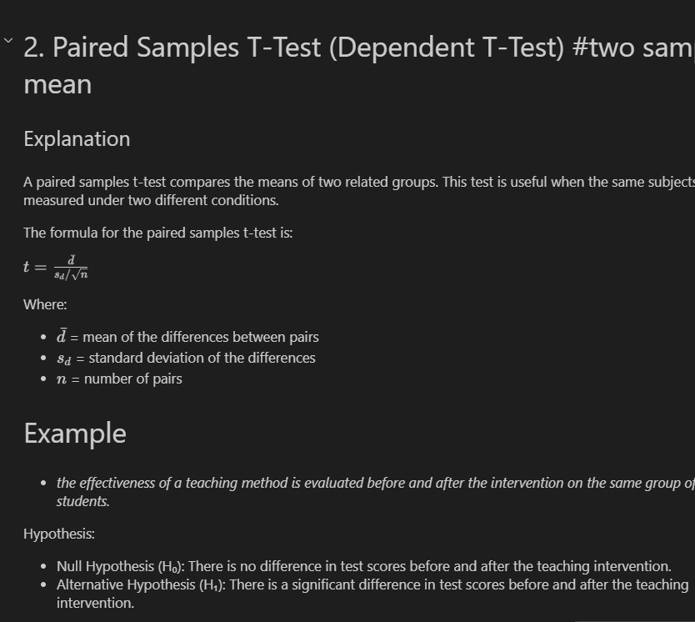

# Step 1: Data

scores_before = np.array([70, 75, 68, 80, 78, 74, 73, 81, 69, 77,

                           72, 76, 79, 74, 82, 71, 75, 78, 70, 80,

                           76, 72, 79, 74, 81])

scores_after = np.array([85, 90, 82, 88, 87, 84, 83, 89, 81, 86,

                          80, 85, 89, 83, 91, 78, 84, 87, 81, 88,

                          85, 80, 88, 83, 90])

# Step 2: Calculate differences

differences = scores_after - scores_before

print(differences)

# Step 3: Calculate the mean of the differences (d_bar)

mean_difference = np.mean(differences)

# Step 4: Calculate the standard deviation of the differences (s_d)

std_difference = np.std(differences, ddof=1)  # Use ddof=1 for sample standard deviation

# Step 5: Calculate the number of pairs (n)

n = len(differences)

# Step 6: Calculate the T-Statistic

t_statistic = mean_difference / (std_difference / np.sqrt(n))

# Step 7: Calculate Degrees of Freedom (df)

df = n - 1

# Step 8: Calculate P-Value

p_value = stats.ttest_rel(scores_before, scores_after).pvalue

# Step 9: Output Results

print(f"Mean of Differences (d_bar): {mean_difference:.2f}")

print(f"Standard Deviation of Differences (s_d): {std_difference:.2f}")

print(f"T-Statistic: {t_statistic:.4f}")

print(f"Degrees of Freedom (df): {df}")

print(f"P-Value: {p_value}") #print(f"P-Value: {p_value:.4f}")

# Step 10: Conclusion

alpha = 0.05

if p_value < alpha:

    print("Reject the null hypothesis (H₀): There is a significant difference in test scores.")

else:

    print("Fail to reject the null hypothesis (H₀): No significant difference in test scores.")

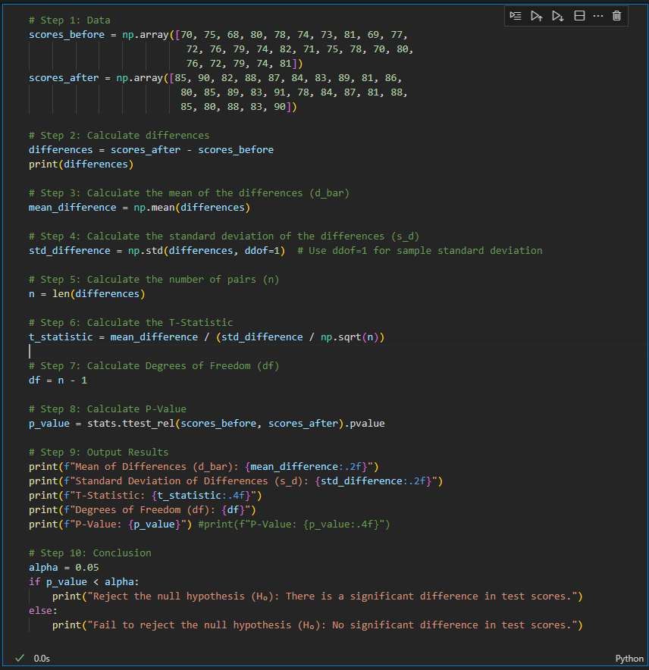

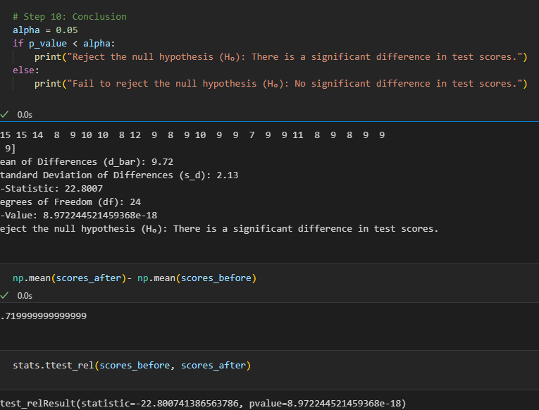

**Using stats library**

import numpy as np

from scipy import stats

# Step 1: Data

scores_before = np.array([70, 75, 68, 80, 78, 74, 73, 81, 69, 77,

                           72, 76, 79, 74, 82, 71, 75, 78, 70, 80,

                           76, 72, 79, 74, 81])

scores_after = np.array([85, 90, 82, 88, 87, 84, 83, 89, 81, 86,

                          80, 85, 89, 83, 91, 78, 84, 87, 81, 88,

                          85, 80, 88, 83, 90])

# Step 2: Use the stats library to perform the paired t-test

t_statistic, p_value = stats.ttest_rel(scores_after, scores_before)

# Step 3: Output Results

print(f"T-Statistic: {t_statistic:.4f}")

print(f"P-Value: {p_value:.4f}")

# Step 4: Conclusion

alpha = 0.05

if p_value < alpha:

    print("Reject the null hypothesis (H₀): There is a significant difference in test scores.")

else:

    print("Fail to reject the null hypothesis (H₀): No significant difference in test scores.")

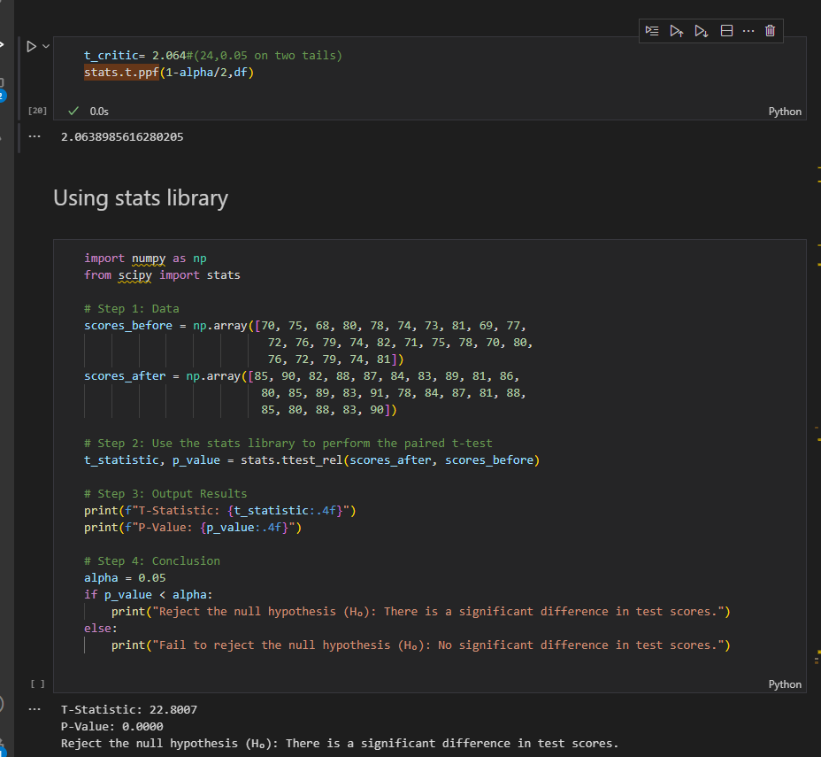

**#test assuming identical variances for two sample**

stats.ttest_ind(experimental, control)

**stats.ttest_ind** (Independent T-Test):

**stats.ttest_rel** (Paired T-Test):

**stats.ttest_ind** (Independent T-Test):

* Used for comparing the means of two independent, unrelated groups.
* Assumes that the two groups are from populations with similar variances (homogeneity of variances). If this assumption doesn't hold, you can use equal_var=False in the function to apply Welch's t-test, which does not assume equal variances.
* Example use case: Testing if two different groups (e.g., treatment and control) have different means on a continuous variable, like comparing test scores between two separate groups of students.

**stats.ttest_rel** (Paired T-Test):

* Used for comparing the means of two related groups, typically the same group measured at two different times (e.g., before and after treatment) or under two different conditions.
* Assumes the samples are paired, meaning each data point in one group has a corresponding data point in the other group.
* Example use case: Testing if there is a significant difference in pre-test and post-test scores for the same group of individuals.

**Sample Question for indepedent two tests**

An independent samples t-test compares the means of two independent groups to determine if they are significantly different from each other.

# Step 1: Data

strategy_a = np.array([250, 300, 275, 400, 320, 275, 310, 290, 330, 350, 275, 360, 310, 295, 340])

strategy_b = np.array([220, 250, 300, 280, 270, 240, 250, 310, 290, 265, 230, 275, 280, 260, 240])

# Step 2: Use the stats library to perform the independent t-test

t_statistic, p_value = stats.ttest_ind(strategy_a, strategy_b) #used when we have both samples

if we don’t have all samples we use

stats.ttest_ind_from_stats(mean1=mean_A, std1=std_A, nobs1=nobs_A,

                          mean2=mean_B, std2=std_B, nobs2=nobs_B,

        equal_var=False)

# Step 3: Output Results

print(f"T-Statistic: {t_statistic:.4f}")

print(f"P-Value: {p_value:.4f}")

# Step 4: Conclusion

alpha = 0.05

if p_value < alpha:

    print("Reject the null hypothesis (H₀): There is a significant difference in average sales.")

else:

    print("Fail to reject the null hypothesis (H₀): No significant difference in average sales.")

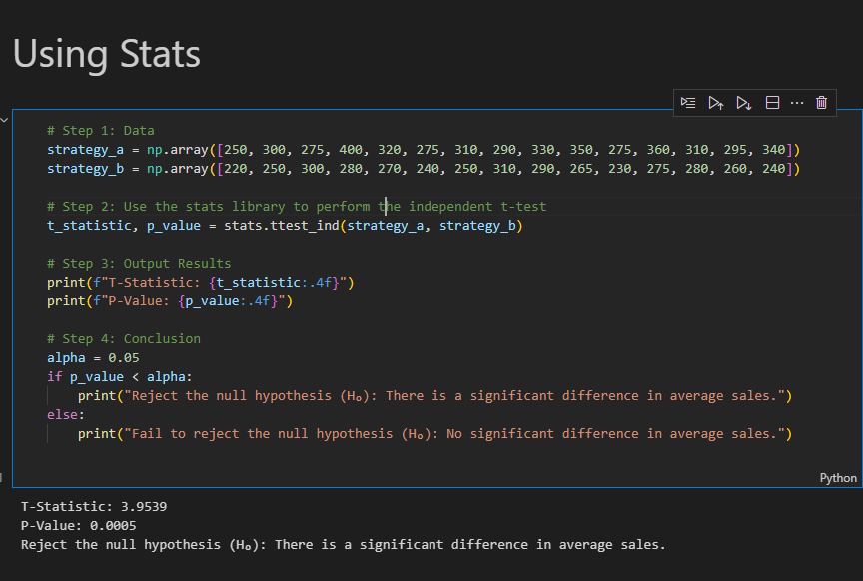

**t-critical formulas(summary notes)**

if one_tailed:

**t_critical = stats.t.ppf(1 - alpha, df)#mostly used**

        critical_region = (t_critical, np.inf)

    else:

        t_critical_left = stats.t.ppf(alpha / 2, df)

        t_critical_right = stats.t.ppf(1 - alpha / 2, df)

        critical_region = (t_critical_left, t_critical_right)



The below 2 are for two tail not 2 sample



1. **P-VALUES AND NULL HYPOTHESIS**

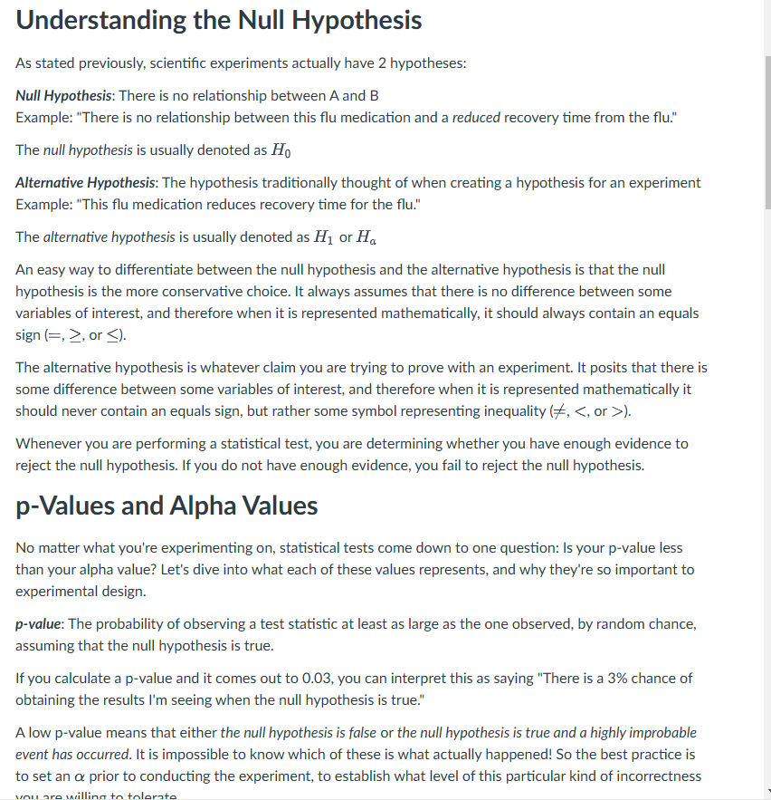

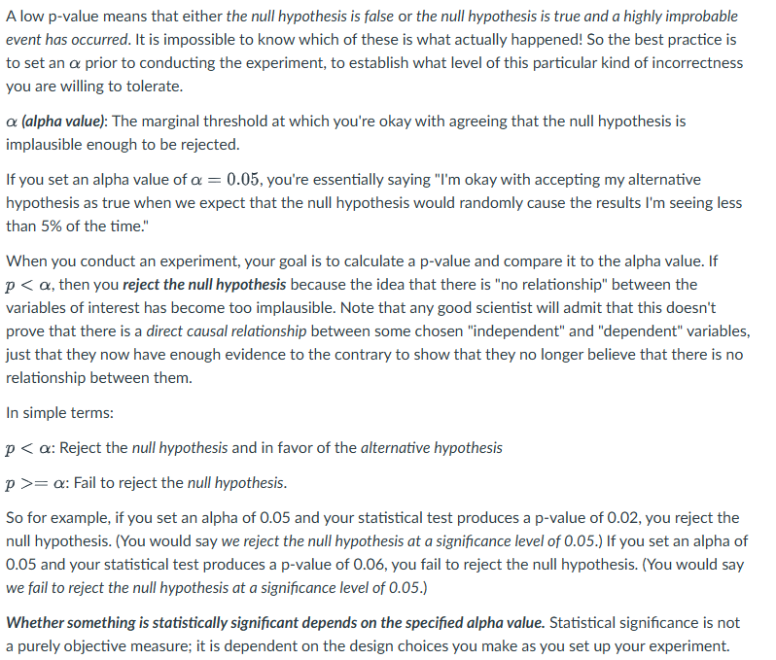

So for example, if you set an alpha of 0.05 and your statistical test produces a p-value of 0.02, you reject the null hypothesis. (You would say *we reject the null hypothesis at a significance level of 0.05*.) If you set an alpha of 0.05 and your statistical test produces a p-value of 0.06, you fail to reject the null hypothesis. (You would say *we fail to reject the null hypothesis at a significance level of 0.05*.)

**NULL AND ALTERNATIVE HYPOTHESIS EXAMPLES**

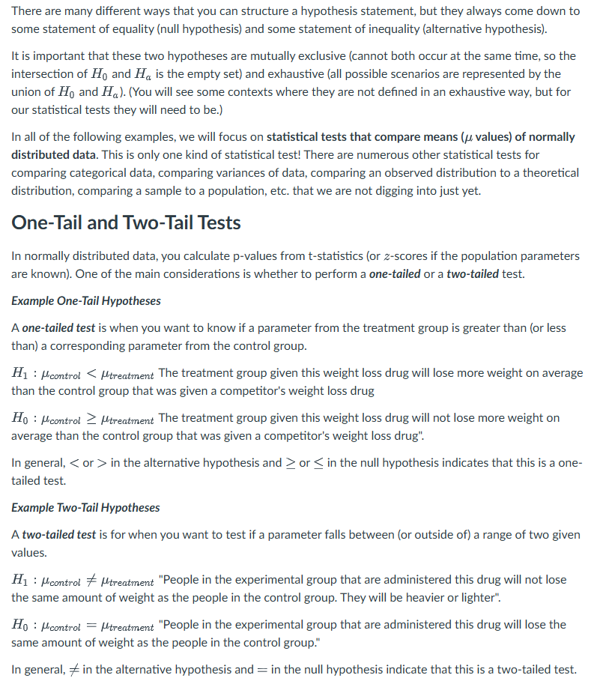

**SAMPLES VS TAILS**

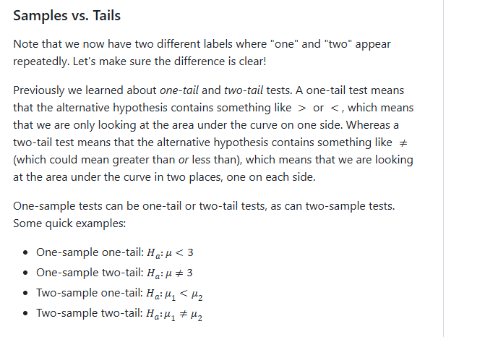

1. **TYPE 1 AND TYPE 11 ERRORS**

* **Alpha and TYPE I (False positive)–** probability that you reject the null hypothesis when its actually true.If a researcher was set to alpha 0.05 this indicates there is a chance that you will reject the null hypothesis when its actually true
* Could also be explained as when we reject the null hypothesis(favouring the alternative hypothesis) but the ‘truth’ we should have failed to reject (favouring the null hypothesis)

**Consequences-** False claims fake alarms,in medical research it could mean approving a treatment that has no real benefit which could be harmful or costly

**Minimize –** Choose a lower alpha value such as 0.01instead of 0.05 however this makes its more stringent which increases the risk of a type II error.

* **Beta and TYPE II Errors(False negative) –** probability that you fail to reject the null hypothesis given that it is actually false
* Could also be explained as when we fail to reject the null hypothesis(favoiring the null hypothesis) nut the truth is that we should have rejected the hypothesis(favouring the laternative hypothesis) I,e we conclude that there is no effect or difference when in reality there is one.

Eg if a drug actually works but you fail to reject the null hypothesis and conclude that it doesn’t work.

**Consequences –** missing a real effect, which could delay discoveries or prevent effective treatment from being recognized.In scientific research it could mean overlook true differences or relationships potentially wasting time and resources

**Minimize**- increase sample size.larger sample provide more reliable estimates and increases tests statisctical power

* Increase significance level-using a higher alpha(0.1) instead of 0.05.increaes the likelihood of rejecting the null hypothesis which reduces type II but increases type I error

**(Hypothesis examples)**

* 1. **Two tailed example**

are consistent before and after their move. They buy a new machine and hire a new barista. In Manhattan, lattes are made with 4 oz of espresso. A random sample of 25 lattes made in their new store in Brooklyn shows a mean of 4.6 oz and standard deviation of 0.22 oz. Are their lattes different now that they've relocated to Brooklyn? Use a significance level of alpha = 0.01.

**Null**: The Brooklyn lattes are not different in size from the Manhattan lattes.

**Alternative**: The Brooklyn lattes are different in size from the Manhattan lattes.

t_stat = (4.6 - 4) / (0.22 / np.sqrt(25))

# This is a two-tailed test, so we want 1/2 of the 1% for

# the right tail and 1/2 for the left tail.

t_crit = stats.t.ppf(0.995, df=24) #stats.t.ppf(1-0.01/2,24)

print("t-statistic: ", t_stat)

print("critical t-value: ", t_crit)

print("p-value: ", stats.t(df=24).sf(t_stat))

# Because the p-value is lower than our threshold of 1% (or, equivalently, because our t-statistic is larger than the critical t-statistic), we should reject the null hypothesis. The Brooklyn lattes are different!

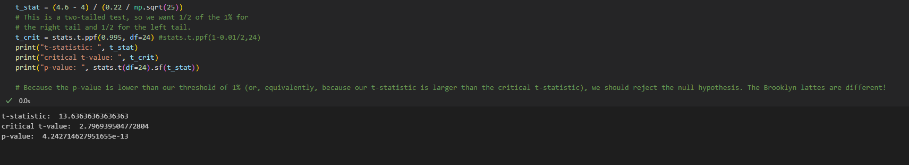

* 1. **Left tail example(one-tail)**

I'm buying jeans from Pants-a-torium. I know nothing about their inventory other than prices after looking at some random jean prices:

50, 75, 25, 30, 30, 40, 80]

However, I know that my typical pants store (Pants-R-Us) sells jeans at an average price of $58 with a standard deviation of $18. (Yes, I do descriptive statistics while I shop. Why do you ask?)

Should I go just to one store for a less expensive pair of jeans? I'm pretty apprehensive about my decision, so alpha = 0.1$.

**Null**: The pants at Pants-a-torium are not cheaper than the pants at Pants-R-Us.

**Alternative:** The pants at Pants-a-torium are cheaper than the pants at Pants-R-Us.

alpha = 0.1

sample = [20, 30, 30, 50, 75, 25, 30, 30, 40, 80]

df = len(sample)-1

t_statistic,p_value = stats.ttest_1samp(sample,58)

print('t_statistic',t_statistic,'p_value ',p_value/2) #since this formula is for two tail

t_crtitical = stats.t.ppf(alpha,df) #one tail(left) less than

print('t_crtitical',t_crtitical)

stats.t.cdf(t_statistic, df)

# p-value is small so we reject the null that is pants in p-atorium are cheaper

#using t-critic since this is a left-tailed test if t_stat < t_critic we reject the null hypothesis

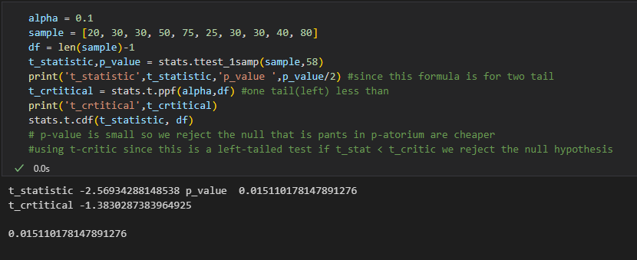

* 1. **Two sample independent test**

You measure the delivery times of ten different restaurants in two different neighborhoods. You want to know if restaurants in the different neighborhoods have the same delivery times. Set your significance threshold to 0.05.

We measured this for neighborhood A:

delivery_times_A = [28.4, 23.3, 30.4, 28.1, 29.4, 30.6, 27.8, 30.9, 27.0, 32.8]

For neighborhood B, someone already reported the values as a mean time of 26.8 minutes and a standard deviation of 2.6 minutes.

**Null:** The delivery times for the restaurants in Neighborhood A are the same as the times for the restaurants in Neighborhood B

**Alternative:** The delivery times for the restaurants in Neighborhood A are NOT the same as the times for the restaurants in  Neighborhood B.

**#This is a TWO-SAMPLE problem. So we'll use stats.ttest_ind_from_stats(). The two sets don't have exactly the same variance, so we'll perform Welch's test by setting the equal_var parameter to False.**

delivery_times_A = [28.4, 23.3, 30.4, 28.1, 29.4, 30.6, 27.8, 30.9, 27.0, 32.8]

mean_A = np.mean(delivery_times_A)

std_A = np.std(delivery_times_A)

nobs_A = len(delivery_times_A)

mean_B = 26.8

std_B = 2.6

nobs_B = 10

stats.ttest_ind_from_stats(mean1=mean_A, std1=std_A, nobs1=nobs_A,

                          mean2=mean_B, std2=std_B, nobs2=nobs_B,

        equal_var=False)

# The p-value is greater than our threshold value of 5%, so we can't reject the null hypothesis that the two neighborhoods have the same restaurant delivery times.

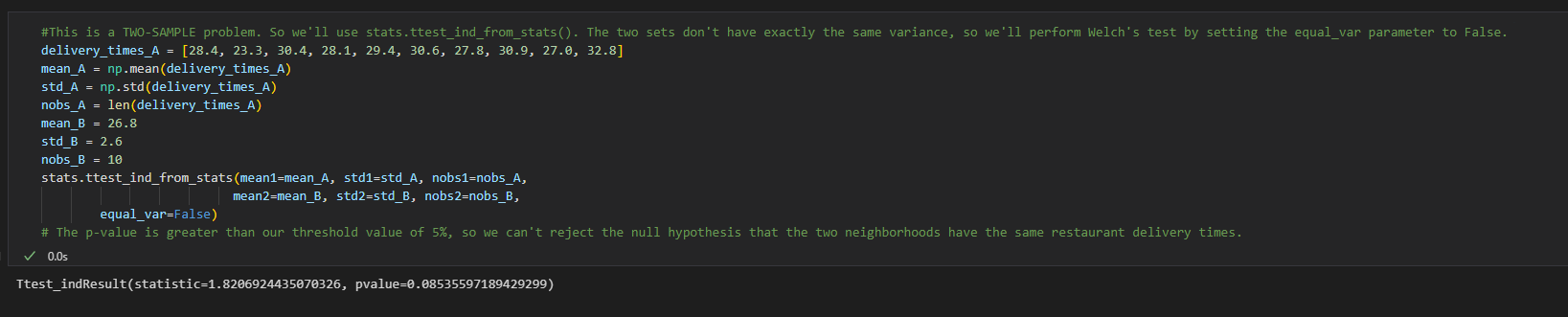

1. **AB TESTING-** general methodology when u want to test a new feature and/or product(especially for online products)

> A/B testing is best suited for informing us what improvements we can make on something we already have. It's not really meant to tell us what *_new direction_* we should go.

>

> An analogy: A/B testing is meant to tell us how to climb up the mountain we're already on, but not necessarily *_what_* mountain we should be on.

**A/B** is essentially hypothesis testing but applied to a business problem

* 1. **Experimental testing –** p-value by itself is prone to misinterpretation if not presented with other relevant design parameters such as effect size,sample size, and alpha.
* Before conducting A/B testing, it’s important to ensure **\*\*well-designed experiments\*\*** that can provide meaningful results.

**Key Design Principles:**

- **Well-Formulated Questions\*\***: Specific and measurable to avoid unintended consequences.

**- Selecting Appropriate Parameters\*\***: Balance between alpha (α), power, sample size, and effect size.

**- Preprocessing Data\*\***: Handle anomalies and outliers before running statistical tests.

**\*\*Goodheart’s Law\*\***: When a measure becomes a target, it ceases to be a good measure.

* 1. **Effect size and p-values**

**Effect size** quantifies how large the difference is between two groups,providing practical insights beyond mere statisctical significance.

**Relationship between Effect size and P-value**

* P-value indicates if the difference is statistically significant
* Effect size shows how meaningful the difference is

**Why do we need to calculate effect size**

* Communicate the practical significance of the results. An effect might be statiscally significant,but does it matter in practical scenarios?
* Effect size calculation and interpretation allows you to draw meta-analytical conclusionsi.e combining and comparing estimates from different studies conducted on different samples.This allows you to group together a number of existing studies, calculate the meta-analytic effect size and get best estimate of the effect size of the population.
* Perform power analysis which helps determine the number of participants (sample size) that a study requires to achieve a certain probability of finding a true effect – if there is any

**Example 1:Height difference between males and females  
Explore the effect size of height between males and females in the US**

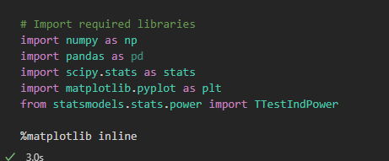

# Define mean and standard deviation for male and female heights

male_mean, male_sd = 178, 7.7

female_mean, female_sd = 163, 7.3

# Create normal distributions for heights

male_height = stats.norm(male_mean, male_sd) #The result male_height is a SciPy rv object which

#represents a normal continuous random variable.

female_height = stats.norm(female_mean, female_sd)

# Function to evaluate the PDF

def evaluate_PDF(rv, x=4):

    '''Input: a random variable object, standard deviation

    output : x and y values for the normal distribution

    '''

    # Identify the mean and standard deviation of random variable

    mean, std = rv.mean(), rv.std()

    # Use numpy to calculate evenly spaced numbers over the specified interval (4 sd) and

    # generate 100 samples.

    xs = np.linspace(mean - x * std, mean + x * std, 100)

    # Calculate the peak of normal distribution i.e. probability density.

    ys = rv.pdf(xs)

    return xs, ys

# Plot PDFs for both distributions to visualize the effect size

xs, ys = evaluate_PDF(male_height)

plt.plot(xs, ys, label='Male', color='blue')

xs, ys = evaluate_PDF(female_height)

plt.plot(xs, ys, label='Female', color='orange')

plt.xlabel('Height (cm)')

plt.legend()

plt.title("PDF of Male and Female Heights")

plt.show()

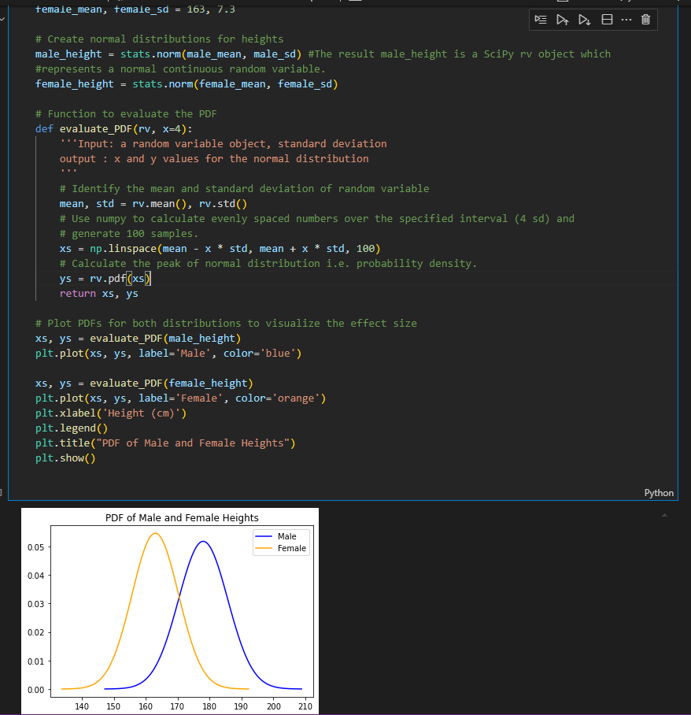

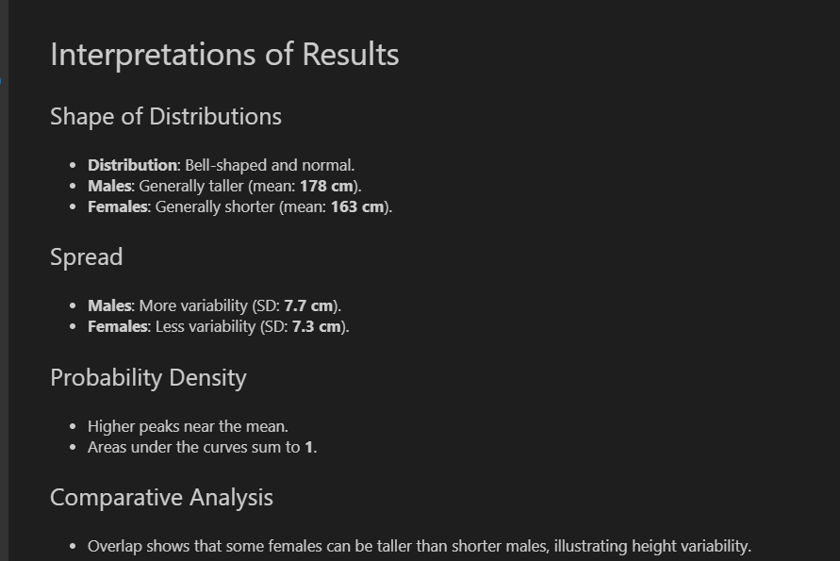

* 1. **CALCULATING EFFECT SIZE (Unstandardized Effect size)**

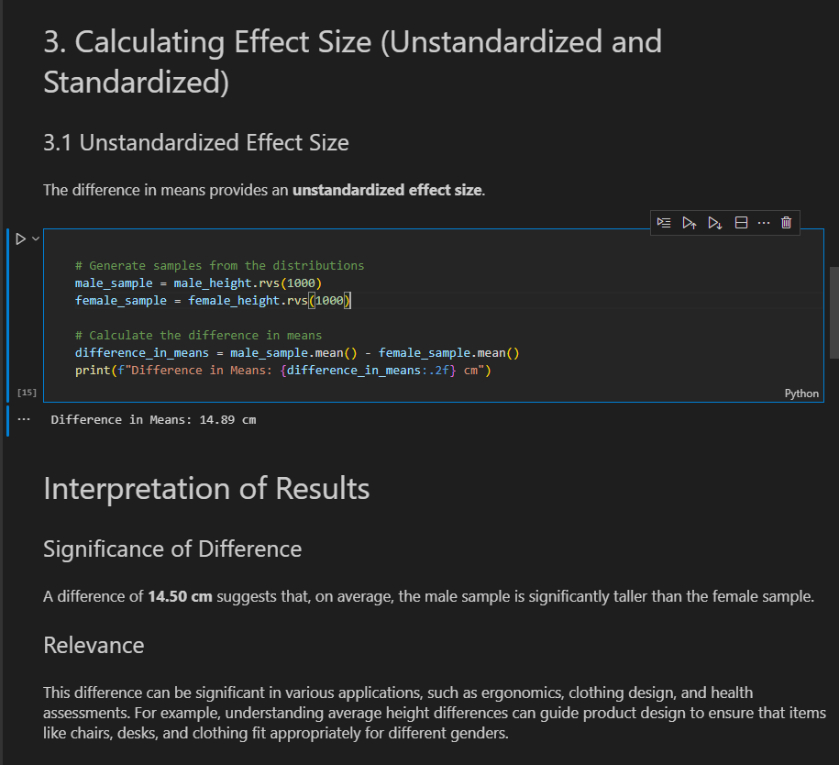

**CALCULATING EFFECT SIZE (Standardized Effect size) Cohen’s d**

Cohen’s d is one of the most common ways to measure effect size. As an effect size, Cohen's d is typically used to represent the **magnitude of differences between two (or more) groups** on a given variable, with larger values representing a greater differentiation between the two groups on that variable.

The basic formula to calculate Cohen’s d is:

d = effect size (difference of means) / pooled standard deviation

The denominator is the standardiser, and it is important to select the most appropriate one for a given dataset. The pooled standard deviation is the average spread of all data points around their group mean (not the overall mean).

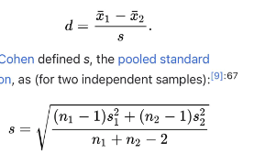

# Function to compute Cohen's d

def Cohen_d(group1, group2):

    diff = group1.mean() - group2.mean()

    n1, n2 = len(group1), len(group2)

    pooled_var = ((n1 - 1) * group1.var() + (n2 - 1) * group2.var()) / (n1 + n2 - 2)

    return diff / np.sqrt(pooled_var)

# Calculate and display Cohen's d

cohen_d_value = Cohen_d(male_sample, female_sample)

print(f"Cohen's d: {cohen_d_value:.2f}")

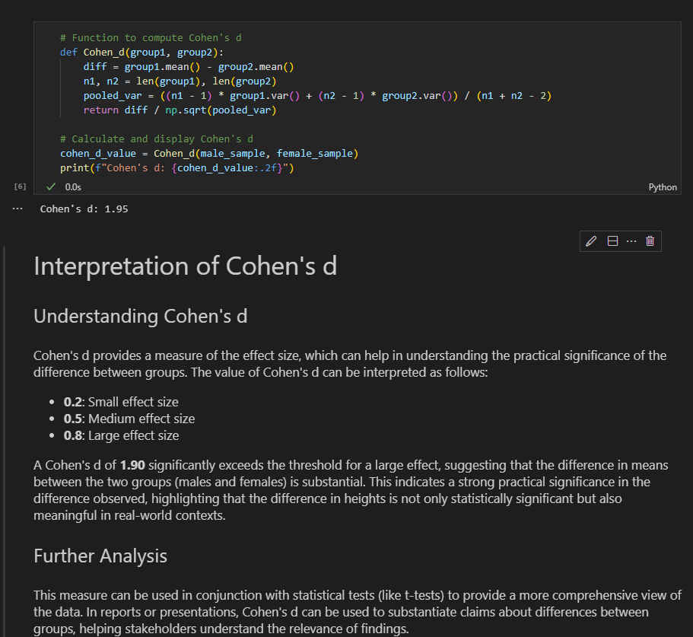

* 1. **Statisctical power -** is the probability of rejecting the null hypothesis when it is false (avoiding a Type II error

**Factors Affecting Power:**

- **\*\*Alpha (α)\*\***: The significance level.lower alpha lower power and vice versa

- **\*\*Sample Size\*\***: Larger samples increase power.

- **\*\*Effect Size\*\***: Larger effect sizes make it easier to detect differences.

We can visualize the power curve using `statsmodels`.

* # Plot power curves for different effect sizes

# import matplotlib.pyplot as plt

# from statsmodels.stats.power import TTestIndPower

power_analysis = TTestIndPower()#This initializes the TTestIndPower class, which is used to compute statistical power for a two-sample independent t-test (e.g., comparing two groups). The class provides methods to calculate power, effect size, sample size, and more.

effect_sizes = [0.2, 0.5, 0.8]

plt.figure(figsize=(10, 6))

nobs_range = np.arange(5, 500)

for es in effect_sizes:

    power = [power_analysis.solve_power(effect_size=es, nobs1=n, alpha=0.05) for n in nobs_range]

    plt.plot(nobs_range, power, label=f'Effect Size: {es}')

plt.title("Power Curves for Different Effect Sizes")

plt.xlabel("Sample Size")

plt.ylabel("Power")

plt.ylim(0, 1)

plt.axhline(y=0.8, color='r', linestyle='--', label='Power = 0.8')

plt.legend()

plt.grid()

plt.show()

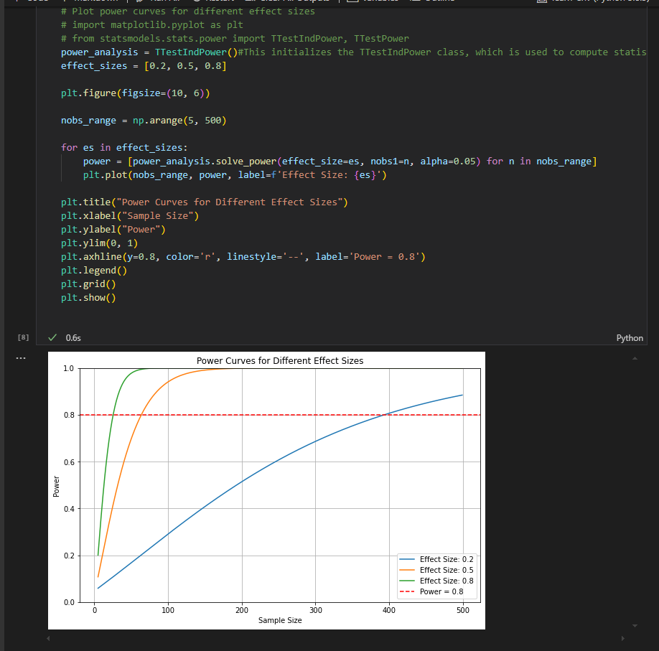

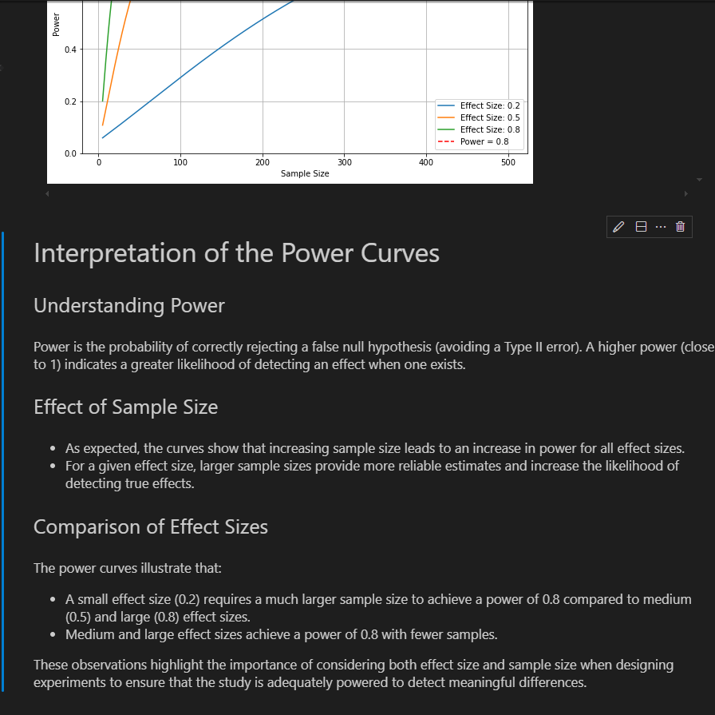

**In addition to plotting a full curve, you can also calculate specific values. Simply don't specify one of the four parameters.**

We can also draw the following conclusion from the plot above: For a specific sample size (*x*-axis), power increases (*y*-axis) as effect size increases.

Power_analysis.solve_power

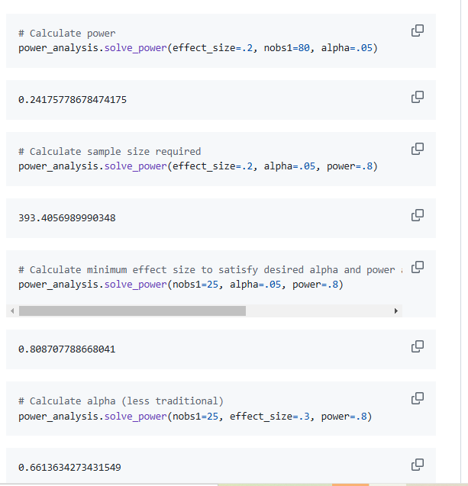

* 1. **Ethical considerations in A/B Testing**

When conducting A/B tests, especially with real users, it is important to consider ethics

**Key ethical considerations**

**-Informed Consent:** participants must be aware of the tests

**-Assesment of Risks and benefits-** weigh potential risks against benefits

**-Fair selection of subjects-** Avoid targeting vulnerable populations

**Example 2:A/B TESTING EXAMPLE**

**## The Scenario**

*You've been tasked with designing an experiment to test whether a new email template will be more effective for your company's marketing team. The current template has a 5% response rate (with standard deviation .0475), which has outperformed numerous other templates in the past. The company is excited to test the new design that was developed internally but nervous about losing sales if it is not to work out. As a result, they are looking to determine how many individuals they will need to serve the new email template in order to detect a 1% performance increase.*

**NULL:** The probability of success of the new email template is < 0.06

**Alternative:** The probability of success for the new email template >=0.06

a) Now define what alpha and beta you believe might be appropriate for this scenario.

To start, arbitrarily set $\alpha$ to 0.05. From this, calculate the required sample size to detect a .01 response rate difference at a power of .8.

> Note: Be sure to calculate a normalized effect size using Cohen's d from the raw response rate

# Calculate the required sample size

from statsmodels.stats.power import TTestIndPower

power_analysis = TTestIndPower()

mean_difference =0.01

std  = .0475

alpha=.05

power=.8

effect_size = 0.01/std #(mean_difference/std)cohens d

sample_size =power_analysis.solve_power(effect_size = effect_size,alpha=alpha,power=power,alternative='larger')

sample_size

# • **alternative='two-sided'**: The test is two-tailed, meaning it checks if the mean difference is either significantly greater than or less than zero (i.e., the means of the two groups are different in either direction).

• **alternative='larger'**: The test is one-tailed, meaning it only checks if the mean of the test group is significantly *greater* than the mean of the control group.

• **alternative='smaller'**: The test is also one-tailed, but it checks if the mean of the test group is significantly *less* than the mean of the control group.

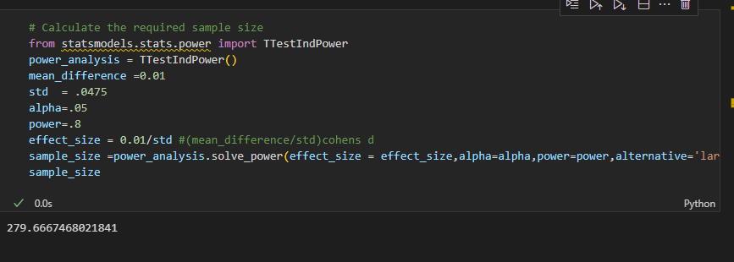

b). **Step 4: Plot Power Curves for Alternative Experiment Formulations**

While you now know how many observations you need in order to run a t-test for the given formulation above, it is worth exploring what sample sizes would be required for alternative test formulations. For example, how much does the required sample size increase if you put the more stringent criteria of alpha=.01? Or what is the sample size required to detect a .03 response rate difference at the same alpha and power thresholds? To investigate this, plot power vs sample size curves for alpha values of .01, .05 and .1 along with varying response rate differences of .005, .01, .02 and .03.

#Your code; plot power curves for the various alpha and effect size combinations

import numpy as np

import matplotlib.pyplot as plt

import seaborn as sns

sns.set_style('darkgrid')

%matplotlib inline

sd = 0.0475

e_sizes = [mu_delta/sd for mu_delta in [.005,.01,.02,.03]]

fig, axes = plt.subplots(ncols=1, nrows=3, figsize=(8,15))

for n, alpha in enumerate([.01, .05, .1]):

    print(type(n), alpha)

    ax = axes[n]

    power_analysis.plot_power(dep_var="nobs",

                              nobs = np.array(range(5,500)),

                              effect_size=e_sizes,

                              alpha=alpha,

                              ax=ax,

                              alternative='larger')

    ax.set_title('Power of Test for alpha = {}'.format(alpha))

    ax.set_xticks(list(range(0,500,25)))

    ax.set_yticks(np.linspace(0,1,11))

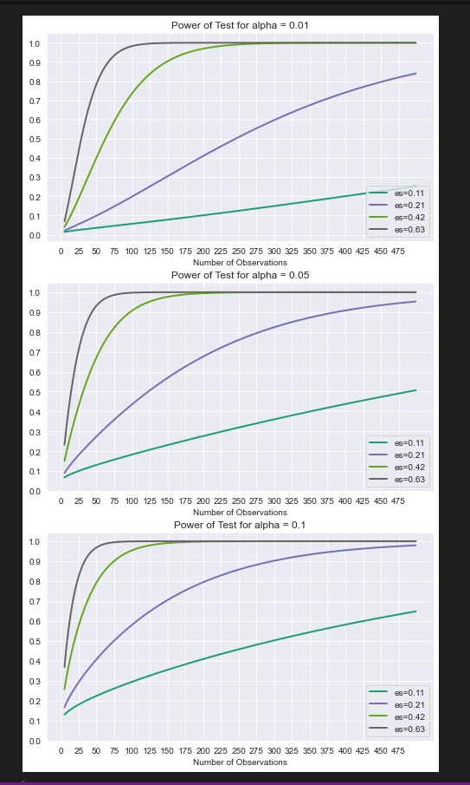

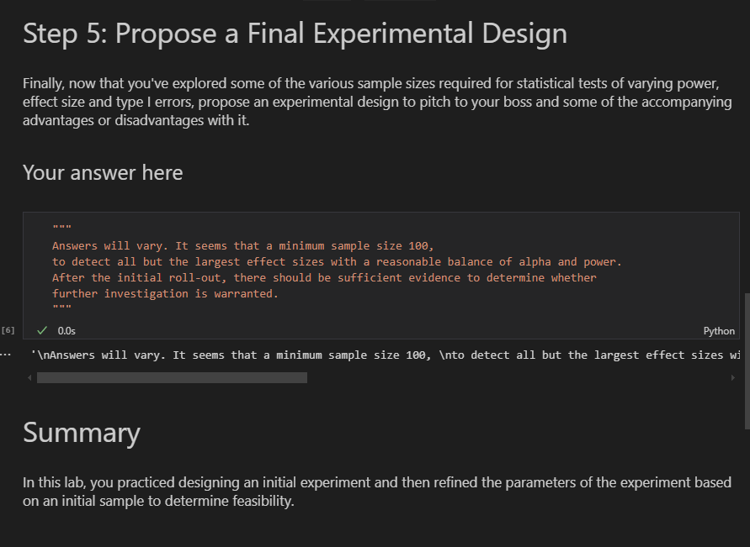

1. **CHI SQUARE-** non-parametric test for analyzing frequencies in categorical data.it helps determine if there is a significant association between categorical variables.

* Unlike t-tests, which examine population parameters(e,g mean), chi square tests focus on observed vs expected frequencies, making them ideal for categorical data
* parametric eg mean compare with pop mean,std, variability egt-test,ztest
* non_parametric- checking correlation no paramters eg does gender affect employment to military,,nothing like mean here**

**Comparing t-tests and Chi-square Tests**

* T-tests are parametric tests used for continuous variables,typically analyzing sample means to test hypotheses about population parameters.A common use is comparing means between two groups, using the t-distribution for significance testing.
* In contrast , chi-square tests are non-parametric and focus on categorical data, examining the association between variables rather than means.This distinction makes each tests suitable for different types of data analysis.
* **T-test example**

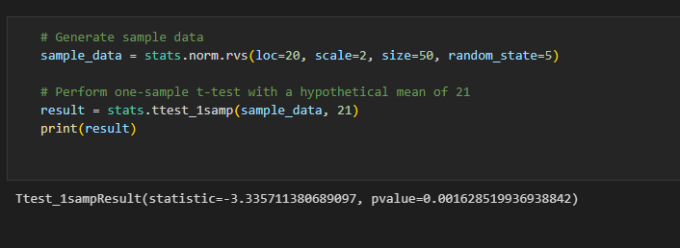

**Chi-square Test Introduction**

Chi-square tests is applicable for discrete variables that can be represented by a **Probability mass function ,** which allows us to understand the data in terms of the **frequencies** of each outcome. here are several different kinds of chi-square tests depending on the question being asked, but we'll focus on *Pearson's chi-square test* and how it is applied for goodness of fit, independence, and homogeneity.

**Goodness of Fit:** compare observed frequencies to expected frequencies under a theoretical distribution.

**Test for Independence –** tests if two categorical variables are independent of each other.

**Test for Homogeneity:** Compares distribution frequencies across different groups

* 1. **Chi-Square Test for Goodness of fit**

We compare observed frequencies in data to expected frequencies under a specific hypothesis.eg we could test if a coin is fair by comparing observed counts of heads and tail

**EXAMPLE:CHI SQUARE**

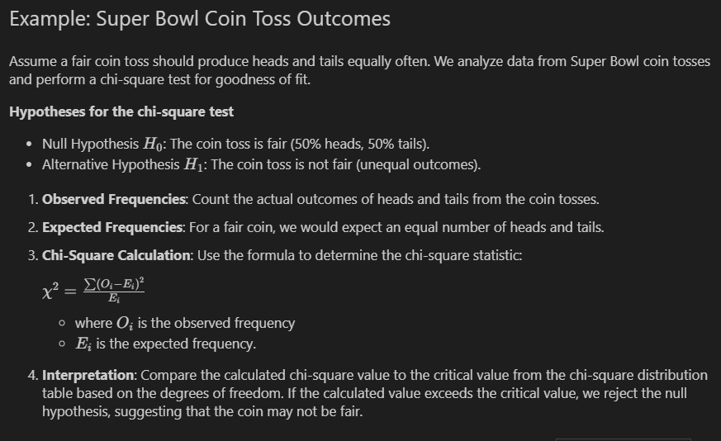

import pandas as pd

from scipy import stats

# Load Super Bowl coin toss data

sb_data = pd.read_csv("superbowl.csv")

coin_toss_counts = sb_data["Coin Toss Outcome"].value_counts()

print('coin_toss_counts:',coin_toss_counts)

# Observed and expected frequencies

observed = coin_toss_counts.values

print('observed:',observed)

expected = [sum(coin_toss_counts) / 2] * 2  # Assuming a fair coin

print('expected:',expected)

# Perform chi-square test

result = stats.chisquare(observed, expected)

# Print the result

print(result)

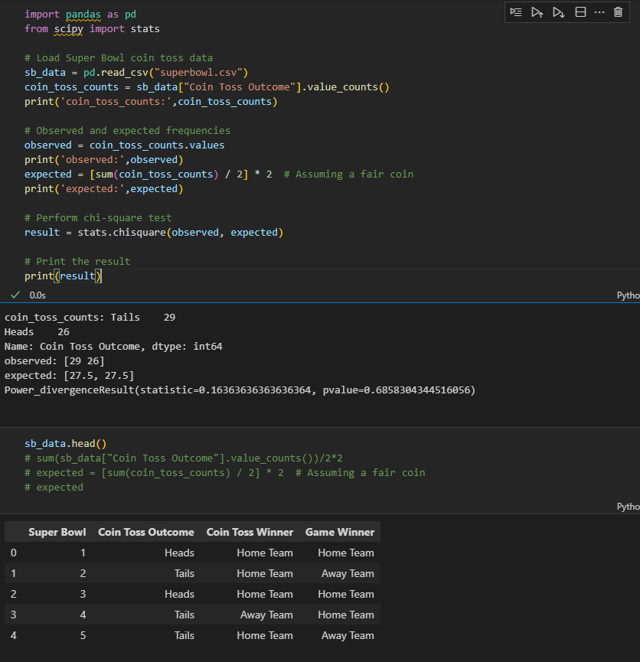

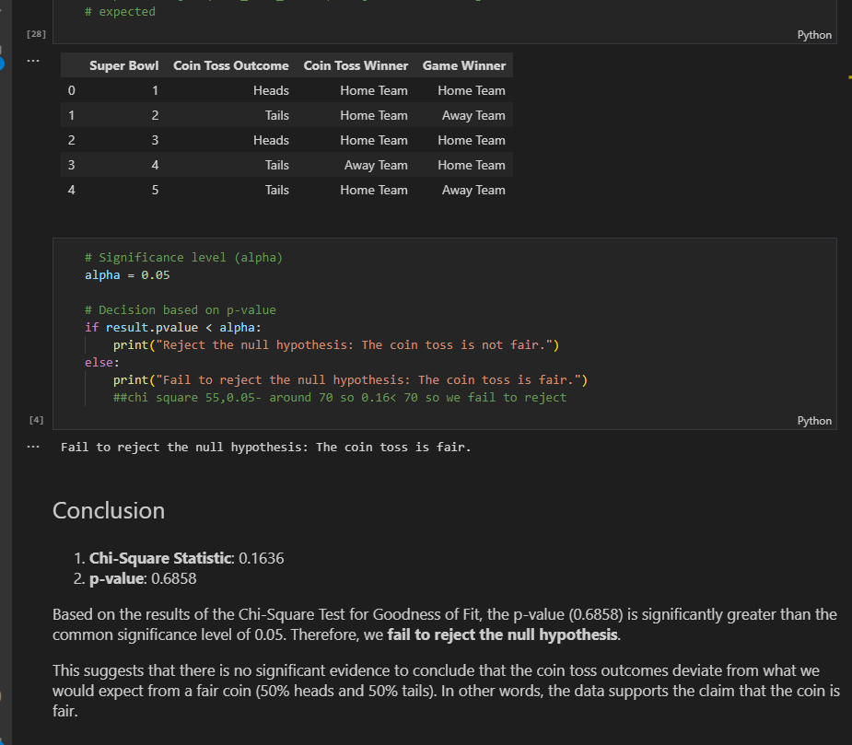

1. **Chi- Square Test for Independence –** tests whether two categorical variables for independent.eg we might examine whether winning a Super Bowl game is related to winning the coin toss.

**NULL:** winning the super Bowl game is independent of winning the coin toss.

**Alternative:** winning the Super Bowl game is not indepent of winning the coin toss

**Example: Super Bowl Game and Coin Toss Winners**

# Create contingency table

independence_table = pd.crosstab(sb_data["Coin Toss Winner"], sb_data["Game Winner"])

# Perform chi-square test for independence

chi2, p, dof, ex = stats.chi2_contingency(independence_table)

print("Chi-square statistic:", chi2)

print("p-value:", p)

##chi square 55,0.05- around 70 so 0.59< 70 so we fail to reject

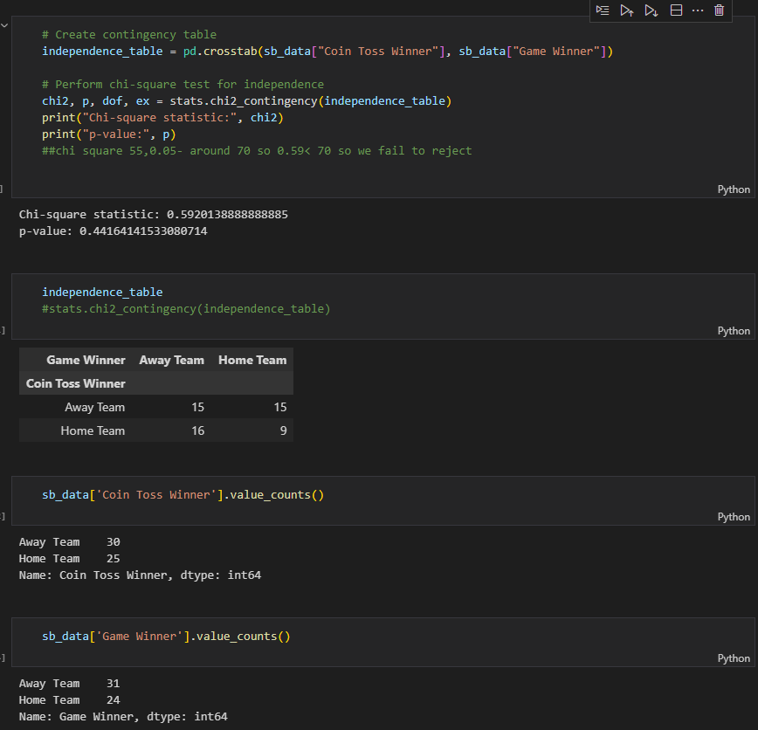

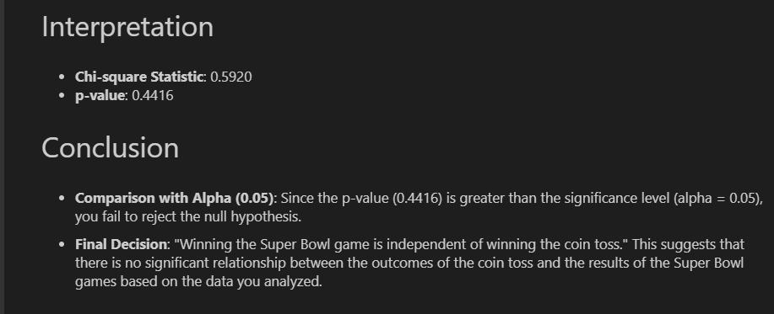

1. **Chi-square Test for** **Homogeneity** – compares the distributions of categorical variable across multiple groups. It answers questions like whether winning the NFL games differ before and after a specific period.

**EXAMPLE: NFL Home-Field advantage Before and After 2020**

**- **Null Hypothesis (H0)**:** The distribution of NFL game winners is the same before (2002-2019) and after (2020 onward) the specified period. (no homegenity)

**- **Alternative Hypothesis (H1)**:** The distribution of NFL game winners differs between the two periods (before and after 2020).(heteregenous)

**#### How**

1. **Contingency Table**: We create a table of game winners across the two periods.

2. **Chi-Square Test**: Calculates if observed winner distributions deviate from expected distributions (assuming no change over time).

3. **Interpret p-value**:

   - Low p-value (< 0.05) → Significant change in winning patterns.

   - High p-value → No significant change.

nfl_data = pd.read_csv('nfl_games.csv')

nfl_data.head()

# Create Game Winner column

nfl_data["Game Winner"] = nfl_data.apply(lambda row: row["team1"]

                                         if row["result1"] == 1.0 else row["team2"], axis=1)

nfl_data.head()

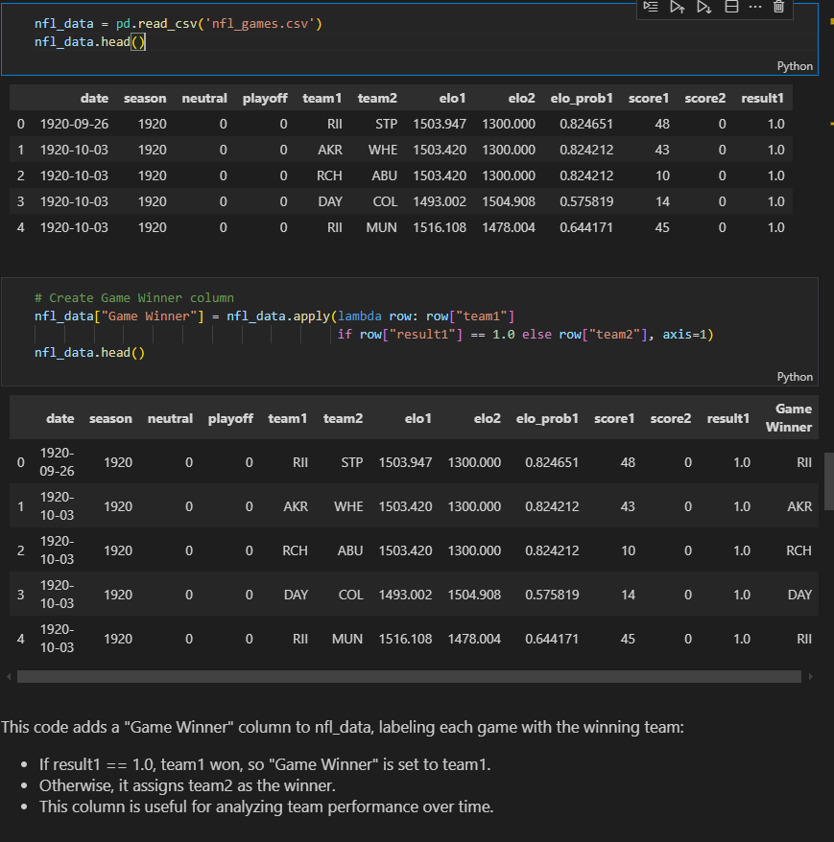

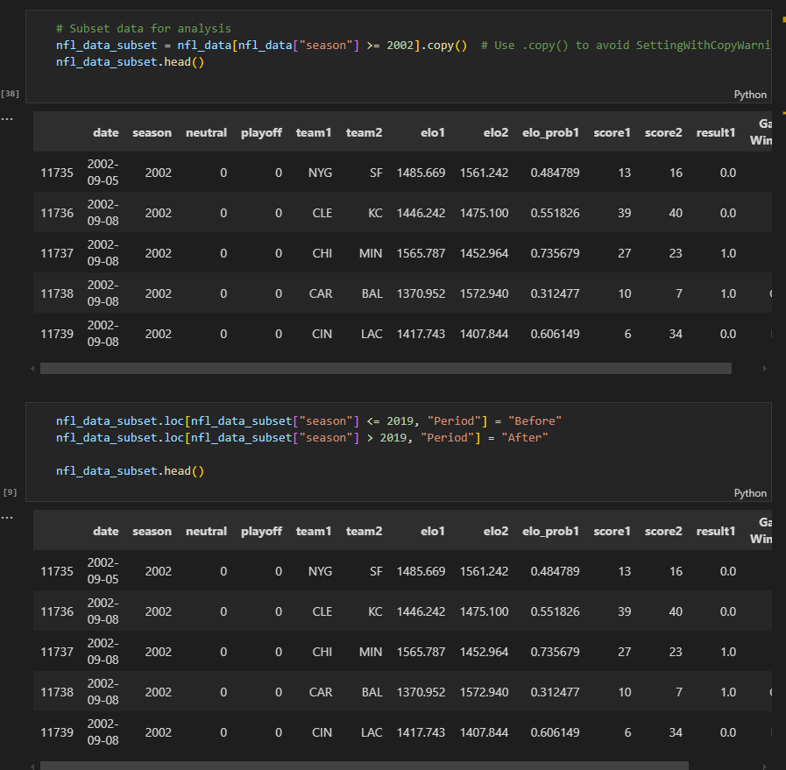

# Create contingency table

homogeneity_table = pd.crosstab(nfl_data_subset["Period"], nfl_data_subset["Game Winner"])

homogeneity_table

# Perform chi-square test for homogeneity

chi2, p, dof, ex = stats.chi2_contingency(homogeneity_table)

print("Chi-square statistic:", chi2)

print("p-value:", p)

* 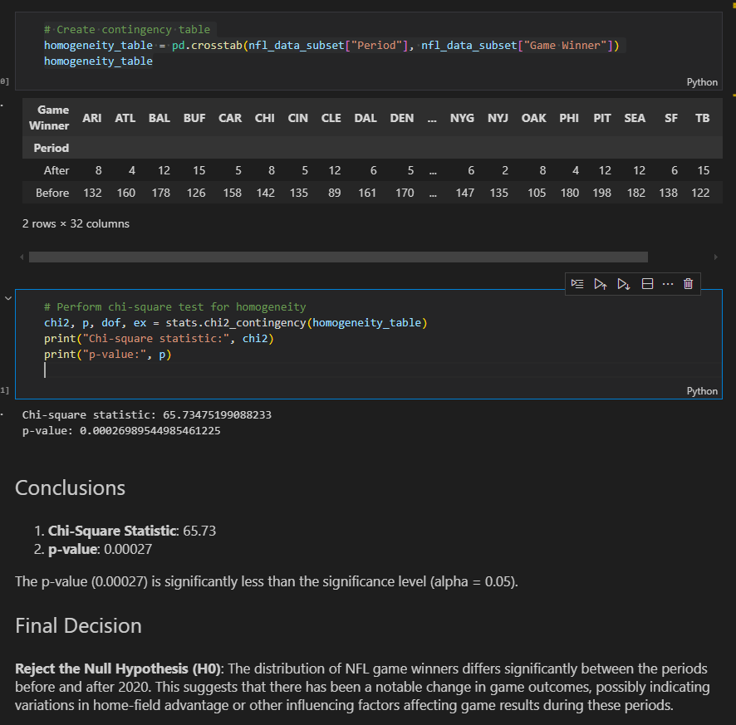

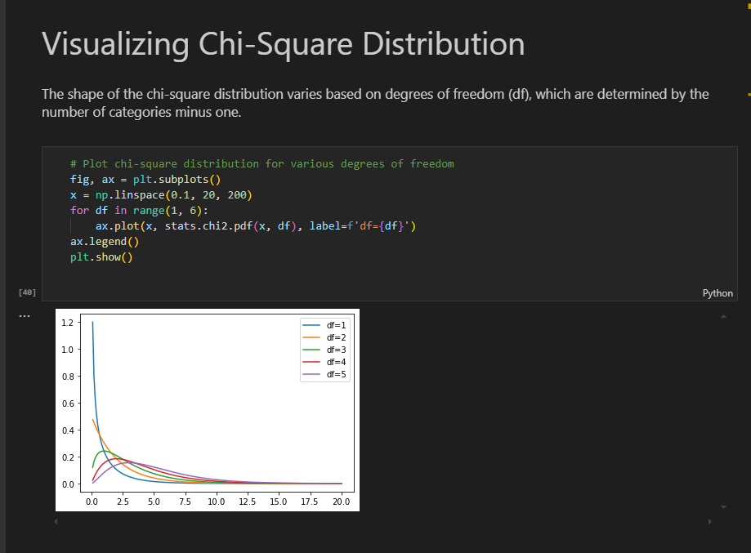

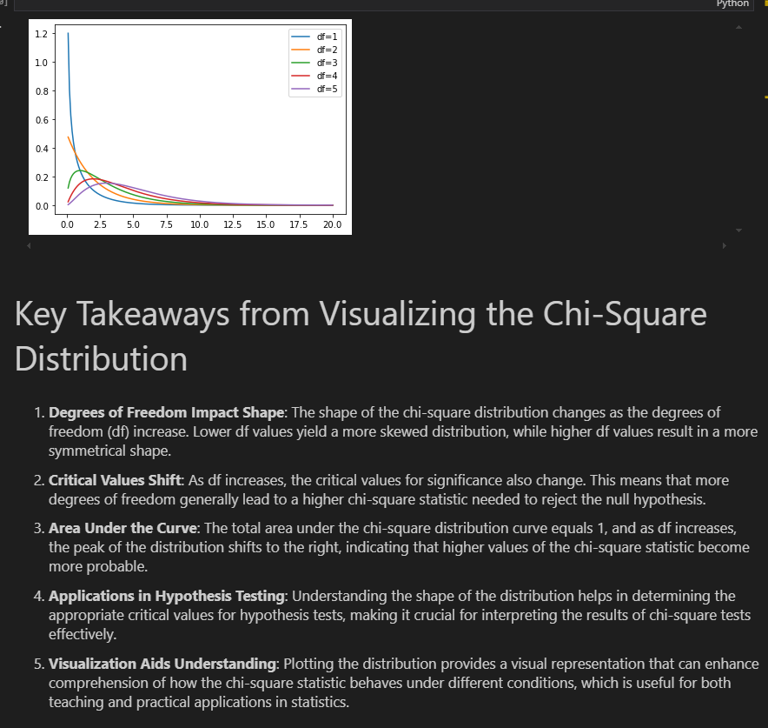

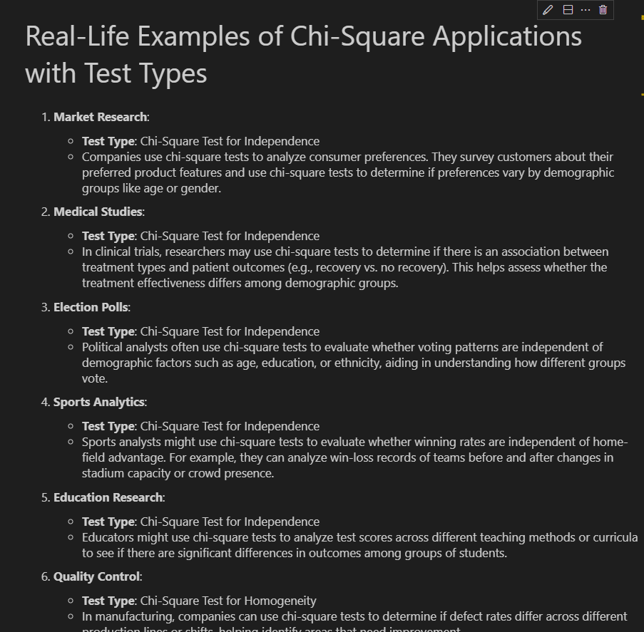

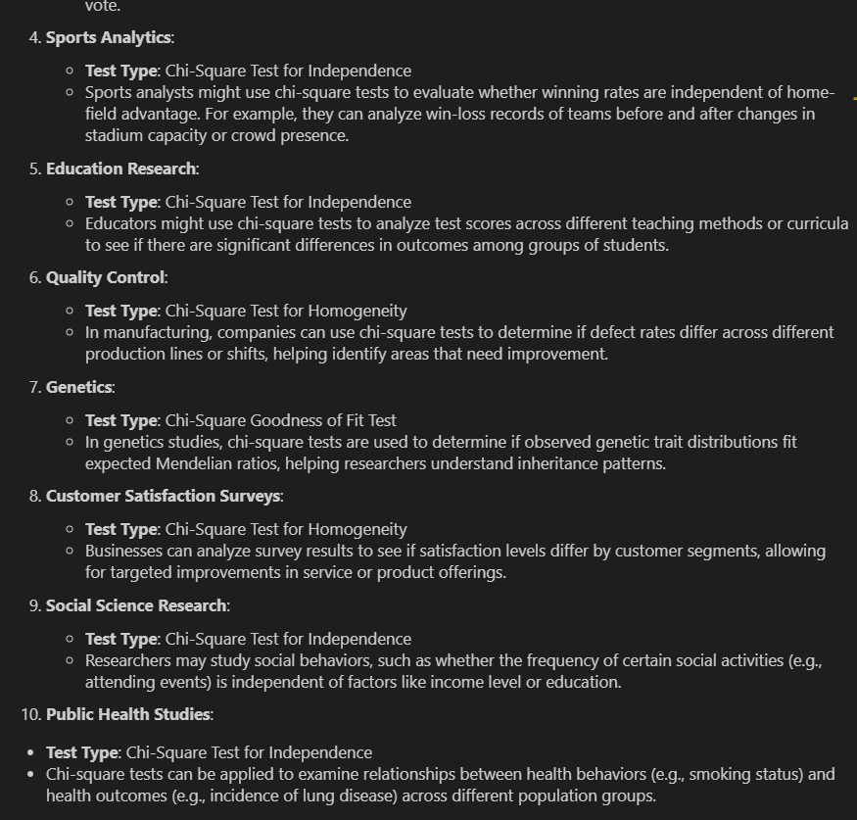

**EXAMPLE1:: A/B TEST AND CHI SQUARE**

We've been hired on by a company looking to see if they can change out their UI to get more website visitors to create an account.

Their innovative idea? Modify their sign-up button from pink to slightly more pink!

They've tasked us to figure out if it's worth them making the change. They say their developers really don't want to put in the effort unless we're confident it has an effect.

The company says if they have an absolute increase in the conversion rate of **\*\*just 2%**, it'd be worth making the change for the whole site! there's an **8\% chance** a visitor viewing the page will sign-up.

**What was decided:**

If we want to see an increase of $2\%$ from $8\%$ and we choose a typical power $0.8$ and a conservative alpha=0.01, we can do a power analysis to find the minimum number of samples needed is about $4,700$ samples.

- Since we're running for just a month and we have about $40,000$ visitors per day, we probably can sample a decent number of visitors without changing a lot of visitor's UI.

- We'll have two groups; a control group that will have no change and an experiment group that will have the updated sign-up button.

from statsmodels.stats.power import TTestIndPower

import statsmodels.stats.api as sms

power_analysis = TTestIndPower()

# n=4700

# m1=0.08

# m2=0.1

# p=m2

# std =np.sqrt(n*p*(1-p))

# print(std)

# d = (m1*n-m2*n)/std

# print(d)

effect_size = sms.proportion_effectsize(0.08, 0.1)

power_analysis.solve_power(alpha=0.01,power=.8,effect_size=effect_size)

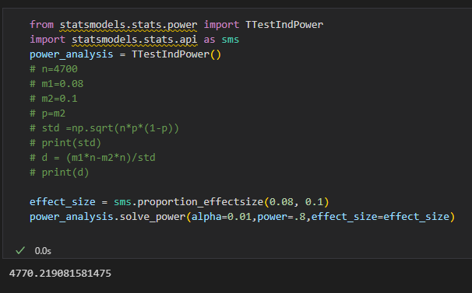

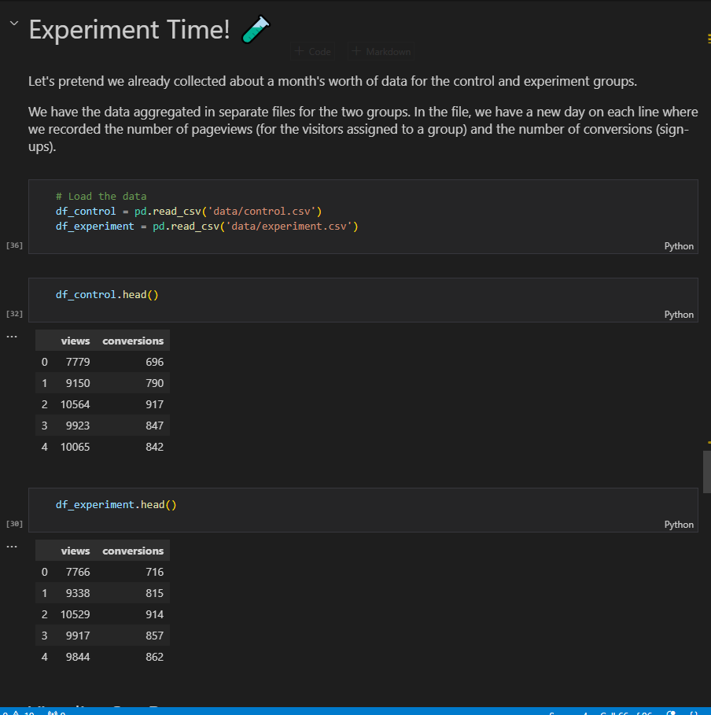

**VISUALIZE OUR DATA**

Lets look at the data and see if we can notice anything visually

f, (ax0,ax1) = plt.subplots(nrows=2, figsize=(10,6))

# Views

ax0.set_title('Views')

sns.kdeplot(data=df_control.views, ax=ax0, label='Control')

sns.kdeplot(data=df_experiment.views, ax=ax0, label='Experiment')

ax0.legend()

# Conversions

ax1.set_title('Conversions')

sns.kdeplot(data=df_control.conversions, ax=ax1, label='Control')

sns.kdeplot(data=df_experiment.conversions, ax=ax1, label='Experiment')

ax1.legend()

plt.tight_layout()

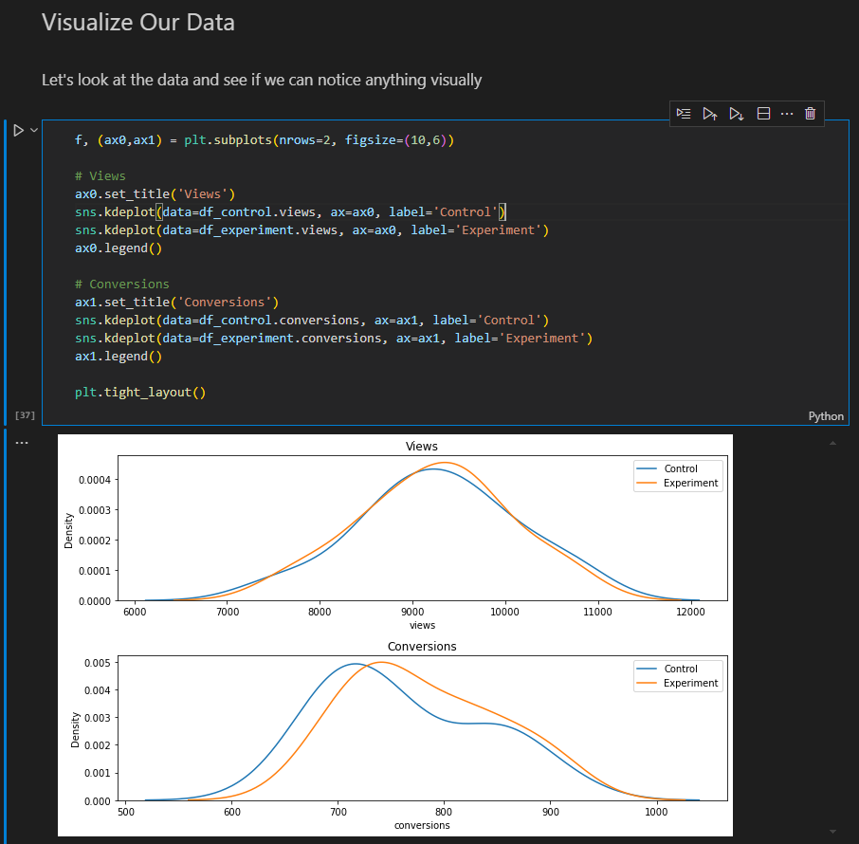

**PERFORM STATISCAL TEST**

**S**ince we are looking at the frequency if ocnversions from views, we can use the chi square goodness-of -fit test.

So the first step is to get our data into a format of ‘observed’ (experiment) vs ‘expected’ (control)

# We'll just sum all the days together to see an overall change

control_views = sum(df_control.views)

control_conv = sum(df_control.conversions)

experiment_views = sum(df_experiment.views)

experiment_conv = sum(df_experiment.conversions)

print('control_views',control_views)

print('control_conv',control_conv)

print('experiment_views',experiment_views)

print('experiment_conv',experiment_conv)

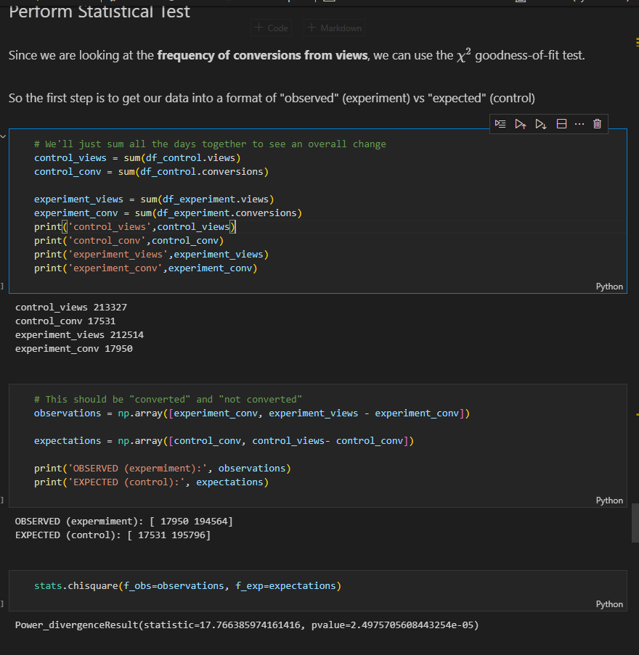

* # This should be "converted" and "not converted"
* observations = np.array([experiment_conv, experiment_views - experiment_conv])
* expectations = np.array([control_conv, control_views- control_conv])
* print('OBSERVED (expermiment):', observations)
* print('EXPECTED (control):', expectations)
* stats.chisquare(f_obs=observations, f_exp=expectations)

Is it statisctically signifant - would it be worth making the change based on the observed effect?

experiment_percent = experiment_conv/experiment_views*100

print(f'Percent Experiment Converted: {experiment_percent:.5}%')

control_percent = control_conv/control_views*100

print(f'Percent Control Converted: {control_percent:.5}%')

print(f'Difference between experiment & control {experiment_percent-control_percent:.3}%')

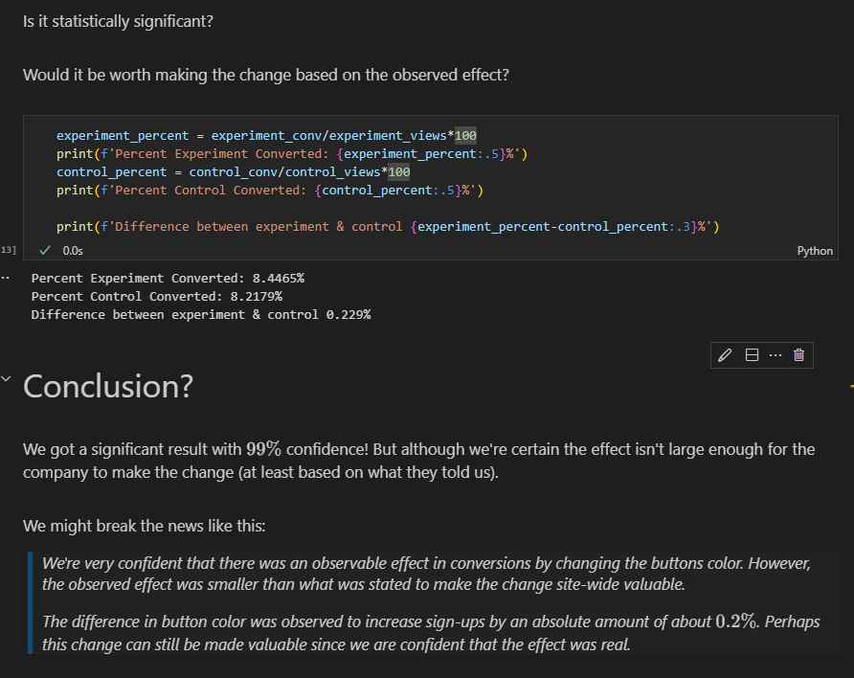

**USING FISHERS TEST**

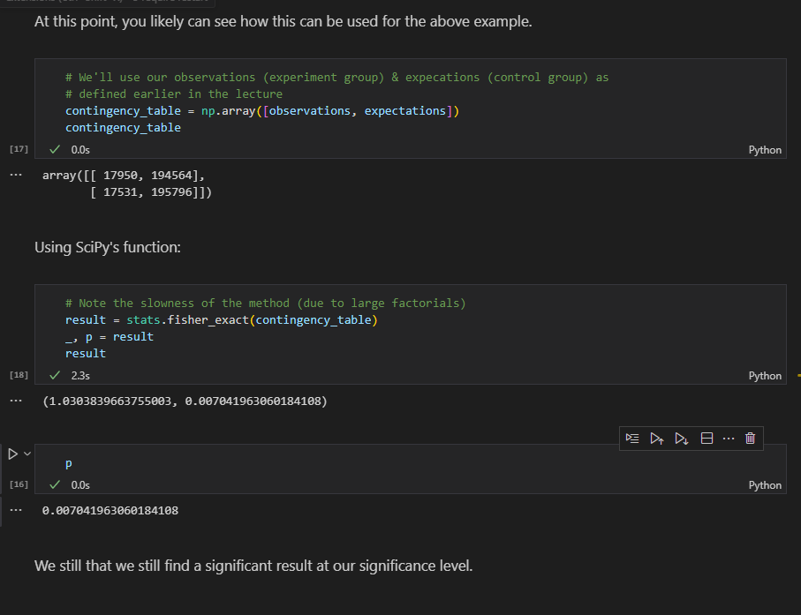

**EXAMPLE2:: A/B TEST AND CHI SQUARE**

*We have data about whether customers completed sales transactions, segregated by the type of ad banners to which the customers were exposed.*

*The question we want to answer is whether there was any difference in sales "conversions" between desktop customers who saw the sneakers banner and desktop customers who saw the accessories banner in the month of May 2019.*



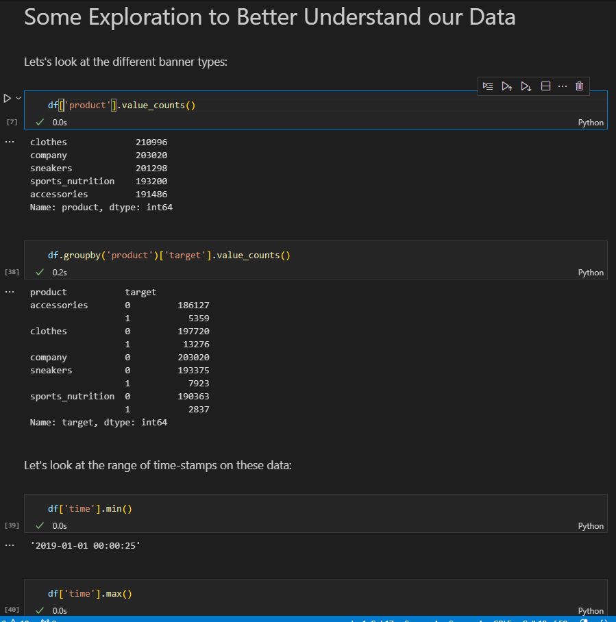

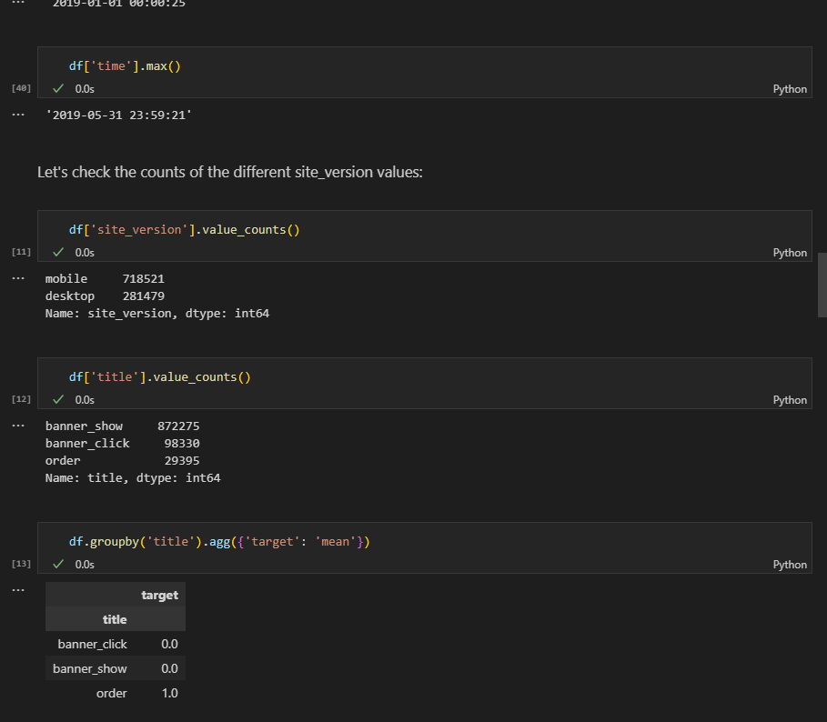

**EXPERIMENTAL SETUP:** We need to filter by site_version, time, and product:

df_AB = df[(df['site_version'] == 'desktop') &

           (df['time'] >= '2019-05-01') &

           ((df['product'] == 'accessories') | (df['product'] == 'sneakers'))].reset_index(drop = True)

df_AB

SAME AS

df_AB2 = df.query('site_version=="desktop" & product in["accessories","sneakers"] & time>="2019-05-01"').reset_index(drop=True)

df_AB2.tail()

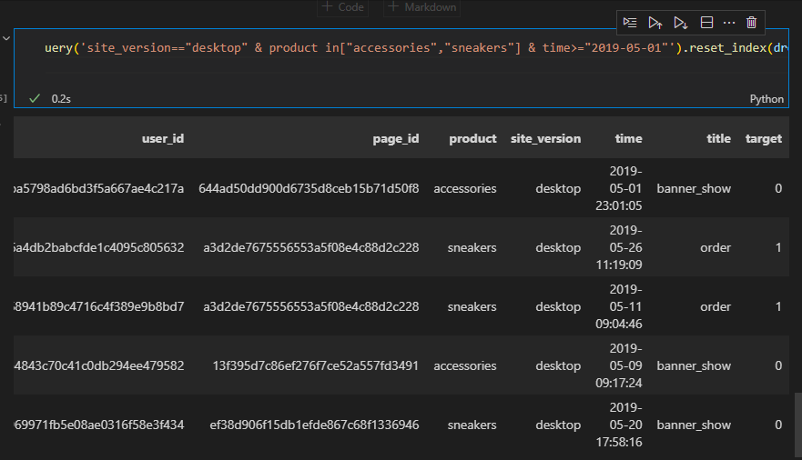

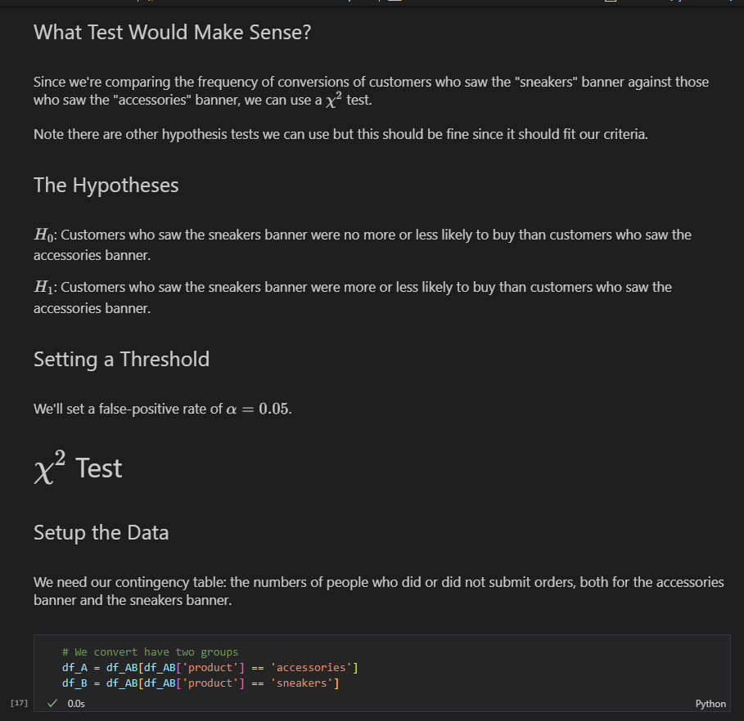

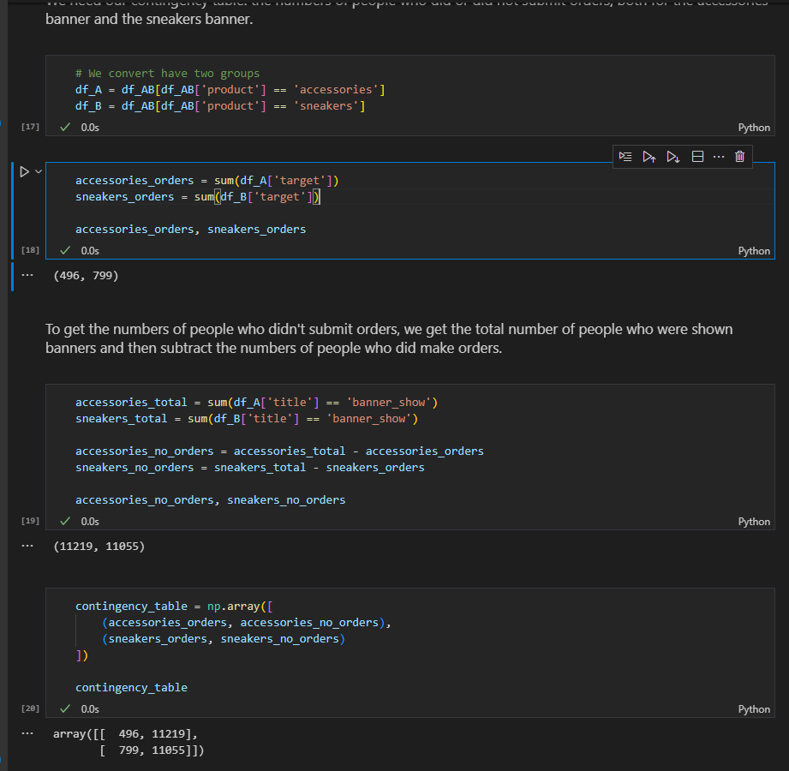

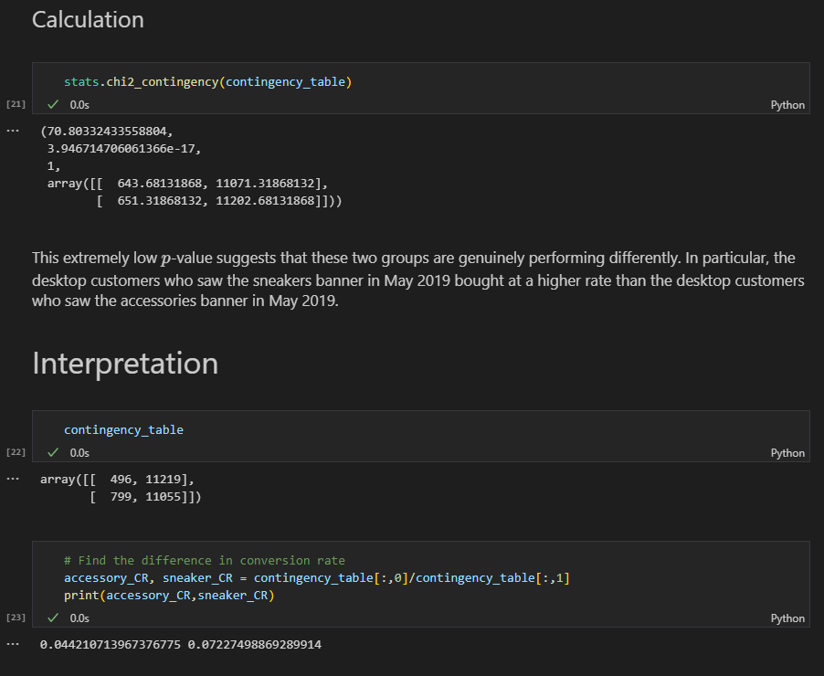

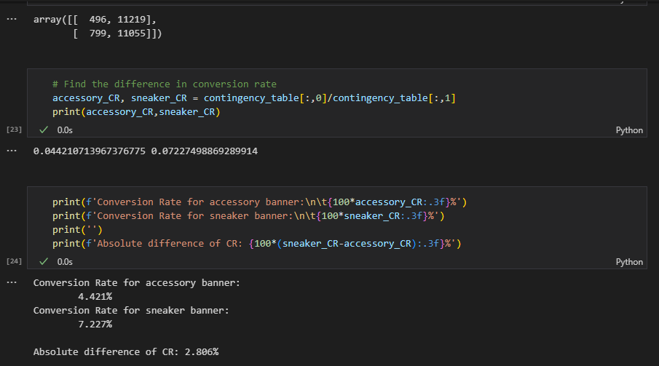

So we can say:

- There was a statistically significant difference at the alpha (confidence level)

- The difference was about 2.8\% in favor of the sneaker banner!

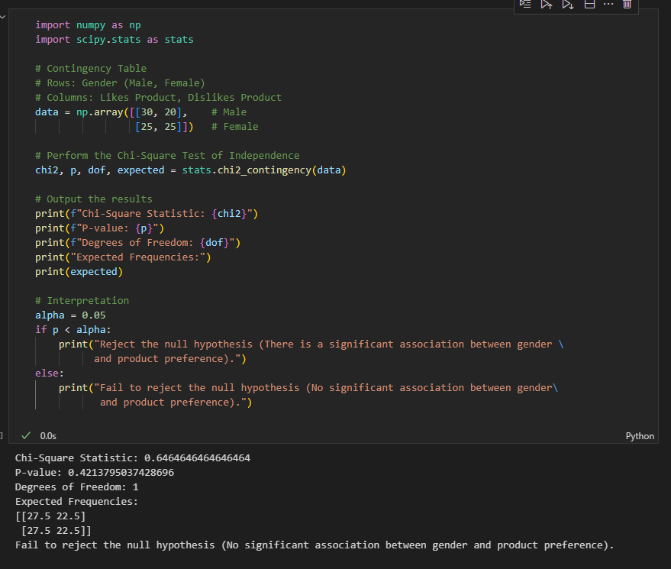

1. **ANOVA(Analysis of Variance)**

Helps dertermine If there are statistically significant differences between the means of three or more independent groups.

**Use Case Examples:**

* Testing different teaching methods’ effectiveness
* Comapring means of sales across regions
* Medical stdies comparing drug effects across multiple groups

**Key Concepts in Anova**

* **Hypotheses:**

**Null** hypothesis: all group meansa are equal

**Alternative** hypothesis: At least one group mean is different

* **Assumptions of Anova**

1. Independence of observations
2. Normally distributed groups- (can use Shapiro test here
3. Homogeneity of variances across groups – same var-levene
4. **EXAMPLE 1:Anova using f_oneway and OLS**

import pandas as pd

import numpy as np

import seaborn as sns

import matplotlib.pyplot as plt

from scipy.stats import f_oneway, levene, shapiro

from statsmodels.stats.multicomp import pairwise_tukeyhsd

# Generate example data

np.random.seed(42)

group_A = np.random.normal(50, 10, 30)

group_B = np.random.normal(55, 10, 30)

group_C = np.random.normal(60, 10, 30)

# Combine into DataFrame

data = pd.DataFrame({

    'Score': np.concatenate([group_A, group_B, group_C]),

    'Group': ['A']*30 + ['B']*30 + ['C']*30

})

data.head(20)

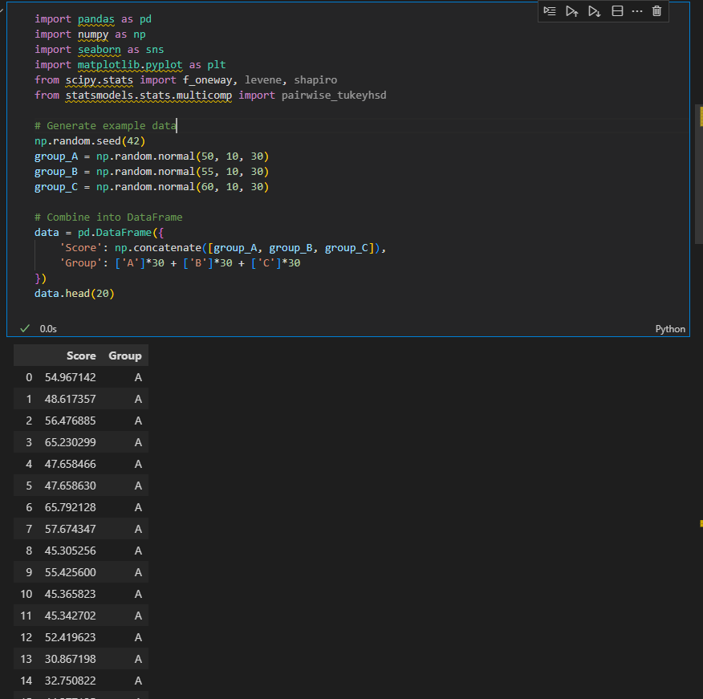

Descriptive statistics and Visualization

data.groupby('Group').describe()

# Visualization

sns.boxplot(x='Group', y='Score', data=data)

plt.title("Box Plot of Scores by Group")

plt.show()

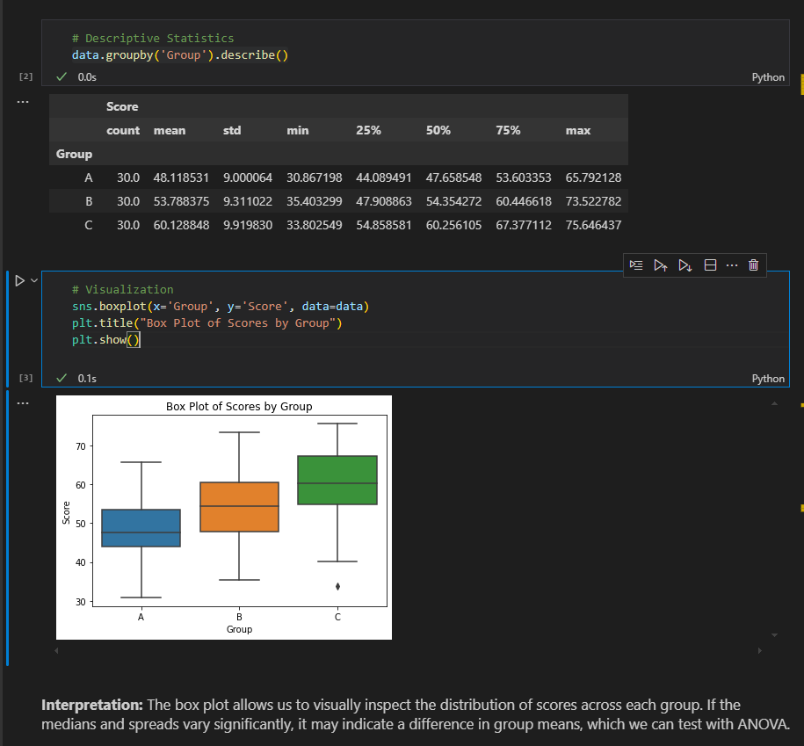

Check for pvalue and statistic

Results= f_oneway(data[data['Group'] == 'A']['Score'],

                           data[data['Group'] == 'B']['Score'],

                           data[data['Group'] == 'C']['Score'])

Results

This also works

f_oneway(data.query('Group=="A"')['Score'],

         data.query('Group=="B"')['Score'],

         data.query('Group=="C"')['Score'],

)

F_stat, p_value = Results[0], Results[1]

print("F-statistic:", F_stat)

print("p-value:", p_value)

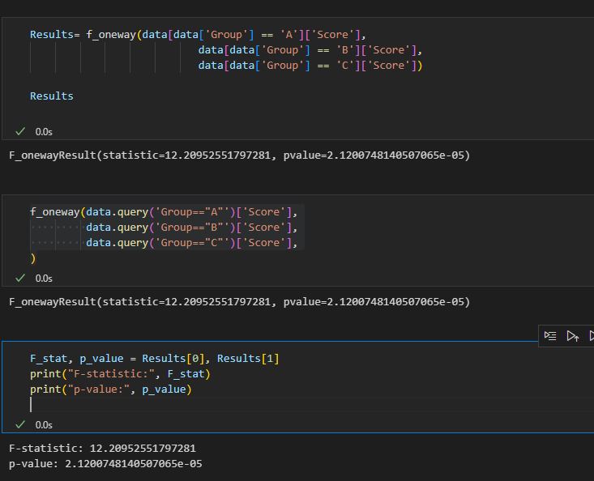

**Performing ANOVA using OLS(Ordinary Least Squares) method**

* **# Performing ANOVA using OLS (Ordinary Least Squares) method**

import statsmodels.api as sm

from statsmodels.formula.api import ols

# Example OLS model for One-Way ANOVA

formula = 'Score ~ C(Group)'

lm = ols(formula, data).fit()

table = sm.stats.anova_lm(lm, typ=2)

print(table)

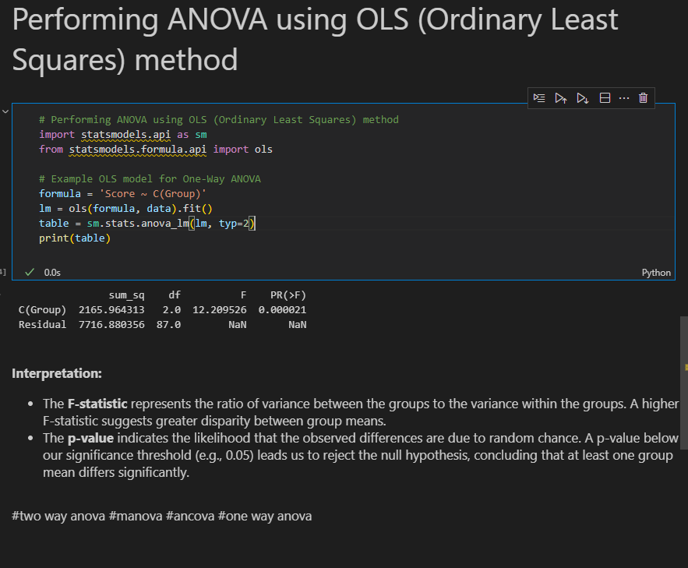

* You can see we have the same p_value and d_statistic we got from one way
* Once we see there is a differences between the group scores we can use turkeys, dunnets test among others to see the exact values for the groups

1. **EXAMPLE 2: Effect of Teaching Methods on Student Performance**

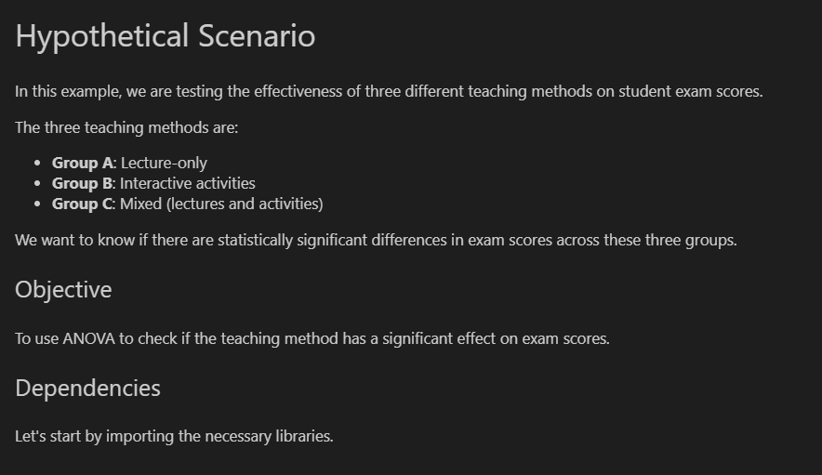

import pandas as pd

import numpy as np

import statsmodels.api as sm

from statsmodels.formula.api import ols

import matplotlib.pyplot as plt

import seaborn as sns

# Ensure plots display within the notebook

%matplotlib inline

# Seed for reproducibility

np.random.seed(0)

# Create random scores for each teaching method

scores_A = np.random.normal(70, 10, 30)  # Lecture-only group

scores_B = np.random.normal(75, 10, 30)  # Interactive activities group

scores_C = np.random.normal(80, 10, 30)  # Mixed methods group

# Combine data into a DataFrame

data = pd.DataFrame({

    'Score': np.concatenate([scores_A, scores_B, scores_C]),

    'Method': ['Lecture-only'] * 30 + ['Interactive'] * 30 + ['Mixed'] * 30

})

# Display the first few rows of the dataset

data.head(50)

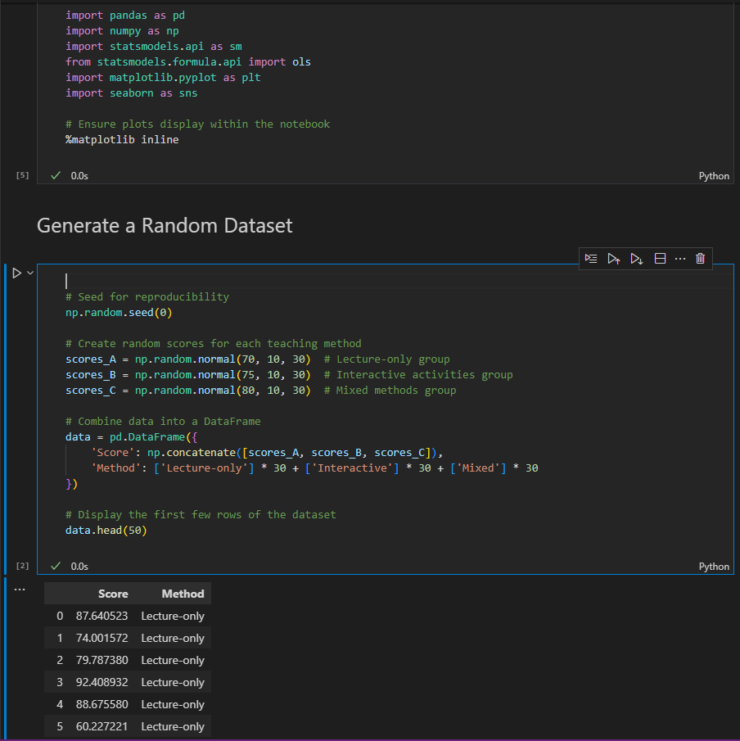

**Visualizing the Data**

# Boxplot to visualize the distribution of scores across teaching methods

plt.figure(figsize=(8, 6))

sns.boxplot(x='Method', y='Score', data=data, palette="Set3")

plt.title('Exam Scores by Teaching Method')

plt.xlabel('Teaching Method')

plt.ylabel('Exam Score')

plt.show()

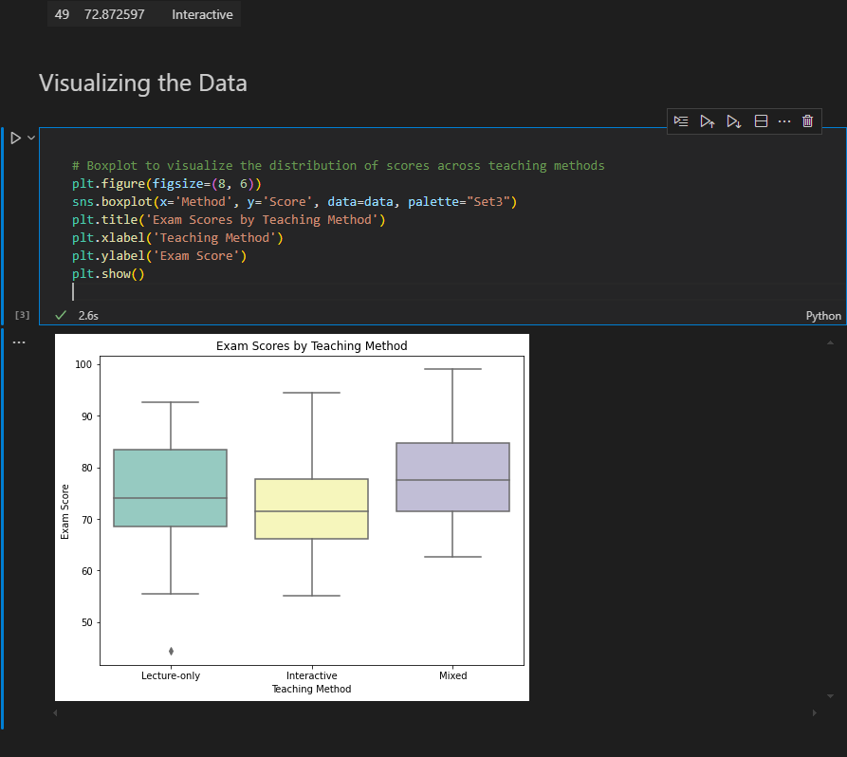

**Perform Anova**

# Define the formula and fit the model

formula = 'Score ~ C(Method)'

model = ols(formula, data).fit()

# Generate the ANOVA table

anova_table = sm.stats.anova_lm(model, typ=2)

anova_table

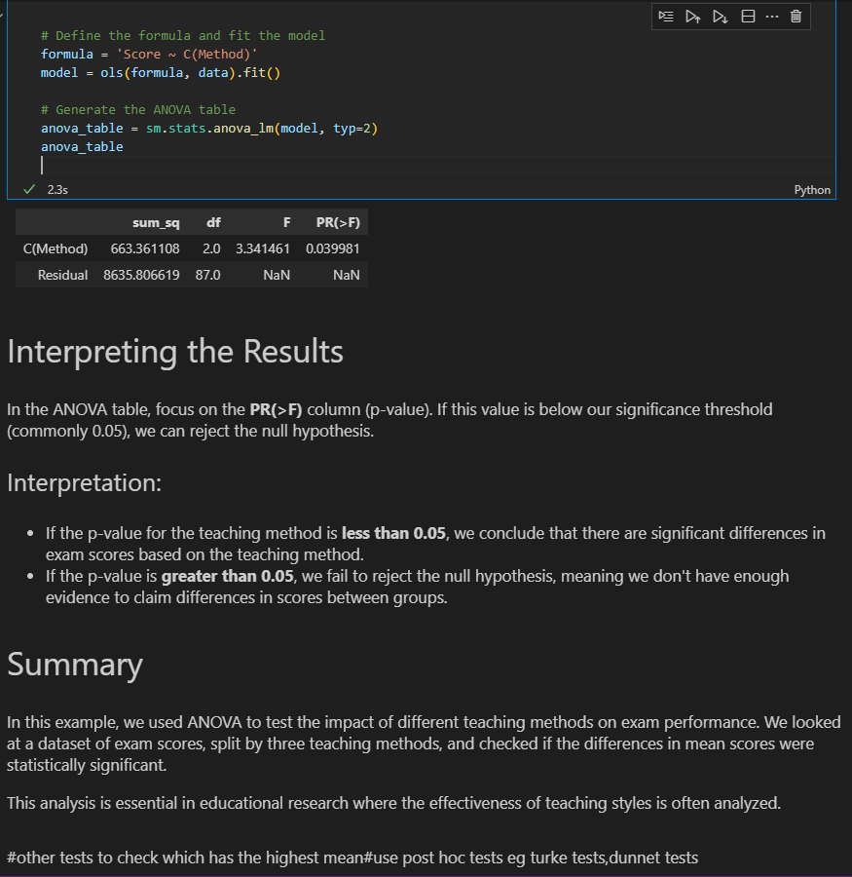

1. **EXAMPLE 3: Check IT salaries**

import pandas as pd

import statsmodels.api as sm

from statsmodels.formula.api import ols

df = pd.read_csv('data/IT_salaries.csv')

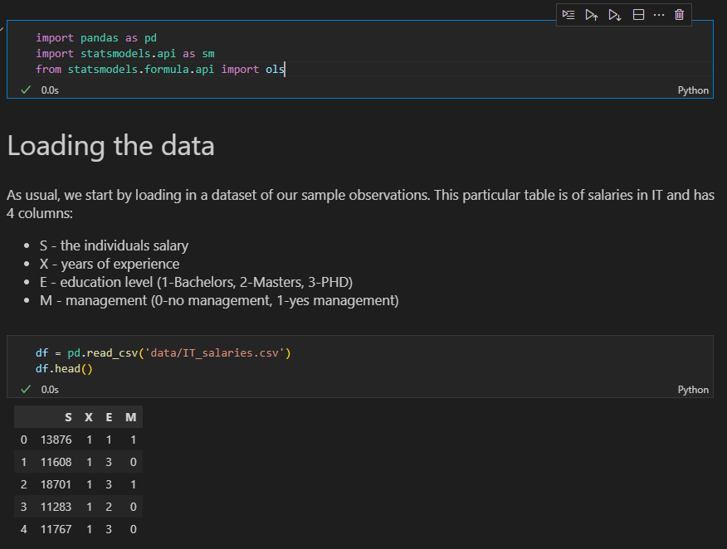

**Generating the Anova table**

formula = 'S ~ C(E) + C(M) + X'

lm = ols(formula, df).fit()

table = sm.stats.anova_lm(lm, typ=2)

print(table)

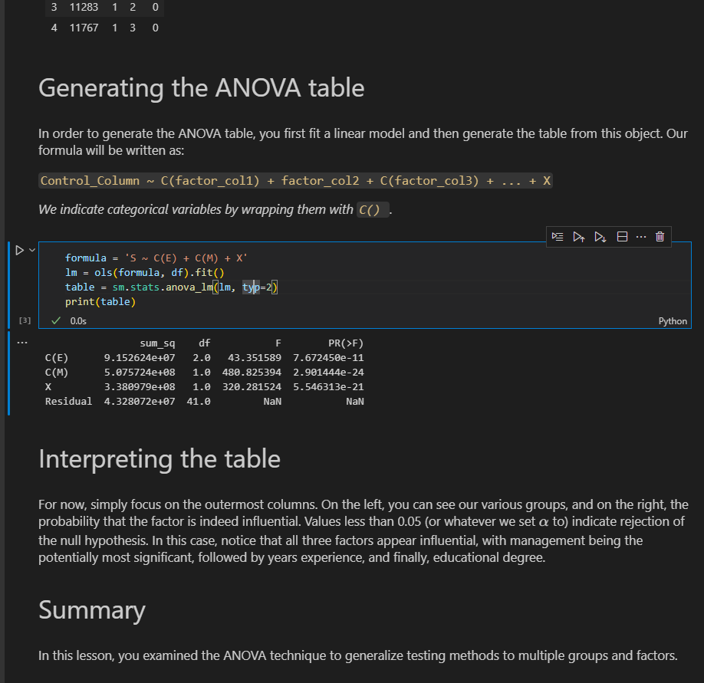

1. **EXAMPLE 4::Tooth growth**

import pandas as pd

from statsmodels.formula.api import ols

import statsmodels.api as sm

tooth_growth = pd.read_csv('./data/ToothGrowth.csv')

tooth_growth.head()

formula = ' len ~ C(supp) + C(dose)'

lm = ols(formula,tooth_growth).fit()

table = sm.stats.anova_lm(lm,typ=2)

print(table)

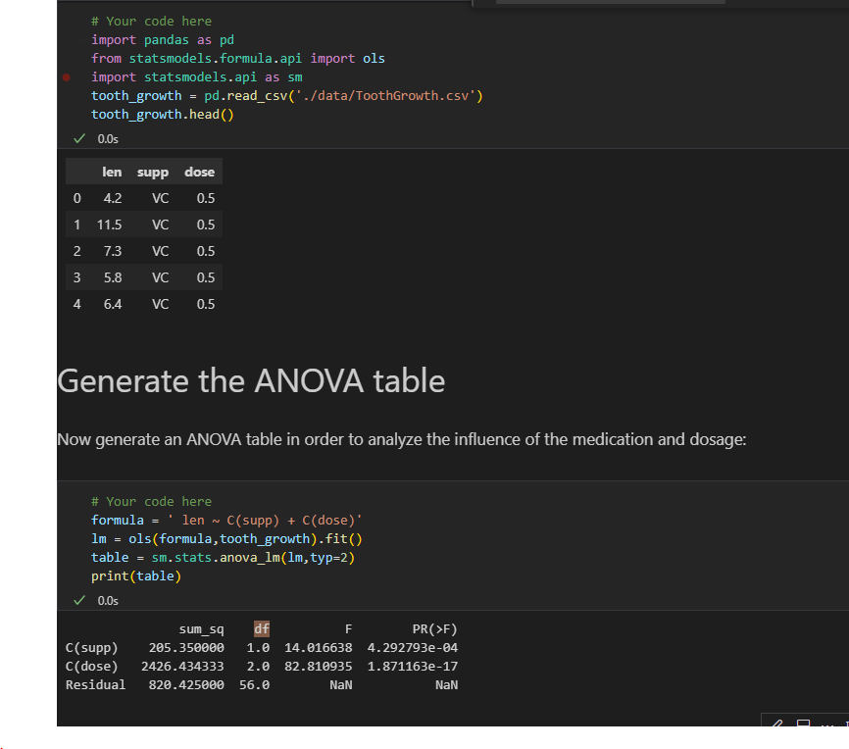



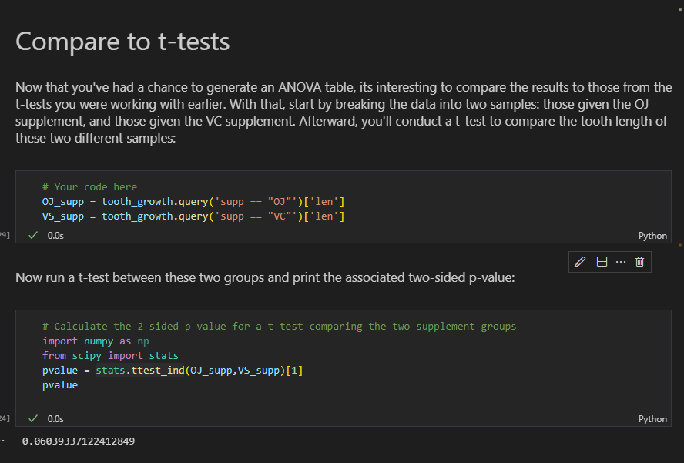

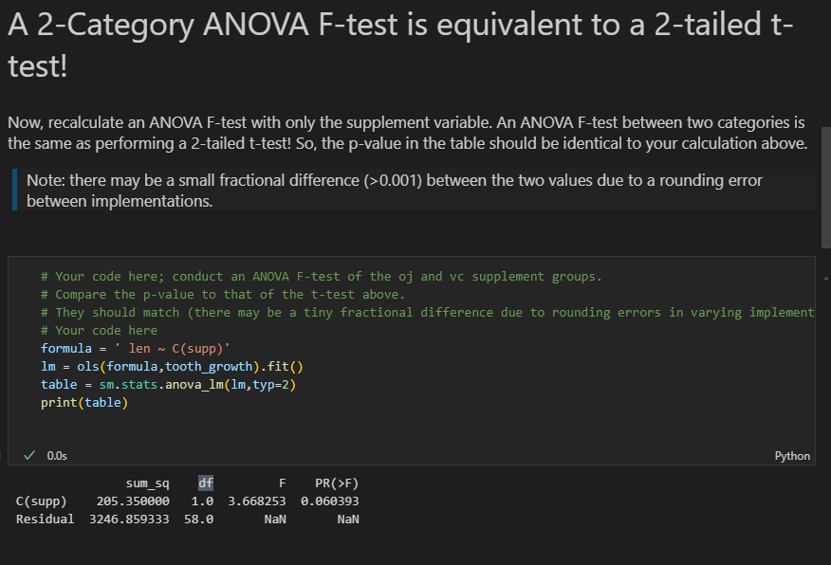

**82 . STATISCTICAL MODELLING -** mathematical approach used to represent and analyze the relationship between variables in data.It involves constructing a model that captures the underlying patterns and structures within a dataset, often with the goal of making predictions or understanding the data better

* One of the first steps of building a model is setting up the independent and depedent variables

**Independent variables-** variables that will affect (or lead to a change) in the depedent variables(s)

Independent variables are also known as predictor variables,input variables,explanatory variables, features.

**Depedent variables –** also known as outcome variables,target variables.response variables

Independent variables goes to the x-axis

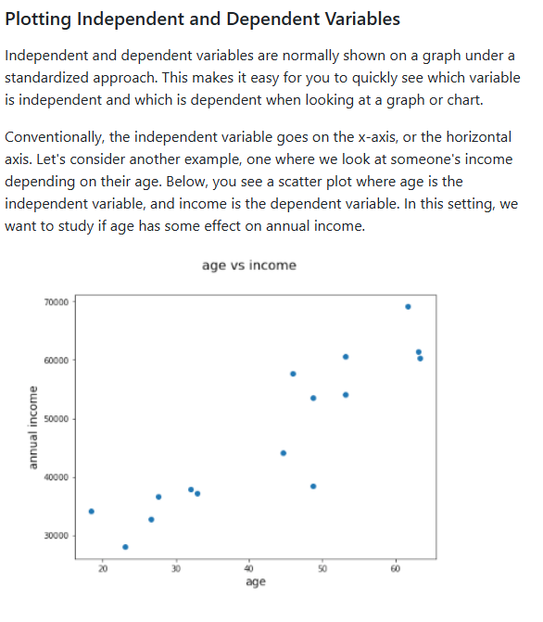

Statistical model can be thought of some kind of transformation that helps us express depedent variables as a function of one or more independent variables.

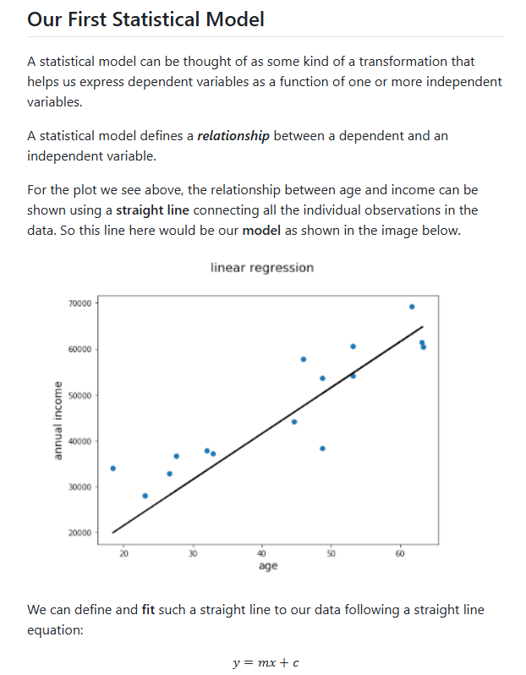

-The line here would be our model

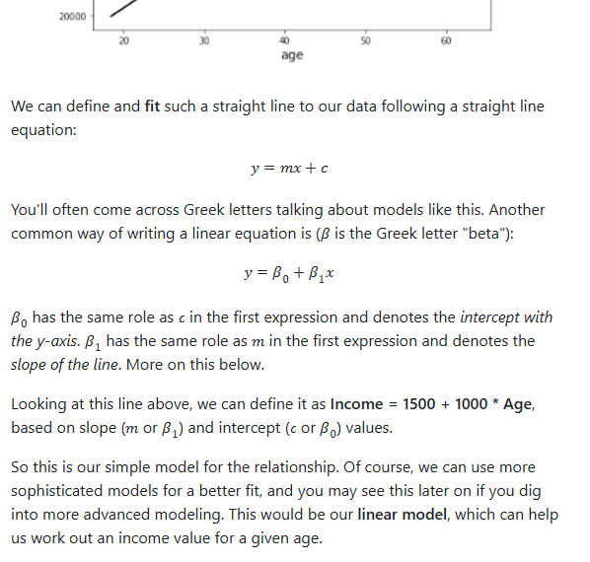

**Statistical model parameters**

In the example above, where Income = 1500 + 1000 * Age, we have modeled Income as the dependent variable and Age as the independent variable.

The other pieces of the equation, 1500 and 1000, are the model *parameters*.

The step of ‘fitting’ a model means finding the best value for these parameters. For linear regression in particular, these parameters are ***coefficients*** and we will use the terms "parameters" and "coefficient" fairly interchangeably.

**MODEL LOSS**

A loss function evaluates how well your model represents the relationships between data variables.If the model is unable to identify the relationship between the independent and dependent variable(s) the loss function will ouput a very high number

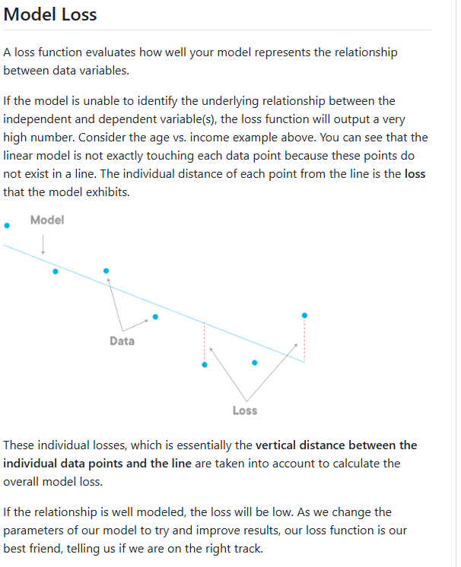

‘**Error’** of a linea regression model - the vertical offset between the fit line and the actual observation

**Simple Linear Regression from scratcg- code along**

In this codealong, you'll get some hands-on practice developing a simple linear regression model. In practice, you would typically use a code library rather than writing linear regression code from scratch, but this is an exercise designed to help you see what is happening "under the hood"

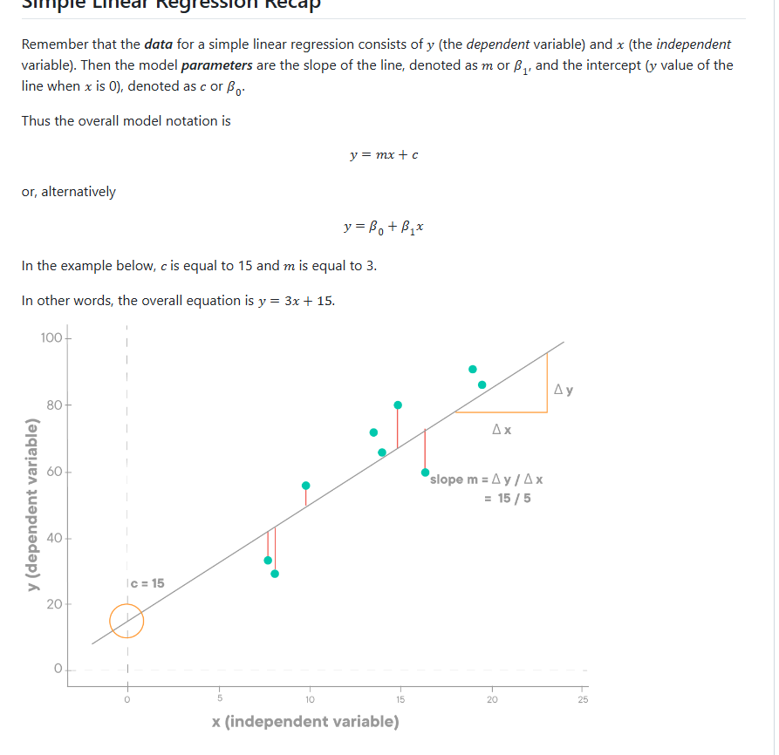

**Finding Model Parameters**

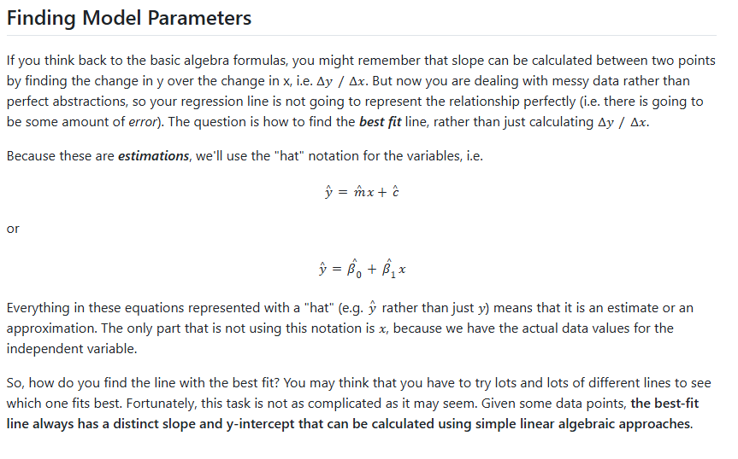

**The Least Squares Method-** an algorithm to find the best-fit line that minimizes the squared error

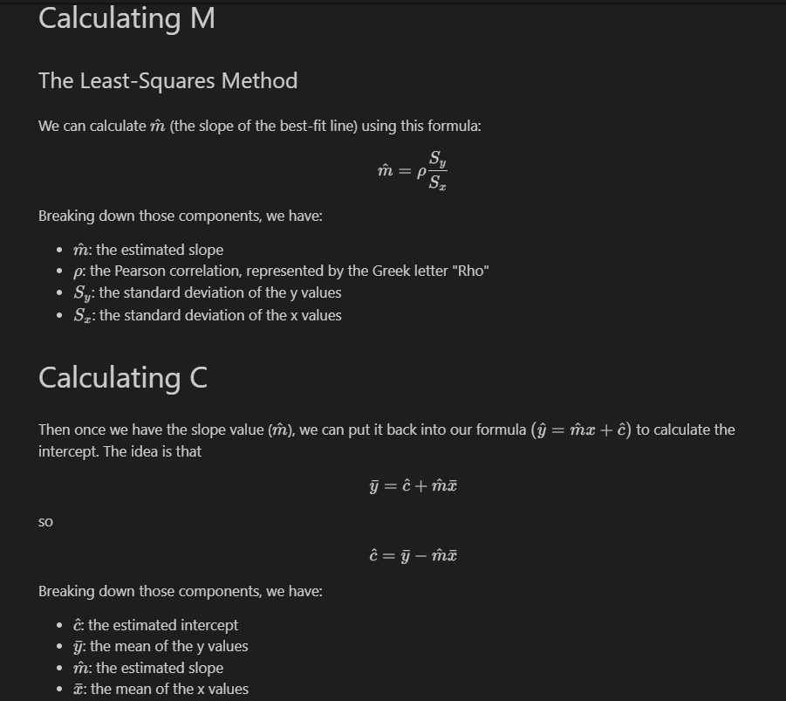

**EXAMPLE:**

# imports

# Run this cell without changes

# import necessary libraries

import numpy as np

import matplotlib.pyplot as plt

from matplotlib import style

style.use('ggplot')

# Initialize arrays X and Y with given values

# X = Independent Variable

X = np.array([1,2,3,4,5,6,8,8,9,10], dtype=np.float64)

# Y = Dependent Variable

Y = np.array([7,7,8,9,9,10,10,11,11,12], dtype=np.float64)

**Step 1: Scatter plot**

Before performing a linear regression analysis, it’s a best practice to look at scatter plot of the indepeddent variables vs depedent variable. Linear regression is only appropriate if there is a linear relationship between them. In the cell below, create a quick scatter plot showing x vs. y.

plt.scatter(X, Y);

sns.scatterplot(x=X,y=Y);

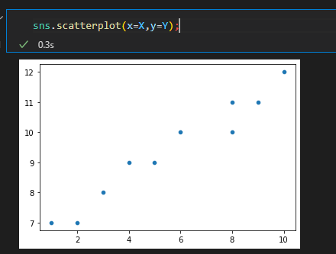

Bases on the plot above,does linear regression analysis seem appropriate?**Yes the relationship is very linear but not perfectly linear. The best line of fit should be able to explain this relationship with a very low error**

**Step 2: Calculate slope**

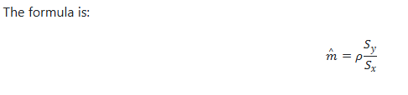

**std_y = Y.std()#np.std(Y)**

**std_x= X.std()#np.std(X)**

**p_corr = np.corrcoef(X,Y)[0][1]**

**m = p_corr * (std_y/std_x)**

**m**

Do the same using a function

def get_slope(X,Y):

    # corr_coef

    p_corr = np.corrcoef(X,Y)[0][1]

    #std y

    std_y = np.std(Y)

    #std X

    std_x = X.std()

    #m

    m = p_corr*(std_y/std_x)

    return m

get_slope(X,Y)

**Step 3: Calculate Intercept**

# calculate the intecept

Y_mean = Y.mean()#np.mean()

X_mean = X.mean()

print('Y_mean',Y_mean)

print('X_mean',X_mean)

c = Y_mean - m*(X_mean)

c

Using a function

def get_c(X,Y):

    #Y_mean

    Y_mean = np.mean(Y)

    #X_mean

    X_mean = np.mean(X)

    m = m= get_slope(X,Y)

    #c

    c = Y_mean - m*(X_mean)

    return c

get_c(X,Y)

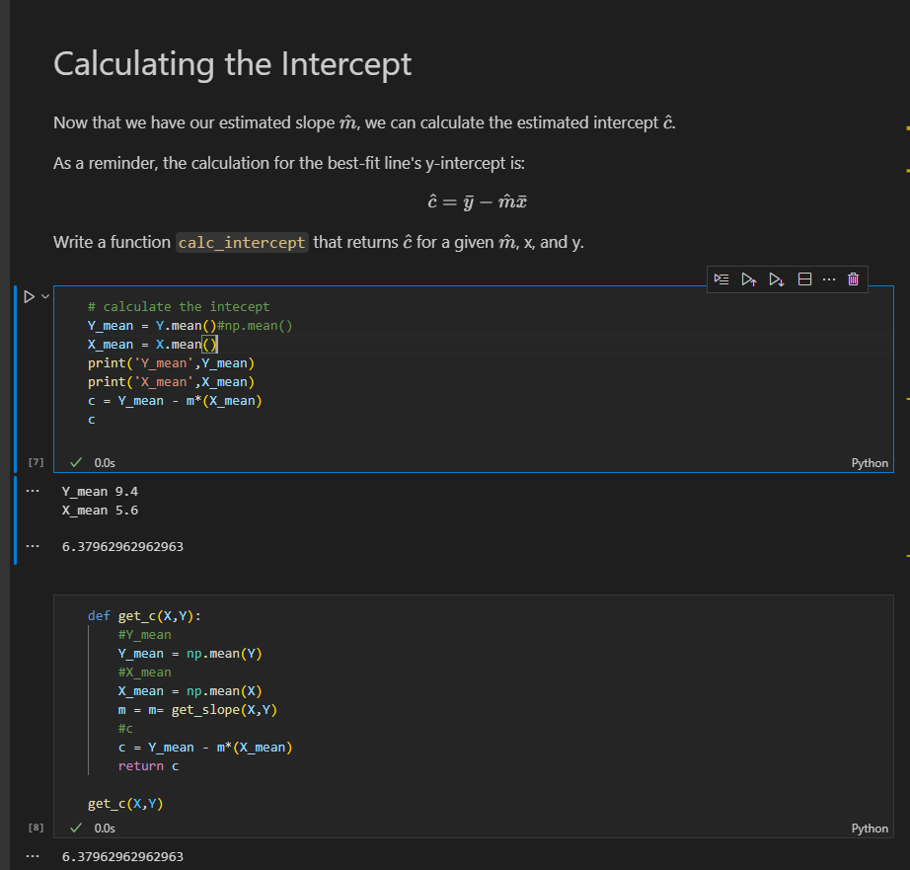

**Step 4: Predicting a new data point**

**y = 3* get_slope(X,Y) + get_c(X,Y)**

**y**

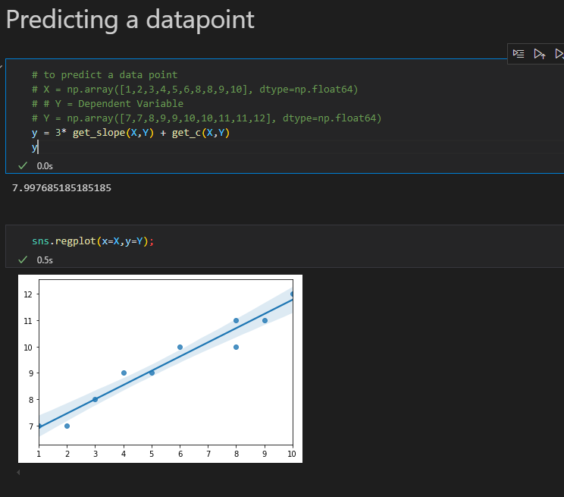**Step 5: Bringing it all together**

import matplotlib.pyplot as plt

def best_fit(x_vals, y_vals):

    # Create a scatter plot of x vs. y

    plt.scatter(x_vals,y_vals)

    # Calculate and print coefficient and intercept

    m = get_slope(x_vals,y_vals)

    c = get_c(x_vals,y_vals)

    print('m',m)

    print('c',c)

    y= m*x_vals +c

    # Plot line created by coefficient and intercept

    plt.plot(x_vals,y,color='g')

best_fit(X, Y)

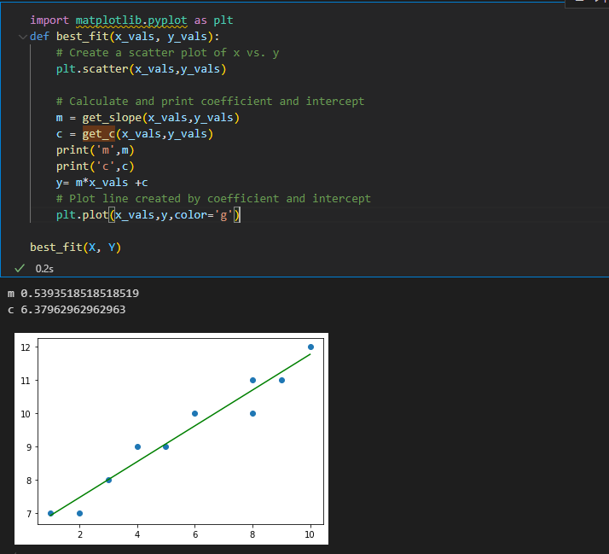

**Step 6: Describe your Model Mathematically and in Words**

The overall formula is y=0.53x+6.37.

The intercept (where the line crosses the y-axis) is at 6.37. This means that if x is equal to 0, the value of y would be 6.37.

The slope of the line is 0.53. This means that every increase of 1 in the value of x is associated with an increase of 0.53 in the value of y.

**LINEAR REGRESSION CONNECTIONS TO OTHER STATISTICAL MEASURES**

Linear models are closely related to other statistical measures: t-test, Pearson correlation, ANOVA, Chi-square, etc

Lets see how linear regression is related to t-tests, confidence intervals and Pearson Correlation

**Our Linear Regression Example**

In the examples below we'll be using the Advertising dataset, using TV spending to predict sales.

import pandas as pd

data = pd.read_csv("data/advertising.csv", index_col=0)

data.plot(x="TV", y="sales", kind="scatter");

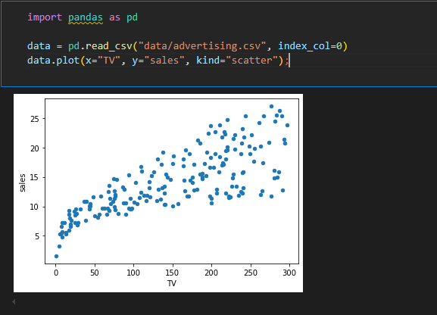

The code below builds a linear regression model using StatsModels and displays the params(i.e coefficients)

# https://www.statsmodels.org/devel/generated/statsmodels.regression.linear_model.OLS.html

import statsmodels.api as sm

results = sm.OLS(data["sales"], sm.add_constant(data[["TV"]])).fit()

results.params

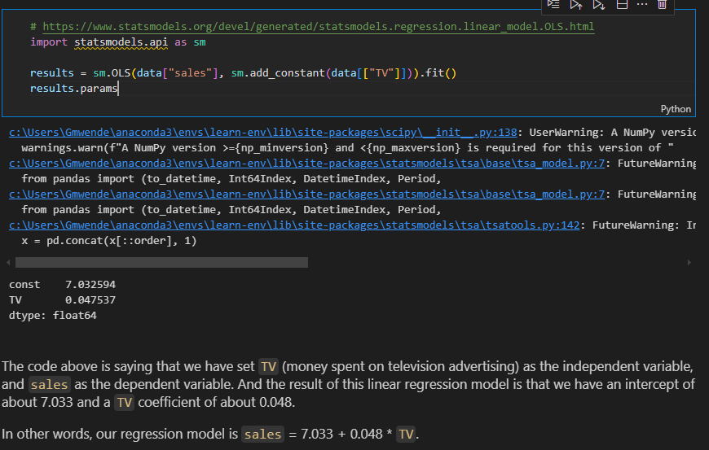

Lets plot that line along with the data

import matplotlib.pyplot as plt

import numpy as np

fig, ax = plt.subplots();

data.plot(x="TV", y="sales", kind="scatter", ax=ax)

# set up line data representing linear regression model

x = np.linspace(data["TV"].min(), data["TV"].max())

y = x * results.params["TV"] + results.params["const"]

# plot model on the same axes as the data

ax.plot(x, y, color="black");

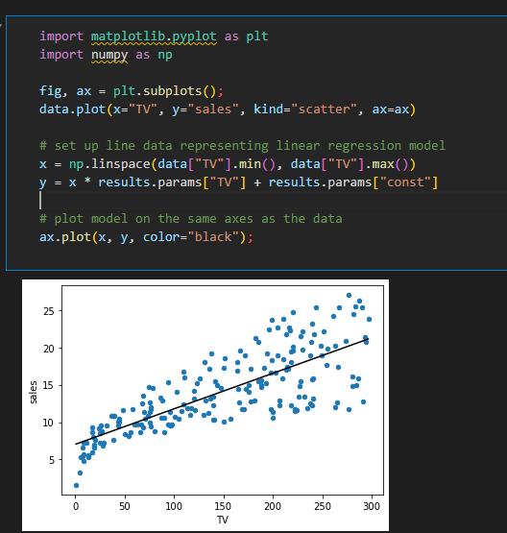

**Linear Regression and t-test**

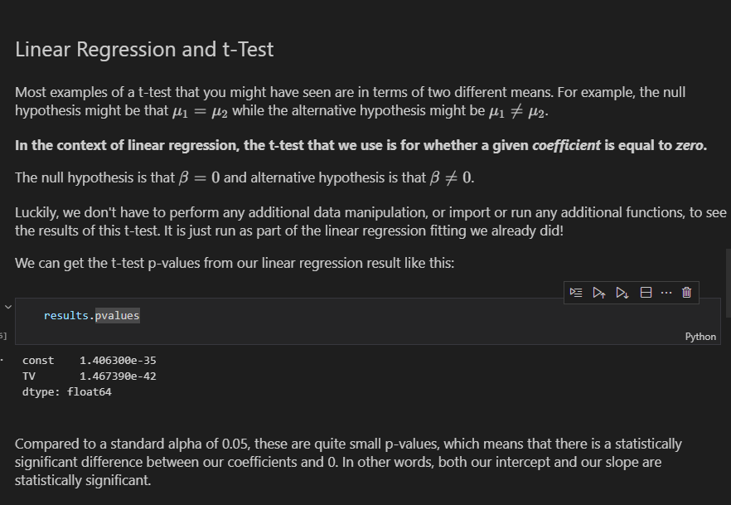

**LINEAR REGRESSION AND CONFIDENCE INTERVALS**

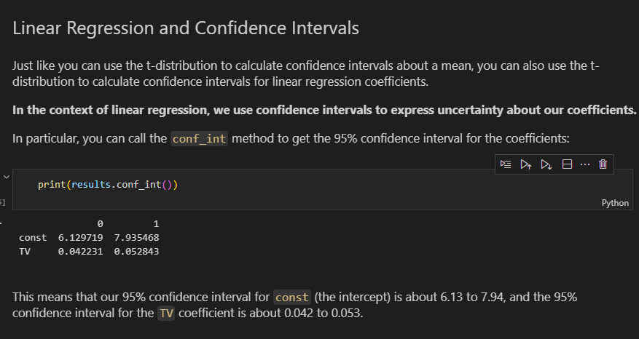

**LINEAR REGRESSION VS CORRELATION**

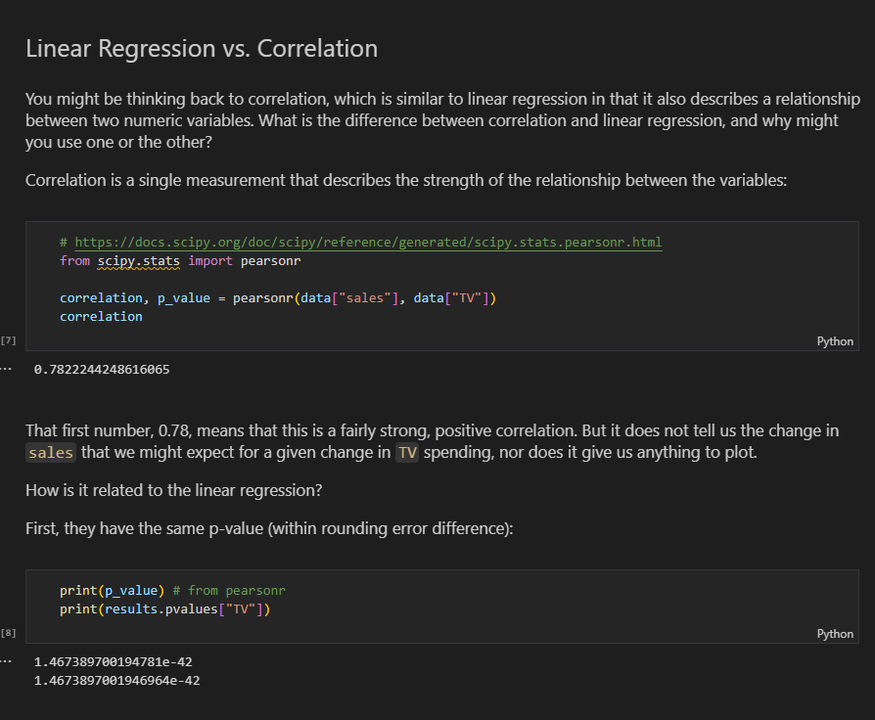

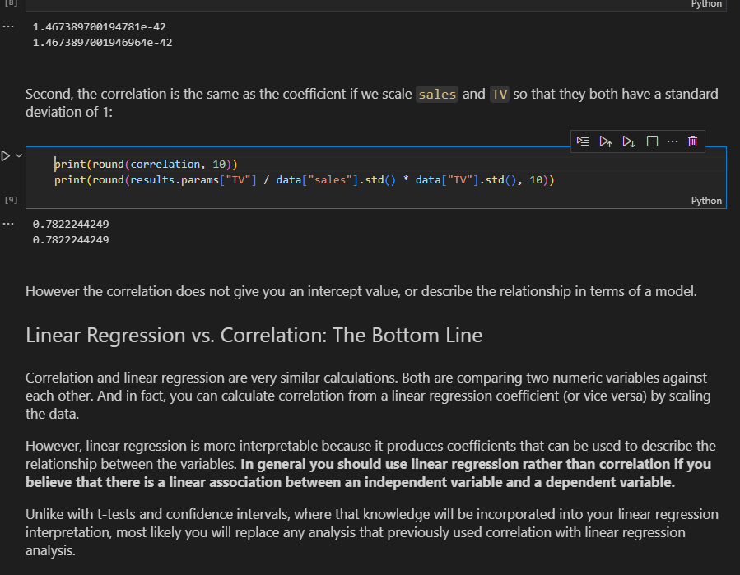

1. **REGRESSION MODEL EVALUATION**

For any given set of X and Y values, we can build a linear regression model using the least squares method to find the best fit line.Just because this model exists does not necessarily mean it is a particularly appropriate or useful way to describe the relationship between the two variables.

-Here we will see techniques to evaluate a regression model.First we use F-tests to tests whether the model overall is **statistically significant .**Then we’ll use the coefficient of determination(also known as ‘R squared’) to measure the **goodness of fit**

**The intercept only Model**

There is no universal, objective standard for evaluating models, because every set of x and y values is different.Therefore we measure the fit of our models against a baseline model known as **intercept-only model**

**Intercept-only model** does not make use of any independent variables to predict the value of depedent variable y. Instead it uses the **mean** of the observed responses of the depedent variable y and always predicts this mean as the value of y for any value of x. It is also known as the ‘mean model’,’baseline model’ or ‘restricted model’

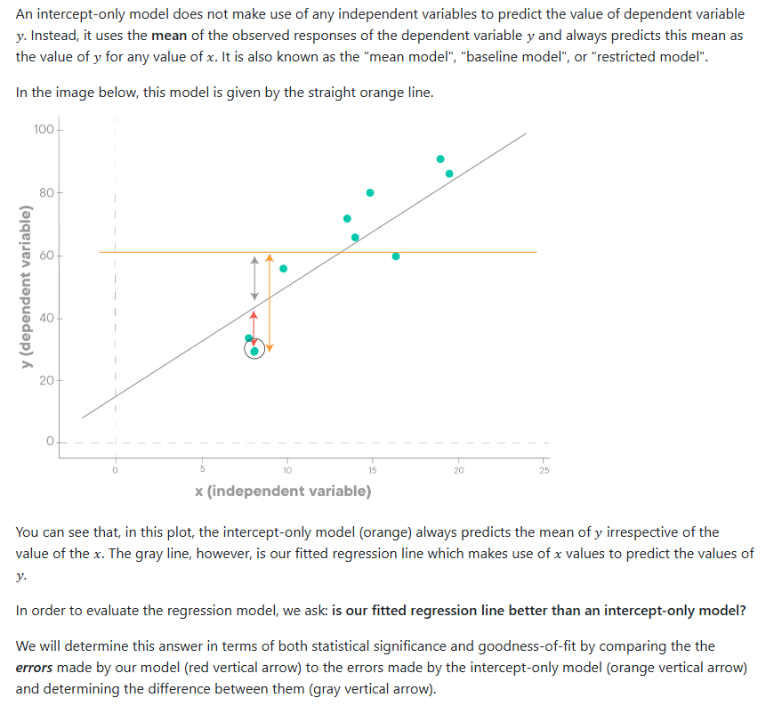

**TOY DATASET EXAMPLE**

#Import necessary libraries

import numpy as np

import matplotlib.pyplot as plt

from matplotlib import style

style.use('ggplot')

# Initialize arrays X and Y with given values

# X = Independent Variable

X = np.array([1,2,3,4,5,6,8,8,9,10],dtype=np.float64)

Y = np.array([7,7,8,9,9,10,10,11,11,12],dtype = np.float64)

plt.scatter(X,Y)

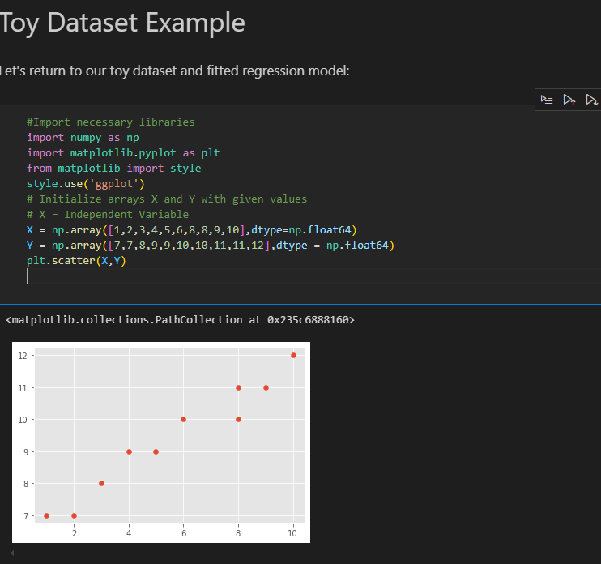

def calc_slope(x_vals, y_vals):

    # setting up components of formula

    rho = np.corrcoef(x_vals, y_vals)[0][1]

    s_y = y_vals.std()

    s_x = x_vals.std()

    # calculating slope estimate

    m = rho * s_y / s_x

    return m

def calc_intercept(m, x_vals, y_vals):

    # setting up components of formula

    y_mean = y_vals.mean()

    x_mean = x_vals.mean()

    # calculating intercept estimate

    c = y_mean - m * x_mean

    return c

fig, ax = plt.subplots()

ax.scatter(X, Y, color='#003F72', label="Data points")

m = calc_slope(X,Y)

c = calc_intercept(m,X,Y)

print(f'Our model is: y = {round(m,3)}x + {round(c,4)}')

regression_line =m*X+c

ax.plot(X,regression_line,label='Regression Line')

intercept_only_line = np.array([Y.mean() for x in X])

print(intercept_only_line)

ax.plot(X,intercept_only_line,label='Intercept-Only Line')

ax.legend();

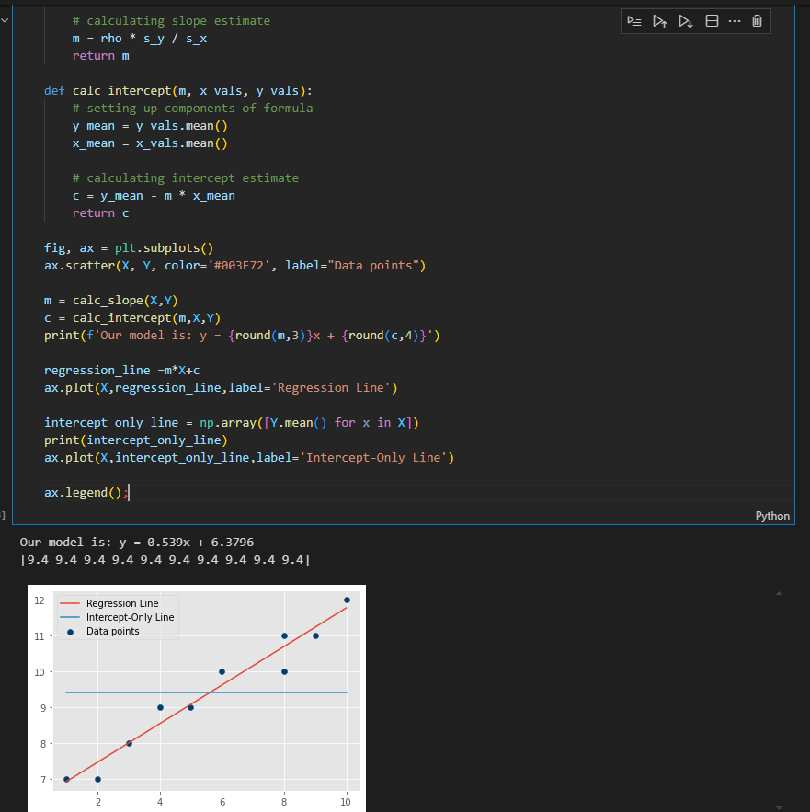

**F-Test for Statistical Significance**

So, is our overall model statistically significant? Let's frame this in terms of a null and alternative hypothesis:

* H0 (**null hypothesis**): the intercept-only model fits the data just as well as (or better than) our model
* Ha (**alternative hypothesis**): our model fits the data better than the intercept-only model

Then we'll follow the typical hypothesis test structure of computing a test statistic, calculating the p-value, then determining whether we can reject the null hypothesis.

import statsmodels.api as sm

model = sm.OLS(endog=Y,exog=sm.add_constant(X))

results = model.fit()

results.f_pvalue, results.fvalue

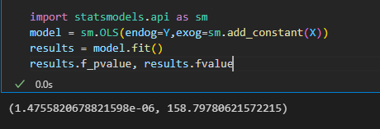

**Is our Model statisctically significant**

We have f statistic of 158 but what does it mean.Our p_value is below the typical alpha of 0.05. We can reject the null hypothesis and say that our model is statistically significant!

**Measuring Goodness of Fit with R Squared(R2 helps to understand the performance of you model compared to the baseline model).**How well the model fits the data

Now that we know our model is statisctically significant, we can go one step further and quantify how much of the variation in the depedent variable is explained by our model. This measure is called  R2 or **coefficient of determination**

results.rsquared

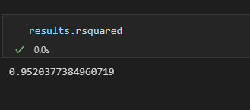

**Interpreting R Squared**

We have a value of about 0.95 as our coefficient of determination (R-squared). What does this mean?

Means that the proportion of the variance explained by our model out of the total variance is about 0.95, or 95%.We can also say that, **95% of the variation in y is explained by our model**

For a least-squares regression model, R-Squared can take a value between 0 and 1 where values closer to 0 represent a poor fit and values closer to 1 represent an (almost) perfect fit

An R Squared of 0 would mean that we are explaining 0% of the variation in y. This is especially likely to occur if your dataset is not actually suited to linear regression modeling, like the image below.

Eg r squared of 61 % with predictor as tv advert for sales- we cld say that **61 %of the variance in the target variable can be explained by TV spending**

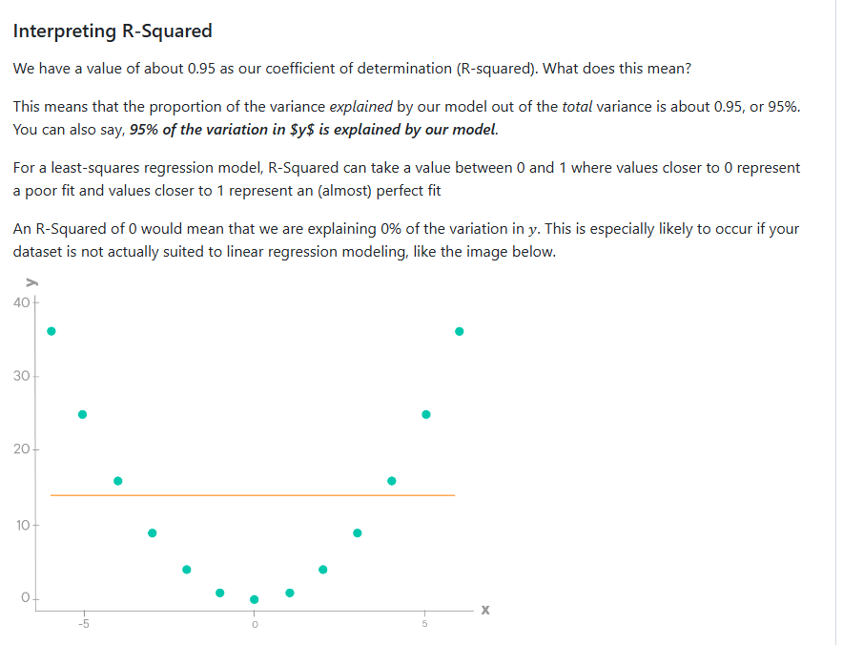

An R-Squared of 1 means that you are explaining 100% of the variation. This is very unlikely to see with linear regression on real-world data, so you probably want to double-check that you have set up your variables properly.

The image below shows what it might look like if you had an R-Squared of 1:

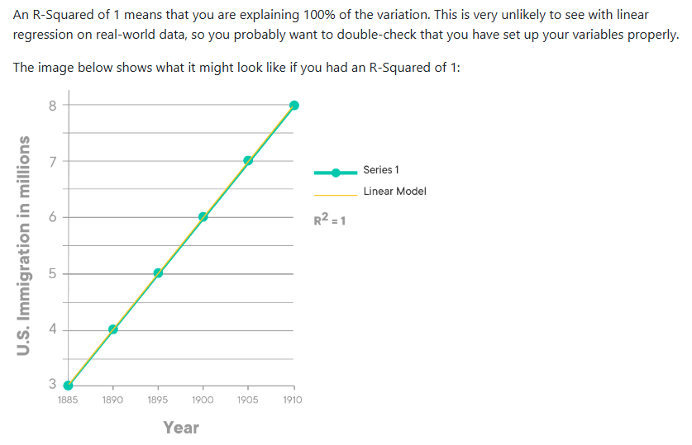

**What is a ‘ good’ R-Squared Value?**If you doing *inferential modelling,* i.e the part of the model you are mostly interested is in the value of the parameters , then as long as the model is statistically significant overall,you don’t need to worry about R-Squared

If you are doing *predictive modelling* i.e you are most interested in making predictions about unknown values of y,then a higher R-squared is important

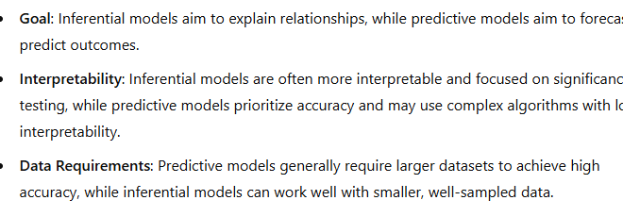

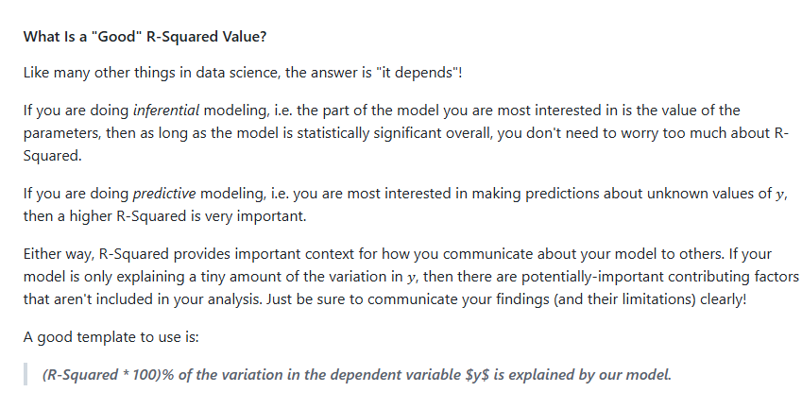

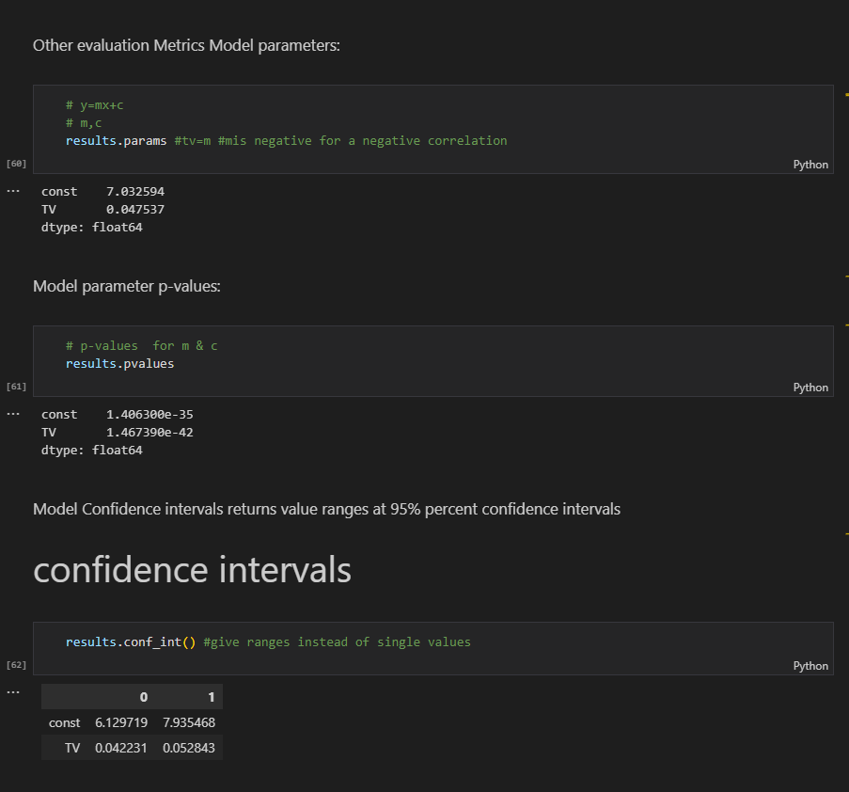

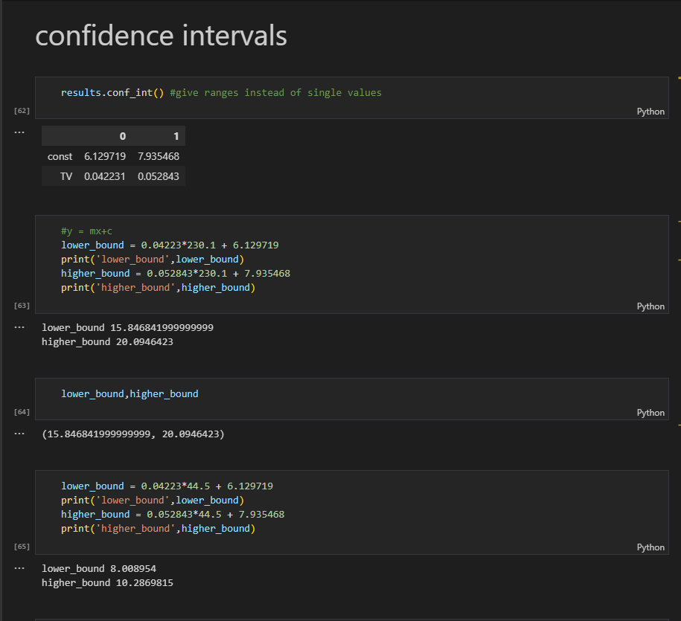

**• Use covariance** to understand the direction of the relationship.

**• Use correlation** to understand both the direction and the strength of the relationship.

*_Why_* does it happen that variables correlate? It *_may_* be that one is the cause of the other. A city having a high population, for example, probably does have some causal effect on the number of buses that the city has. But this *_need not_* be the case, and that is why statisticians are fond of saying that 'correlation is not causation'. An alternative possibility, for example, is that high values of X and Y are *_both_* caused by high values of some third factor Z. The size of children's feet, for example, is correlated with their ability to spell, but this is of course NOT because either is a cause of the other. Rather, BOTH are caused by the natural maturing and development of children. As they get older, both their feet and their spelling abilities grow!

* **Data Handling**: sm.OLS expects arrays or matrices, while sm.formula.ols works with DataFrames and formula strings.
* **Ease of Use**: sm.formula.ols is more user-friendly for typical regression tasks with categorical variables and complex relationships.
* **Automatic Handling**: sm.formula.ols can automatically create dummy variables for categorical data and includes an intercept by default.

In short, use sm.OLS if you need fine-grained control and sm.formula.ols for a more intuitive, formula-based approach, especially when working with DataFrames.

1. **LINEAR REGRESSION IN STATS MODELS**

import matplotlib.pyplot as plt

plt.style.use('seaborn-whitegrid')

import numpy as np

import pandas as pd

import scipy.stats as stats

import seaborn as sns

import statsmodels.api as sm

import warnings

warnings.filterwarnings('ignore')

df = pd.read_csv('data/heightWeight.csv')

df.plot.scatter(x="height", y="weight");

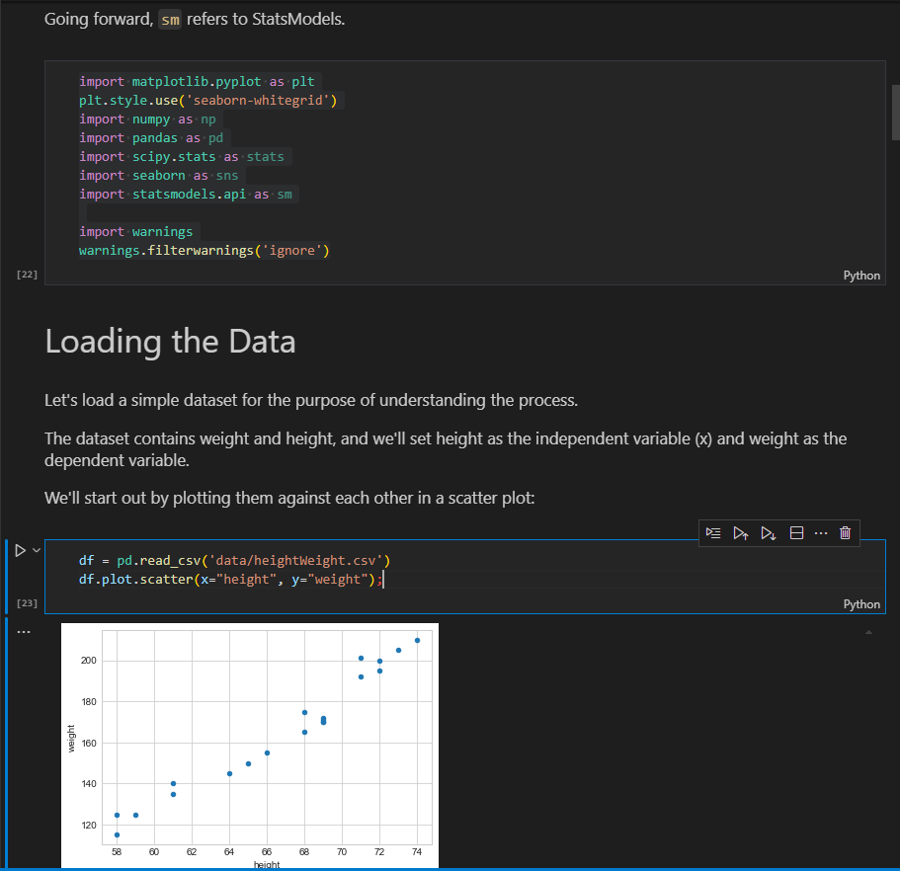

-Looks like a linear relationship

**Building our Linear Regression**

rho = np.corrcoef(df["height"], df["weight"])[0][1]

s_y = df["weight"].std()

s_x = df["height"].std()

m = rho * s_y / s_x

mean_y = df["weight"].mean()

mean_x = df["height"].mean()

c = mean_y - m * mean_x

print(f"Our regression line is: y = {round(m, 5)}x + {round(c, 5)}")

That works, in a way. But now if we wanted to calculate the F-statistic, or R-Squared, or find the confidence intervals for the parameters, that would be a lot of additional calculations.

If we use **StatsModels instead**, all of the calculations are done for us! We just have to set up the appropriate x and y variables and plug them into a model.

**Step 1: Determining X and y variables**

X = df[["height"]]

y = df["weight"]

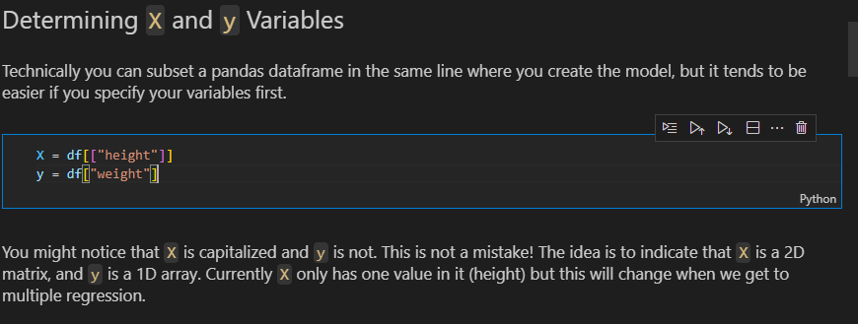

**Step 2: Creating and fit the model**

model = sm.OLS(endog=y, exog=sm.add_constant(X))

model

results = model.fit()

results

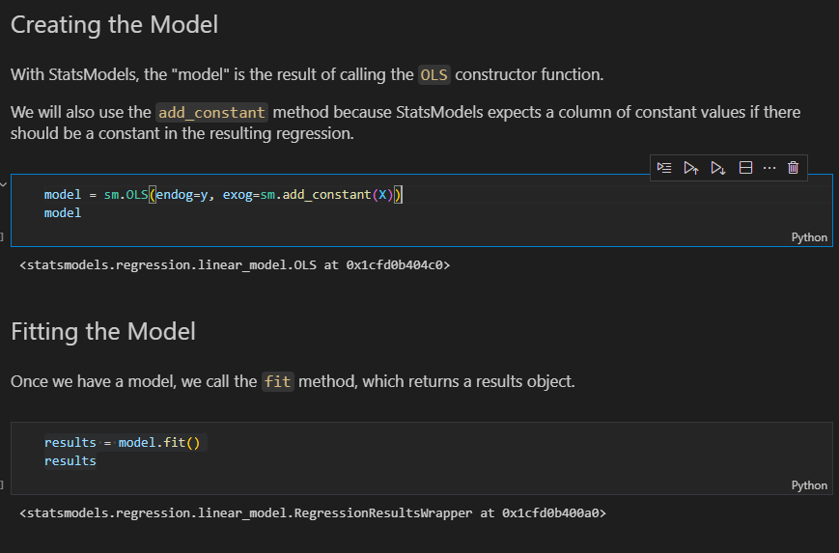

**Step3: Evaluating and interpreting the model**

**a)F statistic and f statistic p value**

results.fvalue, results.f_pvalue

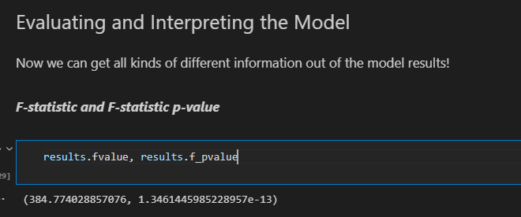

**Interpretation**: our model is statisctically significant, with a p-value below the standard alpha of 0.05

**b)R**-**Squared** (coefficient of determination)

results.rsquared

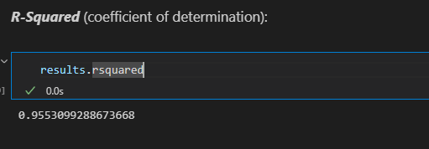

**Interpretation:** Our model explains about 95.5% of the variance in weight, the depedent variable

**c)Model parameters:**

results.params

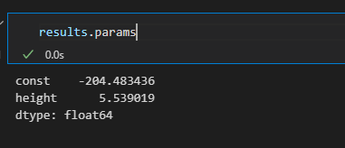

**Interpretation:** For a height of 0, our model would predict a weight of abt -204.5. An increase of 1 in height is associated with an increase of about 5.5 in weight

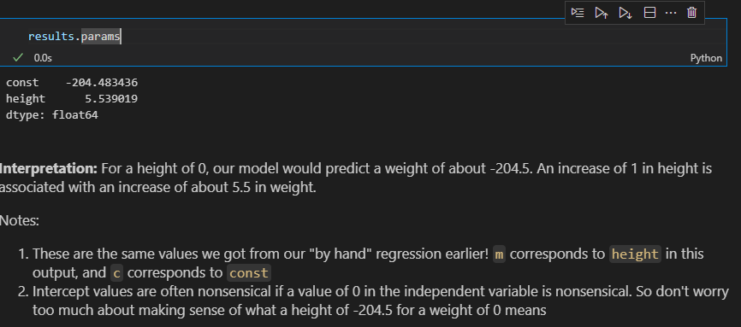

**d)Model parameters p-values**

results.pvalues

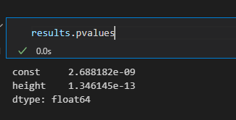

**Interpretation :** both our model parameters (coefficient for height and intercept) are statisctically significant , with p-values well below the standard alpha of 0.05

**e)Model parameter and confidence interval**

print(results.conf_int())

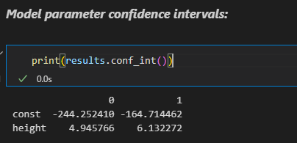

**Interpretation:** our 95% CI for the intercept is abt -244.3 to -164.7.Our 95% CI for the coefficient of height is abt 4.9 to abt 6.1

**f)Results summary**

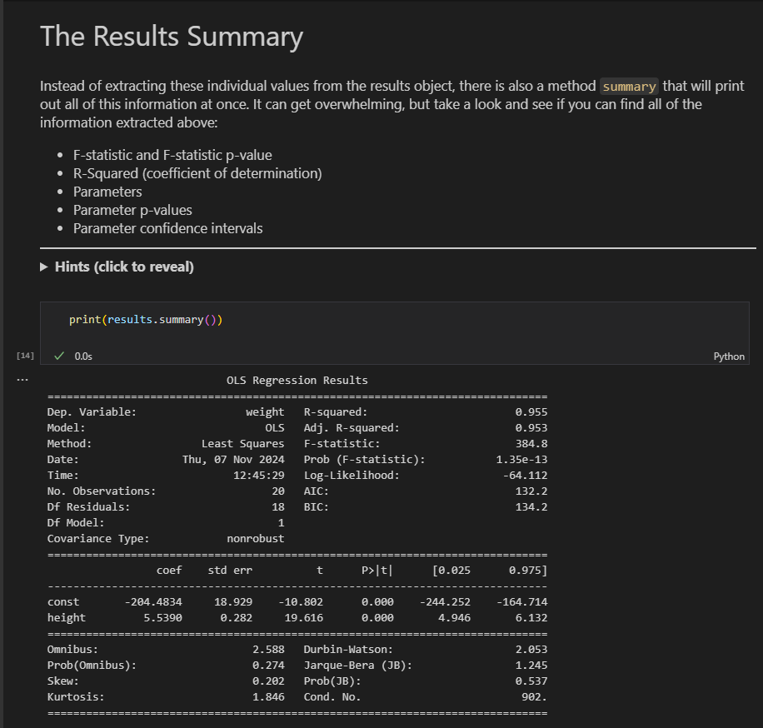

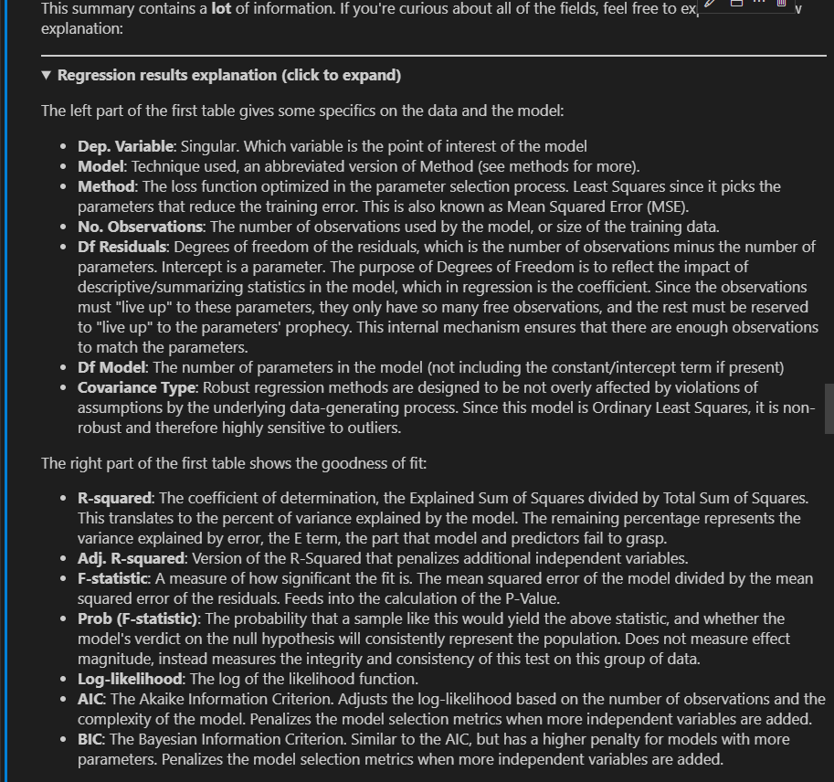

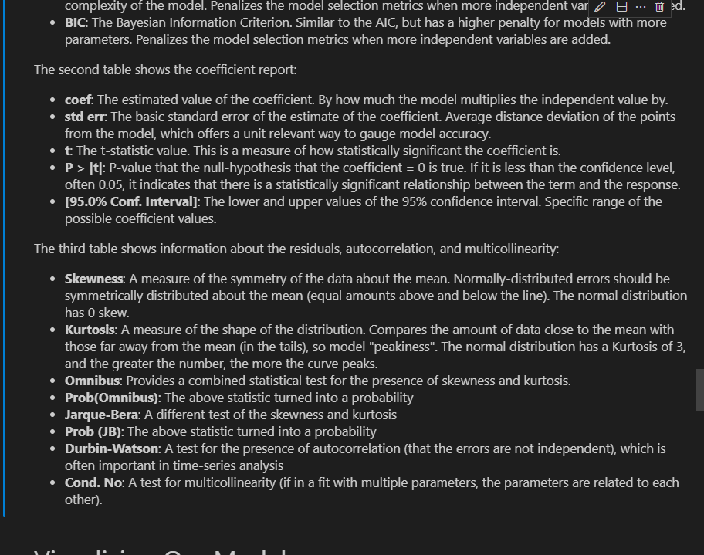

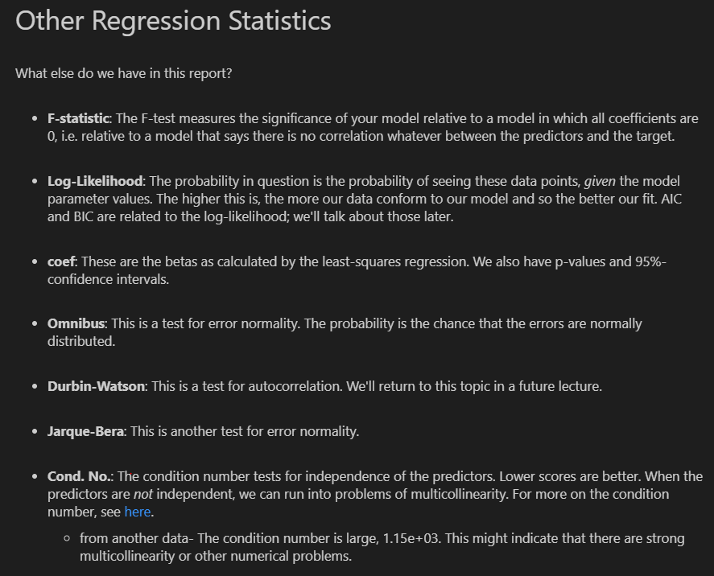

g)**Visualizing our model**

* **Plot fitting**

sm.graphics.plot_fit(results,'height');

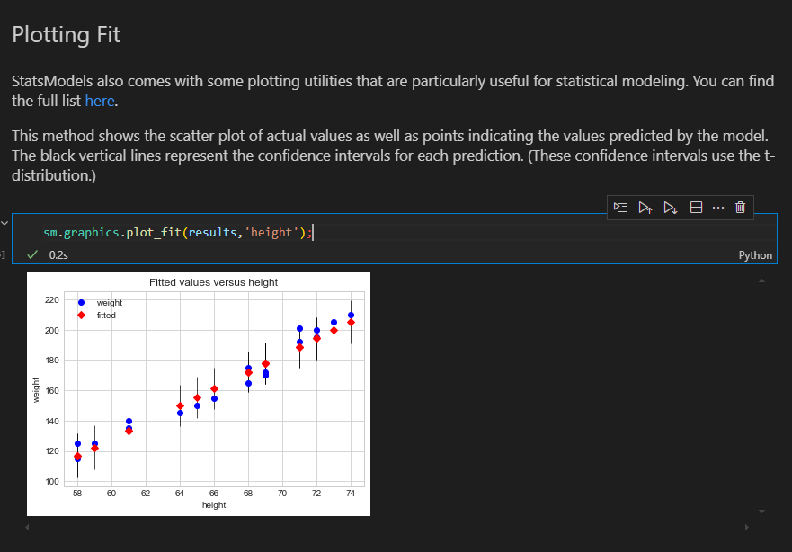

* For a simpler visualization we can use abline_plot

fig, ax= plt.subplots()

df.plot.scatter('height','weight',ax=ax,label='Data points')

sm.graphics.abline_plot(model_results=results,ax=ax,label='Regression Line')

ax.legend()

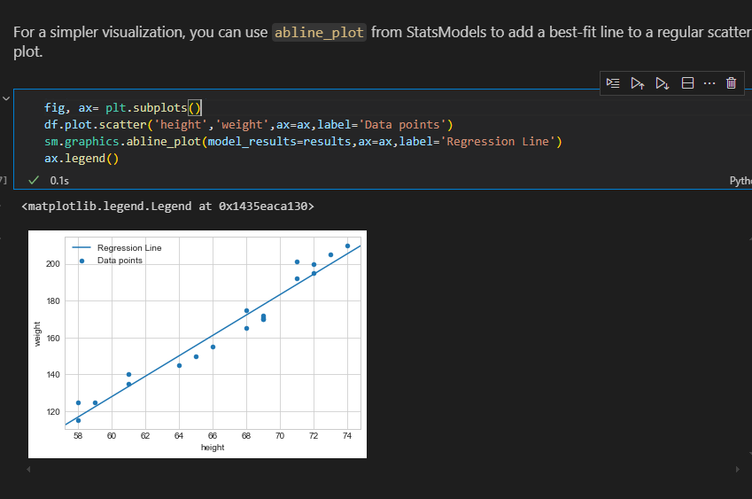

* **Seaborn regplot-** visualizaing original data alongside the regression line

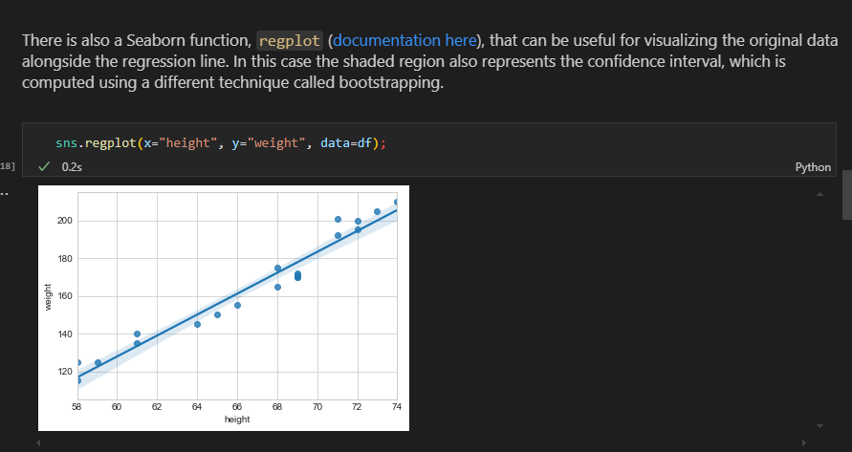

**h)Plotting residuals**

**Model residuals –** Differences between the true values and the values predicted by the model.  We can get them easily from the model results using the `resid` attribute.

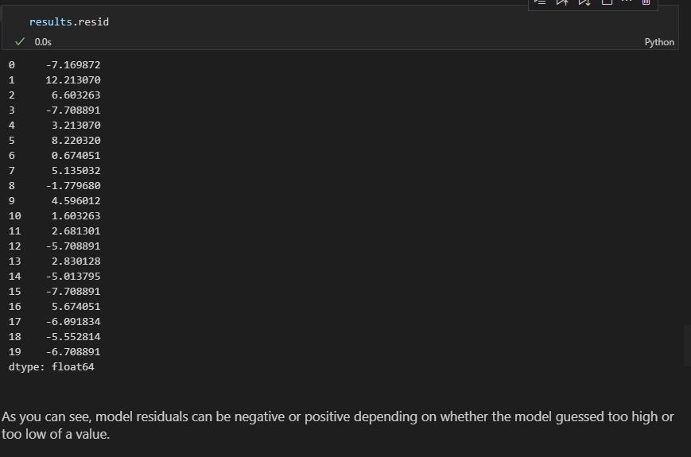

fig, ax = plt.subplots()

ax.scatter(df['height'],results.resid)

ax.axhline(y=0, c='k')

ax.set_xlabel("height")

ax.set_ylabel("residuals");

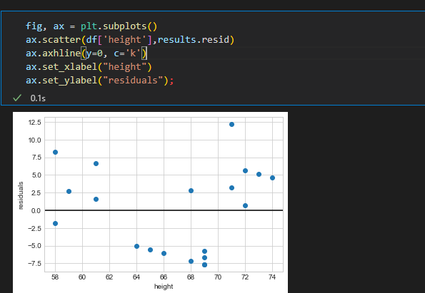

* **Histrogram to check distribution of the residuals**

plt.hist(results.resid,bins='auto')

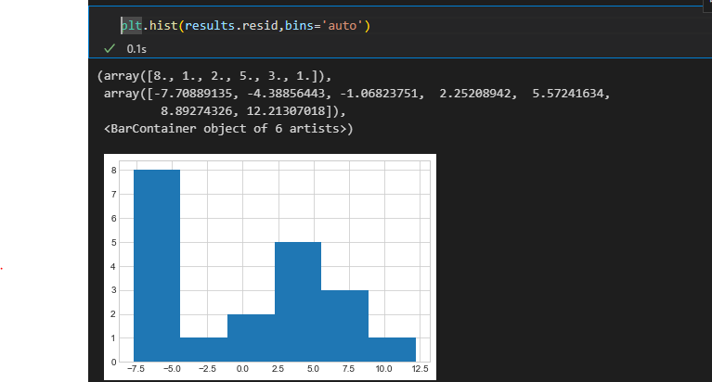

* **Q-Q plot –** It compares the quantiles of the residuals to the quantiles of theoritcal normal distribution .The farther from the line that the data point appear, The farther from a normal distribution they are

sm.graphics.qqplot(results.resid,dist=stats.norm,line='45',fit=True);

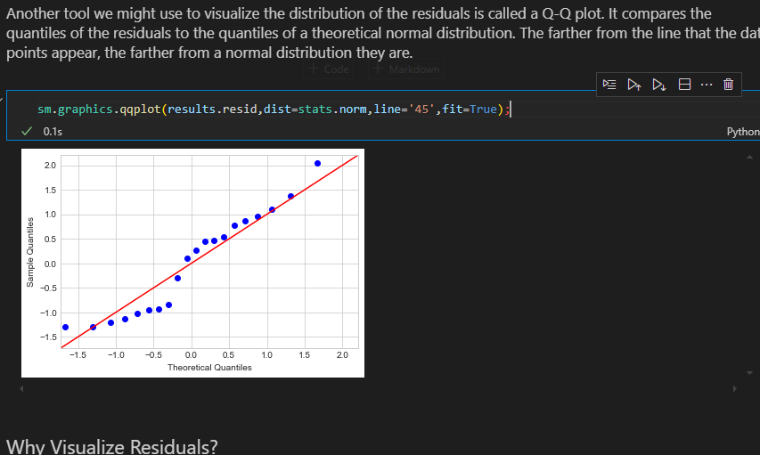

**Why visualize residuals**

The main purpose of visualizing the residuals is to help you better understand where your model is performing well, and where it is performing poorly. For example, some models perform better on smaller values than larger values.

You might use this information to improve the model, or simply to communicate transparently about its strengths and weaknesses. These plots will also become relevant when investigating whether the model assumptions are being met.

1. **R- Style Regression Formulas**

We have been using the primary **(`api`)** interface to StatsModels. There is also an interface **(`formula.api`)** that uses R-style formulas. R-style meaning that the formulas for the models are written in the same style as they would be written in the programming language [R](https://en.wikipedia.org/wiki/R_(programming_language)).

Unlike Python, R has built-in functionality for linear modeling, and so you will find that some foundational statistics and data science resources and papers used R rather than Python. StatsModels includes this R-style interface to be more convenient for people who learned R first. You can read more about it [here](https://www.statsmodels.org/stable/example_formulas.html).

Below we provide an example of the same model above, except developed using an R-style formula.

import statsmodels.formula.api as smf

rstyle_model = smf.ols(formula='weight ~ height',data=df)

rstyle_results = rstyle_model.fit()

print(rstyle_results.summary())

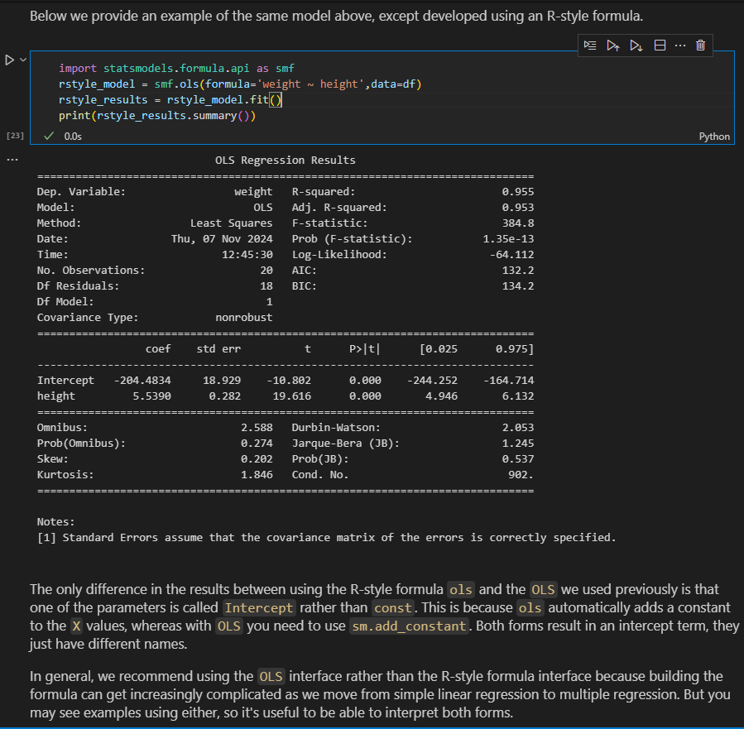

As a stakeholder holder what are we looking at variance or more sales

**Regression Without Error Model in statsmodels**

sm.formula.ols(formula = "y ~ x", data = test_df).fit().summary()

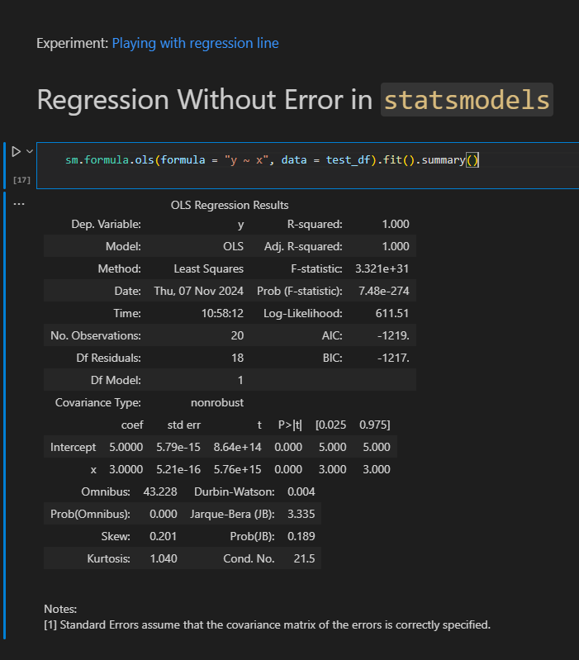

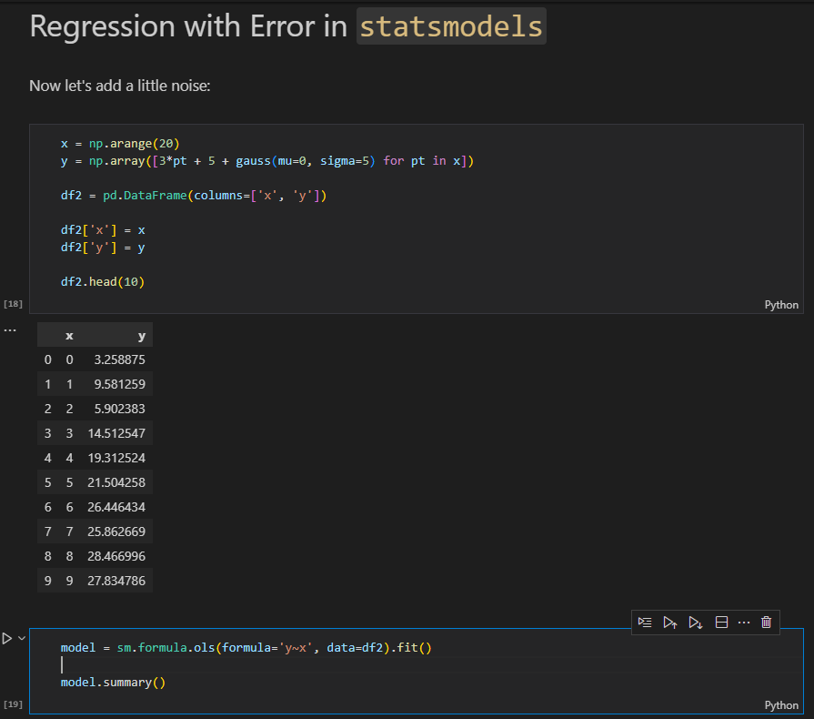

**Introduction to Linear Regression - Recap**

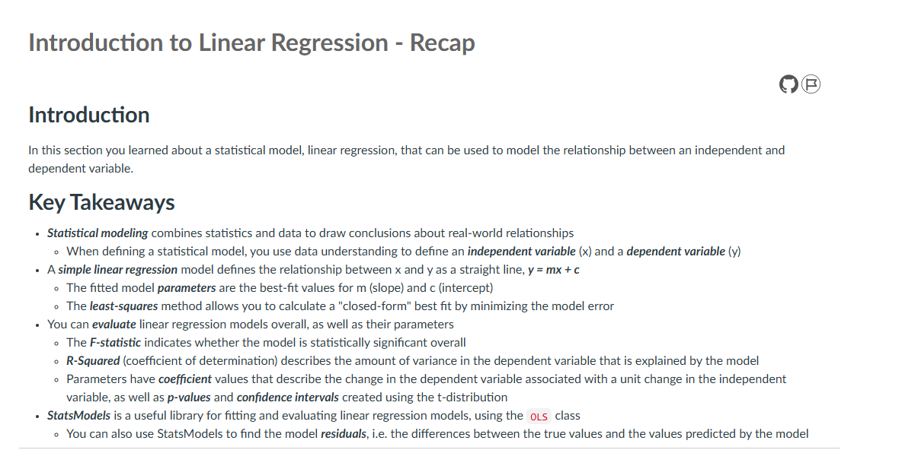

1. **ASSUMPTIONS OF LINEAR REGRESSION**

Like any other statisctical technique, the coefficients and p-values of a linear regression model are based on underlying assumptions about the variables and the relationships between them.

**REGRESSION ASSUMPTIONS AND MODEL DIAGNOSTICS**

When you fit a regression model, the algorithm will find a best fit line **according to how you have defined the model.**if the model is ill-defined , you will still get coefficients and p-values,but they might mot actually describe the true relationship between the underlying variables.

import numpy as np

import statsmodels.api as sm

X=np.linspace(1,10).reshape(-1,1)

y= np.exp(X)

model = sm.OLS(y,sm.add_constant(X))

results = model.fit()

print(f'''

model p-value : {results.f_pvalue}

model R-Squared: {results.rsquared}

coef p-value : {results.pvalues[1]}

coef value : {results.params[1]}

''')

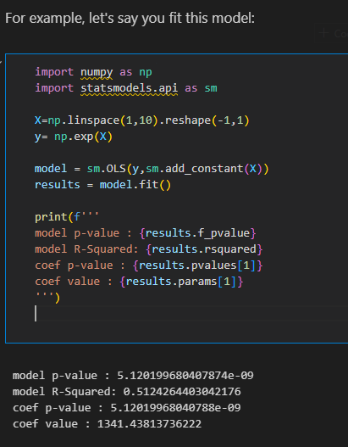

-We are explaining about 51% of the variance in y(r squared),and for each increase of 1 in X you see an associated increase of about 1.3 k in y.The model overall ad coefficients of X are statistically significant.

But whats the problem here.lets look at a graph?

import matplotlib.pyplot as plt

fig,ax = plt.subplots()

ax.scatter(X,y,label='data points')

ax.plot(X,results.predict(sm.add_constant(X)),label='best fit line')

ax.legend();

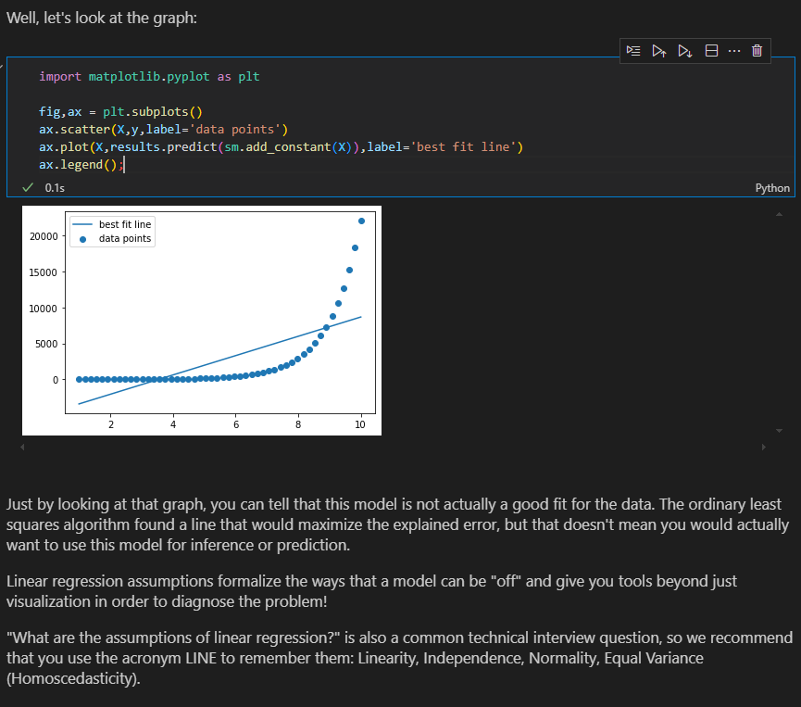

By looking at the graph, you can tell that this model is not actually a good fit for the data.OLS(ordinary least algorithm found a line that would maximize the explained error,but that doesn’t mean you would actually want to use this model for inference or prediction

**Linear Regression assumptions** formalize the ways that a model can be ‘off’ and give you tools beyond just visualization in order to diagnose the problem

**MODEL ASSUMPTIONS –** In the context of statistical modelling, especially in linear regression,model assumptions refert to the set of conditions that the underlying data and model need to satisfy for the results to be valid and reliable.These assumptions are critical because if they are violated, the estimates obtained from the model may be biased, inefficient, or misleading.

**Rule of Thumb:**

    If the p-value is **less than 0.05**, you reject the null hypothesis (H₀).

    If the p-value is **greater than or equal to 0.05**, you fail to reject the null hypothesis.

* **LINEARITY**- requires that there is a linear relationship between the response variable (y) and predictor (X).Linear means that the change in y by 1-unit change in X, is constant

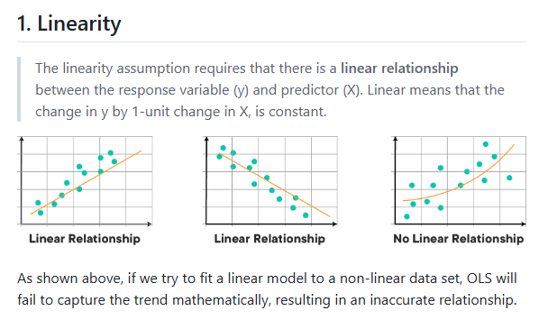

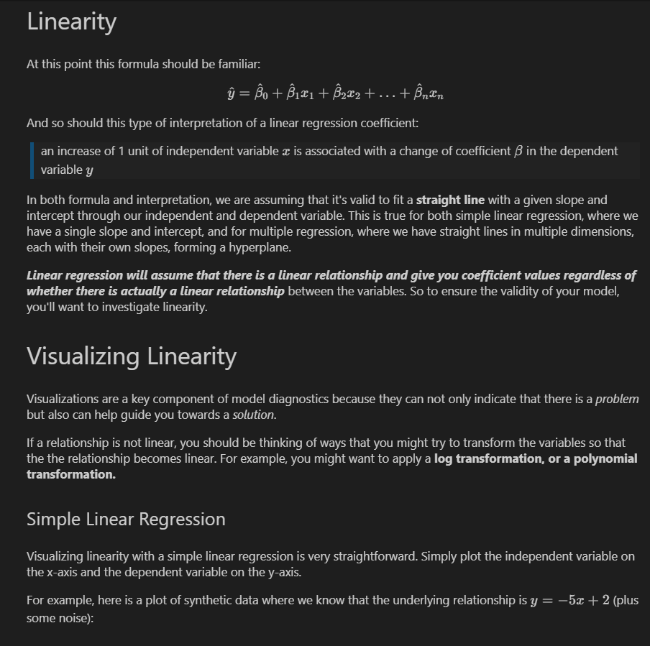

* 1. **Using scatter plot**

import matplotlib.pyplot as plt

import numpy as np

plt.style.use('fivethirtyeight')

np.random.seed(2)

x=np.linspace(0,10,300)

y = -5 * x + 2 + np.random.normal(scale=5,size=300)

fig, ax = plt.subplots()

ax.scatter(x, y, color="green")

ax.set_xlabel("x")

ax.set_ylabel("y")

ax.set_title("Linear Relationship X vs. Y");

np.corrcoef(x,y)[0,1]

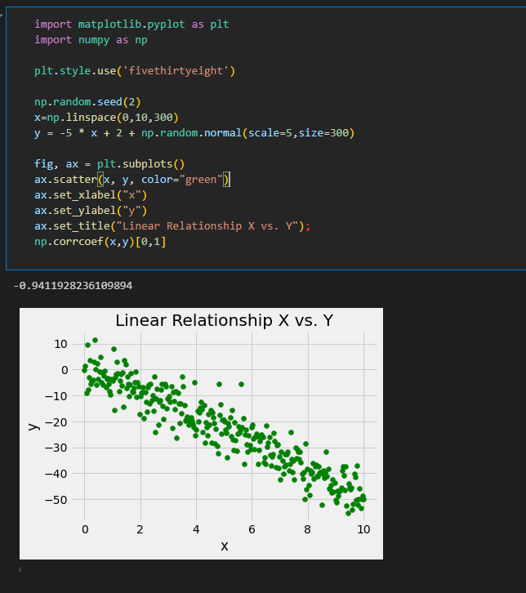

Linear relationship between these two axis is clearly visible

Lets compare this to the below plot, which uses weight and mpg from the Auto MPG Dataset

import pandas as pd

import statsmodels.api as sm

data = pd.read_csv("data/auto-mpg.csv")

y = data["mpg"]

x = data["weight"]

fig, ax = plt.subplots()

ax.scatter(x, y)

ax.set_xlabel("weight")

ax.set_ylabel("mpg")

ax.set_title("Not So Linear Relationship X vs. Y");

np.corrcoef(x,y)[0,1]

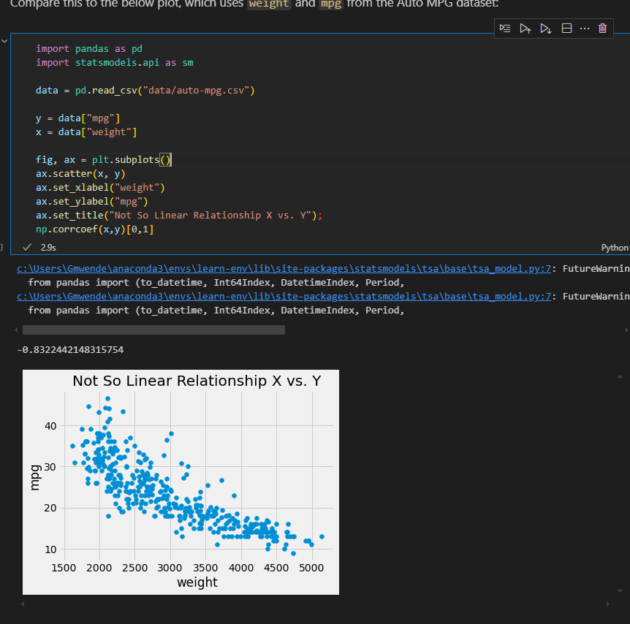

* We can also use pairplot

import seaborn as sns

sns.pairplot(data)

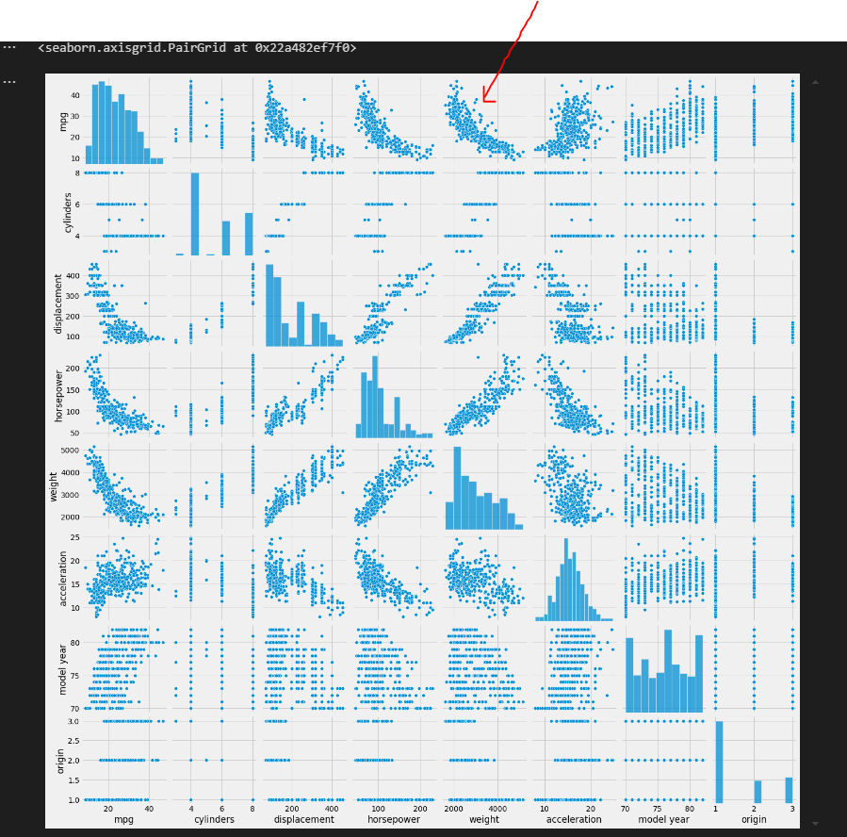

Note the curvature in the **weight** X **mpg** plot compared to the previous one. It looks like the slope is steeper for lower values of `weight`, then less steep as `weight` increases. This inconsistent slope is an indication that the relationship might not be linear.

**Multiple linear regression**

np.random.seed(1)

x1 = np.linspace(start=0, stop=10, num=300) + np.random.normal(size=300)

x2 = np.linspace(start=0, stop=5, num=300) + np.random.normal(size=300)

y = -5 * x1 + 10 * x2 + 2 + np.random.normal(size=300)

fig, axes = plt.subplots(ncols=2, figsize=(15,5))

axes[0].scatter(x1, y, color="orange")

axes[0].set_xlabel("x1")

axes[0].set_ylabel("y")

axes[1].scatter(x2, y, color="orange")

axes[1].set_xlabel("x2")

axes[1].set_ylabel("y")

fig.suptitle("Don't Do This to Evaluate Linearity: Individual X vs. Y for Multiple Regression");

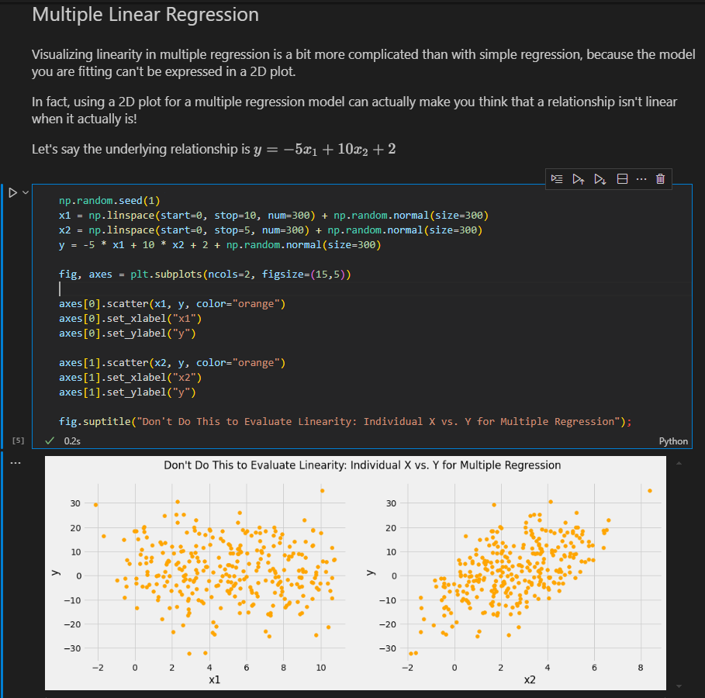

You can somewhat see the linear relationship with x2 but x1 vs y appears to be a random distribution of points.And yet we know there is alinear relationship between x1 and y,because we defined the y variable ourselves.

-The two ways to avoid this issue are **plotting model residuals** and **partial regression plots.**Note that both of these approaches mean that you need to create a model before you can evaluate the linearity of the relationship.

**a)Plotting Model residuals**

If the model is correclly specified, then we shouls not see curvature in the residuals. Let's plot the residuals for the $y = -5x_1 + 10x_2 + 2$ data generated in the previous example.

X = pd.DataFrame()

X["x1"] = x1

X["x2"] = x2

linear_model = sm.OLS(y, sm.add_constant(X))

linear_results = linear_model.fit()

fig, ax = plt.subplots()

ax.scatter(y, linear_results.resid, color="green")

ax.axhline(y=0, color="black")

ax.set_xlabel("y")

ax.set_ylabel("residuals")

ax.set_title("Linear Relationship Residual Plot");

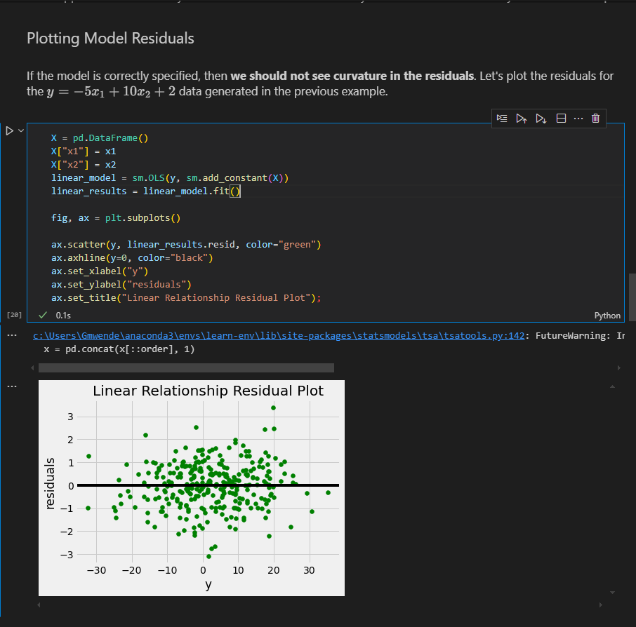

By comparison,here is a residual plot for a model that predicts mpg using weight and model year.

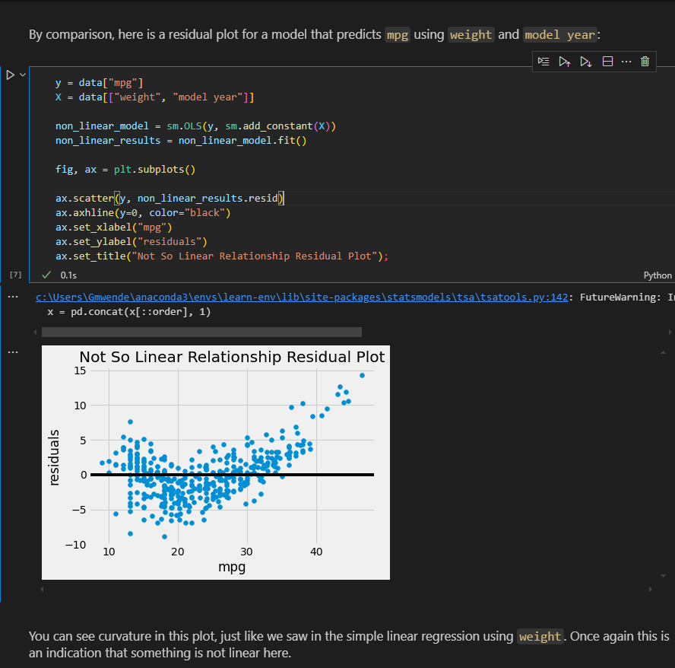

**b)Partial Regression Plots**

Partial regression plots dig into each of the individual predictors to see whether the relationship with the target is linear, all else being equal. This tends to be more useful than residual plot for diagnosing the particular problem with the model, although it can mean a lot of plots if your model has a lot of variables.

We are looking for a linear trend in each partial regression plot.

Let's start with the generated data:

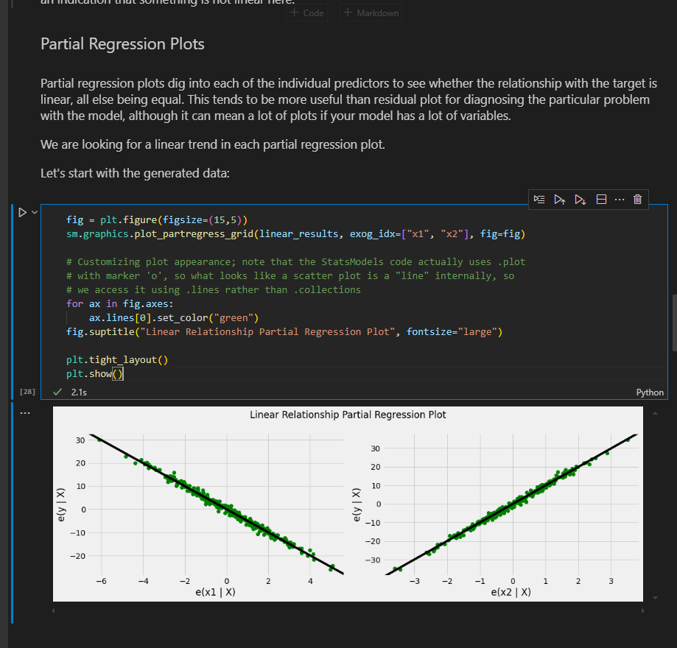

**Compared to when we plotted them individually, now we can clearly see the linear relationships! Let's do the same for the Auto MPG model.**

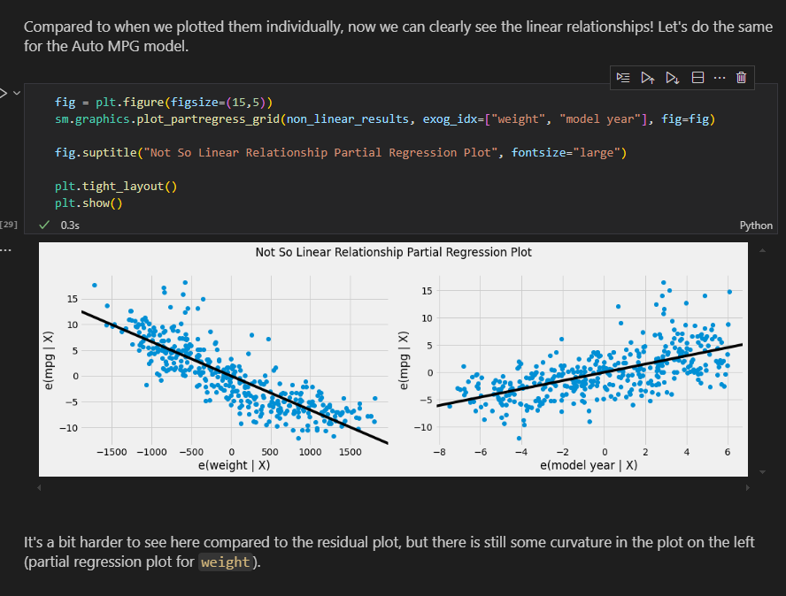

**Statisctical Test for Linearity**

**a)Rainbow test-** linear rainbow is a function that takes in OLS results object and returns a test statisctic and a p-value

**Null**: There is no significant difference between the subset model and the full model I,e the relationshio is linear

Linear relationship is correctly specified I,e(the relationship between the predictors and the target variable is linear)

**Alternative**: linear model is misspecified, and there is a non-linear relationship between the predictors and the depedent variable

from statsmodels.stats.diagnostic import linear_rainbow

linear_rainbow(linear_results)

linear_rainbow(non_linear_results)

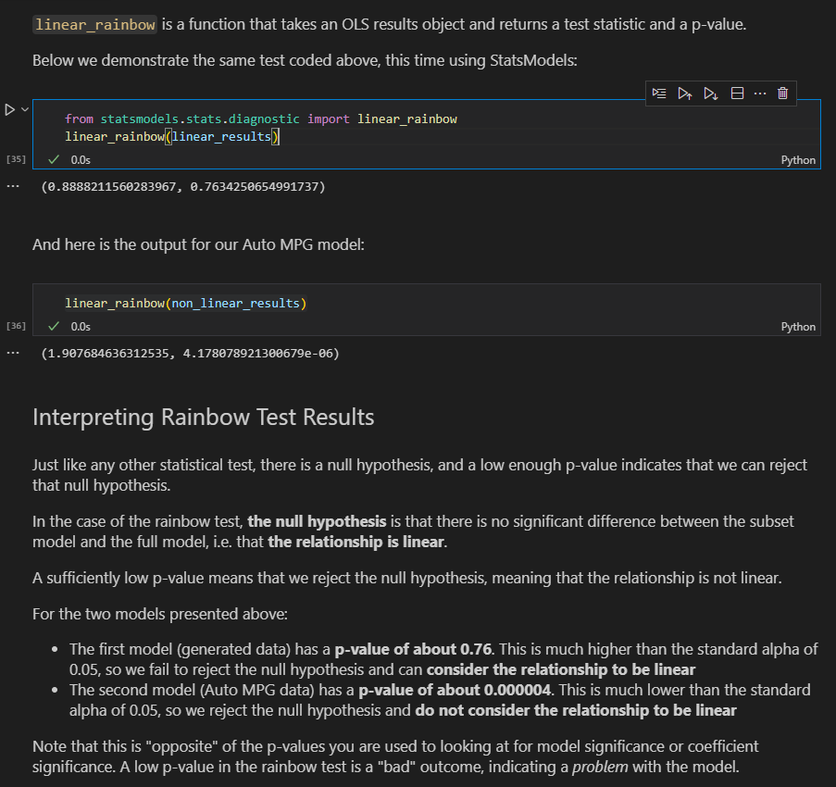

* The first model (generated data) has a **\*\*p-value of about 0.76\*\***. This is much higher than the standard alpha of 0.05, so we fail to reject the null hypothesis and can **\*\*consider the relationship to be linear\*\***

* The second model (Auto MPG data) has a **\*\*p-value of about 0.000004\*\***. This is much lower than the standard alpha of 0.05, so we reject the null hypothesis and **\*\*do not consider the relationship to be linear\*\***

Note that this is "opposite" of the p-values you are used to looking at for model significance or coefficient significance. A low p-value in the rainbow test is a "bad" outcome, indicating a *_problem_* with the model.

**Treating Linearity issues**

If your visualization or statisctical test is indicating that your modeled relationship is not actually linear, you should consider transforming the feature and/or target in order to create a linear relationship. This is going to be different for every dataset, but it will always need to be a **\*\*non-linear transformation\*\*** (e.g. log transformation, adding interaction terms, etc.). A linear transformation (e.g. standardization) will not resolve linearity issues.

Use a function :

def make_model(X,Y):

    model = sm.OLS(endog=Y ,exog=sm.add_constant(X))

    results = model.fit()

    return results

results = make_model(df_auto["horsepower"],df_auto["displacement"])

linear_rainbow(results)

* **INDEPEDENCE -**  The independence assumption has two parts:Independence of features and independence of errors

**Indepedence of features -** we want to avoid collinearity between features in a multiple regression

**Collinearity** means that the features can be used to predict each other, which causes numerical problems for the regression algorithm and leads to unstable coeffcients

**Identifying multicollinearity**

import matplotlib.pyplot as plt

import pandas as pd

data = pd.read_csv('data/auto-mpg.csv')

data['horsepower'].astype(str).astype(int)

data.head()

data_pred = data.iloc[:,1:8]

data_pred.head()

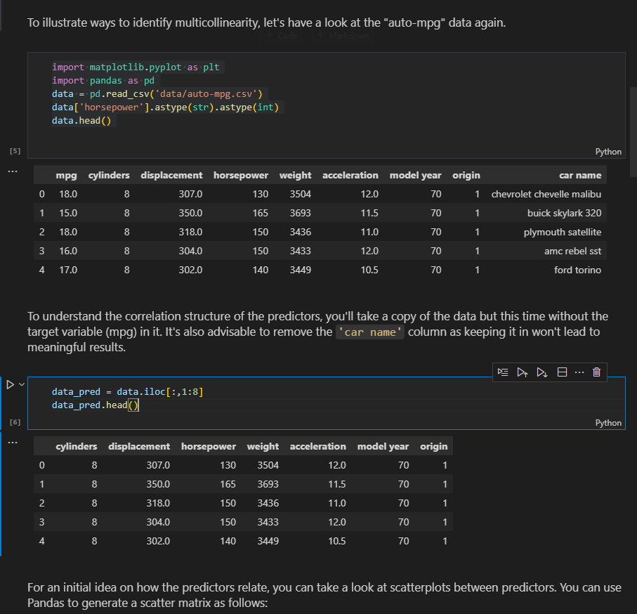

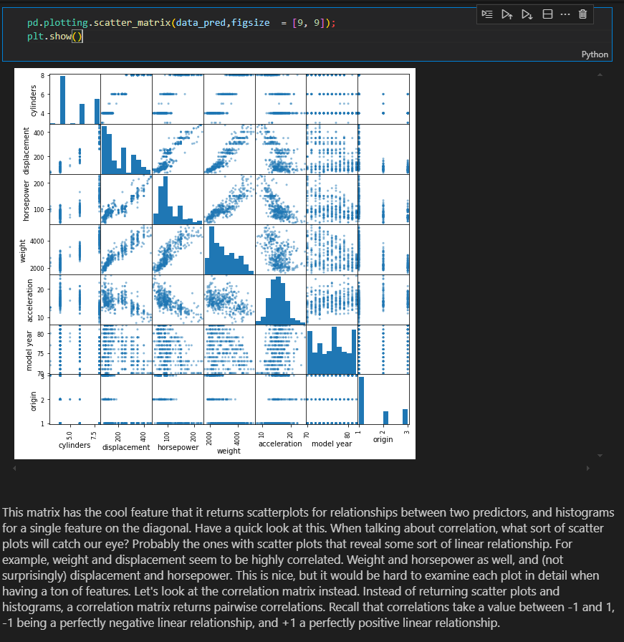

data_pred.corr()

abs(data_pred.corr()) > 0.75

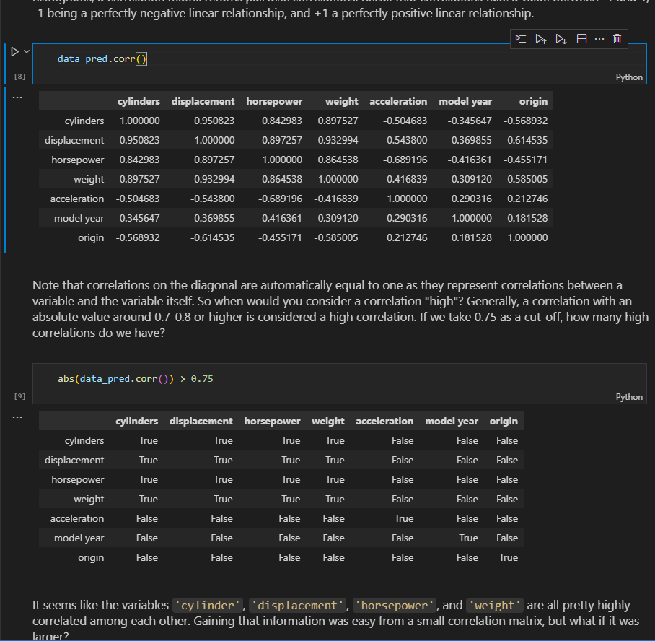

**Because corr** returns a dataframe, a neat fix is to use **stack** and a subset to return only the highly correlated pairs.

# save absolute value of correlation matrix as a data frame

# converts all values to absolute value

# stacks the row:column pairs into a multindex

# reset the index to set the multindex to seperate columns

# sort values. 0 is the column automatically generated by the stacking

df=data_pred.corr().abs().stack().reset_index().sort_values(0, ascending=False)

# zip the variable name columns (Which were only named level_0 and level_1 by default) in a new column named "pairs"

df['pairs'] = list(zip(df.level_0, df.level_1))

# set index to pairs

df.set_index(['pairs'], inplace = True)

#drop level columns

df.drop(columns=['level_1', 'level_0'], inplace = True)

# rename correlation column as cc rather than 0

df.columns = ['cc'] # df.rename(columns=

          #{0:'cc'},

          #inplace=True)

# drop duplicates. This could be dangerous if you have variables perfectly correlated with variables other than themselves.

# for the sake of exercise, kept it in.

df.drop_duplicates(inplace=True)

df[(df.cc>.75) & (df.cc <1)] #df.query('cc >.75 & cc<1')

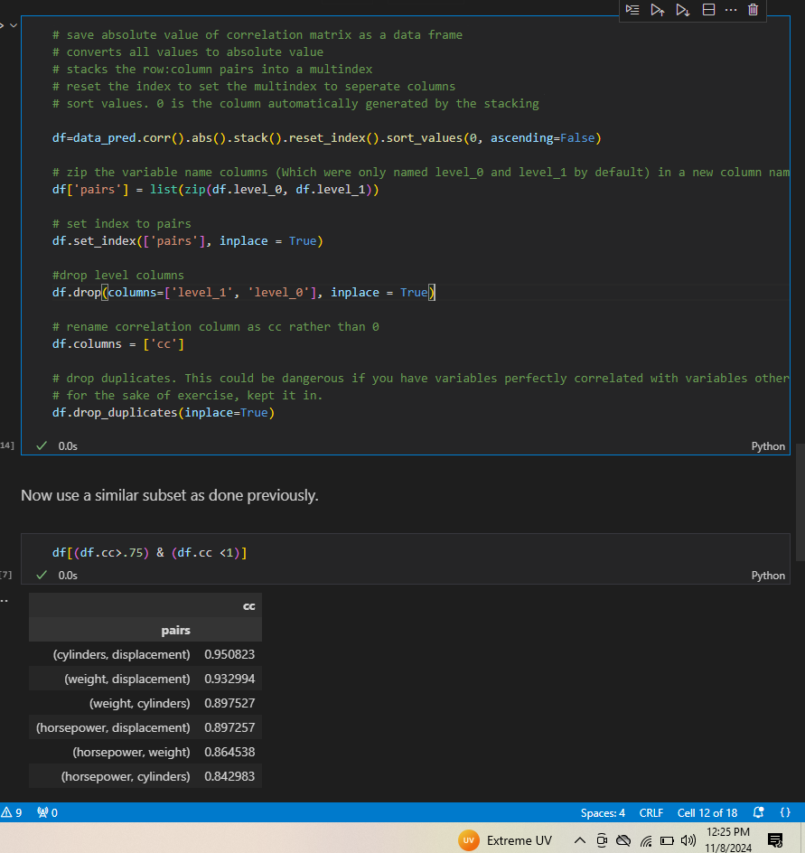

**With the variables `'cylinder'`, `'displacement'`, `'horsepower'`, and `'weight'` so highly correlated, you would typically remove *_three_* of them in order to remove collinear features.**

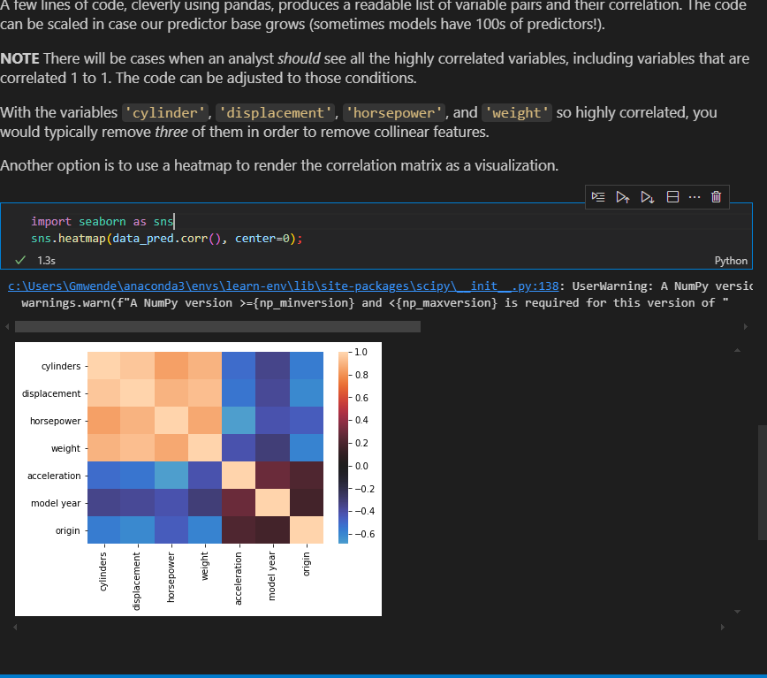

**Lets says we found correlation like the following in housing dataset.What variables are highly correlated?**

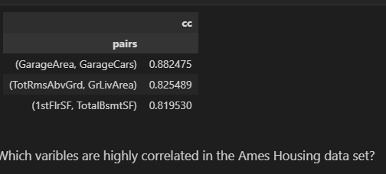

#There are three sets of variables that are highly correlated.

#GarageArea with  GarageCars

#Total rooms above ground with Total square feet of living space above ground

#First floor square feet with  Total Basement square foot

**Now that we know which variables are correlated with each other, which would you drop from the dataset?**

#__SOLUTION__

"""

Since three different pairs of variables are highly correlated, the correct approach would be to drop one variable from each pair.

One approach would be to drop Garage Area, Total Rooms, and Total Basement Square Feet.

Garage Area: The size of the garage is dependent on how many cars are in it. If you wanted to still keep the information captured by Garage Area, you could create a new variable "Average space per car" before dropping Garage Area.

Total Rooms: There are other variables that count the number of kitchens, bathrooms, bedrooms, etc.

Total Basement Square Feet: The first floor of a building is usually built upon the foundation, which contains the basement. To keep the information that there *is* a basement, you could create a variable "HasBasement", when TotalBsmtSF >0, before deleting the original variable.

"""

Using code we remove columns as

ames_preprocessed['AreaPerCar'] = ames_preprocessed['GarageArea']/ames_preprocessed['GarageCars']

ames_preprocessed.drop(columns=['GarageArea','TotRmsAbvGrd','TotalBsmtSF'],inplace=True)

ames_preprocessed

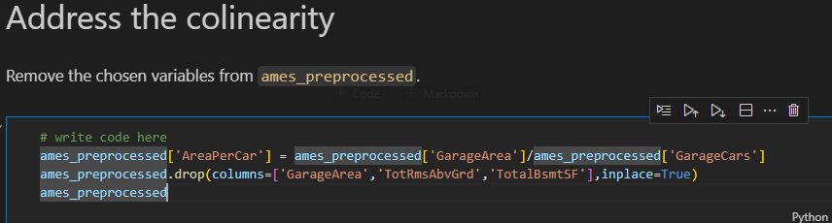

**Independence of errors -**  we want to avoid autocorrelation of error. Autocorrelation means that a variable is correlated with itself, so that later values can be predicted bases on previous values

* **NORMALITY ASSUMPTION –** model residuals should follow a normal distribution

Recall that a normal distribution looks something like this:

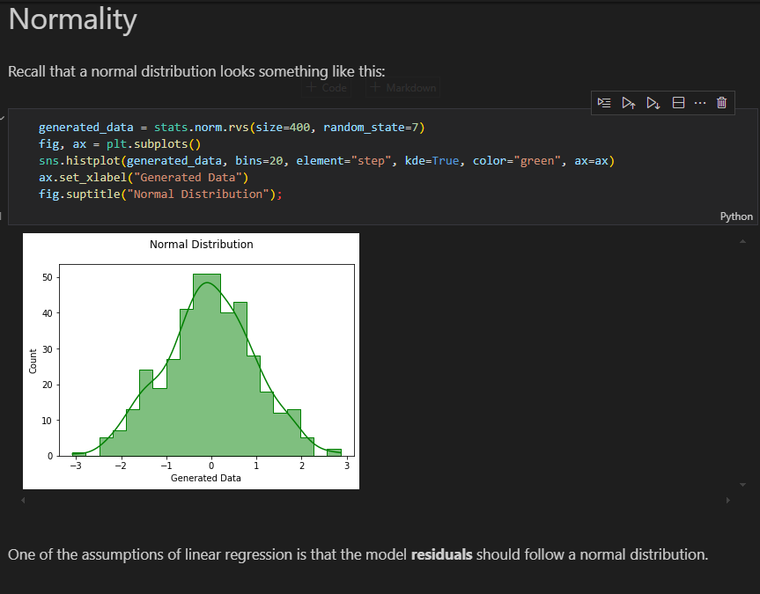

**Visualizing Normality**

-**Histogram**  and **Q-Q plots**

data = pd.read_csv('data/auto-mpg.csv')

y = data['mpg']

X = data[['displacement', 'horsepower', 'weight', 'acceleration']]

model = sm.OLS(y, sm.add_constant(X))

results = model.fit()

fig, ax = plt.subplots()

sns.histplot(results.resid, bins=20, element="step", kde=True, ax=ax)

ax.set_xlabel("Model Residuals")

fig.suptitle("Not So Normal Distribution");

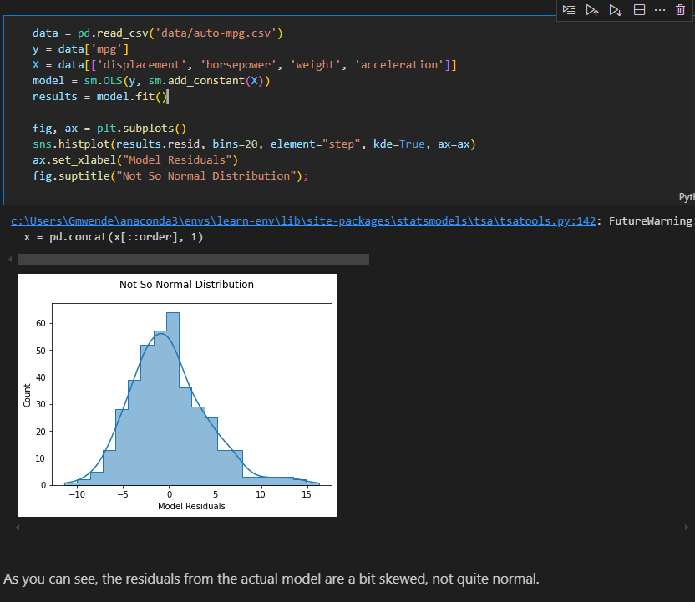

**-**Also use Kde plot **sns.kdeplot(results.resid)**

**Q- Q plot**

Below is for normal data

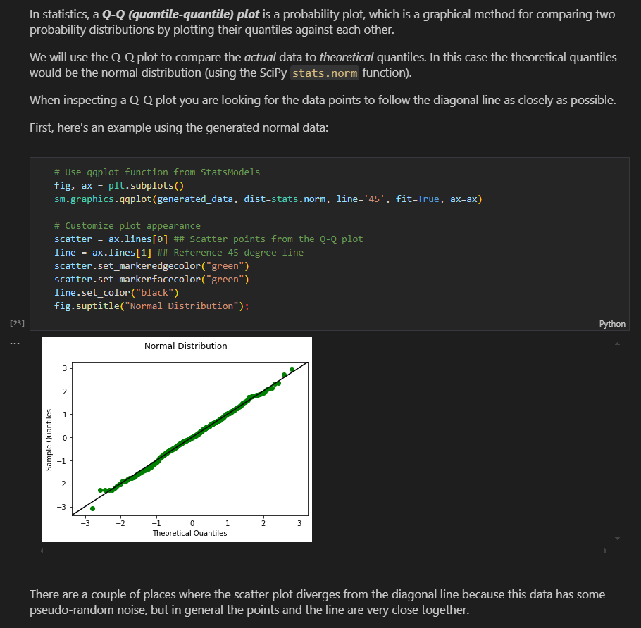

Lets compare above to the auto mpg model residuals

fig, ax = plt.subplots()

sm.graphics.qqplot(results.resid, dist=stats.norm, line='45', fit=True, ax=ax)

# Customize plot appearance

line = ax.lines[1]

line.set_color("black")

fig.suptitle("Not So Normal Distribution");

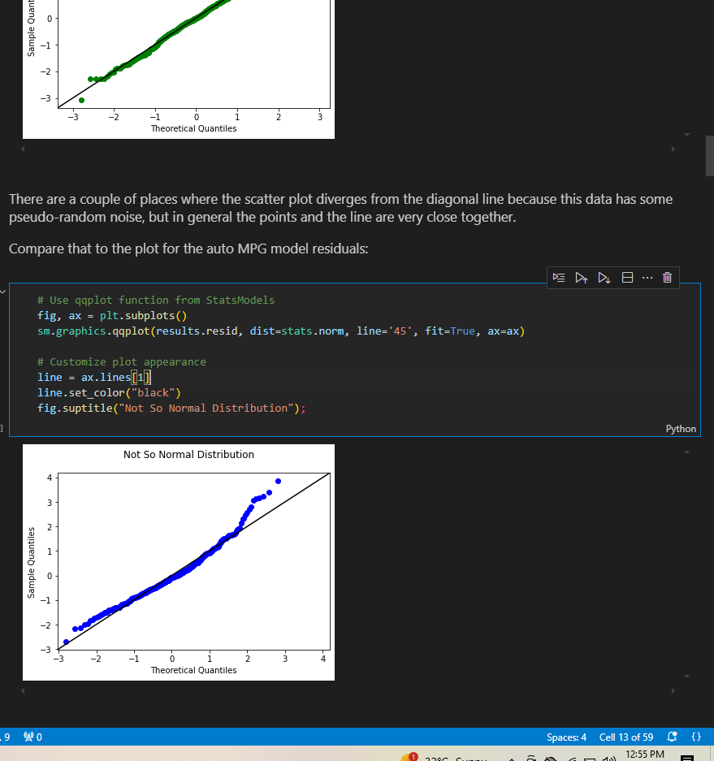

We see that the middle looks ok, but the ends,especially the higher end, are diverging from a normal distribution.This aligns with the skew that we observed from the histogram

**More exampples of histograms and their associated Q-Q plots**

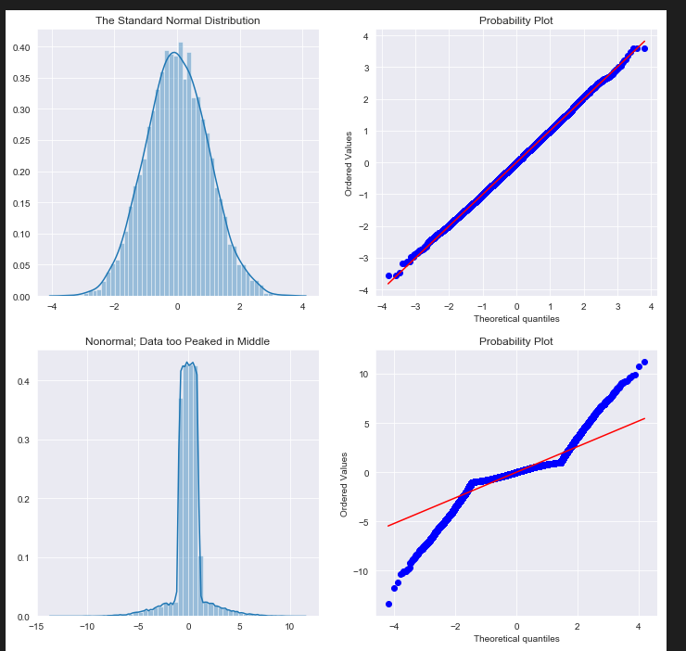

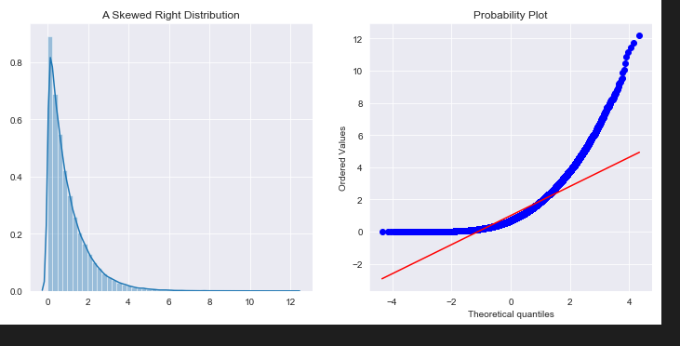

**Statistical Testing for Normality**

**i)Jarque-bera test**

**NULL:** the data follows a normal distribution

**Alternative:** The data does not follow a normal distribution

from statsmodels.stats.stattools import jarque_bera

jarque_bera(generated_data)

jarque_bera(results.resid)

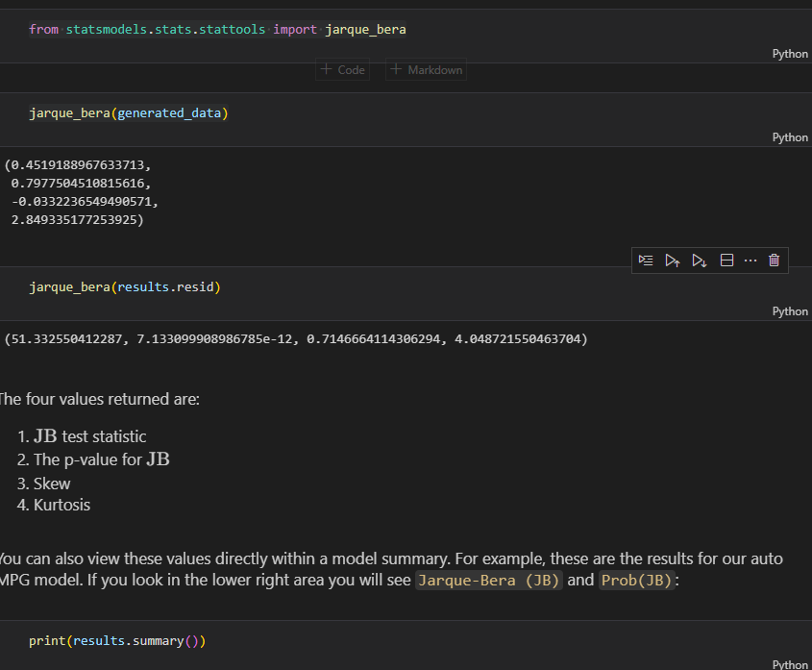

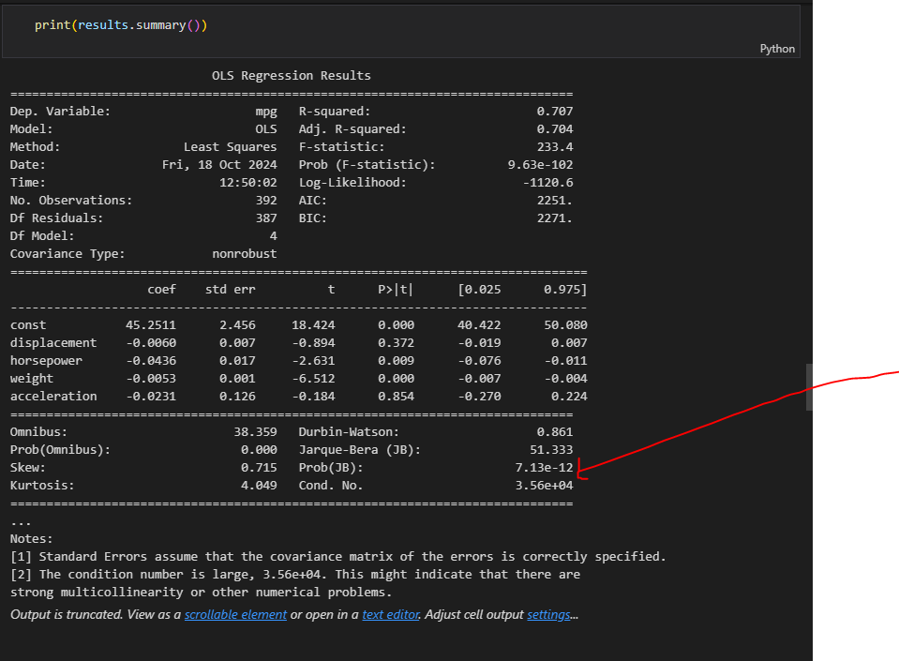

**### Interpreting Jarque-Bera Test Results**

In the case of the Jarque-Bera test the **\*\*null hypothesis is that the distribution is normal\*\***. A sufficiently low p-value means we reject the null hypothesis, i.e. that the distribution is not normal.

For the two datasets presented above:

* The generated data's **\*\*p-value is about 0.8\*\***. This is much higher than the standard alpha of 0.05, so we fail to reject the null hypothesis and can **\*\*consider the distribution to be normal\*\***

* The model residuals' **\*\*p-value is about 0.000000000007\*\***. This is much lower than the standard alpha of 0.05, so we reject the null hypothesis and **\*\*do not consider the distribution to be normal\*\***

Like with some other model assumption checks, this is "opposite" of the p-values you want for model significance or coefficient significance. A low p-value in the Jarque-Bera test is a "bad" outcome, indicating a problem with the model.

**Other statisctical tests**

As mentioned previously, there are several different options to test for normality, each of which uses a slightly different approach. Below are some additional tests you might want to consider:

**#### 1. Kolmogorov-Smirnov Test**

stats.kstest(generated_data, "norm")

stats.kstest(results.resid, "norm")

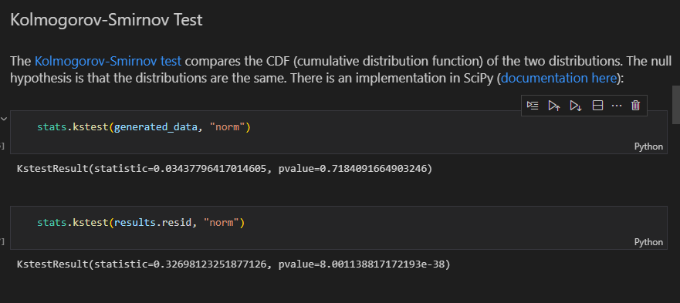

**2.** **Lilliefors Test**

The [Lilliefors test](https://en.wikipedia.org/wiki/Lilliefors_test) is based on the Kolmogorov-Smirnov test and uses estimated parameters. The null hypothesis is that the specified data comes from a normal distribution. There is an implementation in StatsModels ([documentation here](https://www.statsmodels.org/devel/generated/statsmodels.stats.diagnostic.kstest_normal.html)), which returns the test statistic and the p-value:

from statsmodels.stats.diagnostic import kstest_normal

kstest_normal(generated_data)

kstest_normal(results.resid)

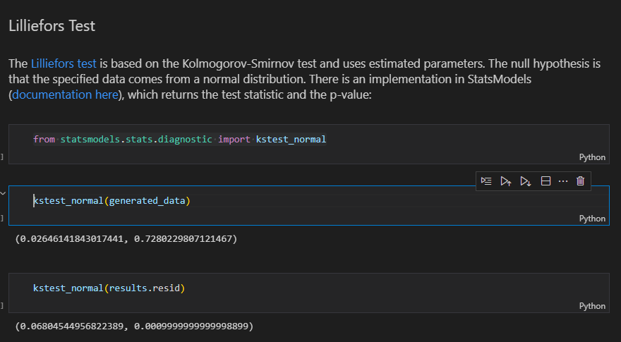

3. **#### Anderson-Darling Test**

The [Anderson-Darling test](https://en.wikipedia.org/wiki/Anderson%E2%80%93Darling_test) also compares the CDF of the two distributions. The null hypothesis is that the specified data comes from a normal distribution. There is an implementation in StatsModels ([documentation here](https://www.statsmodels.org/devel/generated/statsmodels.stats.diagnostic.normal_ad.html)), which returns the test statistic and p-value:

from statsmodels.stats.diagnostic import normal_ad

normal_ad(generated_data)

normal_ad(results.resid)

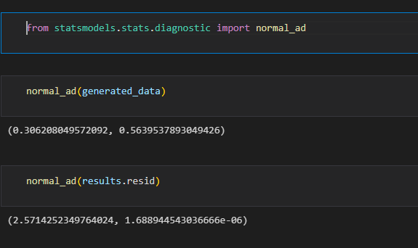

4.**Omnibus Test**

for normality tests for deviations that result from skewness or kurtosis. The null hypothesis is that the specified data comes from a normal distribution. There is an implementation in StatsModels ([documentation here](https://www.statsmodels.org/devel/generated/statsmodels.stats.stattools.omni_normtest.html)):

from statsmodels.stats.stattools import omni_normtest

omni_normtest(generated_data)

omni_normtest(results.resid)

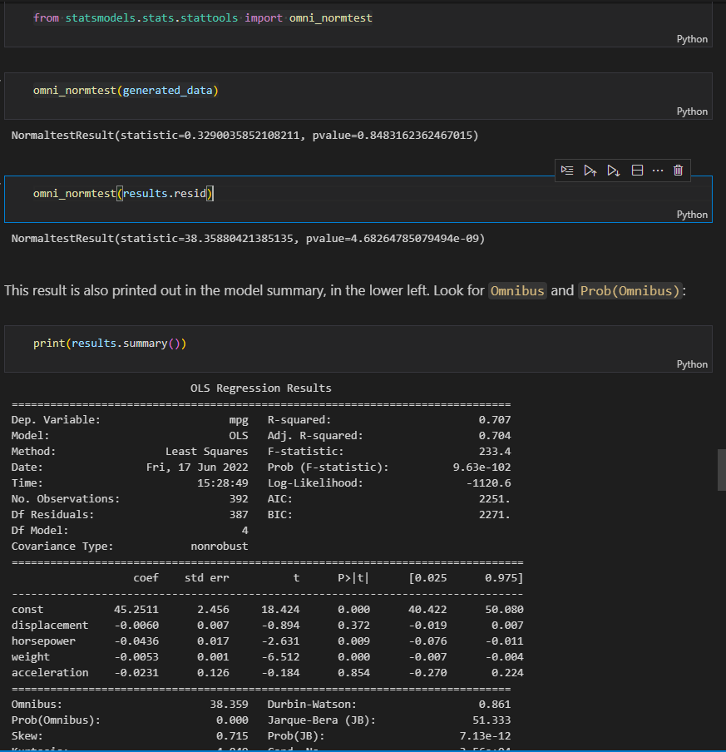

**Treating Normality Issues**

Log transformations tend to be the most helpful when it comes to normality issues. Non-normality in the features or target is often associated with non-normality in the residuals. Below we plot the distributions of all data in the auto MPG model:

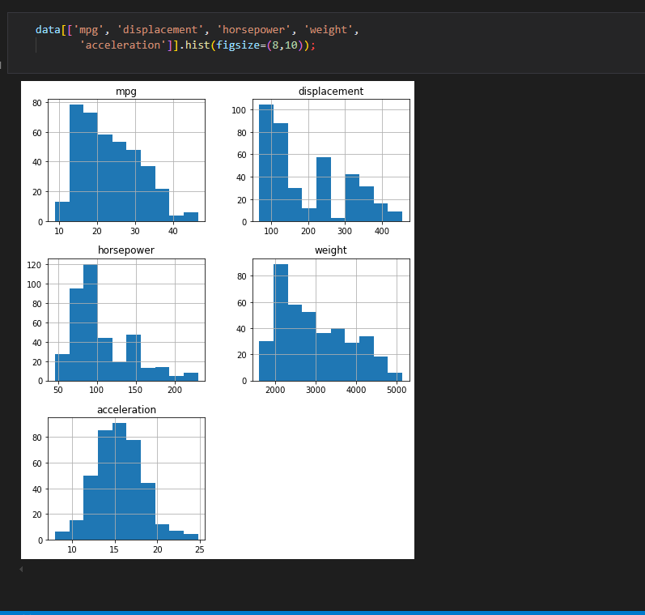

Same distributions after being log transformed

np.log(data[['mpg', 'displacement', 'horsepower', 'weight',

       'acceleration']]).hist(figsize=(8,10),color='lightgreen');

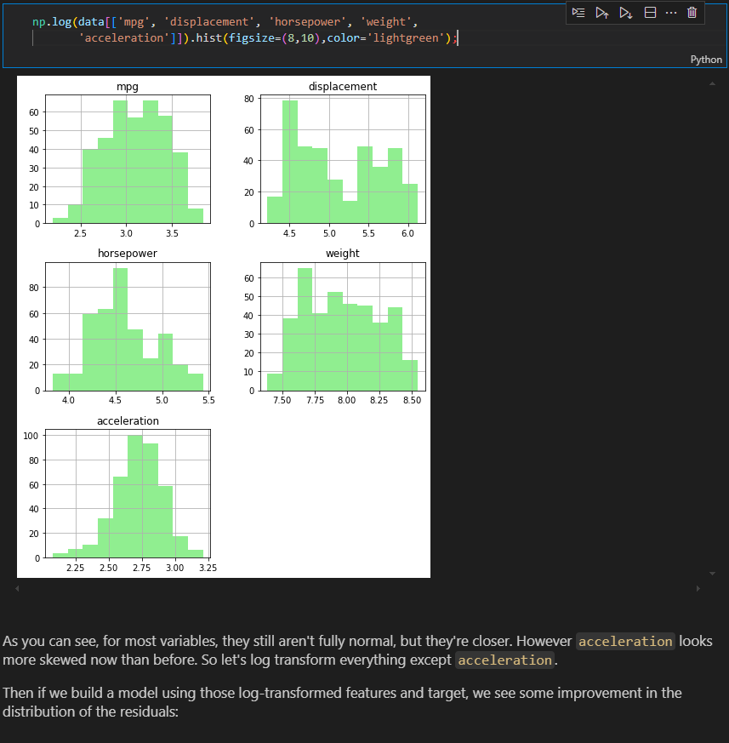

# Build log transformed model

y_log = np.log(data["mpg"])

X_log = pd.concat([np.log(data[['displacement', 'horsepower', 'weight']]), data[['acceleration']]], axis=1)

log_model = sm.OLS(y_log, sm.add_constant(X_log))

log_results = log_model.fit()

# Set up plot and properties of two models

fig, axes = plt.subplots(nrows=2, ncols=2, figsize=(12,10))

resids = [results.resid, log_results.resid]

labels = ["Original Model", "Log Transformed Model"]

colors = ["blue", "lightgreen"]

# Plot histograms

for index, ax in enumerate(axes[0]):

    sns.histplot(resids[index], bins=20, element="step", kde=True, color=colors[index], ax=ax)

    ax.set_xlabel("Model Residuals")

    ax.set_title(labels[index])

# Plot Q-Q plots

for index, ax in enumerate(axes[1]):

    sm.graphics.qqplot(resids[index], dist=stats.norm, line='45', fit=True, ax=ax)

    scatter = ax.lines[0]

    line = ax.lines[1]

    scatter.set_markeredgecolor(colors[index])

    scatter.set_markerfacecolor(colors[index])

    line.set_color("black")

    ax.set_title(labels[index])

fig.tight_layout()

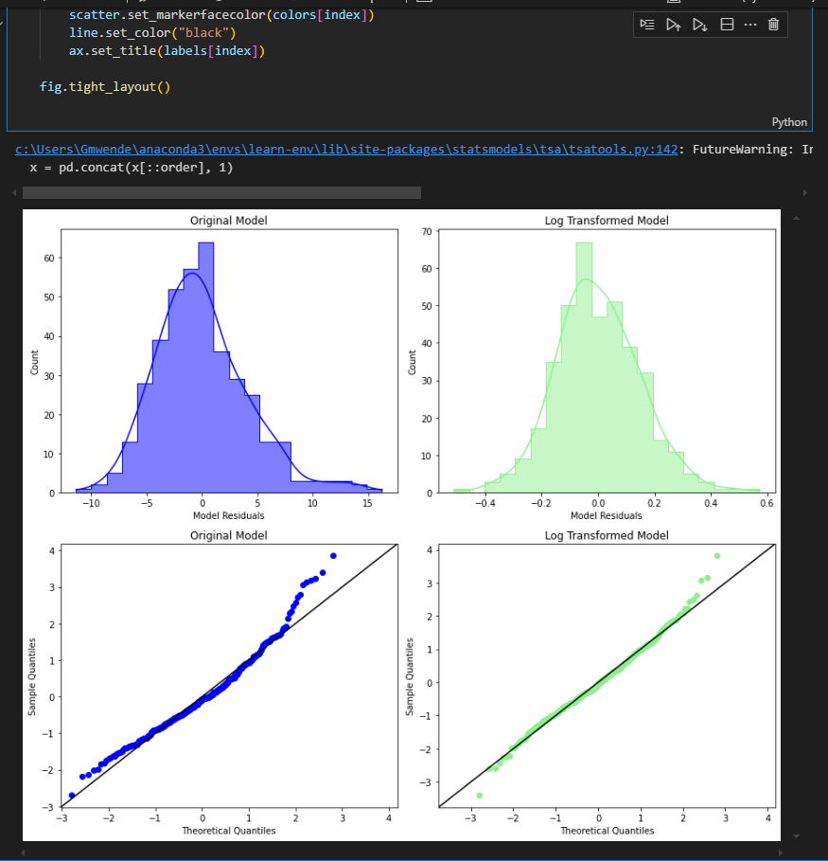

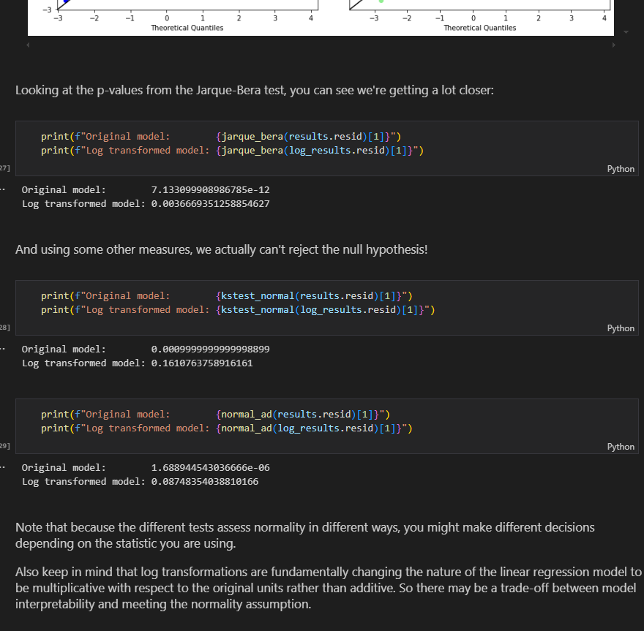

1. **QQ Plots**

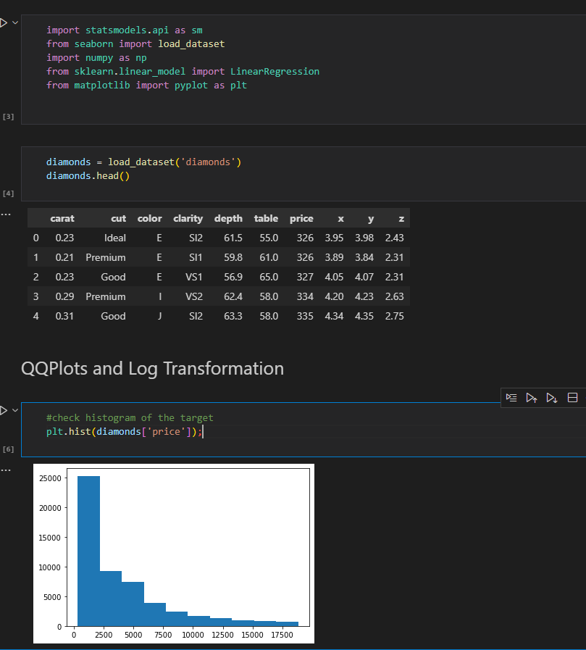

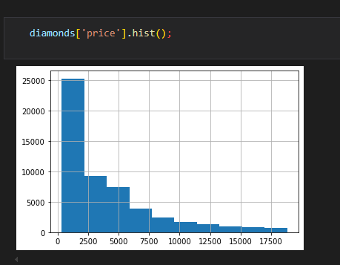

**Check qqplot against normal**

sm.qqplot(diamonds['price'],line='r');

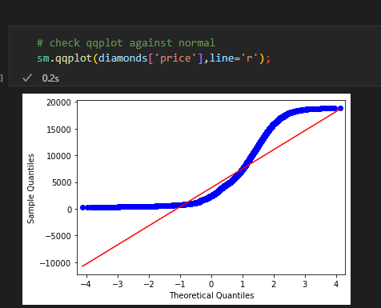

**Histogram of log-transformed target**

np.log(diamonds['price']).hist();

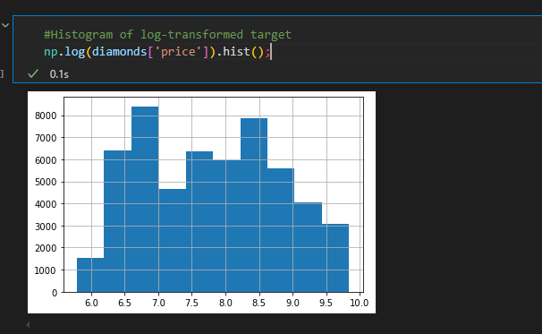

**QQ plot of log-transformed target**

sm.qqplot(np.log(diamonds['price']),line='r'); #not perfect but better

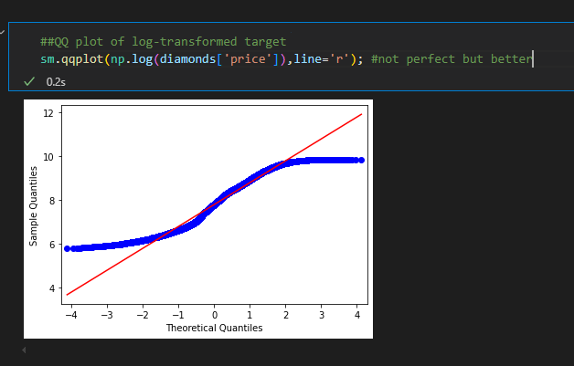

**QQ plot For model residuals**

#set up X, y and lr

X = diamonds[['carat']]

y = diamonds['price']

lr = LinearRegression().fit(X,y)

#store model predictins

preds = lr.predict(X)

#check the histogram of the residuals

resids = y -preds

#plt.hist(resids)

fig, ax = plt.subplots()

ax.hist(resids,bins=30);

sm.qqplot(resids,line='r');

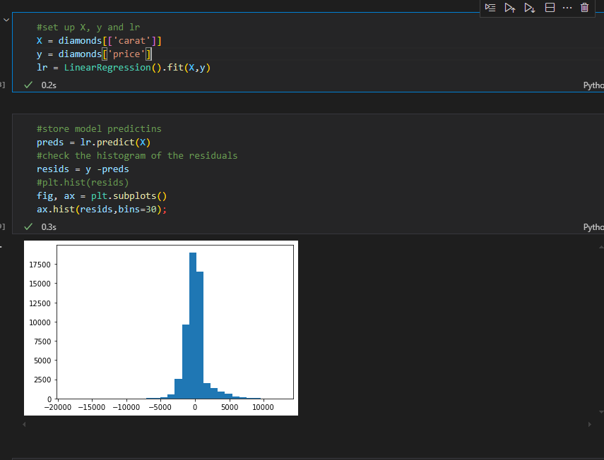

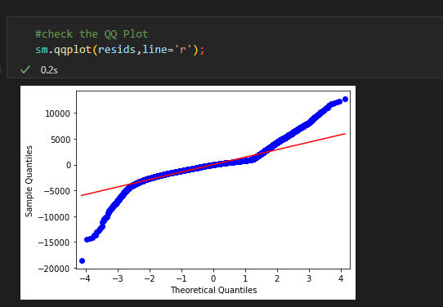

**BUILD MODEL ON TRANSFORMED TARGET**

log_target = np.log(y)

log_lr = LinearRegression().fit(X,log_target)

#store predictions

log_preds = log_lr.predict(X)

#new QQ plot

sm.qqplot(log_target - log_preds, line='r');

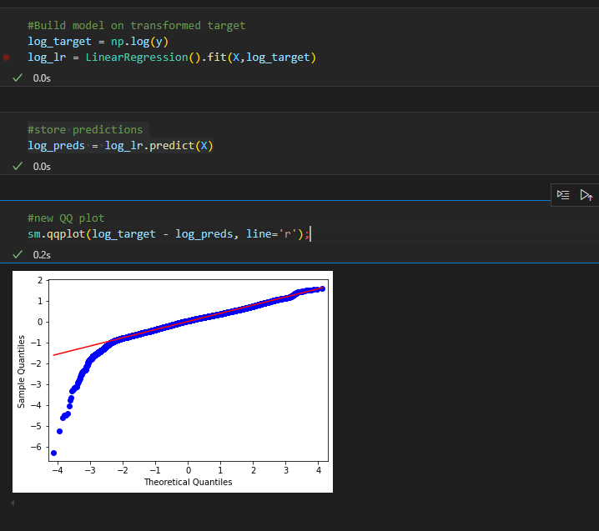

**Check shape of our predictor**

diamonds['carat'].hist()

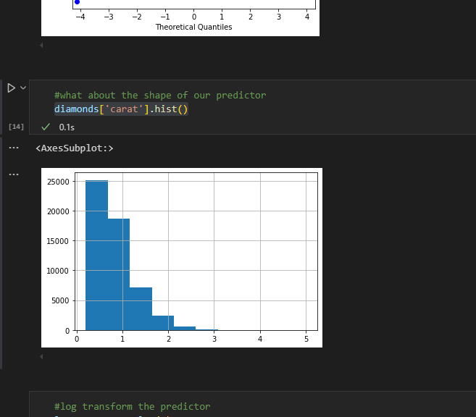

**Log transform our predictor**

#log transform the predictor

log_carat = np.log(X)

two_logs_lr = LinearRegression().fit(log_carat,log_target)

##QQ plot of double log-transformed data

two_logs_predict = two_logs_lr.predict(log_carat)

sm.qqplot(log_target-two_logs_predict,line='r');

#sm.qqplot(np.log(y)-two_logs_predict,line='r');

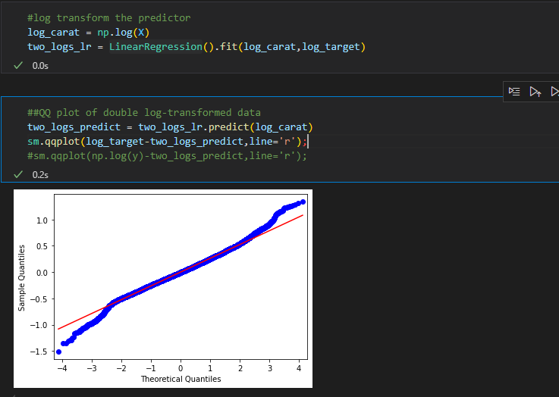

* **HOMOSCEDASTICITY ASSUMPTION:EQUAL VARIANCE(**https://github.com/GraceMwende/PHASE_2-MS_DS/blob/main/Flatiron/week5/The%20Homoscedasticity%20Assumption.ipynb**)**

States that we want to avoid **heteroscedasticity** of the error.heteroscedascticity refers to the circumstance in which a variable’s variability is unequal across the range of values of the predictor(s)

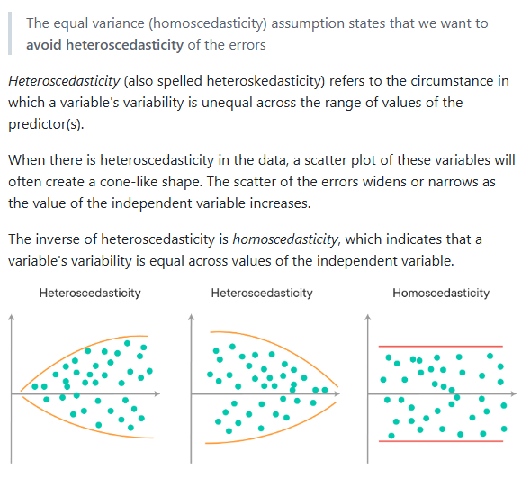

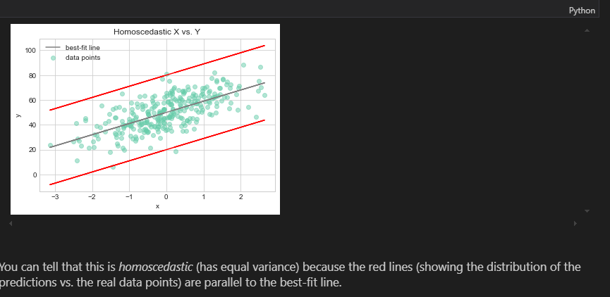

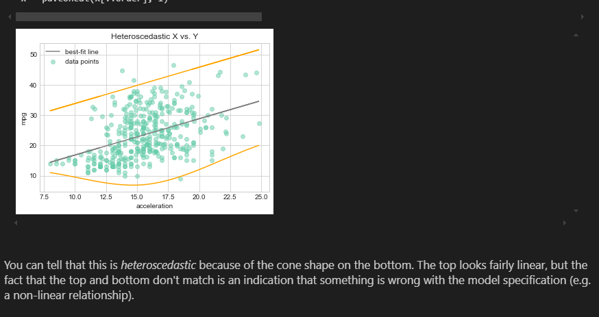

**Residual Plot(Simple or Multiple Linear Regression)**

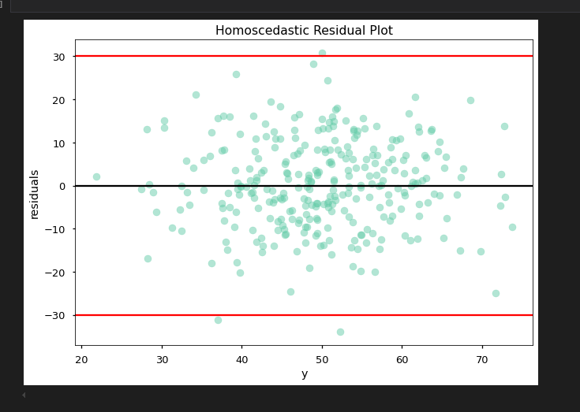

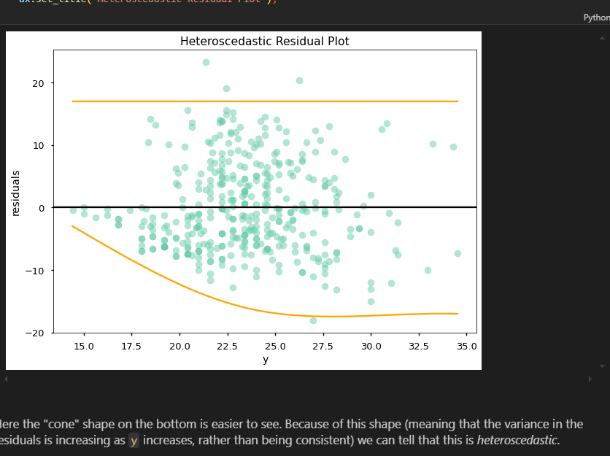

**Statistical tests for Homoscedasticity**

**Null :** The variance of the residuals is constant(i.e the error terms are homoscedastic)

**Alternative:** The variance of the residuals is not constant(i.e the error terms are heteroscedastic)

1.**Goldfeld-Quandt Test**

divides the dataset into two groups, then finds the MSE of the residuals for each group. The ratio of the second group's `mse_resid` divided by the first group's `mse_resid` becomes a statistic that can be compared to the f-distribution to find a p-value.

There is a StatsModels implementation ([documentation here](https://www.statsmodels.org/stable/generated/statsmodels.stats.diagnostic.het_goldfeldquandt.html)) that returns:

1. Goldfeld-Quandt test statistic

2. Goldfeld-Quandt test p-value

3. Ordering

(Ordering relates to the direction of the heteroscedasticity you want to be able to detect. By default it is `'increasing'` but you can also specify `'decreasing'` or `'two-sided'`.)

This implementation actually creates models and computes residuals for each subset of the dataset, so you pass in the target and features, not the residuals.

from statsmodels.stats.diagnostic import het_goldfeldquandt

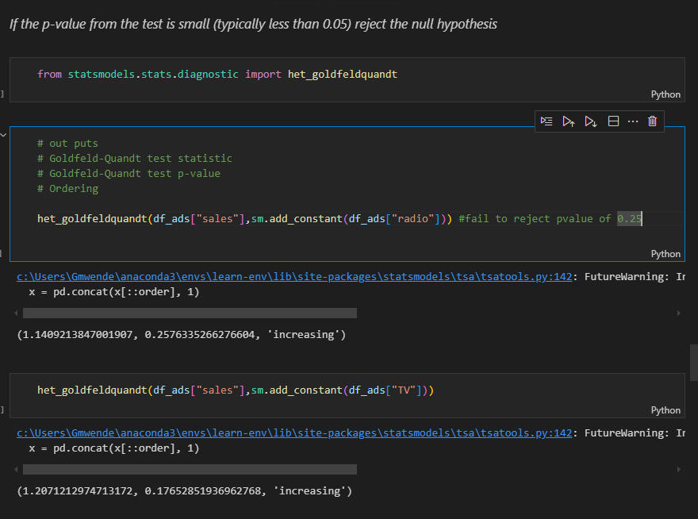

2. **Breusch-Pagan Test**

